**ENGR 102 Sect 508 Lab 4b**

**100 points**

**Reading assignment:**

|  |  |
| --- | --- |
| **Lecture Slides** | **L04** |
| **zyBook chapter 4** | **Complete all participation and challenge activities** |

***Attention!!***

***For submission: pdf/word file and all py-files as asked in the assignment. No pictures by the phone – it is impossible to read. You will be allowed to resubmit and reupload HW as many times as you want to within the due date/time, only last submission will be graded. No late submissions.***

***For submission you may use this file as template: rename file including your name. Do not forget to put your name inside of this file as well. If it is a team work, include the team number and all team members.***

***For this submission use Individual Header. Submit individually.***

You are to write the following programs, each of which should be done individually. However, you may talk with others in lab about how to go about doing each of them. Do not forget to put comments into your programs and provide examples of input/output.

**Program 1: [10 points]**

Using conditional statements (i.e. statements like if-elif-else) write a program that asks a user for 3 numbers **[5 points]**, and then reports what the largest of those 3 numbers is **[5points]. Include example of input/output.**

*# By submitting this assignment, I agree to the following:  
# “Aggies do not lie, cheat, or steal, or tolerate those who do”  
# “I have not given or received any unauthorized aid on this assignment”  
#  
# Name: ALEXIA PEREZ  
# Section: 508  
# Assignment: Lab 1b, Activity 4 (e.g. Lab 1b-2)  
# Date: 20-09-2018***import** numpy  
**from** math **import** *  
  
x = float(input(**"What is the first number?"**))  
y = float(input(**"What is the second number?"**))  
z = float(input(**"What is the third number?"**))  
**if** (x>y **and** x>z):  
 print(x,**" is the largest number."**)  
**elif** ( y>x **and** y>z):  
 print(y, **" is the largest number."**)  
**elif** (z>x **and** z>y):  
 print(z, **" is the largest number."**)

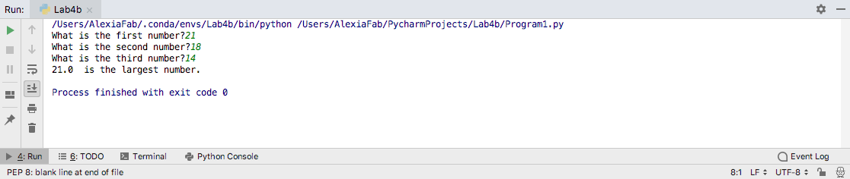

**Program 2: [15 points]**

Write a program to read in values of a fluid velocity, kinematic viscosity, and characteristic linear dimension to compute a Reynolds number. From this, report whether flow is laminar **[5points**], transient **[5points]** , or turbulent **[5 points].**

* The exact transition points below which flow is laminar, or above which it is turbulent have varying definitions. You are to find an online source that gives values that you will use for these levels. Output a text statement that gives a website address for the source you find to use for the breakpoints.
* **Include input/output examples for each possible case.**

*# By submitting this assignment, I agree to the following:  
# “Aggies do not lie, cheat, or steal, or tolerate those who do”  
# “I have not given or received any unauthorized aid on this assignment”  
#  
# Name: ALEXIA PEREZ  
# Section: 508  
# Assignment: Lab 1b, Activity 4 (e.g. Lab 1b-2)  
# Date: 20-09-2018***import** numpy  
**from** math **import** *  
  
d = float(input(**"What is the inside diameter?"**))  
v = float(input(**"What is the velocity?"**))  
k = float(input(**"What is the kinematic viscosity"**))  
R = (v*d)/k  
**if** (R <= 2000):  
 print(R, **" is Laminar."**)  
**elif**(2000< R <= 4000):  
 print(R, **" is Transient."**)  
**elif** (R > 4000):  
 print(R, **" is Turbulant."**)

Example 1:

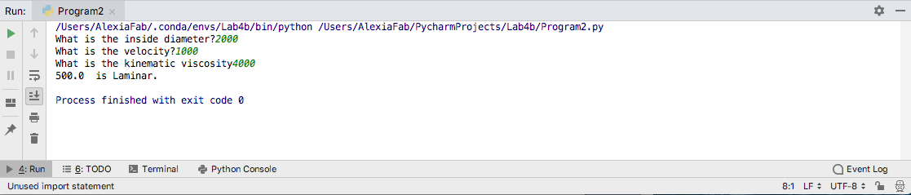

Example 2:

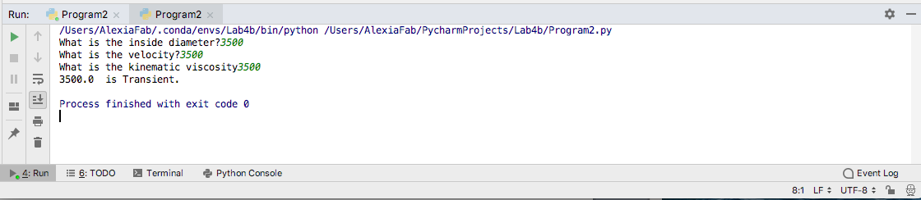

Example 3:

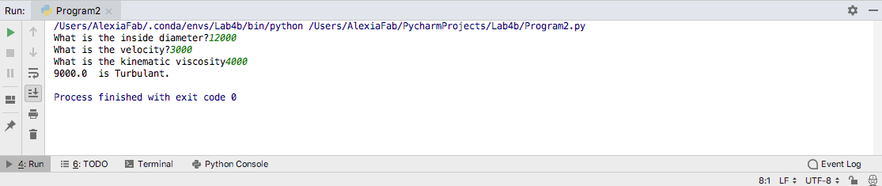

**Program 3: [25 points]**

**[5points**] Assume a machine during its initial testing phase produces 10 widgets a day.

**[5 points]** After 10 days of testing (starting on day 11), it begins to run at full speed, producing 40 widgets a day.

**[5 points]** After 50 days at full speed (days 11-60), it gradually starts becoming less productive, and produces 1 widget less per day, (ie. 39 widgets on day 61, etc.) until on day 100 it no longer produces any widgets.

Write a program that will read in a day **[2 points],** and will report the total number of widgets produced by that day (including that day) **[2 points]**. For example, entering 3 would report 30 widgets. (Note: part of the challenge in this program is for YOU to work out the model for how to compute widgets produced in total, given the above information.)

**Include input/output examples for each possible case.**

*# By submitting this assignment, I agree to the following:  
# “Aggies do not lie, cheat, or steal, or tolerate those who do”  
# “I have not given or received any unauthorized aid on this assignment”  
#  
# Name: ALEXIA PEREZ  
# Section: 508  
# Assignment: Lab 1b, Activity 4 (e.g. Lab 1b-2)  
# Date: 20-09-2018***import** numpy  
**from** math **import** *  
  
n = int(input(**"How many days days has the machine been running?"**))  
first_ten= n*10  
btwn_11and60 = (100+(n-10)*40)  
btwn_61and100= (2100+(40*(n-60))-sum(range(n-59)))  
**if** n <= 10:  
 print(first_ten,**"produced"**)  
**elif** (10 <n<= 60):  
 print(btwn_11and60,**"produced"**)  
**elif** (60 <n<= 100):  
 print(btwn_61and100,**"produced"**)

Example 1:

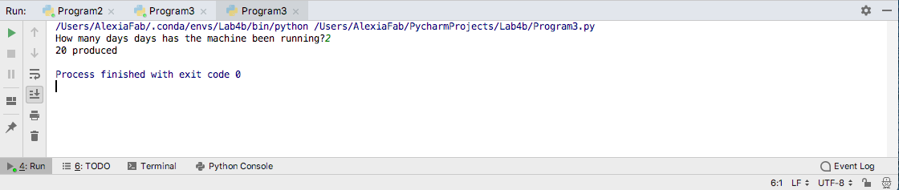

Example 2:

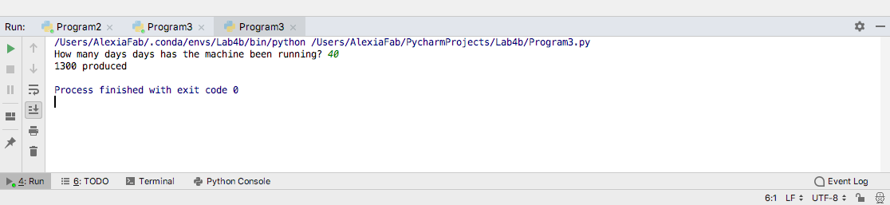

Example 3:

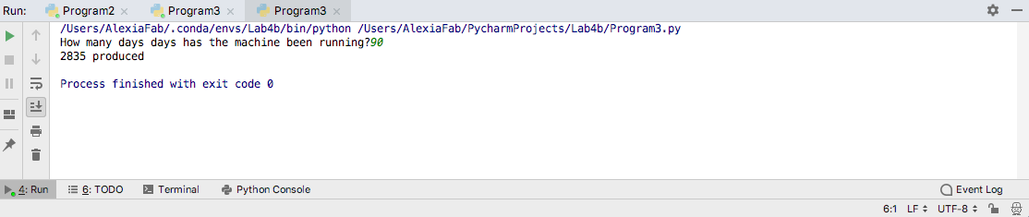

**Program 4: [50 points]**

A quadratic equation is an equation of the form Ax2+Bx+C. A, B, and C are the coefficients of the equation, and the roots are the values of x at which the equation evaluates to 0, and the well-known quadratic formula is often used to find these roots.

Write a program that asks a user for the 3 coefficients and outputs the roots of that equation. Be aware of the following:

* Be sure that your request for input and your output both have descriptive text.
* Be sure to handle the cases where some or even all of the coefficients are 0.
* If the roots have an imaginary component, use i when representing the imaginary term in the output. For example, you may output “3 + 7i” as a root.
* There could be 2 roots, 1 root, no roots, or infinite roots. If 1 or 2, you should output those. If no roots or infinite roots, you should output text stating that.

**Please provide examples for input and outputs for the following cases:**

* **[5 points]:** Read in coefficients, with descriptive text in both input and output
* **[8 points]:** Positive discriminant (two real roots) case
* **[8 points]:** 0 discriminant (1 real root) case
* **[12 points]:** negative discriminant (two complex roots) case, including outputting both real and imaginary parts in reasonably readable way.
* **[6 points]:** Cases where A==0 but B!=0 (1 real root).
* **[6 points]:** Case no roots (A==B==0 but C!=0) case
* **[5 points]:** Case infinite roots (A==B==C==0) case

*# By submitting this assignment, I agree to the following:  
# “Aggies do not lie, cheat, or steal, or tolerate those who do”  
# “I have not given or received any unauthorized aid on this assignment”  
#  
# Name: ALEXIA PEREZ  
# Section: 508  
# Assignment: Lab 1b, Activity 4 (e.g. Lab 1b-2)  
# Date: 20-09-2018***import** numpy  
**from** math **import** *  
**from** numpy.lib.scimath **import** *  
  
a= float(input(**"what is the value of a"**))  
b= float(input(**"what is the value of b"**))  
c= float(input(**"what is the value of c"**))  
discriminant= (b**2)-(4*a*c)  
print(**"The coefficients are"**,a,b,c)  
**if** discriminant < 0:  
 print(**"The coefficients are "**,a,b,c)  
 print(**"The equation has 2 complex solutions, and no real solutions."**)  
 print(complex((((-b)+(sqrt((b**2)-(4*a*c)))))/(2*a)),**","**,complex(((-b)-(sqrt((b**2)-(4*a*c))))/(2*a)))  
**elif** discriminant == 0 **and** (a **and** b)==0 **and not** c==0:  
 print(**"The equation has 1 real solution."**)  
 print(-c)  
**elif**(a==0 **and not** b==0):  
 print(**"The equation has 1 real solution."**)  
 print(-c/b)  
**elif** (a==b==c==0):  
 print(**"The equation has infinite many solutions."**)  
**elif** discriminant == 0 **and** c == 0:  
 print(**"The equation has 1 real solution."**)  
 print((-b) / (2 * a))  
**elif** discriminant == 0:  
 print(**"The equation has 1 solution"**)  
 print(float((-b)+(sqrt((b**2)-(4*a*c))))/(2*a))  
**elif** discriminant > 0 :  
 print (**"The equation has 2 solutions."**)  
 print(float((-b)+(sqrt((b**2)-(4*a*c))))/(2*a),**","**,float(((-b)-(sqrt((b**2)-(4*a*c))))/(2*a)))

Example 1

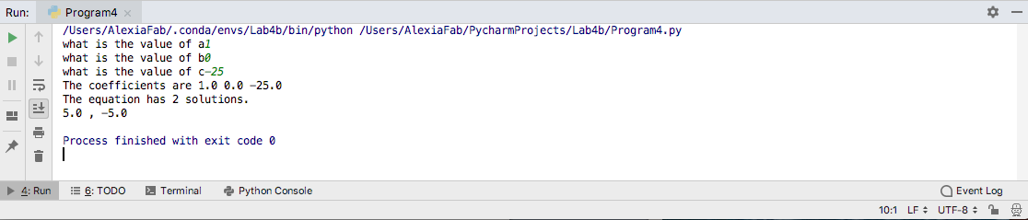

Example 2

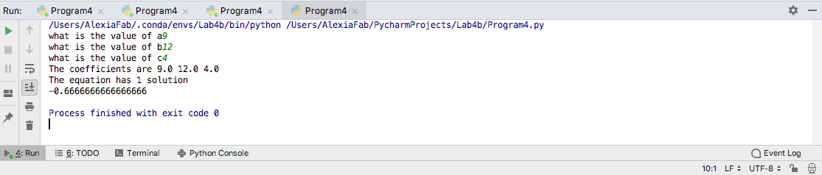

Example 3

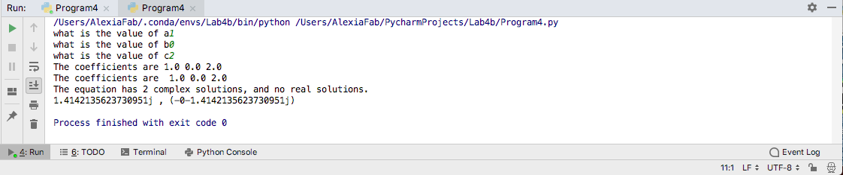

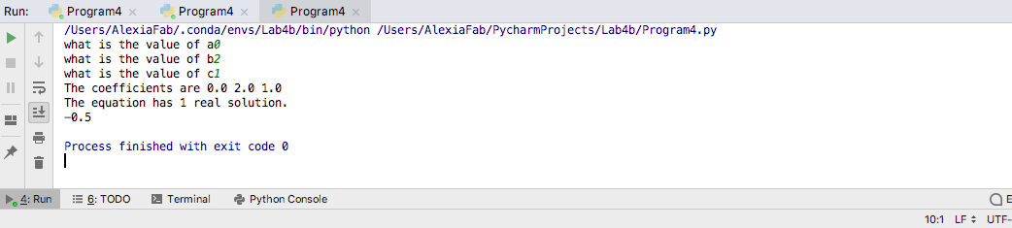Example 4

Example 5:

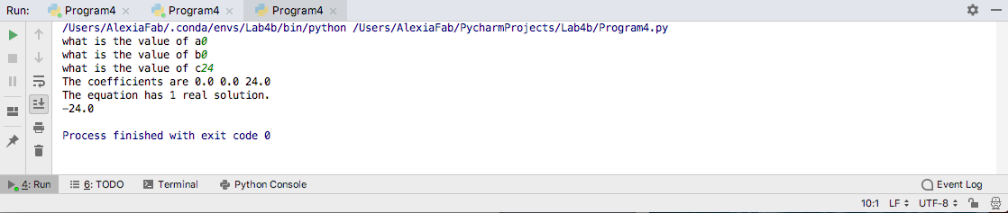

Example 6

