**ENGR 102 Sect 508 Lab 6b**

**100 points**

**Reading assignment:**

|  |  |
| --- | --- |
| **Lecture Slides: 2 presentations** | **L06** |
| **zyBook chapter 6** | **Complete all participation and challenge activities** |

*Attention!!*

*Individual submission.*

*Submit* *your Py-files together with your word/pdf file with screenshots of your tests outputs. Include any derivations, comments and supplemental notes in your word/pdf files.*

*No pictures by the phone – it is impossible to read. You will be allowed to resubmit and reupload HW as many times as you want to within the due date/time, only last submission will be graded. No late submissions. For submission you may use this file as template: rename file including your name. Do not forget to put your name inside of this file as well. If it is a team work, include the team number and all team members.*

Write programs to do each of the following. The programs should be labeled a through c:

For all programs, you should Include comments in your code that describe the purpose of individual blocks.

1. **[40 points]** The Collatz conjecture:

The Collatz conjecture, also known as the 3n+1 conjecture (and other names), deals with the following operation to produce a sequence of numbers. Given a number, n, if n is even then the next number is n divided by 2. If n is odd, then the next number is 3n+1. The Collatz conjecture is that this sequence of numbers always eventually reaches 1. As simple as this seems, it is unproven (and considered extremely hard to prove) by mathematicians.

As an example of a sequence, if you start with the number 6, then the terms of the sequence will be: 6, 3, 10, 5, 16, 8, 4, 2, 1.

Write a program that takes in a positive integer from a user, and computes the Collatz sequence, printing out all the numbers in the sequence, followed by a line stating how many iterations it took to reach the value 1.

Code:

*# By submitting this assignment, I agree to the following:  
# “Aggies do not lie, cheat, or steal, or tolerate those who do”  
# “I have not given or received any unauthorized aid on this assignment”  
#  
# Name: ALEXIA PEREZ  
# Section: 508  
# Assignment: LAB 6B  
# Date: 04-10-2018***from** math **import** *  
**import** numpy  
  
*# In this program I will ask the user for a number input  
# and will use the Collatz conjecture until the number is 1.  
  
# First we define the Conjecture:  
# i will be the number of iterations,  
# while the number is not 1, the program keeps running  
# if the number is odd, a rule will apply  
# if the number is even , a different rule will apply (Both of these are given by the Conjecture  
# Once the number reaches 1, the program will stop.***def** conjecture(n):  
 i = 0  
 **while** n != 1:  
 print(n)  
 **if** n % 2 == 0:  
 n = int(n / 2)  
 i = i+1  
 **else**:  
 n = int(3 * n + 1)  
 i= i+1  
 **else**:  
 print(n)  
 print(**"The number of iterations is "**,i)  
  
**def** main():  
 n = int(input(**"Input a number: "**))  
 conjecture(n)  
  
main()

Output:

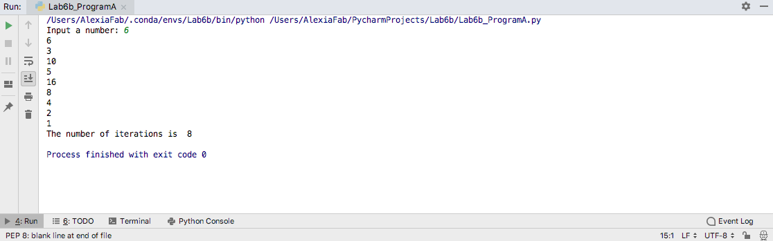

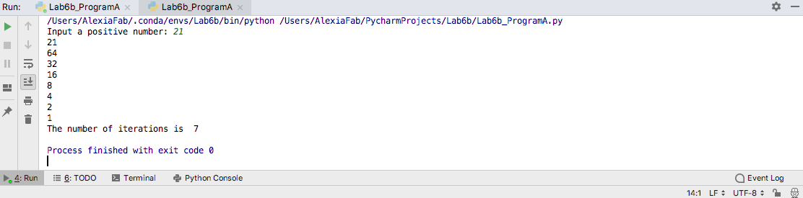

1. **[30 points]** Averaging measurements:

Assume that someone has collected a set of measurements and wants some statistical data about them. Write a program that asks a user for measurements and prints the **average [10]**, the **maximum [10]**, and **the minimum [10]** measurement. Users should be allowed to enter as many measurements as they want, until entering a **negative measurement**. The negative measurement should not be processed, but is just used to indicate that the user has finished entering measurements. [Note: do not use a list to store the measurements.]

Code:

*# By submitting this assignment, I agree to the following:  
# “Aggies do not lie, cheat, or steal, or tolerate those who do”  
# “I have not given or received any unauthorized aid on this assignment”  
#  
# Name: ALEXIA PEREZ  
# Section: 508  
# Assignment: LAB 6B  
# Date: 04-10-2018***from** math **import** *  
**import** numpy  
  
*# In this program I will ask the user for measurments (input),  
# then I will find the minimun, and maximum values  
# and finally I will find the average.*measurement= int(input(**"Input a measurement "**))  
max = 0  
min = measurement  
average = 0  
i = 0  
**while** measurement > 0:  
 average = average + measurement  
 i = i + 1  
 **if** measurement > max:  
 max = measurement  
 **elif** measurement < min:  
 min = measurement  
 measurement = int(input(**"Input another measurement "**))  
print(**"The minimum value is: "**,min)  
print(**"The maximum value is: "**,max)  
average = average/i  
print(**"The average is:"**,average)

Output:

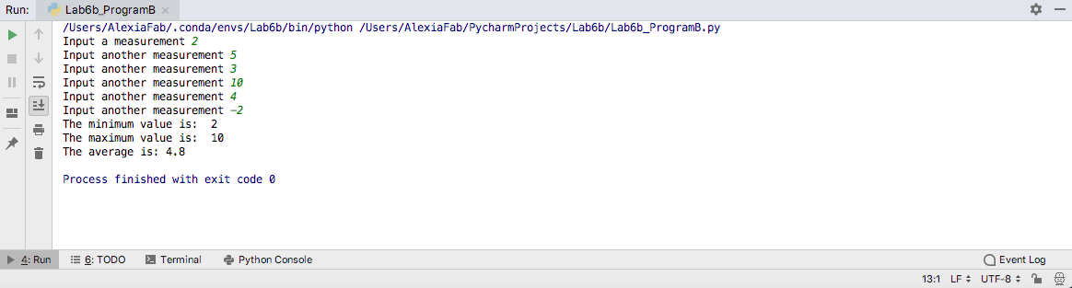

1. **[30 points]** Divisors:  
   For numbers from 2 to 100, print a series of lines indicating which numbers are divisors of other numbers. For each, print out “X divides Y”, where X <= Y, and both X and Y are between 2 and 100. The first few lines will be:

2 divides 2

3 divides 3

2 divides 4

4 divides 4

5 divides 5

etc.

Code:

*# By submitting this assignment, I agree to the following:  
# “Aggies do not lie, cheat, or steal, or tolerate those who do”  
# “I have not given or received any unauthorized aid on this assignment”  
#  
# Name: ALEXIA PEREZ  
# Section: 508  
# Assignment: LAB 6B  
# Date: 04-10-2018***from** math **import** *  
**import** numpy  
  
*# In this program I will print a series of lines indicating  
# which numbers are divisors of other numbers from 2 to 100.***for** n **in** range (2,101):  
 **for** x **in** range (2,101):  
 **if** x%n == 0:  
 print(n,**"divides"**,x)

Output:

