**ENGR 102 Sect 508 Lab 7b**

**180 points**

**Reading assignment:**

|  |  |
| --- | --- |
| **Lecture Slides** | **L07** |
| **zyBook chapter 7** | **Complete all participation and challenge activities** |
| **Halterman python book handout** | **Chapter 9 Lists** |

*Attention!!*

*Individual submission.*

*Submit* *your Py-files together with your word/pdf file with screenshots of your tests outputs. Include any derivations, comments and supplemental notes in your word/pdf files.*

*No pictures by the phone – it is impossible to read. You will be allowed to resubmit and reupload HW as many times as you want to within the due date/time, only last submission will be graded. No late submissions. For submission you may use this file as template: rename file including your name. Do not forget to put your name inside of this file as well. If it is a team work, include the team number and all team members. For this submission use Individual Header, include all team members into the list of participants.*

**[20 points] Activity #1: Individual task**

Create a list of integer numbers using **the range function** to produce a regular sequence of integers. Ask the user to put the minimum number of the list, the maximum number of the list and step. You should ask user if he/she wants to create another list. Keep creating lists until the user wants to stop. You can do it for example by analyzing user’s response Yes and No. As the output print your created lists and rules by what you created them.

Code:

*# By submitting this assignment, I agree to the following:  
# “Aggies do not lie, cheat, or steal, or tolerate those who do”  
# “I have not given or received any unauthorized aid on this assignment”  
#  
# Name: ALEXIA PEREZ  
# Section: 508  
# Assignment: LAB 7B  
# Date: 11-10-2018***from** math **import** *  
**import** numpy  
  
*# This program will create a list of integer numbers using the range function.  
  
# First we're going to create a loop that will repeat until the user tells it to stop:*confirm = 1  
**while** confirm == 1:  
 *# Now we're going to ask the user for the range and step:* x = int(input(**"What will be the first number in your list: "**))  
 y = int(input(**"What will be the last number in your list: "**))  
 s = int(input(**"What step do you want to use in this list: "**))  
 y = y+1  
 list = numpy.arange(x,y,s)  
 print(list)  
 confirm = int(input(**"Do you want to make another list, input 1 for yes and 0 for no: "**))  
**else**:  
 print(**"Finished, thank you."**)

Output:

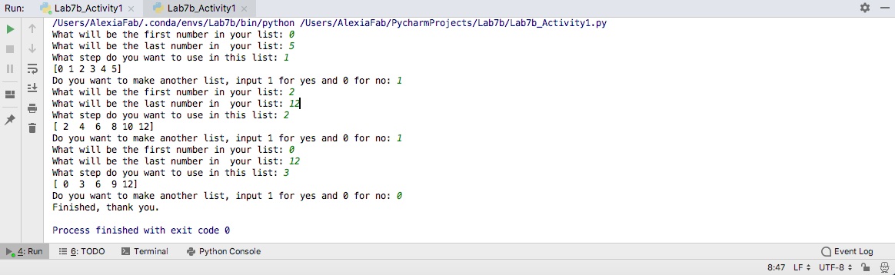

**Activity 2 [10 points]**

For a given list ask user if he/she wants to create a new list that repeats n-times itself. If Yes- create a new list that repeats itself n-times, (n is user specified).

Code:

*# By submitting this assignment, I agree to the following:  
# “Aggies do not lie, cheat, or steal, or tolerate those who do”  
# “I have not given or received any unauthorized aid on this assignment”  
#  
# Name: ALEXIA PEREZ  
# Section: 508  
# Assignment: LAB 7B  
# Date: 11-10-2018***from** math **import** *  
**import** numpy  
  
*# In this program I will ask the user if they want to create a list that repeats itself n number of times.*n = 0  
confirm = 1  
  
**while** confirm == 1:  
 n = int(input(**"How many times do you want the list to repeat itself: "**))  
 x = int(input(**"What will be the first number in your list: "**))  
 y = int(input(**"What will be the last number in your list: "**))  
 s = int(input(**"What step do you want to use in this list: "**))  
 y = y + 1  
 list = numpy.arange(x, y, s)  
 list = str(list).strip(**"[]"**)+**" "** list = list * n  
 print(list)  
 confirm = int(input(**"Do you want to make another list, input 1 for yes and 0 for no: "**))  
**else**:  
 print(**"Finished, thank you."**)

Output:

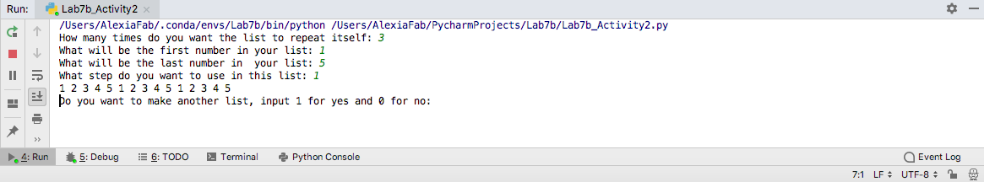

**Activity 3 [10 points]**

Write a program that takes numbers from the user, saves them in a list, calculates the averages number while retaining all the values the user enters. As the output you should print all entered numbers as one list, the amount of entered numbers and the average number.

Code:

*# By submitting this assignment, I agree to the following:  
# “Aggies do not lie, cheat, or steal, or tolerate those who do”  
# “I have not given or received any unauthorized aid on this assignment”  
#  
# Name: ALEXIA PEREZ  
# Section: 508  
# Assignment: LAB 7B  
# Date: 11-10-2018***from** math **import** *  
**import** numpy  
  
*# In this program we will create a list from user input and calculate the average.  
# At the end the program will print the list, how many numbers there are and the average number.*numbers = int(input(**"Enter the number you want to add to the list: "**))  
list = []  
sum = numbers  
**while** numbers >= 0: *# This loop will stop if the value enetered for a widget is negative.* list.append(numbers)  
 numbers = int(input(**"Enter a new number: "**))  
 **if** numbers >= 0:  
 sum = sum + numbers  
**else**:  
 print(**"Negative numbers end this loop."**)  
  
  
items = len(list) *# gives number of items in list*average = sum / items  
  
print(list)  
print(**"The average is: "**,average)  
print(**"There are: "**,items,**" numbers in this list."**)

Output:

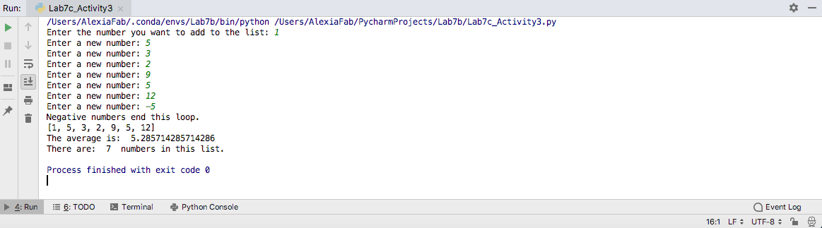

**Activity 4 [22 points]**

Complete the following table by supplying the command and m and n values in the slice assignment a[m:n] statement needed to produce the indicated list from the given original list.

Slice indices

Original List Target List m n

|  |  |  |  |
| --- | --- | --- | --- |
|  | Original list | Target List | Slice command |
|  |  |  |  |
| 1 | [2, 4, 6, 8, 10] | [2, 4, 6, 8, 10, 12, 14, 16, 18, 20] | list[5:]=[12,14,16,18,20] |
| 2 | [2, 4, 6, 8, 10] | [-10, -8, -6, -4, -2, 0, 2, 4, 6, 8, 10] | list[:0]=[-10,-8,-6,-4,-2,0] |
| 3 | [2, 4, 6, 8, 10] | [2, 3, 4, 5, 6, 7, 8, 10] | list[1:1]=[3] list[3:3]=[5] list[5:5]=[7] |
| 4 | [2, 4, 6, 8, 10] | [2, 4, 6, ’a’, ’b’, ’c’, 8, 10] | list[3:3]=[“a”,”b”,”c”] |
| 5 | [2, 4, 6, 8, 10] | [2, 4, 6, 8, 10] | list[0:5] |
| 6 | [2, 4, 6, 8, 10] | [] | list[-1:0] |
| 7 | [2, 4, 6, 8, 10] | [10, 8, 6, 4, 2] | list[::-1] |
| 8 | [2, 4, 6, 8, 10] | [2, 4, 6] | list[0:3] |
| 9 | [2, 4, 6, 8, 10] | [6, 8, 10] | list[2:5] |
| 10 | [2, 4, 6, 8, 10] | [2, 10] | list[0:5:4] |
| 11 | [2, 4, 6, 8, 10] | [4, 6, 8] | list[1:4] |

Code:

*# By submitting this assignment, I agree to the following:  
# “Aggies do not lie, cheat, or steal, or tolerate those who do”  
# “I have not given or received any unauthorized aid on this assignment”  
#  
# Name: ALEXIA PEREZ  
# Section: 508  
# Assignment: LAB 7B  
# Date: 11-10-2018***from** math **import** *  
**import** numpy  
  
list= [2,4,6,8,10]  
list[5:]=[12,14,16,18,20]  
print(list)  
  
list= [2,4,6,8,10]  
list[:0]=[-10,-8,-6,-4,-2,0]  
print(list)  
  
list= [2,4,6,8,10]  
list[1:1]=[3]  
list[3:3]=[5]  
list[5:5]=[7]  
print(list)  
  
list= [2,4,6,8,10]  
list[3:3]=[**"a"**,**"b"**,**"c"**]  
print(list)  
  
list= [2,4,6,8,10]  
list=list[0:5]  
print(list)  
  
list= [2,4,6,8,10]  
list=list[-1:0]  
print(list)  
  
list= [2,4,6,8,10]  
list=list[::-1]  
print(list)  
  
list= [2,4,6,8,10]  
list=list[0:3]  
print(list)  
  
list= [2,4,6,8,10]  
list=list[2:5]  
print(list)  
  
list=[2,4,6,8,10]  
list=list[0:5:4]  
print(list)  
  
list=[2,4,6,8,10]  
list=list[1:4]  
print(list)

Output:

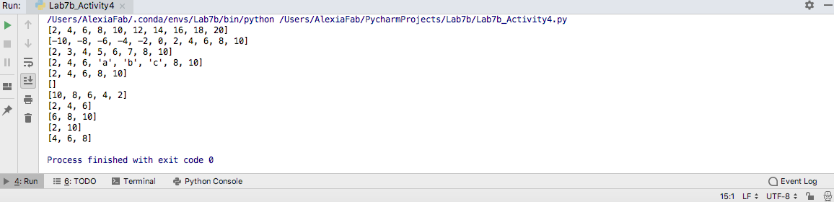

**Activity 5 [20 points]**

Write a code that reorders the contents of a list so they are reversed from their original order. a is a list. Note that your function must physically rearrange the elements within the list, not just print the elements in reverse order.

Code:

*# By submitting this assignment, I agree to the following:  
# “Aggies do not lie, cheat, or steal, or tolerate those who do”  
# “I have not given or received any unauthorized aid on this assignment”  
#  
# Name: ALEXIA PEREZ  
# Section: 508  
# Assignment: LAB 7B  
# Date: 11-10-2018***from** math **import** *  
**import** numpy  
string = int(input(**"Do you want to input words or numbers? Input 1 for words and 0 for numbers: "**))  
list = []  
confirm = 1  
  
**if** string == 1:  
 **while** confirm == 1: *# This loop will stop if the value enetered for a widget is negative.* item = str(input(**"Enter an item: "**))  
 list.append(item)  
 confirm = int(input(**"Do you want to input another item? Input 1 for yes and 0 for no: "**))  
  
**elif** string == 0:  
 **while** confirm == 1: *# This loop will stop if the value enetered for a widget is negative.* item = int(input(**"Enter a new item: "**))  
 list.append(item)  
 confirm = int(input(**"Do you want to input another item? Input 1 for yes and 0 for no: "**))  
  
print(**"The initial list is: "**,list)  
list=list[::-1]  
print(**"The re-organized list is: "**,list)

Output:

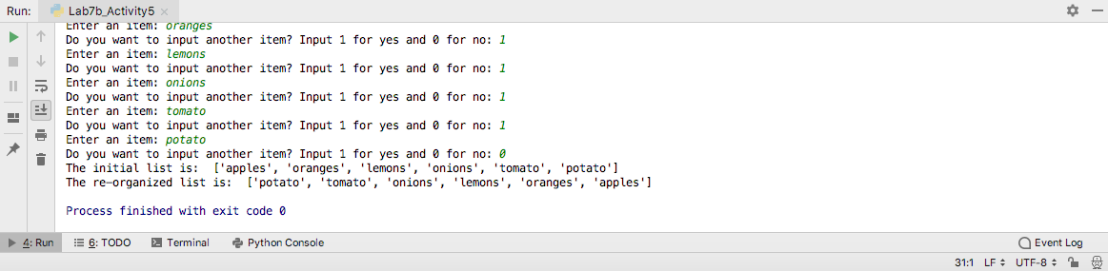

**Activity 6 [30points]**

Sorting—arranging the elements within a list into a particular order—is a common activity. For example, a list of integers may be arranged in ascending order (that is, from smallest to largest). A list of strings may be arranged in lexicographical (commonly called alphabetical) order. Many sorting algorithms exist, and some perform much better than others. We will consider one sorting algorithm that is relatively easy to implement.

The selection sort algorithm is relatively easy to implement and easy to understand how it works. If A is a list, and i represents a list index, selection sort works as follows:

1. Set n = length of list A.

2. Set i = 0.

3. Examine all the elements A[ j], where i < j < n. (This simply means to consider all the elements in

the list from index i to the end.) If any of these elements is less than A[i], then exchange A[i] with the

smallest of these elements. (This ensures that all elements after position i are greater than or equal to

A[i].)

4. If i is less than n−1, set i equal to i+1 and go to Step 2.

5. Done; list A is sorted.

Write a program that takes a list of integer numbers from a user and creates a new sorted in ascending order list. As output you need to print original list and sorted one.

Code:

*# By submitting this assignment, I agree to the following:  
# “Aggies do not lie, cheat, or steal, or tolerate those who do”  
# “I have not given or received any unauthorized aid on this assignment”  
#  
# Name: ALEXIA PEREZ  
# Section: 508  
# Assignment: LAB 7B  
# Date: 11-10-2018***from** math **import** *  
**import** numpy  
  
numbers = int(input(**"Enter a number: "**))  
numbers_list= []  
  
**while** numbers >= 0: *# This loop will stop if the value enetered is negative.* numbers_list.append(numbers)  
 numbers = int(input(**"Enter a new number: "**))  
**else**:  
 print(**"Negative numbers end this loop."**)  
  
*# This prints the whole list (except the negative value entered last, as it is assumed  
# that a negative value will only be inputted to stop the loop.*print(**"The initial list is: "**,numbers_list)  
items = len(numbers_list) *# gives number of items in list*print(**"The number of items in this list is: "**,items)  
  
  
i = 1  
j = 0  
  
**for** i **in** range(0,items-1):  
 **for** j **in** range(0,items-1):  
 **if** numbers_list[j]>numbers_list[(j+1)]:  
 temp = numbers_list[j]  
 numbers_list[j]=numbers_list[(j+1)]  
 numbers_list[(j+1)]=temp  
  
print(**"The re-organized list is: "**,numbers_list)

Output:

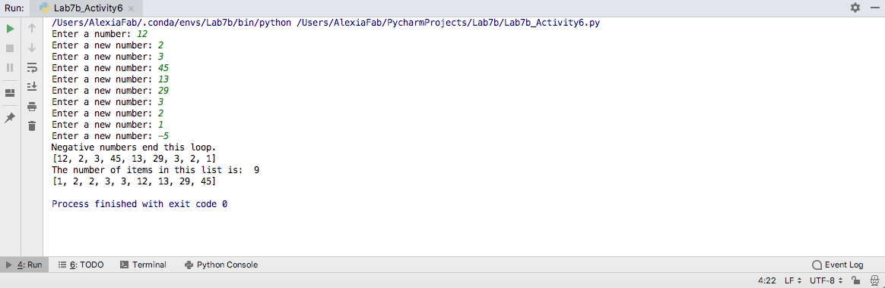

**Activity 7: (Pig Latin) [35 points]**

This program is meant to help give you practice with string manipulation.

“Pig Latin” is a way of converting words in standard English to similar words that sound different. The rules for converting from standard words to Pig Latin are as follows:

* If a word starts with a consonant, move the consonants to the end of the word, and add “ay” to the end.
  + e.g. “computer” becomes “omputercay”
* If a word starts with a vowel, add “yay” on to the end of the word.
  + e.g. “engineering” becomes “engineeringyay”
* Note: treat “y” as a vowel for this assignment.

Write a program that repeatedly reads in a word from a user and converts it to Pig Latin. The program should continue reading words until the user enters “stop”.

Challenge: Try to write a program where, instead of just one word, the user enters an entire sentence, and all words in the sentence are converted to Pig Latin.

Code:

*# By submitting this assignment, I agree to the following:  
# “Aggies do not lie, cheat, or steal, or tolerate those who do”  
# “I have not given or received any unauthorized aid on this assignment”  
#  
# Name: ALEXIA PEREZ  
# Section: 508  
# Assignment: LAB 7B  
# Date: 11-10-2018***from** math **import** *  
**import** numpy  
  
pyg = **'yay'**confirm = **"yes"  
  
while** confirm != **"stop"**:  
 **if** confirm == **"stop"**:  
 **break** original = input(**'Enter a word:'**)  
 **if** len(original) > 0 **and** original.isalpha():  
 word = original.lower()  
 first = word[0]  
 **if** first == **'y' or** first== **'a' or** first== **'e' or** first== **'i' or** first==**'o' or** first== **'u'**:  
 new_word = word + pyg  
 print(new_word)  
 **else**:  
 new_word = word[1:] + first + pyg  
 print(new_word)  
 **else**:  
 print(**'empty'**)  
 confirm = input(**"Do you want to input another word, say yes to continue or stop to finish: "**)

Output:

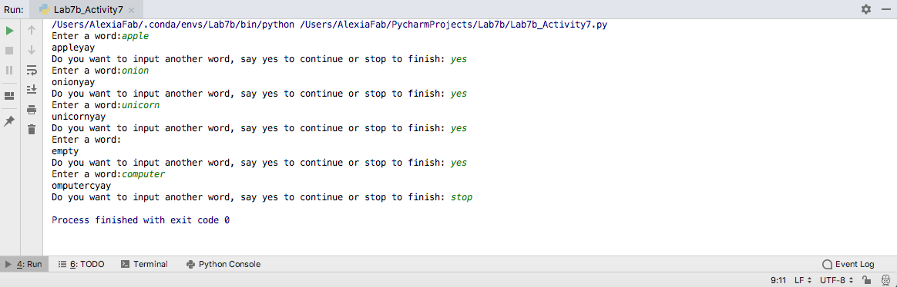

**Activity 8: (Vector Math) [33 points]**

This program is meant to give you practice with lists and looping on them, as well as practice with vector computations.

Write a program that lets a user enter two vectors, A and B, of arbitrary dimension. You should allow the user to first enter the dimension of the vector, then get the elements of the two vectors from the user. Then, you should output (in a clearly labeled way), the results of these computations:

* The magnitude of vector A and the magnitude of vector B
* A + B
* A – B
* And the dot product (inner product) of A and B

Note: You should use lists when solving this problem. Later we will see some other ways to work with vectors more directly.

Code:

*# By submitting this assignment, I agree to the following:  
# “Aggies do not lie, cheat, or steal, or tolerate those who do”  
# “I have not given or received any unauthorized aid on this assignment”  
#  
# Name: ALEXIA PEREZ  
# Section: 508  
# Assignment: LAB 7B  
# Date: 11-10-2018***from** math **import** *  
**import** numpy  
  
*# In this program I will ask a user to enter two vectors, A and B, of arbitrary dimension.  
# then I'll get the elements of the two vectors from the user.  
# and output the results of different computations:  
  
# This first part of the code takes a string of user input and splits it into different components (items in a list)  
# after every comma (,).*inputA = input(**"Input vector A: "**)  
vector_A = list(map(int,inputA.split(**","**)))  
inputB = input(**"Input vector B: "**)  
vector_B = list(map(int,inputB.split(**","**)))  
  
print(**"Vector A is: "**,vector_A)  
print(**"Vector B is: "**,vector_B)  
  
*# Now we proceed to calculate the magnitude of each vector:*magnitude_A = sqrt((vector_A[0])**2+(vector_A[1])**2)  
magnitude_B = sqrt((vector_B[0])**2+(vector_B[1])**2)  
print(**"The magnitude of vector A is: "**, magnitude_A)  
print(**"The magnitude of vector B is: "**, magnitude_B)  
  
*# We now calculate the sum of the 2 vectors:*sum = [vector_A[0]+vector_B[0],vector_A[1]+vector_B[1]]  
print(**"The sum of the two vectors is: "**,sum)  
  
*# Now we calculate A-B :*difference = [vector_A[0]-vector_B[0],vector_A[1]-vector_B[1]]  
print(**"The difference between the vectors is: "**,difference)  
  
*# Finally we calculate the dot product:*dot_prod = vector_A[0]*vector_B[0]+vector_A[1]*vector_B[1]  
print(**"The dot product of the vectors is: "**,dot_prod)

Output:

