**ENGR 102 Sect 508 Lab 8b**

**150 points**

**Reading assignment:**

|  |  |
| --- | --- |
| **Lecture Slides** | **L07** |
| **zyBook chapter 7** | **Complete all participation and challenge activities** |
| **Halterman python book handout** | **Chapter 9 Lists** |

*Attention!!*

*You are allowed to work in group, but it is individual submission.*

*Submit* *your Py-files together with your word/pdf file with screenshots of your tests outputs. Include any derivations, comments and supplemental notes in your word/pdf files.*

*No pictures by the phone – it is impossible to read. You will be allowed to resubmit and reupload HW as many times as you want to within the due date/time, only last submission will be graded. No late submissions. For submission you may use this file as template: rename file including your name. Do not forget to put your name inside of this file as well. If it is a team work, include the team number and all team members.*

You are tasked with writing a program. These problems are straightforward but will require you to spend time developing your logic. Complete any 3 green [3x10=30 points], 3 cyan[3x10=30 points], 3 yellow[3x10=30 points], and 6 magenta[6x10=60 points] python files.

1. Python Program to Replace all Occurrences of ‘a’ with $ in a String

2. Python Program to Remove the nth Index Character from a Non-Empty String

3. Python Program to Detect if Two Strings are Anagrams

4. Python Program to Form a New String where the First Character and the Last Character have been Exchanged

5. Python Program to Count the Number of Vowels in a String

6. Python Program to Take in a String and Replace Every Blank Space with Hyphen

7. Python Program to Calculate the Length of a String Without Using a Library Function

8. Python Program to Remove the Characters of Odd Index Values in a String

Code for green programs:

Program 1:

*# By submitting this assignment, I agree to the following:  
# “Aggies do not lie, cheat, or steal, or tolerate those who do”  
# “I have not given or received any unauthorized aid on this assignment”  
#  
# Name: ALEXIA PEREZ  
# Section: 508  
# Assignment: LAB 8B  
# Date: 18-10-2018  
  
# Program 1  
# Python program to replace all ocurrences of "a" with a $ in a string:*string = str(input(**"Enter a letter, word, or sentence: "**))  
string = string.replace(**"a"**,**"$"**)  
print(string)

Program 5:

*# By submitting this assignment, I agree to the following:  
# “Aggies do not lie, cheat, or steal, or tolerate those who do”  
# “I have not given or received any unauthorized aid on this assignment”  
#  
# Name: ALEXIA PEREZ  
# Section: 508  
# Assignment: LAB 8B  
# Date: 18-10-2018  
  
  
# Program 5  
# Python Program to Count the Number of Vowels in a String:*string = str(input(**"Enter a letter, word, or sentence: "**))  
vowels = [**"a"**,**"e"**,**"i"**,**"o"**,**"u"**]  
count = 0  
  
**for** i **in** string:  
 **if** i **in** vowels:  
 count += 1  
print(**"There are "**,count,**" vowels in your string."**)

Program 8:

*# By submitting this assignment, I agree to the following:  
# “Aggies do not lie, cheat, or steal, or tolerate those who do”  
# “I have not given or received any unauthorized aid on this assignment”  
#  
# Name: ALEXIA PEREZ  
# Section: 508  
# Assignment: LAB 8B  
# Date: 18-10-2018  
  
# Program 8  
# Python Program to Remove the Characters of Odd Index Values in a String:*string=str(input(**"Enter a letter, word, or sentence: "**))  
list = list(string)  
string_two = **""**print(list)  
**for** i **in** range(len(list)):  
 **if** i % 2 == 0:  
 string_two = string_two + string[i]  
  
print(string_two)

Output for green programs:

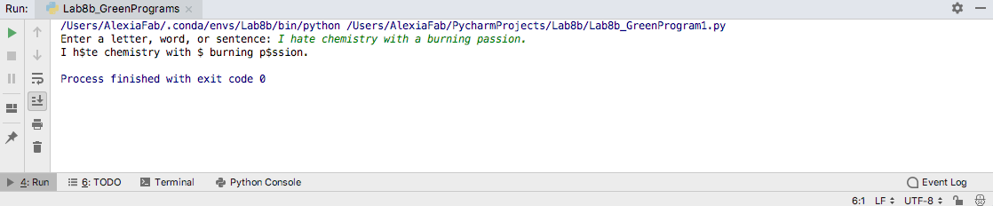

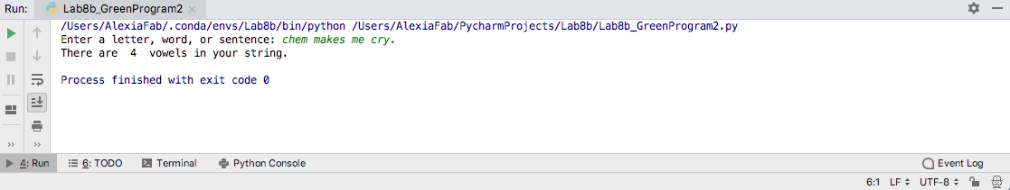

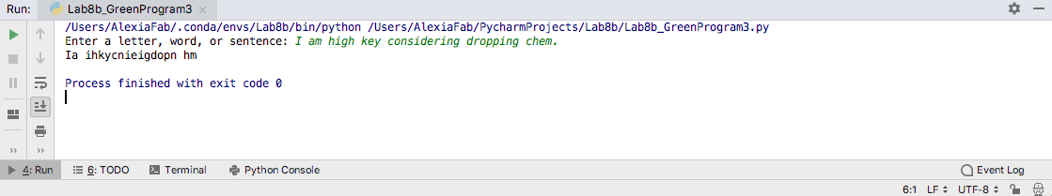

9. Python Program to Add a Key-Value Pair to the Dictionary

10. Python Program to Concatenate Two Dictionaries Into One

11. Python Program to Check if a Given Key Exists in a Dictionary or Not

12. Python Program to Generate a Dictionary that Contains Numbers (between 1 and n) in the Form (x,x*x).

13. Python Program to Sum All the Items in a Dictionary

14. Python Program to Multiply All the Items in a Dictionary

Code for cyan programs:

Program 9:

*# By submitting this assignment, I agree to the following:  
# “Aggies do not lie, cheat, or steal, or tolerate those who do”  
# “I have not given or received any unauthorized aid on this assignment”  
#  
# Name: ALEXIA PEREZ  
# Section: 508  
# Assignment: LAB 8B  
# Date: 18-10-2018  
  
# Program 9  
# Program to add a key-value pair to a dictionary:*name_and_age = {**"Bethany"**:18,**"Tyler"**:18,**"Sam"**:18,**"Alexia"**:17}  
name_and_age[str(input(**"What name do you want to add to the dictionary: "**))]\  
 = int(input(**"What is the age of this person: "**))  
print(name_and_age)

Program 10:

*# By submitting this assignment, I agree to the following:  
# “Aggies do not lie, cheat, or steal, or tolerate those who do”  
# “I have not given or received any unauthorized aid on this assignment”  
#  
# Name: ALEXIA PEREZ  
# Section: 508  
# Assignment: LAB 8B  
# Date: 18-10-2018  
  
# Program 10  
# Python Program to Concatenate Two Dictionaries Into One*name_and_age = {**"Bethany"**:18,**"Tyler"**:18,**"Sam"**:18,**"Alexia"**:17}  
grades = {**"Engr"**:**"A"**,**"Chem"**:**"B"**,**"Math"**:**"A"**,**"Geog"**:**"A"**}  
merged_dictionary = {**name_and_age,**grades}  
print(merged_dictionary)  
  
*# If the same value is used as a key in both dictionaries, the value for that key will be t  
# the one in the second dictionary. For example:  
  
# If we add one more key-value pair to both dictionaries:  
# name_and_age["Nicolas"]=18  
# grades["Nicolas"]= "B"  
# Now we merge them  
# merged_dictionary= {**name_and_age,**grades}  
# print(merged_dictionary)  
# Output would be => {'Bethany': 18, 'Tyler': 18, 'Sam': 18, 'Alexia': 17,   
# 'Nicolas': 'B', 'Engr': 'A', 'Chem': 'B', 'Math': 'A', 'Geog': 'A'}*

Program 11:

*# By submitting this assignment, I agree to the following:  
# “Aggies do not lie, cheat, or steal, or tolerate those who do”  
# “I have not given or received any unauthorized aid on this assignment”  
#  
# Name: ALEXIA PEREZ  
# Section: 508  
# Assignment: LAB 8B  
# Date: 18-10-2018  
  
  
# Program 11  
# Python Program to Check if a Given Key Exists in a Dictionary or Not*dictionary **=** {**"a":**90,**"b":**80,**"c":**70,**"d":**60,**"f":**50}  
given_key **=** str(input(**"Which key do you want to check: "**))  
**if** given_key **in** dictionary**:** print(dictionary[given_key])  
**else:** print(**"The key entered does not exist."**)

Output for cyan programs:

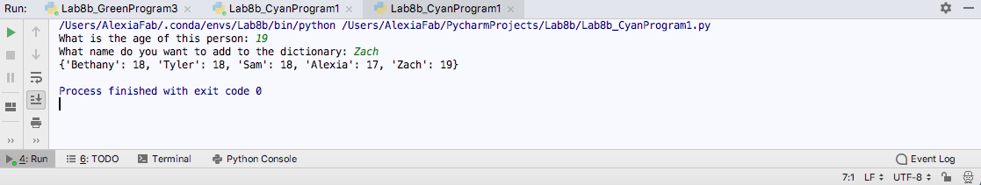

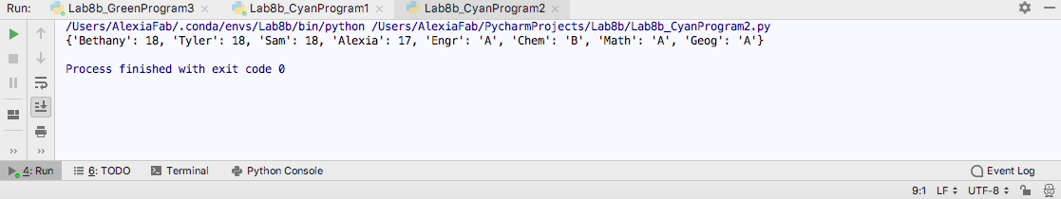

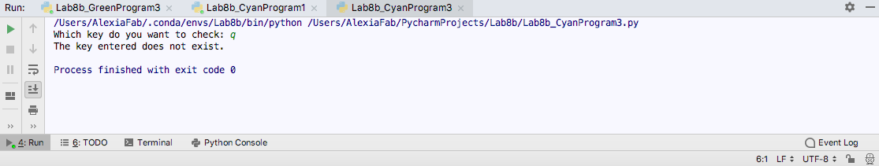

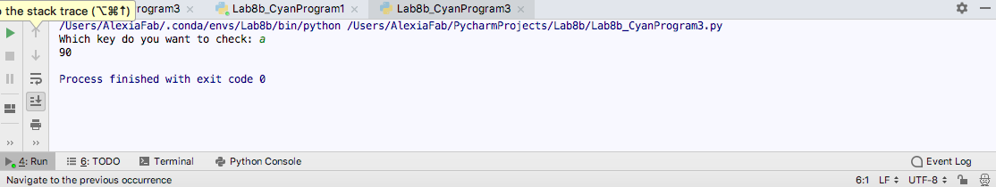

15. Python Program to Find the Largest Number in a List

16. Python Program to Find the Second Largest Number in a List

17. Python Program to Put Even and Odd elements in a List into Two Different Lists

18. Python Program to Merge Two Lists and Sort it

19. Python Program to Sort the List According to the Second Element in Sublist

20. Python Program to Find the Second Largest Number in a List Using Bubble Sort

21. Python Program to Sort a List According to the Length of the Elements

22. Python Program to Find the Union of two Lists

23. Python Program to Find the Intersection of Two Lists

Code for yellow programs:

Program 15:

*# By submitting this assignment, I agree to the following:  
# “Aggies do not lie, cheat, or steal, or tolerate those who do”  
# “I have not given or received any unauthorized aid on this assignment”  
#  
# Name: ALEXIA PEREZ  
# Section: 508  
# Assignment: LAB 8B  
# Date: 18-10-2018***import** numpy  
*# Program 15  
# Python Program to Find the Largest Number in a List*list **=** []  
number **=** 1  
**while** number **>=**0**:** number **=** int(input(**"Input a number to the list: "**))  
 **if** number **>=** 0**:** list.append(number)  
print(list)  
max **=** int(list[0])  
**for** i **in** range (len(list))**:  
 if** int(list[i])**>=** max**:** max **=** int(list[i])  
print(**"The greatest number is "**,max)

Program 17:

*# By submitting this assignment, I agree to the following:  
# “Aggies do not lie, cheat, or steal, or tolerate those who do”  
# “I have not given or received any unauthorized aid on this assignment”  
#  
# Name: ALEXIA PEREZ  
# Section: 508  
# Assignment: LAB 8B  
# Date: 18-10-2018  
  
# Program 17  
# Python Program to Put Even and Odd elements in a List into Two Different Lists*list **=** []  
number **=** 1  
**while** number **>=**0**:** number **=** int(input(**"Input a number to the list: "**))  
 **if** number **>=** 0**:** list.append(number)  
print(list)  
odd_numbers **=** []  
even_numbers **=** []  
**for** i **in** range (len(list))**:  
 if** int(list[i]) **%** 2 **==** 0**:** even_numbers.append(int(list[i]))  
 **else:** odd_numbers.append(int(list[i]))  
print(**"The even numbers are:"**,even_numbers,**"The odd numbers are:"**,odd_numbers)

Program 21:

*# By submitting this assignment, I agree to the following:  
# “Aggies do not lie, cheat, or steal, or tolerate those who do”  
# “I have not given or received any unauthorized aid on this assignment”  
#  
# Name: ALEXIA PEREZ  
# Section: 508  
# Assignment: LAB 8B  
# Date: 18-10-2018  
  
# Program 21  
# Python Program to Sort a List According to the Length of the Elements*list **=** []  
n **=** int(input(**"Enter number of elements:"**))  
**for** i **in** range(1, n **+** 1)**:** b **=** input(**"Enter element:"**)  
 list.append(b)  
list.sort(key**=**len)  
print(list)

Output for yellow programs:

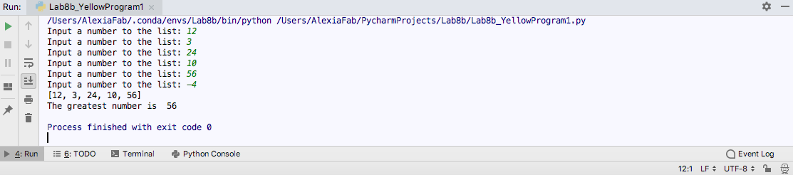

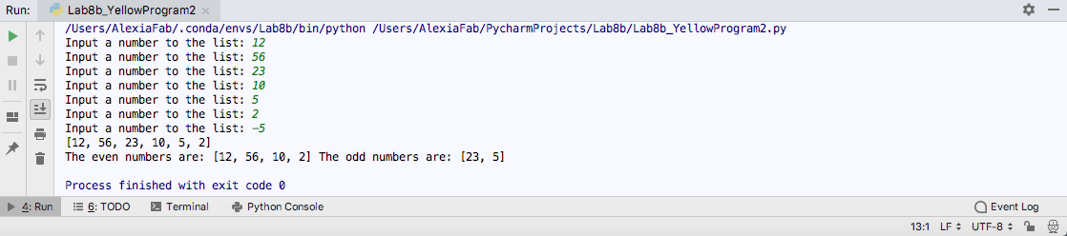

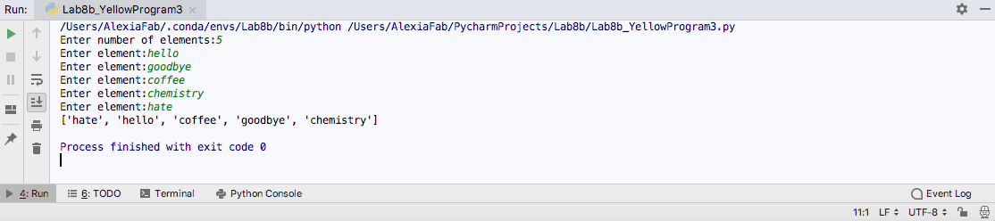

24. Python Program to Compute Prime Factors of an Integer

25. Python Program to Generate all the Divisors of an Integer

26. Python Program to Print Table of a Given Number

27. Python Program to Print Sum of Negative Numbers, Positive Even Numbers and Positive Odd numbers in a List

28. Python Program to Print Largest Even and Largest Odd Number in a List

29. Python Program to Form an Integer that has the Number of Digits at Ten's Place and the Least Significant Digit of the Entered Integer at One's Place

30. Python Program to Find Those Numbers which are Divisible by 7 and Multiple of 5 in aGiven Range of Numbers

31. Python Program to Check if a Number is an Armstrong Number

32. Python Program to Print the Pascal's triangle for n number of rows given by the user

33. Python Program to Check if a Number is a Perfect Number

34. Python Program to Check if a Number is a Strong Number

35. Python Program to Find the Least Common Multiple of Two Numbers

36. Python Program to Find the Greatest Common Divisor of Two Numbers

37. Python Program to Compute a Polynomial Equation given that the Coefficients of the Polynomial are stored in a List

38. Python Program to Check If Two Numbers are Amicable Numbers

39. Python Program to Find the Area of a Triangle Given All Three Sides

40. Python Program to Find the Smallest Divisor of an Integer

Code for magenta programs:

Program 24:

*# By submitting this assignment, I agree to the following:  
# “Aggies do not lie, cheat, or steal, or tolerate those who do”  
# “I have not given or received any unauthorized aid on this assignment”  
#  
# Name: ALEXIA PEREZ  
# Section: 508  
# Assignment: LAB 8B  
# Date: 18-10-2018  
  
# Program 24  
# Python Program to Compute Prime Factors of an Integer*integer **=** int(input(**"Enter an integer: "**))  
  
print(**"The prime factors are:"**)  
i**=**1  
**while**(i**<=**integer)**:** k**=**0  
 **if**(integer**%**i**==**0)**:** j**=**1  
 **while**(j**<=**i)**:  
 if**(i**%**j**==**0)**:** k**=**k**+**1  
 j**=**j**+**1  
 **if**(k**==**2)**:** print(i)  
 i**=**i**+**1

Program 25:

*# By submitting this assignment, I agree to the following:  
# “Aggies do not lie, cheat, or steal, or tolerate those who do”  
# “I have not given or received any unauthorized aid on this assignment”  
#  
# Name: ALEXIA PEREZ  
# Section: 508  
# Assignment: LAB 8B  
# Date: 18-10-2018  
  
# Program 25  
# Python Program to Compute Divisors of an Integer*integer**=**int(input(**"Enter an integer:"**))  
print(**"The divisors of the number are:"**)  
**for** i **in** range(1,integer**+**1)**:  
 if**(integer**%**i**==**0)**:** print(i)

Program 26:

*# By submitting this assignment, I agree to the following:  
# “Aggies do not lie, cheat, or steal, or tolerate those who do”  
# “I have not given or received any unauthorized aid on this assignment”  
#  
# Name: ALEXIA PEREZ  
# Section: 508  
# Assignment: LAB 8B  
# Date: 18-10-2018  
  
# Program 26  
# Python Program to Print Table of a Given Number*number **=** int(input(**"Enter a number: "**))  
table **=** []  
  
**for** i **in** range(11)**:** multiplication **=** number **\*** i  
 table.append(multiplication)  
print(table)

Program 28:

*# By submitting this assignment, I agree to the following:  
# “Aggies do not lie, cheat, or steal, or tolerate those who do”  
# “I have not given or received any unauthorized aid on this assignment”  
#  
# Name: ALEXIA PEREZ  
# Section: 508  
# Assignment: LAB 8B  
# Date: 18-10-2018  
  
# Program 28  
# Python Program to Print Largest Even and Largest Odd Number in a List  
  
# Creates list:*list **=** []  
n **=** int(input(**"Enter number of elements:"**))  
**for** i **in** range(1, n **+** 1)**:** b **=** input(**"Enter element:"**)  
 list.append(b)  
print(list)  
*# Sorts numbers into odd and even lists*odd_numbers **=** []  
even_numbers **=** []  
**for** i **in** range (len(list))**:  
 if** int(list[i]) **%** 2 **==** 0**:** even_numbers.append(int(list[i]))  
 **else:** odd_numbers.append(int(list[i]))  
print(**"The even numbers are:"**,even_numbers,**"The odd numbers are:"**,odd_numbers)  
  
*# Gets greatest even number :*max_even **=** int(even_numbers[0])  
**for** i **in** range (len(even_numbers))**:  
 if** int(even_numbers[i])**>=** max_even**:** max_even **=** int(even_numbers[i])  
print(**"The greatest even number is "**,max_even)  
  
*# Gets greatest odd number:*max_odd **=** int(odd_numbers[0])  
**for** i **in** range (len(odd_numbers))**:  
 if** int(odd_numbers[i])**>=** max_odd**:** max_odd **=** int(odd_numbers[i])  
print(**"The greatest odd number is "**,max_odd)

Program 36:

*# By submitting this assignment, I agree to the following:  
# “Aggies do not lie, cheat, or steal, or tolerate those who do”  
# “I have not given or received any unauthorized aid on this assignment”  
#  
# Name: ALEXIA PEREZ  
# Section: 508  
# Assignment: LAB 8B  
# Date: 18-10-2018  
  
# Program 36  
# Python Program to Find the Greatest Common Divisor of Two Numbers*x**=**int(input(**"Enter a number: "**))  
y**=**int(input(**"Enter another number: "**))  
  
**for** i **in** range(1,y**+**1)**:  
 if** x **%** i **==** 0 **and** y **%** i **==** 0**:** gcd **=** i  
  
print(**"The greatest common divisor is"**,gcd)

Program 39:

*# By submitting this assignment, I agree to the following:  
# “Aggies do not lie, cheat, or steal, or tolerate those who do”  
# “I have not given or received any unauthorized aid on this assignment”  
#  
# Name: ALEXIA PEREZ  
# Section: 508  
# Assignment: LAB 8B  
# Date: 18-10-2018  
  
# Program 39  
# Python Program to Find the Area of a Triangle Given All Three Sides***from** math **import *  
import** numpy  
  
*# First we assign each side with a specific value:*a **=** float(input(**"Enter length of 1st side: "**))  
b **=** float(input(**"Enter length of 2nd side: "**))  
c **=** float(input(**"Enter length of 3rd side: "**))  
  
*# Now we calculate the heigth of the triangle using Heron's formula:*s **=** float((a**+**b**+**c)**/**2)  
  
*# Now we use the second part of Heron's formula to find the area:*area **=** float(sqrt((s**\***(s**-**a)**\***(s**-**b)**\***(s**-**c))))  
  
print(**"The area of the given triangle is: "**,area,**"meters squared."**)  
print(**"Finished!"**)

Output for magenta programs:

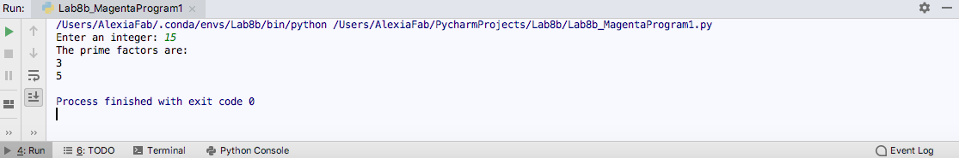

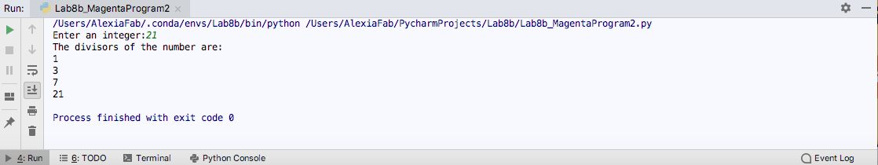

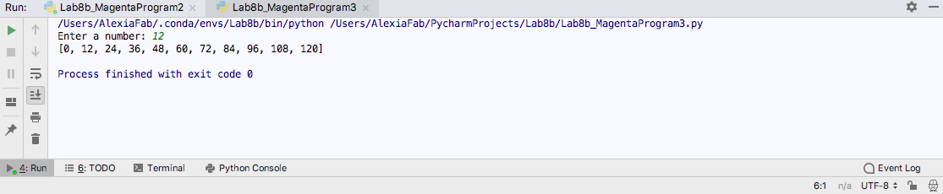

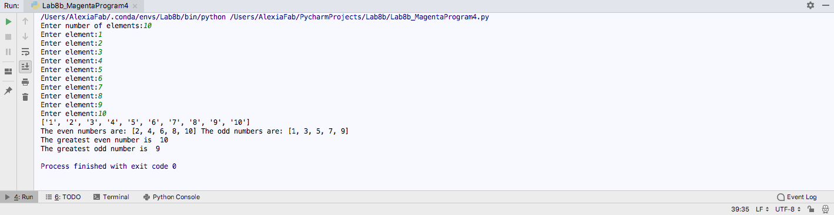

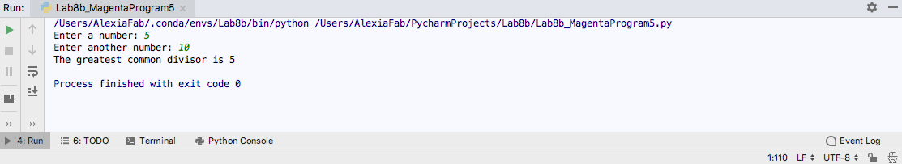

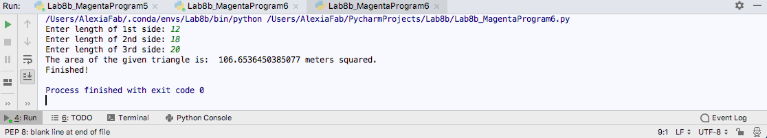

You will be complete any 3 green, 3 cyan, 3 yellow, and 6 magenta python files.