**ENGR 102 Sect 508 Lab 3a**

**50 points**

**Reading assignment:**

|  |  |
| --- | --- |
| **Lecture Slides** | **L03** |
| **zyBook chapters 3** | **Complete all participation and challenge activities** |

***Attention!!***

***For submission: pdf/word file and all py-files as asked in the assignment. No pictures by the phone – it is impossible to read. You will be allowed to resubmit and reupload HW as many times as you want to within the due date/time, only last submission will be graded. No late submissions.***

***For submission you may use this file as template: rename file including your name. Do not forget to put your name inside of this file as well. If it is a team work, include the team number and all team members.***

**To do in lab as a team**

***For this submission use Team Header, include all team members into the list of participants. Submit 1 assignment per team.***

**Activity #1: [25] To do in lab – as a team**

*This activity is meant to help illustrate the process of asking a user for input and then reading their input, performing processing, and outputting a result. Many programs will follow that basic format.*

As a team, write the following short programs. For each one, you are to write a program that converts from one type of unit to another. You should ask the user for input in one unit, convert it to the other, and output the answer in the converted units. Do so for each of the following conversions. For each, write a separate program (labeled .11, 1.2-.. 1.5) and turn in all files together.

1. [5] Pounds to Newtons

*# By submitting this assignment, all team members agree to the following:  
# “Aggies do not lie, cheat, or steal, or tolerate those who do”  
# “I have not given or received any unauthorized aid on this assignment”  
#  
# Names: Alexia Perez  
# Bethany Gawalis  
# Nicolas Martinez  
# Sam Lyzzaik  
# Tyler Scataglia  
# Section: 508  
# Assignment: Lab 3a  
# Date: 11-09-2018***from** math **import**\*  
**import** numpy  
  
*#This program converts a*n= 4.4482  
p=1  
x=float(input(**"How many Pounds do you wish to convert into Newtons?"**))  
Newtons=x*(n/p)  
print(**"The answer is "**), print(Newtons), print(**"Newtons."**)

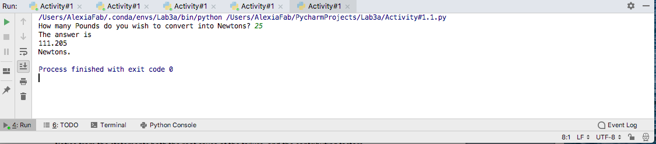

1. [5] BTUs to Joules

*# By submitting this assignment, all team members agree to the following:  
# “Aggies do not lie, cheat, or steal, or tolerate those who do”  
# “I have not given or received any unauthorized aid on this assignment”  
#  
# Names: Alexia Perez  
# Bethany Gawalis  
# Nicolas Martinez  
# Sam Lyzzaik  
# Tyler Scataglia  
# Section: 508  
# Assignment: Lab 3a  
# Date: 11-09-2018***from** math **import**\*  
**import** numpy  
  
*#This program will convert from BTUs to Joules*btu=1  
J=1055.06  
y=float(input(**"How many BTUs do you wish to convert into Joules?"**))  
Joules=y*(J/btu)  
print(**"The answer is "**), print(Joules), print(**"Joules."**)

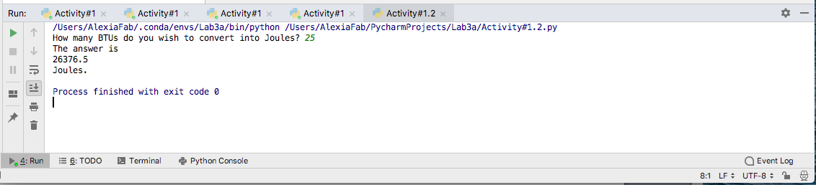

1. [5] Pascals to Millimeters of Mercury

*# By submitting this assignment, all team members agree to the following:  
# “Aggies do not lie, cheat, or steal, or tolerate those who do”  
# “I have not given or received any unauthorized aid on this assignment”  
#  
# Names: Alexia Perez  
# Bethany Gawalis  
# Nicolas Martinez  
# Sam Lyzzaik  
# Tyler Scataglia  
# Section: 508  
# Assignment: Lab 3a  
# Date: 11-09-2018***from** math **import**\*  
**import** numpy  
  
*#This program will convert from Pascals to mmHg (millimeters of mercury)*pa=1  
mmHg=0.0075  
z=float(input(**"How many Pascals do you wish to convert into mmHg?"**))  
Millimeters_mercury=z*(mmHg/pa)  
print(**"The answer is "**), print(Millimeters_mercury), print(**"Millimeters of Mercury."**)

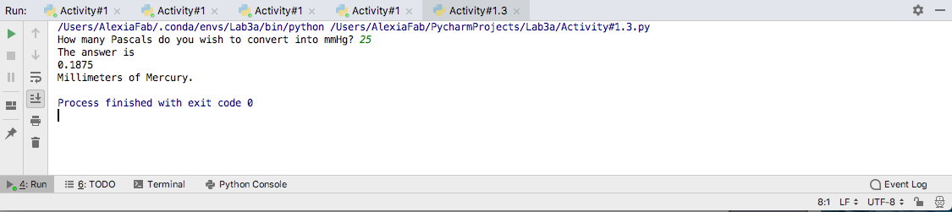

1. [5] Revolutions per second to Hertz

*# By submitting this assignment, all team members agree to the following:  
# “Aggies do not lie, cheat, or steal, or tolerate those who do”  
# “I have not given or received any unauthorized aid on this assignment”  
#  
# Names: Alexia Perez  
# Bethany Gawalis  
# Nicolas Martinez  
# Sam Lyzzaik  
# Tyler Scataglia  
# Section: 508  
# Assignment: Lab 3a  
# Date: 11-09-2018***from** math **import**\*  
**import** numpy  
  
*#This program will convert from Revolutions per second to Hertz*rps=1  
Hz=1  
w=float(input(**"How many rps do you wish to convert into Hz?"**))  
Hertz=w*(Hz/rps)  
print(**"The answer is "**), print(Hertz), print(**"Hertz."**)

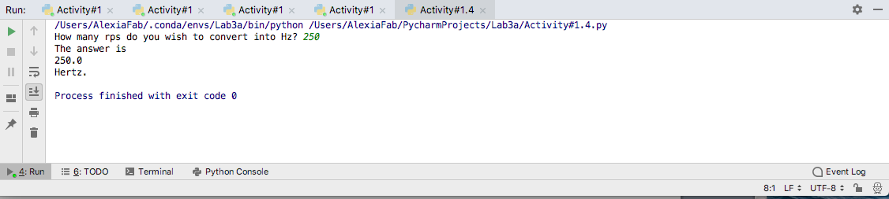

1. [5] Fahrenheit to Celsius

*# By submitting this assignment, all team members agree to the following:  
# “Aggies do not lie, cheat, or steal, or tolerate those who do”  
# “I have not given or received any unauthorized aid on this assignment”  
#  
# Names: Alexia Perez  
# Bethany Gawalis  
# Nicolas Martinez  
# Sam Lyzzaik  
# Tyler Scataglia  
# Section: 508  
# Assignment: Lab 3a  
# Date: 11-09-2018***from** math **import**\*  
**import** numpy  
  
*#This program will convert from degrees Fahrenheit to degrees Celsius.*F=float(input(**"How many Farenheit do you wish to convert into Celsius?"**))  
c=(F-32)*5/9  
print(**"The answer is "**), print(c), print(**"Celsius."**)

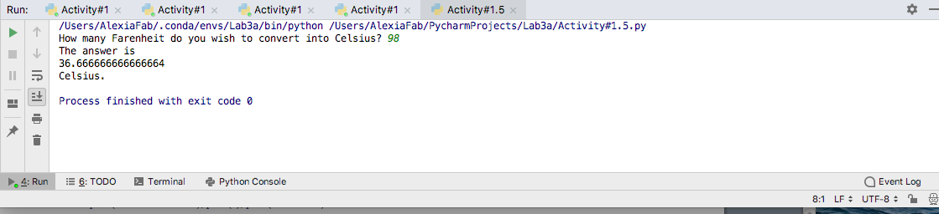

This sort of activity (unit conversions) might seem very basic, but it’s also critically important. Conversion (a) above has a particularly costly history. Before your team leaves today, please search and read a little bit about the Mars Climate Orbiter, and read the two statements from NASA:

* <https://mars.nasa.gov/msp98/news/mco990930.html>
* <https://mars.nasa.gov/msp98/news/mco991110.html>

Notice from the statements both the root cause of the failure, and the contributing factors.

**Activity #2: [25] To do in lab – as a team**

This activity is meant to give your team a chance to write a larger program, together. You are to write a program that will read in four people’s names, birthdays and favorite color, and will output them in a formatted list. The final list should include people’s names and their birthdates and favorite color in 3 formatted columns.

1. First, in a separate document (a text file, Word file, etc.) make a list of the variables that your team will use in this program. Your list should include:
   1. The variable names:

name_title, birthday_title, fav_color, name_1, name_2, name_3, name_4, bday_1, bday_2, bday_3, bday_4, color_1, color_2, color_3, color_4

* 1. The type of each variable

name_title, birthday_title, and fav_color will be strings previously defined, the resto will be input.

* 1. A *very brief* description of what each variable is (you can write one description for multiple variables if it is clear what they all are)

name_title, birthday_title, and fav_color are the variables that will define the title of each column.

All the name_# variables are each of the team members’ names (will be input)

All the bday_# variables are each of the team members’ birthdays (will be input)

All the color_# variables are each of the team members’ favorite colors (will be input).

1. Next, determine what instructions you want to give to the users. You should determine the text you want to tell the users. Be sure to be specific about the way you want them to enter information!

For the name input: “Insert the 1st/2nd/3rd/4th member’s name”

For the birthday input: “Insert the 1st/2nd/3rd/4th member’s birthday”

For the favorite color input: “Insert the 1st/2nd/3rd/4th member’s favorite color

1. Third, determine how you want the output to be formatted. Consider how you want to align the various columns of the document. Note that all information should be lined up in clear columns as much as possible

First, all the input prompts will appear, after answering all of them and pressing enter, the information will be displayed in the following format.

1. First row will be the titles of each row, which indicate what information is being displayed underneath.
2. Following rows will be each of the team member’s info, underneath each title, and evenly spaced
3. The result will be 3 columns and each row will be a different team member’s info.
4. Fourth, and only after completing the above, write your code. You can (and should) test your program to make sure it is working as expected. You should have to use comments inside of the program to include description of your variables.
5. Turn in the document, as well as tam’s program

CODE FOR ACTIVITY #2

*# By submitting this assignment, all team members agree to the following:  
# “Aggies do not lie, cheat, or steal, or tolerate those who do”  
# “I have not given or received any unauthorized aid on this assignment”  
#  
# Names: Alexia Perez  
# Bethany Gawalis  
# Nicolas Martinez  
# Sam Lyzzaik  
# Tyler Scataglia  
# Section: 508  
# Assignment: Lab 3a  
# Date: 11-09-2018  
  
#In this program we are going to display different strings of information in formatted columns  
  
#column titles*name_title=**"Name"**birthday_title=**"Birthday"**fav_color=**"Favorite color"***#input for user 1*name_1= input(**"Insert name of 1st group member"**)  
bday_1=input(**"Insert the 1st group member's birthday"**)  
color_1=input(**"Insert the 1st group member's favorite color"**)  
  
*#input for user 2*name_2= input(**"Insert name of 2nd group member"**)  
bday_2=input(**"Insert the 2nd group member's birthday"**)  
color_2=input(**"Insert the 2nd group member's favorite color"**)  
  
*#input for user 3*name_3= input(**"Insert name of 3rd group member"**)  
bday_3=input(**"Insert the 3rd group member's birthday"**)  
color_3=input(**"Insert the 3rd group member's favorite color"**)  
  
*#input for user 4*name_4= input(**"Insert name of 4th group member"**)  
bday_4=input(**"Insert the 4th group member's birthday"**)  
color_4=input(**"Insert the 4th group member's favorite color"**)  
  
*#Output*print(**"%-15s %-15s %-15s"** % (name_title, birthday_title, fav_color))  
print(**"%-15s %-15s %-15s"** % (name_1, bday_1, color_1))  
print(**"%-15s %-15s %-15s"** % (name_2, bday_2, color_2))  
print(**"%-15s %-15s %-15s"** % (name_3, bday_3, color_3))  
print(**"%-15s %-15s %-15s"** % (name_4, bday_4, color_4))

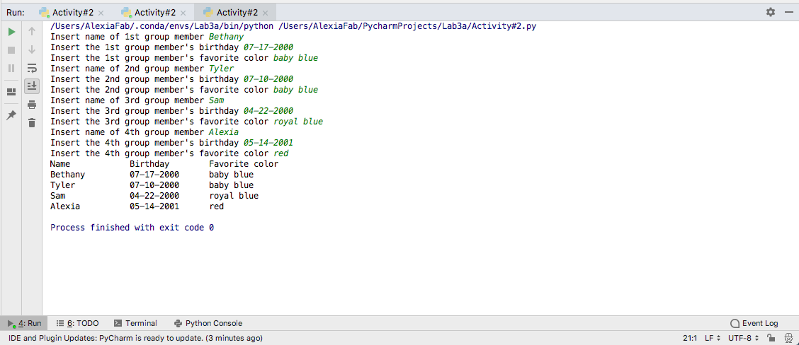

Try experimenting by printing out strings containing the following escape characters, to see what they do:

\n, \t, \\, \b. If you cannot deduce what these do, feel free to look them up in an online Python guide.

Make sure that *each member* of your team understands how each of those characters work.

You may add any other additional information as you wish.

Note: the purpose in this assignment was, in addition to giving you practice for reading input and formatting output, to see that there can be different ways of constructing programs, and different ways of assuming input might be formatted. In most programming, there is not a single solution to a problem, and the programmer’s choices for variables, information provided to the user, and output can vary, and still be correct.