**ENGR 102 Sect 508**

**Lab 4a**

**100 points**

**Reading assignment:**

|  |  |
| --- | --- |
| **Lecture Slides** | **L04** |
| **zyBook chapter 4** | **Complete all participation and challenge activities** |

***Attention!!***

***For submission: pdf/word file and all py-files as asked in the assignment. No pictures by the phone – it is impossible to read. You will be allowed to resubmit and reupload HW as many times as you want to within the due date/time, only last submission will be graded. No late submissions.***

***For submission you may use this file as template: rename file including your name. Do not forget to put your name inside of this file as well. If it is a team work, include the team number and all team members.***

***For this submission use Team Header, include all team members into the list of participants. Submit 1 assignment per team.***

**[60 points total] Activity #1: To do in lab – as a team**

When performing numerical computations, one of the challenges you can run into is floating-point roundoff error. This occurs when the computer needs to represent a number that would require an infinite number of decimal digits, but rounds them off after some point. That small roundoff error can cause some significant issues.

This activity is meant to help you understand floating-point roundoff error a bit more, and learn about one way of dealing with it.

***Activity 1 Part 1: Identifying floating-point problems. [24 points]***

We first want to illustrate some examples where floating-point roundoff can cause trouble, and see other cases where it turns out not to.

First, as a team, type in and run the following program:

a = 1/7

print(a)

b = a*7

print(b)

Notice that the value of a is rounded off. The value of b, if we have no roundoff, should be 1. Is it? Yes, it is.

Now try the following program:

a = 1/7

print(a)

b = 7*a

print(b)

c = 2*a

d = 5*a

e = c+d

print(e)

In this case, the value of e, if we have no roundoff, should be 1. Is it? The program outputs 0.99999999999, but that is due to the round off error.

Finally, try the following program:

from math import *

x = sqrt(1/3)

print(x)

y = x*x*3

print(y)

z = x*3*x

print(z)

Again, the value of y and z, if we have no roundoff error, should be 1 in both cases. Is it? The program outputs 0.99999999999 again, but that is also due to the round off error.

Was that surprising? You should have seen from those examples that sometimes we will encounter issues due to roundoff error and sometimes we won’t. We can’t always predict when roundoff error will be obvious.

**[8x3=24 points]**

Your team should write a program to demonstrate generating roundoff error in computations. It should have the following structure:

* Generate at least 8 different examples of roundoff error from numerical computations. You can use small variations of the ones shown above for 2 of them. Try to come up with different types of ways that roundoff can come up in a computation.
* For each of the examples, you should output a line saying: “Is XXX the same as YYY? AAA” where XXX is one way of computing a value and YYY is another, and AAA is either True or False.
  + Note: You can output a Boolean value and it will output either “True” or “False”. For example, a line like print(1==2) would output False.
* For at least one case, try to see how large of a difference you can get between the two values (i.e. how big you can get the numerical error to become). This usually requires performing multiple operations: one where the numerical error is introduced, then subsequent operations that cause that error to grow.

*# By submitting this assignment, all team members agree to the following:  
# “Aggies do not lie, cheat, or steal, or tolerate those who do”  
# “I have not given or received any unauthorized aid on this assignment”  
#  
# Names: Alexia Perez  
# Bethany Gawalis  
# Nicolas Martinez  
# Sam Lyzzaik  
# Tyler Scataglia  
# Section: 508  
# Assignment: Lab 3a  
# Date: 18-09-2018***import** numpy  
**from** math **import** *  
  
*# This program will generates examples of round off errors*x = sqrt(1/5)  
print(x)  
y = x*x*5  
print(y)  
z= x*5*x  
print(z)  
print(**"Is"**,y,**"equal to"**,z,**"?"**)  
print(y==z)  
print(**"----------------"**)  
  
  
x = sqrt(1/3)  
print(x)  
y = x*x*3  
print(y)  
z= x*3*x  
print(z)  
print(**"Is"**,y,**"equal to"**,z,**"?"**)  
print(y==z)  
print(**"----------------"**)  
  
  
v= pi/3  
j= cos(v)  
print(j)  
c=sin(v/2)  
print(c)  
print(**"Is"**,j,**"equal to"**,c,**"?"**)  
print(j==c)  
print(**"----------------"**)  
  
a = 1/7  
print(a)  
b = 7*a  
print(b)  
c = 2*a  
d = 5*a  
e = c+d  
print(e)  
print(**"Is"**,b,**"equal to"**,e,**"?"**)  
print(b==e)  
print(**"----------------"**)  
  
a = 1/3  
print(a)  
b = 3*a  
print(b)  
c = 5/2*a  
d = 1/2*a  
e = c+d  
print(e)  
print(**"Is"**,b,**"equal to"**,e,**"?"**)  
print(b==e)  
print(**"----------------"**)  
  
a= sqrt(3)*sqrt(7)  
print(a)  
b = a*a/21  
print(b)  
c= a/21*a  
print(c)  
print(**"Is"**,b,**"equal to"**,c,**"?"**)  
print(b==c)  
print(**"----------------"**)  
  
a = 1/17  
print(a)  
b = a*17  
print(b)  
c= 10/17+7/17*a  
print(c)  
print(**"Is"**,b,**"equal to"**,c,**"?"**)  
print(b==c)  
print(**"-------------------"**)  
  
v= 3*pi/2  
*#this will cause a big round off error, because the computer will use an aprox. decimal value of pi,  
# and therefore its cosine won't be -1,  
# causing the next calculations to have an accumulation of roundoff errors.*j= cos(v)  
print(j)  
c=sin(v*2/3)  
print(c)  
print(**"Is"**,j,**"equal to"**,c,**"?"**)  
print(j==c)  
print(**"----------------"**)

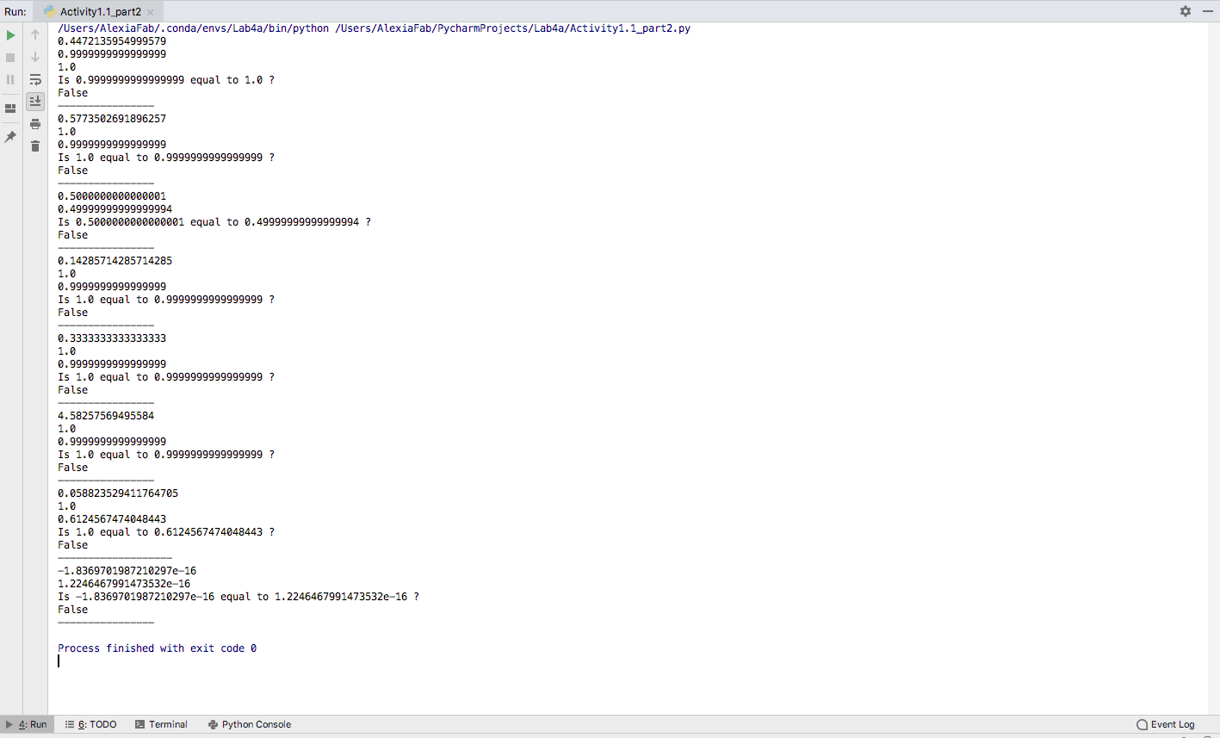

***Activity 1 Part 2: Tolerances for Comparisons. [16 points total]***

In part 1, you should have seen that two different ways of computing values that “should” be identical might actually come out differently. In some cases, this is not a problem. For example, we usually don’t care if speed is incorrect in the 10th decimal place, since we usually can’t measure that precisely, anyway. But, floating point error can become a big problem if comparisons are made with floating-point values. Think about the cases from part 1. The Boolean value you output on each line was likely coming out “False” even if the values should have been the same.

A common way for dealing with floating-point error is to use **tolerances**. Tolerances let you compare two values that are close, but not identical to each other. Rather than checking whether a==b, we instead compute a-b, and see if that is within some small distance away from 0 (above or below). To do this, you take the absolute value of (a-b), and check whether it’s less than some small value, called the tolerance. If it is, the two things are considered to be equal. The tolerance is commonly abbreviated TOL or EPS (short for epsilon).

**[8x2=16 points]** As a team, modify your program from part 1:

* Each case should contain a second line, stating: “Is XXX within tolerance of YYY? AAA”, where now you perform a tolerance-based comparison.
* You should set a single variable, named TOL, TOLERANCE, EPSILON, EPS, or something similar, and use that as the tolerance for your computation.
* Note that if you created a large numerical error in any of your cases, you might find it is outside of the tolerance zone.

*# By submitting this assignment, all team members agree to the following:  
# “Aggies do not lie, cheat, or steal, or tolerate those who do”  
# “I have not given or received any unauthorized aid on this assignment”  
#  
# Names: Alexia Perez  
# Bethany Gawalis  
# Nicolas Martinez  
# Sam Lyzzaik  
# Tyler Scataglia  
# Section: 508  
# Assignment: Lab 3a  
# Date: 18-09-2018***import** numpy  
**from** math **import** *  
  
*# This program will generates examples of round off errors*x = sqrt(1/5)  
print(x)  
y = x*x*5  
print(y)  
z= x*5*x  
print(z)  
tolerance=abs(y-z)  
print(**"Is"**,y,**"equal to"**,z,**"within"**,tolerance,**"?"**)  
print(y-z<= tolerance)  
print(**"----------------"**)  
  
x = sqrt(1/3)  
print(x)  
y = x*x*3  
print(y)  
z= x*3*x  
print(z)  
tolerance=abs(y-z)  
print(**"Is"**,y,**"equal to"**,z,**"within"**,tolerance,**"?"**)  
print(y-z<= tolerance)  
print(**"----------------"**)  
  
v= pi/3  
j= cos(v)  
print(j)  
c=sin(v/2)  
print(c)  
tolerance=abs(j-c)  
print(**"Is"**,j,**"equal to"**,c,**"within"**,tolerance,**"?"**)  
print(j-c<=tolerance)  
print(**"----------------"**)  
  
  
a = 1/7  
print(a)  
b = 7*a  
print(b)  
c = 2*a  
d = 5*a  
e = c+d  
print(e)  
tolerance=abs(b-e)  
print(**"Is"**,b,**"equal to"**,e,**"within"**,tolerance,**"?"**)  
print(b-e<=tolerance)  
print(**"----------------"**)  
  
a = 1/3  
print(a)  
b = 3*a  
print(b)  
c = 5/2*a  
d = 1/2*a  
e = c+d  
print(e)  
tolerance=abs(b-e)  
print(**"Is"**,b,**"equal to"**,e,**"within"**,tolerance,**"?"**)  
print(b-e<=tolerance)  
print(**"----------------"**)  
  
a= sqrt(3)*sqrt(7)  
print(a)  
b = a*a/21  
print(b)  
c= a/21*a  
print(c)  
tolerance=abs(b-c)  
print(**"Is"**,b,**"equal to"**,c,**"within"**,tolerance,**"?"**)  
print(b-c<=tolerance)  
print(**"----------------"**)  
  
a = 1/17  
print(a)  
b = a*17  
print(b)  
c= 10/17+7/17*a  
print(c)  
tolerance=abs(b-c)  
print(**"Is"**,b,**"equal to"**,c,**"within"**,tolerance,**"?"**)  
print(b-c<=tolerance)  
print(**"-------------------"**)  
  
v= 3*pi/2  
*#this will cause a big round off error, because the computer will use an aprox. decimal value of pi,  
# and therefore its cosine won't be -1,  
# causing the next calculations to have an accumulation of roundoff errors.*j= cos(v)  
print(j)  
c=sin(v*2/3)  
print(c)  
tolerance=abs(j-c)  
print(**"Is"**,j,**"equal to"**,c,**"within"**,tolerance,**"?"**)  
print(j-c<=tolerance)  
print(**"----------------"**)

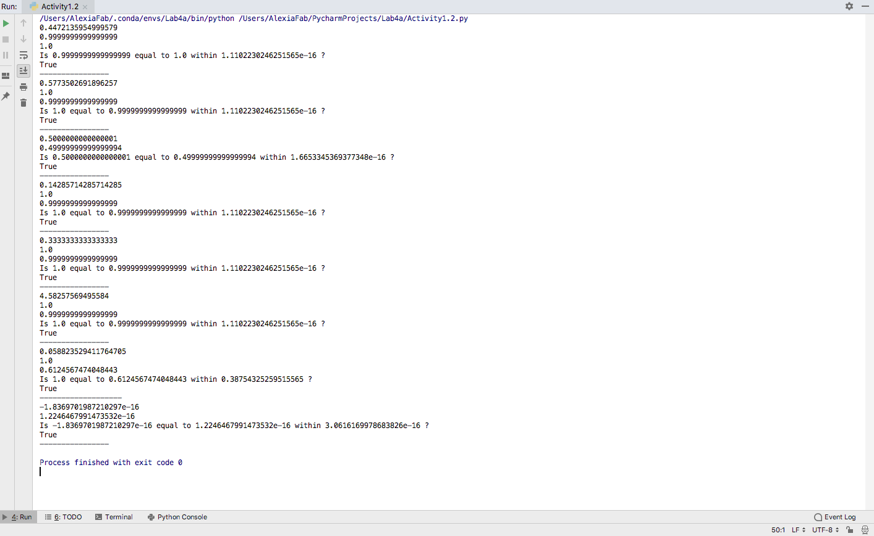

***Activity 1 Part 3: Tolerance sizes. [20 points]***

Keep in mind that the larger the tolerance, the more numerical error you can tolerate. A large enough tolerance can catch almost any numerical errors. However, this also increases the chances of mistakenly identifying two things that should not be the same as being identical.

Finally, add one more section to your program. You may reuse any of the examples from the earlier parts in this section, as you wish.

You want to **create** two pairs of numbers: **a and b**, and **x and y**, along with a tolerance value (you may use different names for your variables).

* **[1 point]** Print a line to clearly separate this part of the program from the earlier parts.
* [You should output all values: a, b, x, y, and the tolerance. You should output True or False as to whether a and b are within tolerance, and whether x and y are within tolerance.
* **[8 points]** Numbers a and b should be two numbers that SHOULD be the same but are different due to roundoff error. Feel free to reuse examples from part 1.
* **[8 points]** Numbers x and y should be two numbers that SHOULD NOT be the same but are close to each other.
* **[3 points]** You should have a tolerance value that is of a size so that a and b are NOT within tolerance of each other, but x and y ARE within tolerance of each other.
  + Obviously, if you set a tolerance value large enough, you could find that all were within tolerance of each other.
  + And, if you set a small enough tolerance (like 0), you would find that neither is within tolerance.
  + The point of this exercise is to demonstrate to you that you can have cases where tolerances will fail on both sides: they might be too small to catch the cases they should, but too large to exclude cases that shouldn’t be the same.

*# By submitting this assignment, all team members agree to the following:  
# “Aggies do not lie, cheat, or steal, or tolerate those who do”  
# “I have not given or received any unauthorized aid on this assignment”  
#  
# Names: Alexia Perez  
# Bethany Gawalis  
# Nicolas Martinez  
# Sam Lyzzaik  
# Tyler Scataglia  
# Section: 508  
# Assignment: Lab 3a  
# Date: 18-09-2018***import** numpy  
**from** math **import** *  
  
a=1.0  
b=5/3+7/3*3/12  
x=sqrt(5)  
y=2+24/100  
tolerance=abs(x-y)  
print(a,b)  
print(**"Is"**,a,**"equal to"**,b,**"within"**,tolerance,**"?"**)  
print(abs(a-b)==tolerance)  
print(x,y)  
print(**"Is"**,x,**"equal to"**,y,**"within"**,tolerance,**"?"**)  
print(abs(x-y)==tolerance)

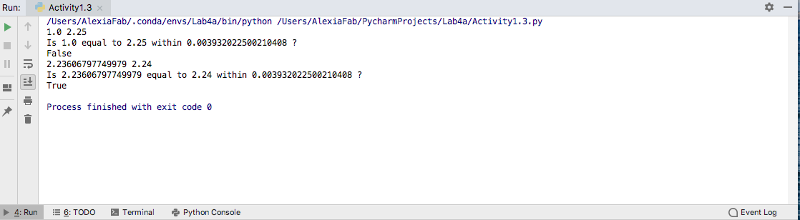

***Summary:***

Turn in a single program for this activity: it should incorporate all of the code from parts 1-3. There should be 8 examples at the beginning, each with two numbers that are compared for equality and then for being within tolerance of each other. Then, there should be the two examples of numbers that should be equal but are beyond tolerance, and two that should be different but are within tolerance.

As you write programs, please think about your comparisons and decide whether you need to use tolerances or not. If you are making a comparison where you are checking for exact equality and you might have some floating-point error, you probably will want to use tolerances, while if you are just checking which of two things is larger, a tolerance comparison is likely unnecessary. Tolerances are particularly helpful when checking things like whether a denominator is (nearly) 0, and thus a division is likely to create error.

Side note: Tolerances have problems of their own besides the difficulty of setting a “correct” tolerance value. Notably, with tolerances, you can might find that a==b, and b==c, but a != c. Dealing with issues of roundoff error is a long-standing and ongoing area of research.

**Activity #2: [40 points] To do in lab – individually**

The purpose of this program is to give you practice with performing Boolean logic.

You may discuss in general terms with your teammates how you can approach these problems.

***Activity 2. Part a: Evaluating Booleans [12 points total]***

Write a program that reads in true/false values for the variables a, b, and c and evaluates the following Boolean expressions. Your program should thus read in 3 True/False values [5 points], and should output 4 values. [4x3=12points]

1**)[3points]** a and b and c

2**)[3points]** a or b or c

3**)[3points]** (not (a and not b) or (not c and b)) and (not b) or (not a and b and not c) or (a and not b)

4**)[3points]** (not ((b or not c) and (not a or not c))) or (not (c or not (b and c))) or (a and not c) and (not a or (a and b and c) or (a and ((b and not c) or (not b))))

***Activity 2 Part b: Writing Boolean expressions [9 points total]***

Extend the program above to write Boolean expressions that meet the following criteria:

5) **[4 points]** Is true if just one of a or b is true, but not if both are true or both or false

(Note: this is also called an “exclusive or” between a and b.)

6) **[5 points]** Is true if an odd number (i.e. exactly 1 or 3) of the variables a, b, and c is true, and is false otherwise.

***Activity 2. Part c: Simplifying Booleans [14 points total]***

Extend the program from above, but try to create simpler versions of complex Boolean expressions that still give the same results

7) **[7 points]** For the expression #3, try to provide a simpler version

8) **[7 points]** Likewise for the expression #4

Hint: There are 2 possible values for each of A, B, and C. Any expression that evaluates the same for all possible combinations of True/False of those values is an equivalent Boolean expression!

Each individual should write their own separate program. When all 4 team members have completed their programs, the whole team should look at everyone else’s program, to see the alternatives that individuals developed for #5-6.

Code for program 2:

*# By submitting this assignment, all team members agree to the following:  
# “Aggies do not lie, cheat, or steal, or tolerate those who do”  
# “I have not given or received any unauthorized aid on this assignment”  
#  
# Names: Alexia Perez  
# Bethany Gawalis  
# Nicolas Martinez  
# Sam Lyzzaik  
# Tyler Scataglia  
# Section: 508  
# Assignment: Lab 3a  
# Date: 18-09-2018***import** numpy  
**from** math **import** *  
  
a= float(input(**"Do you think a is true? If you do, input 1, if you don't input 0. "**))  
b= float(input(**"Do you think b is true? If you do, input 1, if you don't input 0. "**))  
c= float(input(**"Do you think c is true? If you do, input 1, if you don't input 0. "**))  
**if** a==1:  
 a==**True  
else**:  
 a== **False  
if** b==1:  
 b==**True  
else**:  
 b==**False  
if** c==1:  
 c=**True  
else**:  
 c==**False***# 1*print(**"-------------------"**)  
print(a==b==c)  
print(**"------------------------"**)  
  
*# 2***if** a==b **or** a==c **or** b==c:  
 print(**"True"**)  
**else**:  
 print(**"False"**)  
print(**"------------------------"**)  
  
*# 3***if** (**not** (a **and not** b) **or** (**not** c **and** b)) **and** (**not** b) **or** (**not** a **and** b **and not** c) **or** (a **and not** b):  
 print(**"True"**)  
**else**:  
 print(**"False"**)  
print(**"------------------------"**)  
  
*# 4***if** (**not**(**not** c == b) == (**not** a **or not** c)) **or not**(**not**(b==c)**or** c **or** ((**not** c== a)) == (**not** a)**or**(a==b==c)) **or** \  
 (a== (**not** c== b) **or not** b):  
 print(**"True"**)  
**else**:  
 print(**"False"**)  
*# When all values are true, outputs false  
# when all values are false, ouputs true  
# when only a or c is true outputs true  
# when only b is true outputs false  
# when any 2 values are true, outputs true  
# therefore, it only outputs false when only b is true or when all values are true.*print(**"-----------------------------------------------------"**)  
  
print(**"PARTS TWO AND THREE:"**)  
  
*# Activity 2 part B:  
  
# 5***if** a==b:  
 print(**"False"**)  
**elif** a **or** b == **True**:  
 print(**"True"**)  
print(**"-------------------"**)  
  
*# 6*number = a+b+c  
**if** number%2 == 0:  
 print(**"False"**)  
**else**:  
 print(**"True"**)  
print(**"------------------------"**)  
  
*# Activity 2 part C  
  
# 7***if** (a **and** b **and** c)==1:  
 print(**"False"**)  
**elif** (a **and** b)==1 **and** (**not** c == a **and** b):  
 print(**"False"**)  
**elif** (b **and** c)==1 **and** (**not** a == b **and** c):  
 print(**"False"**)  
**else**:  
 print(**"True"**)  
print(**"-------------------"**)  
  
  
*# 8  
# When all values are true, outputs false  
# when all values are false, ouputs true  
# when only a or c is true outputs true  
# when only b is true outputs false  
# when any 2 values are true, outputs true  
# therefore, it only outputs false when only b is true or when all values are true.***if** (a **and** b **and** c)== 1:  
 print(**"False"**)  
**elif** (b==1)**and** ((**not** a ==b )**and** (**not** c == b)):  
 print(**"False"**)  
**else**:  
 print(**"True"**)

