1. What does the program do? (Program Description)
The program processes seven numbers, labeled a, b, c, d, e, f, and g. It performs the division of the first two numbers, adds the third number to the quotient, and then multiplies the resulting sum by the fourth number. Subsequently, the entire result is divided by the fifth number and multiplied by the sixth. Finally, the last number is added to the product to obtain the final result.

2. Source Code
;p22- calculation of the expression {[(a:b+c)*d]:e}*f+g, numbers generated in distinct memory areas (d.m.a), at Word level
segm_stiva SEGMENT ;open stack segment
stiva DW 128 DUP (?)
segm_stiva ENDS ;close stack segment

segm_date SEGMENT ;open data segment directive
a DW 4
b DW 2
c DW 13
d DW 8
E DW 12
F DW 7
G DW 2
rez DW ?
;data declarations
msg DB "P22-1012, Vacaru Alexia" ;displays the ASCII code for all characters between " "; defined at byte level - DB
segm_date ENDS ;close data segment directive

segm_cod SEGMENT ;open code segment directive
ASSUME CS:segm_cod, DS:segm_date, SS:segm_stiva ; directive that assigns segment registers to corresponding segments
et: ; program entry point, marked with the label "et"; program instructions follow
MOV AX, segm_date ;loads the value associated with the "segm_date" label into the AX register
MOV DS, AX ;sets the DS (Data Segment) register with the value from the AX register

MOV AX, a ; moves the value from memory location "a" into the AX register
DIV b ;divides the content of AX by value "b"; quotient in AX, remainder in DX
ADD AX, c ;adds value from memory location "c" to the AX register content
MUL d ;multiplies AX content by value "d"; result is in AX and DX
DIV e ;divides the double-word content (DX:AX) by value "e"; quotient in AX, remainder in DX
MUL f ;multiplies AX content by value "f"; result is in AX and DX
ADD AX, g ;adds value from memory location "g" to the AX register content
MOV rez, AX ;moves the AX register content into "rez" memory location

MOV AX, 4C00H ;moves hexadecimal value 4C00H into the AX register
INT 21H ;invokes DOS interrupt to perform various I/O operations and terminate program
segm_cod ENDS ;close code segment directive
END et ;end of program

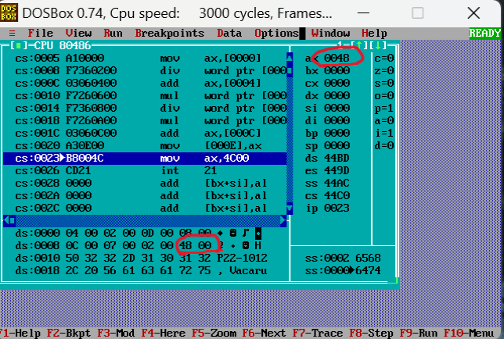

3. Final Results

The calculation of the expression is as follows: {[(4 / 2 + 13) * 8] / 12} * 7 + 2 = 72 = (48)H

Input Values (Hexadecimal Conversion):
- 4 hex = 04
- 2 hex = 02
- 13 hex = 0D (Correction: 13 in decimal is 0D, not 0F)
- 8 hex = 08
- 12 hex = 0C
- 7 hex = 07
- 2 hex = 02

Step-by-Step Calculation:
- 4 / 2 = 2 (02)H
- 2 + 13 = 15 (0F)H
- 15 * 8 = 120 (78)H
- 120 / 12 = 10 (0A)H
- 10 * 7 = 70 (46)H
- 70 + 2 = 72 (48)H

Final Memory and Register State:
- In AX Register: 00 48
- In Memory: .. .. .. .. .. .. 48 00

