1. Introduction
In this project I analyzed the Netflix catalog using the public "Netflix Titles" dataset, which contains 8,807 records: 6,131 movies and 2,676 TV shows. I chose this dataset because it lends itself both to a classic descriptive analysis (frequencies, shares, distributions over time) and to a fairly interesting economic discussion: how a streaming platform builds its offering, and what that offering tells us about the company's strategy.
The analysis was done entirely in Excel, without external tools such as Power BI. The workbook has five sheets (netflix_clean, calc, country_table, genre_table and dashboard), and every figure shown in the dashboard is a formula that starts from the cleaned data. If the data changes, the results recalculate on their own. This document does not repeat the formulas; instead it explains what I obtained and, above all, why I think the results look the way they do.
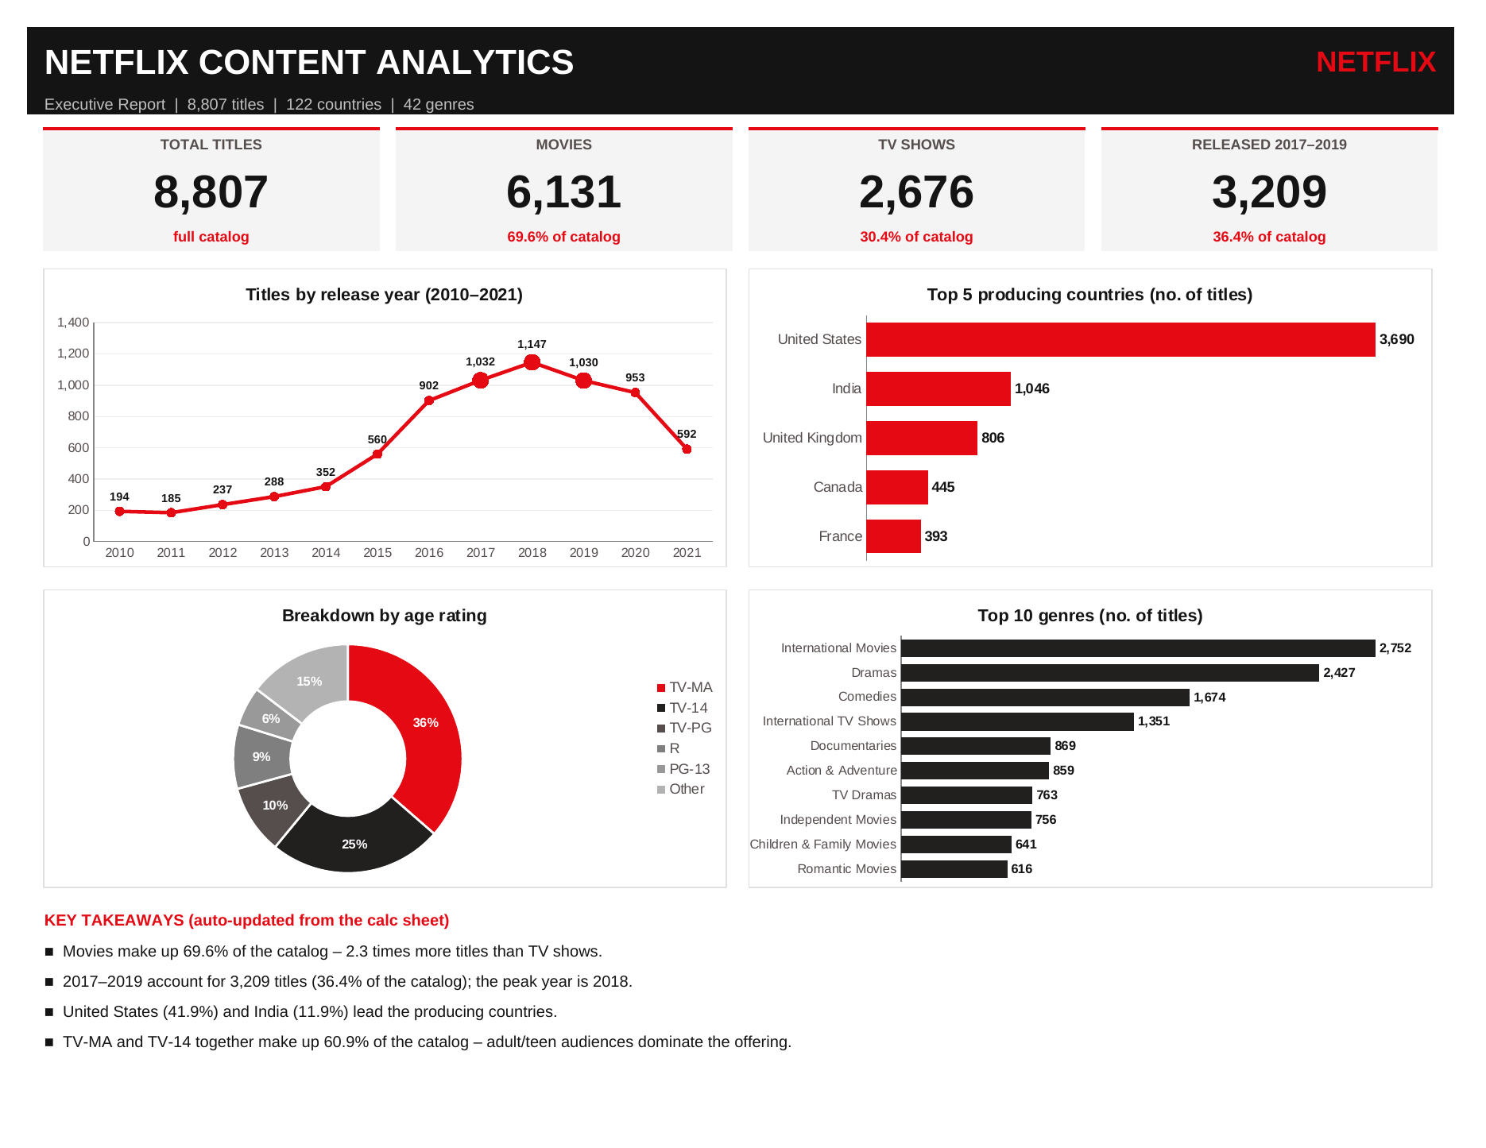
Figure 1. The dashboard built in Excel

2. The Data and How I Prepared It
The raw file has 12 columns. The first thing I checked was how many values are missing, because how they are handled directly affects the conclusions. Most gaps are in the director field (2,634 records, or 29.9%), the country field (831, or 9.4%) and the cast field (825). The other columns have only a few missing values: 10 in the date added, 4 in the rating and 3 in the duration.
I did not delete any rows. I replaced the gaps in director, cast and country with "Unknown", so that all 8,807 titles stay in the analysis and the unknown values can be counted separately rather than mistaken for a real country or director. One observation that seemed important to me: 2,446 of the 2,676 TV shows (over 91%) have no director listed. The gap is therefore not random but structural, because in a series the directors change from one episode or season to another and the field is left blank. For this reason I did not try to "estimate" the missing directors, and I did not use that column for statistical conclusions.
I also found a data-entry error in the rating column: for three movies (Louis C.K. 2017, Louis C.K.: Hilarious and Louis C.K.: Live at the Comedy Store) the duration had been typed into the rating column while the duration column was empty. I marked their rating as "Unknown", which explains why the cleaned sheet shows 7 unknown ratings rather than 4.
The country and listed_in columns contain multiple values separated by commas (for example "United States, India"). I split them into separate tables (country_table and genre_table), and the counting is done with formulas. The consequence I have to keep in mind when interpreting is that a co-produced title is counted for each country: 1,315 titles (14.9%) list more than one country, so the country percentages do not add up to 100%. The same holds for genres, where a title can carry up to three labels. Finally, I converted the date added into a proper date field (from which I extracted the year and month) and split the duration into a numeric value and a unit (minutes for movies, seasons for TV shows).

3. Research Questions
I formulated six questions, which I answer one by one in the next section:
Q1. What share of the catalog do movies hold compared to TV shows, and how can this proportion be explained?
Q2. How has the number of titles evolved over time, and is there a peak in 2017–2019?
Q3. Which are the main producing countries, and what position does India hold?
Q4. Which genres dominate the offering?
Q5. Who is the content aimed at, judging by age ratings, and what does the high share of the TV-MA category mean?
Q6. How robust are the conclusions, given the limitations of the data?

4. Results and Interpretation

4.1. Why do movies dominate? (Q1)
Movies account for 69.6% of the catalog (6,131 titles) and TV shows for 30.4% (2,676), which means roughly 2.3 movies for every TV show. At first glance the result suggests that Netflix is primarily a movie platform, but I think the explanation is more nuanced.
The first explanation has to do with cost and production time. A movie is a finished product that can be licensed from large libraries at a relatively low price per title, whereas a TV show means multiple episodes, multiple seasons and a long-term commitment. The platform initially grew precisely on the licensing of existing content, and movies are the easiest thing to accumulate in volume.
The second explanation concerns the unit of measurement. I counted titles, not viewing hours. A movie lasts about 100 minutes on average (the median in the data is 98), while a series with three seasons can run to dozens of hours. So the fact that movies are more numerous does not mean they take up most of the time subscribers spend on the platform. A conclusion about consumption would require audience data, which my dataset does not contain.
The third observation seems the most interesting to me: the dominance of movies shrinks over time. The share of TV shows among released titles rose from about 27% in 2016 to 38.5% in 2019 and 53.2% in 2021 (2021 being an incomplete year). A series keeps a subscriber attached to the platform longer than a movie does, so its growth points to a focus on retention. It is also worth noting that 67% of the TV shows have a single season. From the data alone I cannot tell whether these are recent productions or series cancelled quickly, but it is a sign that the TV show offering is still under construction.

4.2. The 2017–2019 peak (Q2)
The distribution by release year shows a sharp increase after 2014. The number of titles grew from 352 in 2014 to 902 in 2016, about 2.6 times in just two years, and then peaked in 2018 with 1,147 titles. The three years 2017, 2018 and 2019 add up to 3,209 titles, or 36.4% of the whole catalog, even though they are only three years in a range that runs from 1925 to 2021.
Release year | 2015 | 2016 | 2017 | 2018
Titles | 560 | 902 | 1,032 | 1,147
Release year | 2019 | 2020 | 2021* | Total 2017–2019
Titles | 1,030 | 953 | 592 | 3,209
Table 1. Titles by release year
How do I interpret this peak? The period coincides with the moment Netflix moved from being a distributor of licensed content to being a producer, investing heavily in original productions while also expanding its service to over 190 countries (the big expansion took place in January 2016). It needed new content that it could offer not only in the US but also in new markets, and growing competition, with other streaming platforms about to appear, made owning its own content a priority. I must state that the dataset contains no budgets or producer information, so here I use the number of titles only as an indirect indicator of investment intensity, and the link to an original-content strategy is an interpretation, not something the data proves directly.
A lag is also worth noticing. If I look at the year in which titles were added to the platform rather than the release year, the maximum is in 2019, with 2,016 titles added, compared with 1,188 in 2017. This makes sense: titles released in a given year reach the catalog with a delay, and some of them are licensing deals rather than in-house productions.
Finally, the decline in 2020 (953) and 2021 (592) should be read with caution. The last title in the dataset was added on 25 September 2021, so 2021 is an incomplete year. In addition, the pandemic interrupted filming in 2020, and the catalog is a snapshot of one moment: titles whose licenses have expired no longer appear. The final decline is therefore not necessarily a real drop in investment.

4.3. Producing countries and the role of India (Q3)
Country | Titles | % of titles | Rank
United States | 3,690 | 41.9% | 1
India | 1,046 | 11.9% | 2
United Kingdom | 806 | 9.2% | 3
Canada | 445 | 5.1% | 4
France | 393 | 4.5% | 5
Table 2. Top 5 producing countries
The United States leads clearly, with 3,690 titles (41.9%), which is natural for an American company with access to the largest film industry in the world. What seems more important to me, however, is the opposite fact: almost 58% of the catalog is not exclusively American in origin, so Netflix is a truly international platform. The five countries in the top add up to 6,380 appearances, about 72% of titles (with the caveat that some titles are counted twice), while the remaining 117 countries share the rest. Concentration is therefore high, but there is a "long tail" of countries with small contributions.
India's second place (1,046 titles, 11.9%) is the result I found most relevant. India is one of the largest potential markets in the world, with a very large population and intensive use of mobile phones for viewing, and Netflix officially entered this market in 2016. Beyond market size, a specific pattern is visible: 92% of the titles that include India are movies, and the most frequent rating is TV-14 (572 titles), not TV-MA (266). In other words, the Indian offering leans toward family-friendly movies, in line with the local cinema tradition, where the feature film is the main form of entertainment. My economic interpretation is that, in a market with lower average revenue per subscriber, the platform pursues user volume and needs local content in several languages, not just translated American productions. This remains a hypothesis, since the data contains no information on prices or revenue.
The United Kingdom (806) and Canada (445) complete the top, probably thanks to the shared language, well-developed audiovisual industries and numerous co-productions with the US. It should be noted that 831 titles (9.4%) have no country filled in; even if they were all assigned to a single country, the order of the first places would not change significantly, but the ranking from fourth place downward could be affected.

4.4. The dominant genres (Q4)
Genre | Titles | % of titles | Rank
International Movies | 2,752 | 31.2% | 1
Dramas | 2,427 | 27.6% | 2
Comedies | 1,674 | 19.0% | 3
International TV Shows | 1,351 | 15.3% | 4
Documentaries | 869 | 9.9% | 5
Table 3. Top 5 genres
Dramas (27.6%) and comedies (19.0%) are the "universal" genres of the catalog. My explanation is that they are the genres that travel best across cultures: dramatic emotion and situational humor can be subtitled or dubbed without major losses, which matters for a platform present in hundreds of markets. Documentaries (9.9%) cost less to produce than fiction and bring prestige and visibility, which is why they are common.
A critical remark is needed, though. The "International" label in the top positions is not a genre in the strict sense but an indicator of non-American origin; in other words, the platform's taxonomy mixes two different criteria (genre and market). For this reason the genre ranking is not perfectly comparable across positions, and a more rigorous analysis would separate the genre criterion from the geographic one. In any case, the fact that "International Movies" is the most frequent tag (31.2%) reinforces the conclusion of the previous section about the international character of the catalog.

4.5. Age ratings and the mature TV-MA audience (Q5)
Rating | Titles | % of titles | Rank
TV-MA | 3,207 | 36.4% | 1
TV-14 | 2,160 | 24.5% | 2
TV-PG | 863 | 9.8% | 3
R | 799 | 9.1% | 4
PG-13 | 490 | 5.6% | 5
Table 4. Top 5 age ratings
The TV-MA category, meaning content intended exclusively for adults, is the most frequent (36.4%), followed by TV-14 (24.5%). Together the two add up to 60.9% of the catalog. If I add the R and NC-17 categories, almost half of the titles (45.5%) are intended for adults, while children's content (TV-Y, TV-Y7, TV-G, G) makes up only about 10% (908 titles).
From an economic point of view, I think there are several reasons for this profile. First, the subscription is paid for and managed by adults, and content for them is what justifies the monthly fee. Second, unlike traditional television, a subscription platform does not depend on advertisers and does not have to follow the same broadcast limits, so it can afford subjects, violence or language that mass-market television would avoid. Mature content (thrillers, crime dramas, "prestige" series) is precisely what sets the offering apart from ordinary television. Third, parental controls on profiles allow the same account to serve the whole family, so a large adult offering is not a problem.
I should mention that the share of TV-MA is somewhat higher among TV shows (42.8%) than among movies (33.6%), which fits the observation that series are the ones building the image of "premium television". In addition, the ratings come from the American system and are not equivalent to classifications in other countries, so for markets such as India or Europe the interpretation must be made with caution.

5. Limitations of the Analysis (Q6)
I believe the most important part of a data analysis project is to say clearly what it cannot prove. In my case there are several limitations. The data is a snapshot from September 2021, so titles withdrawn since then are missing, and 2021 is incomplete. The counting is by titles, not by viewing hours, revenue or budgets, so conclusions about "investment" and "strategy" are indirect interpretations, not measured results. Co-productions are counted for each country and multiple genres for each label, so the percentages do not add up to 100%. Almost 30% of titles have no director and about 9% have no country, and the gaps are not completely random. Finally, the analysis is descriptive: I observe associations and shares, but I cannot claim causal relationships.
As directions for further work, it would be useful to test statistically the association between title type and rating (for example with the chi-square test), to produce a simple forecast of titles per year with a regression, or to run a text analysis on the title descriptions, and to supplement the data with audience information.

6. Conclusions
The analysis of the Netflix catalog, carried out in Excel on 8,807 records, leads to four main conclusions. First, the catalog is numerically dominated by movies (69.6%), but the share of TV shows keeps growing among more recent titles, which points to a shift toward content that retains subscribers. Second, the 2017–2019 period concentrates 36.4% of titles, with a peak in 2018, consistent with the platform's move toward in-house production and its international expansion. Third, although the US remains in the lead with 41.9%, the catalog is truly international, and India, with 11.9%, is the second country by number of titles, with an offering focused on family movies. Fourth, the target audience is mainly adult: TV-MA and TV-14 together make up 60.9% of the catalog.
From the standpoint of the project, I aimed to show that a complete dashboard, with indicators, helper tables and charts, can be built using only Excel functions (COUNTIF, SUMPRODUCT, INDEX, MATCH, LARGE), without additional tools, and that the results are verifiable, because every number in the dashboard can be traced back to a formula in the calc sheet.

