Tree Prefuse Navigation – I think I can browse through any collections from the existing model.

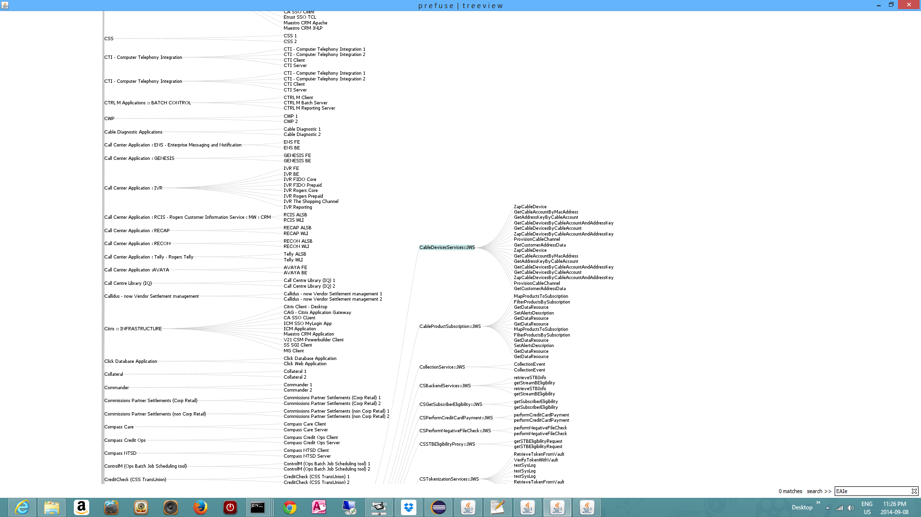

E.g EAI express - WS services and Interfaces

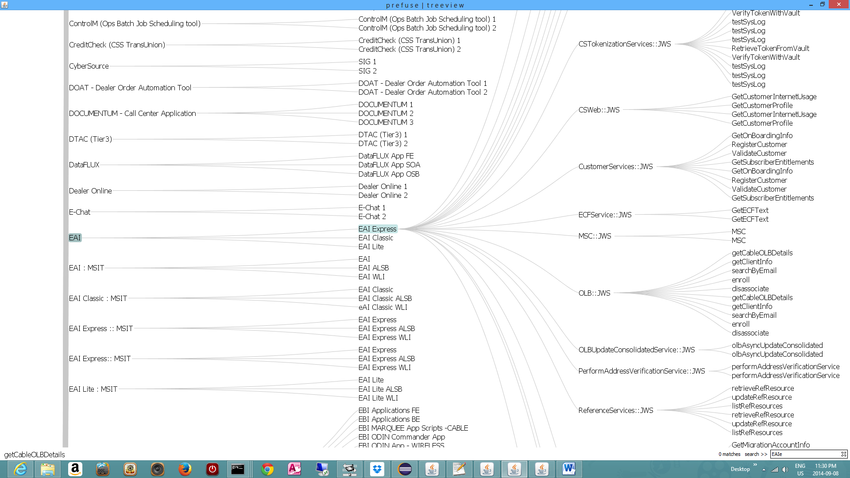

EBI

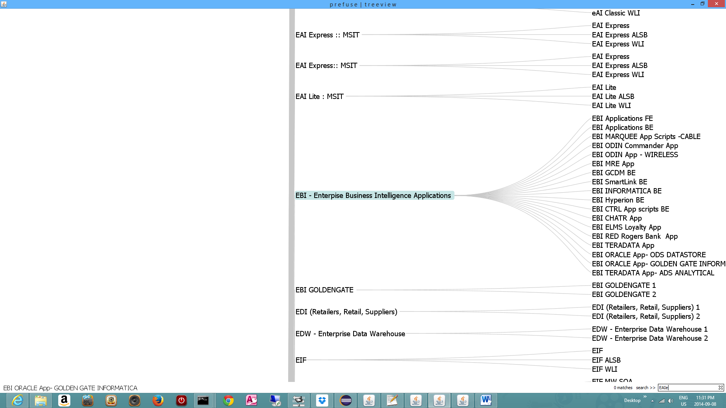

FIDO.ca

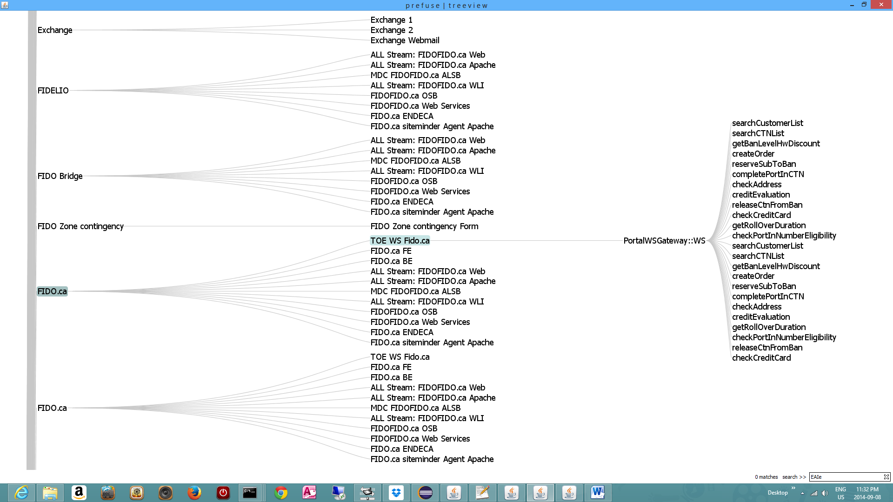

HRM

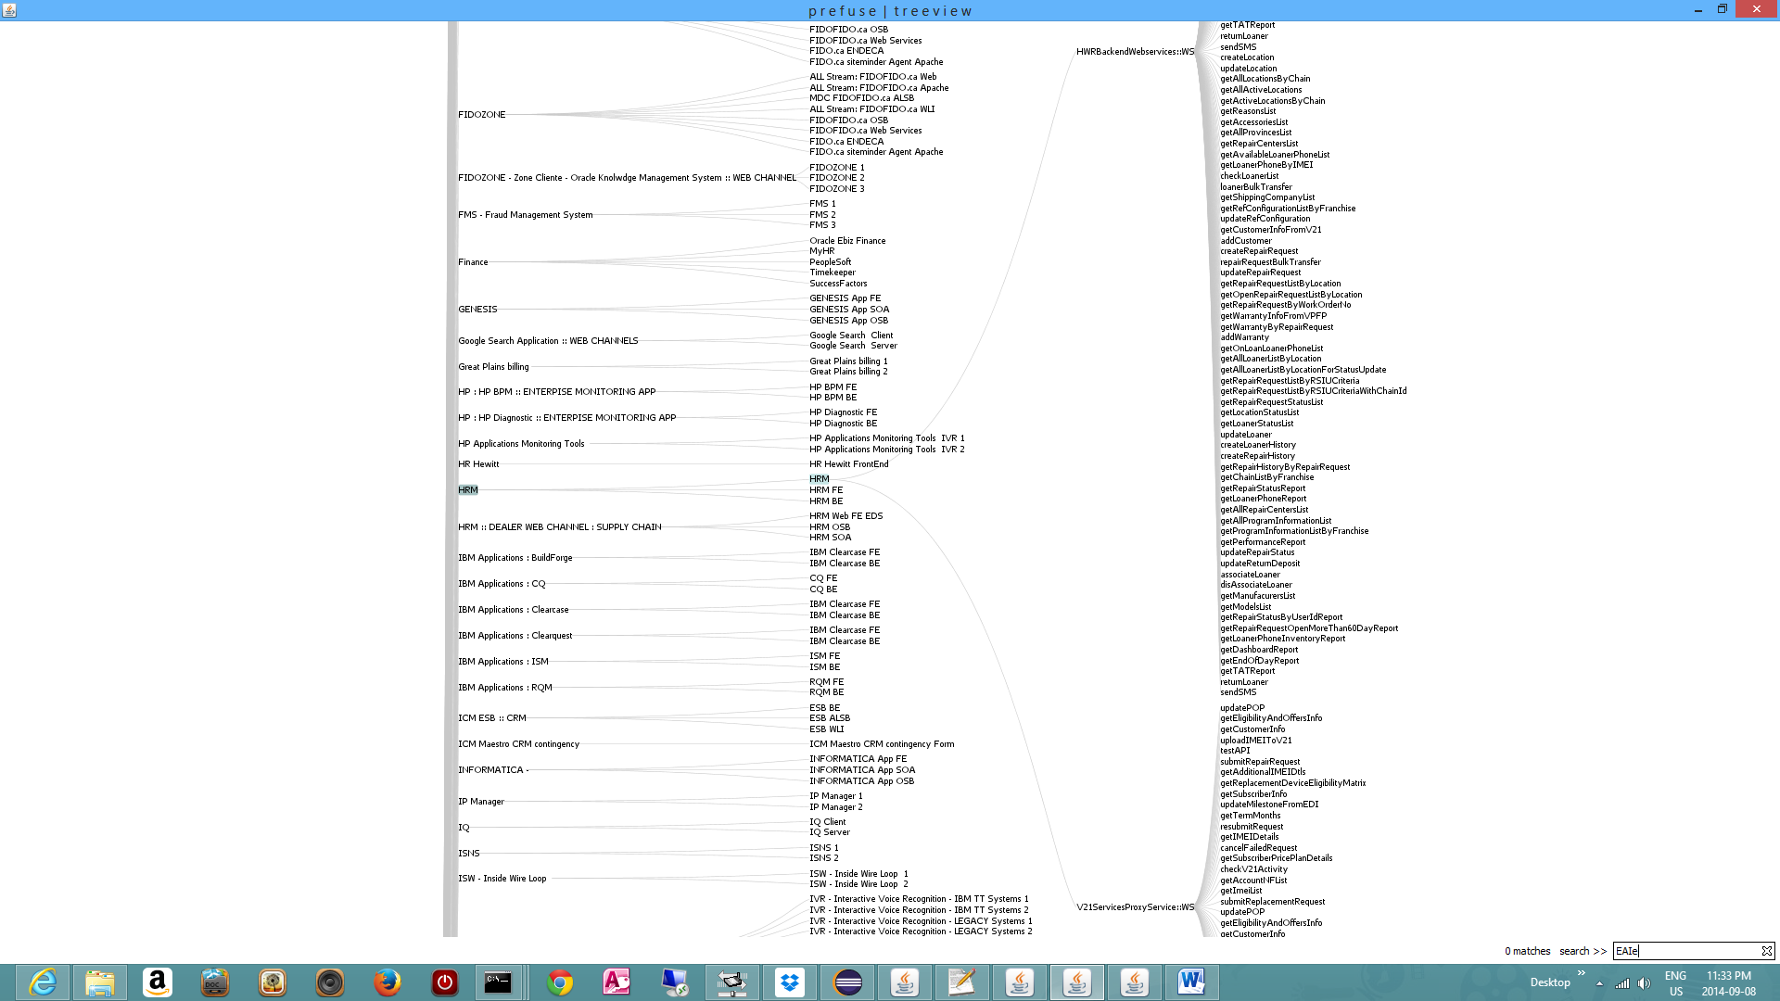

Highlight seach for CRM –this is powerfull function; also this is having zoom in and zoom out

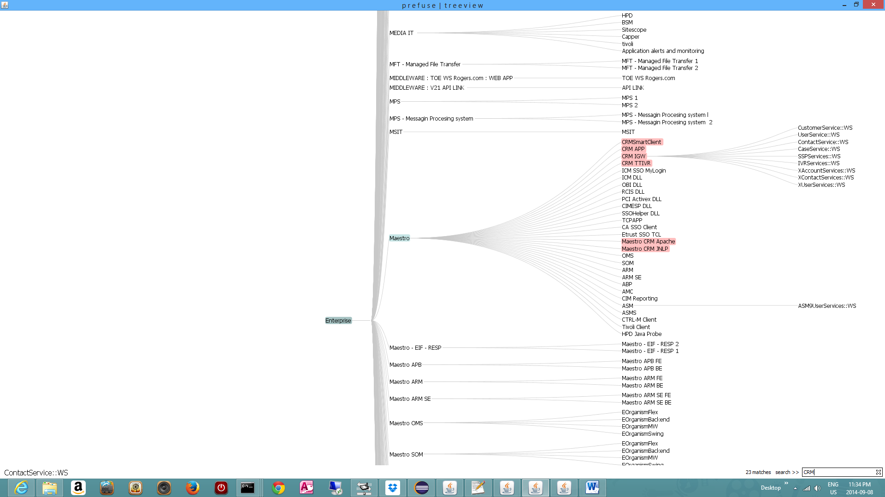

Zoom in/out

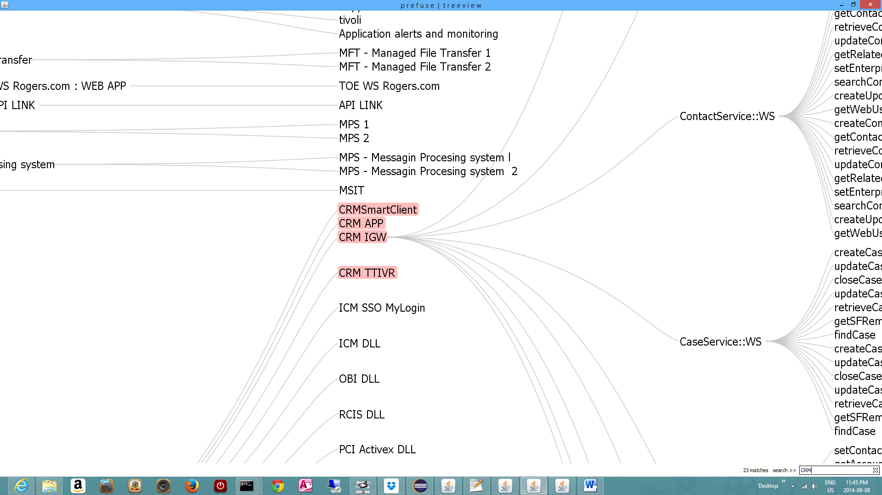

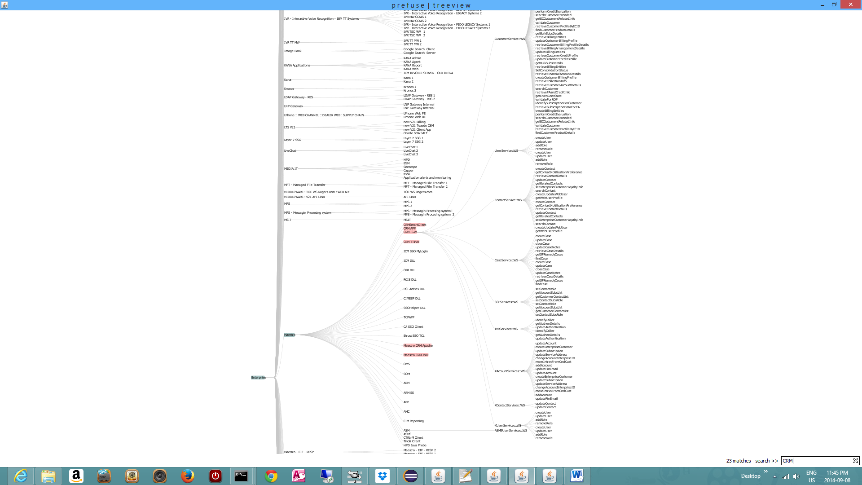

And Maestro CRM IGW Web services Interfaces – view

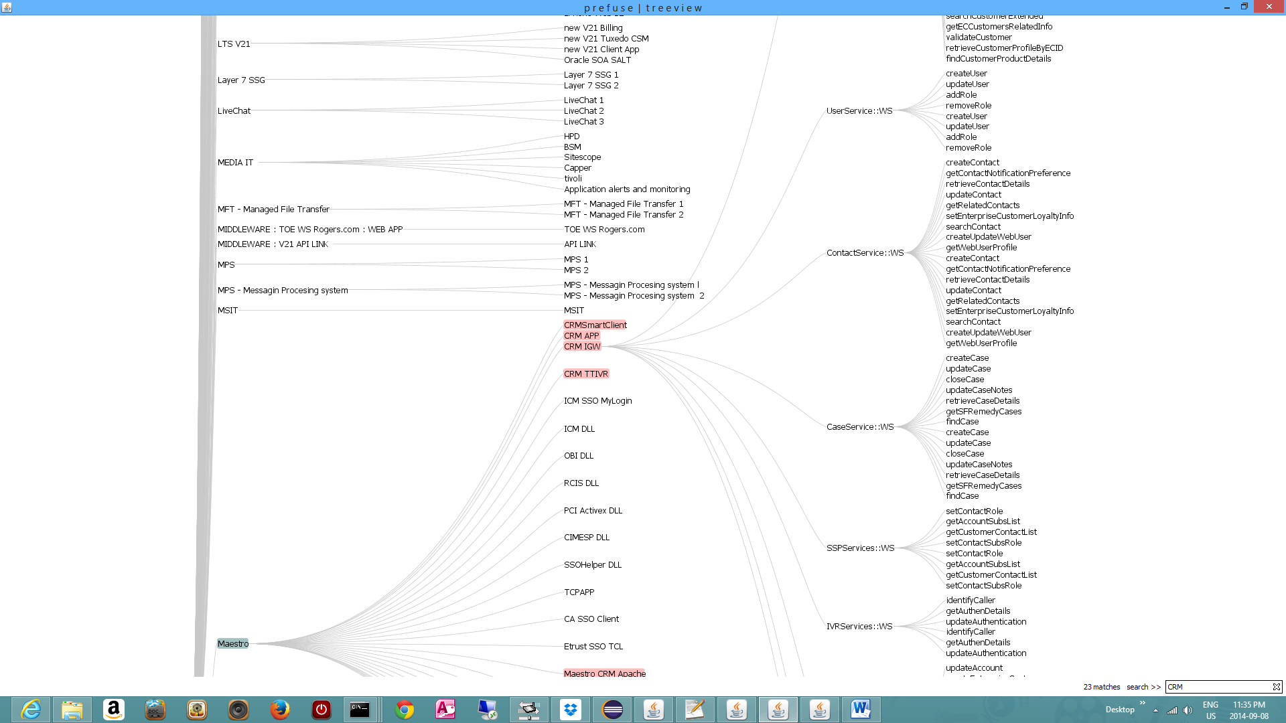

– one can seach easily through the Web services methods/ interfaces; e.g. seach a Web service with pattern “find%”

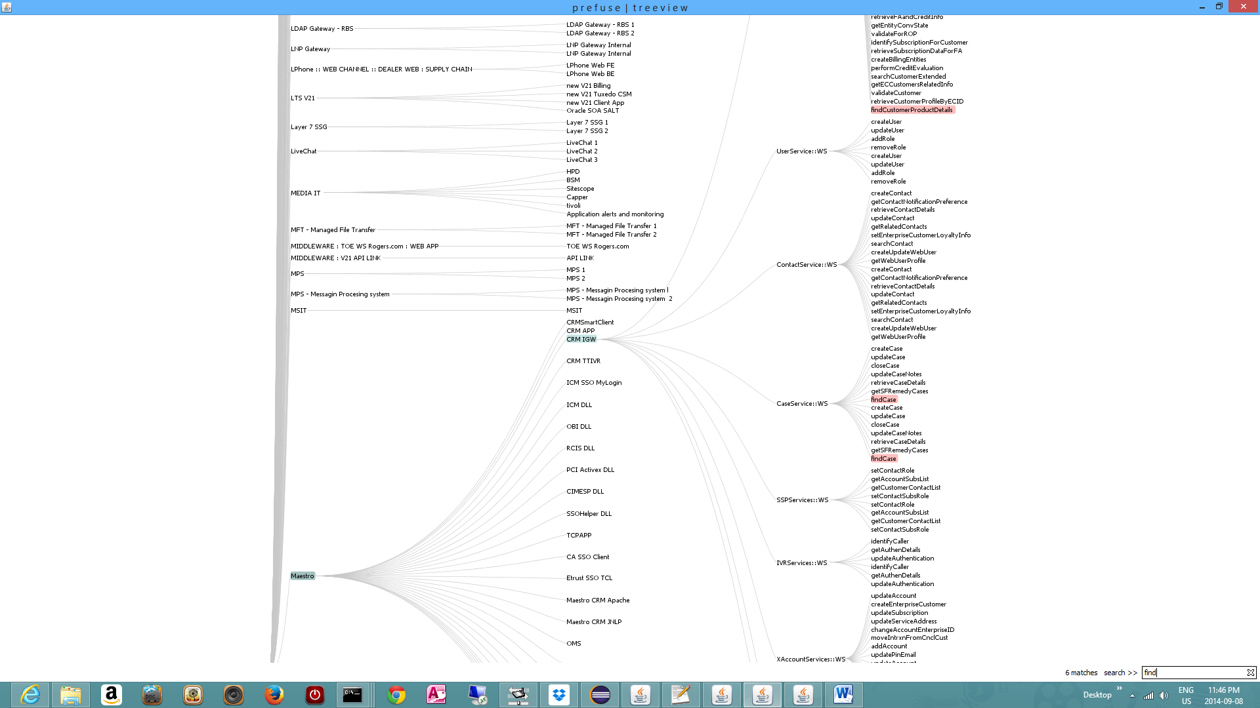

Radial Tree Explorer is not yet implemented, but is looking like this screen bellow– code is already under control – I just have to populate some XML. GraphlML XML format to be more precise

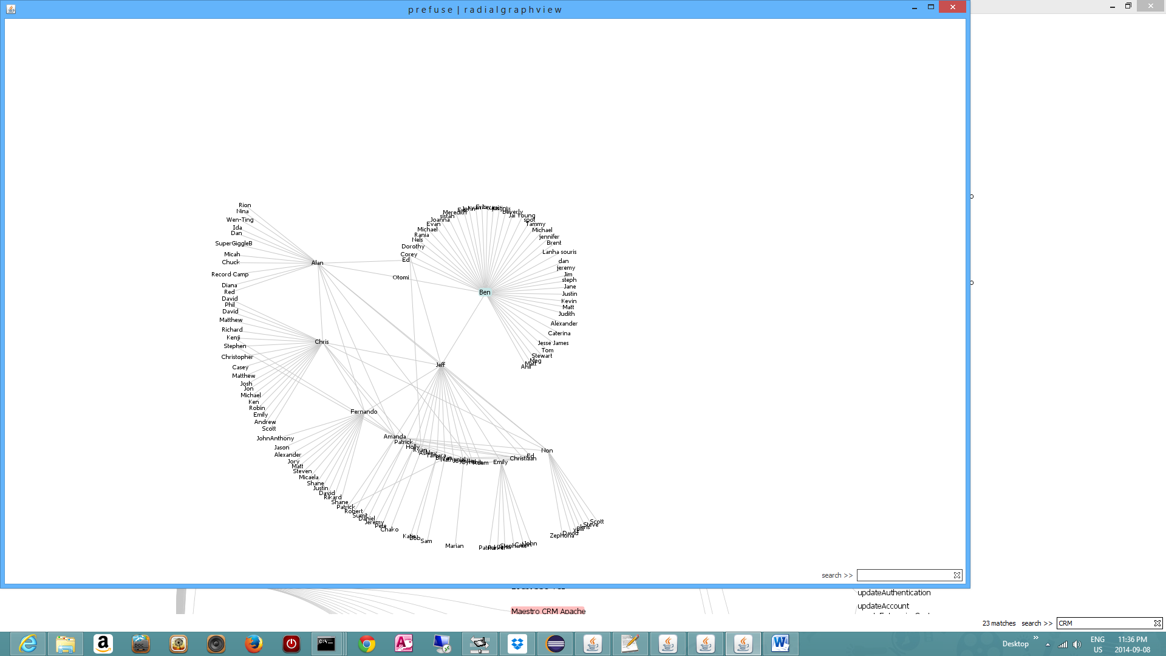

And latest Models/ Modules in the Main Swing Tree Model Explorer

Environments – module was not ready last time, I guess

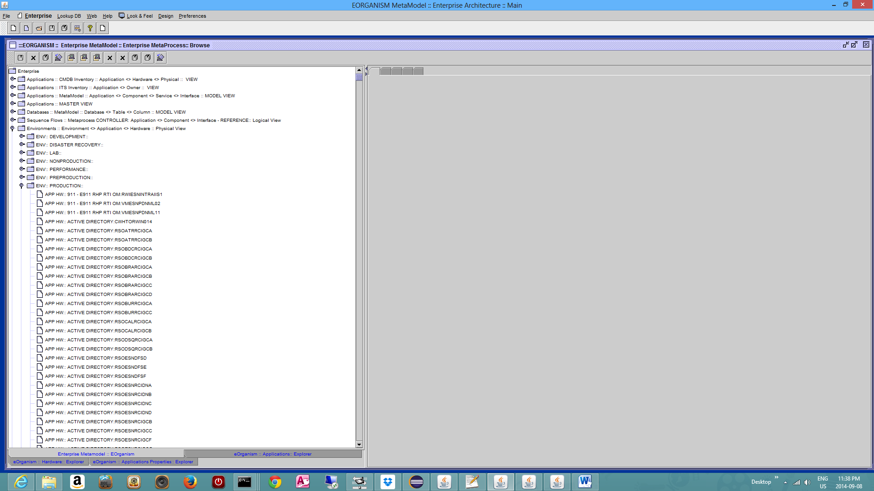

Person <> App <> HW relation and browsing

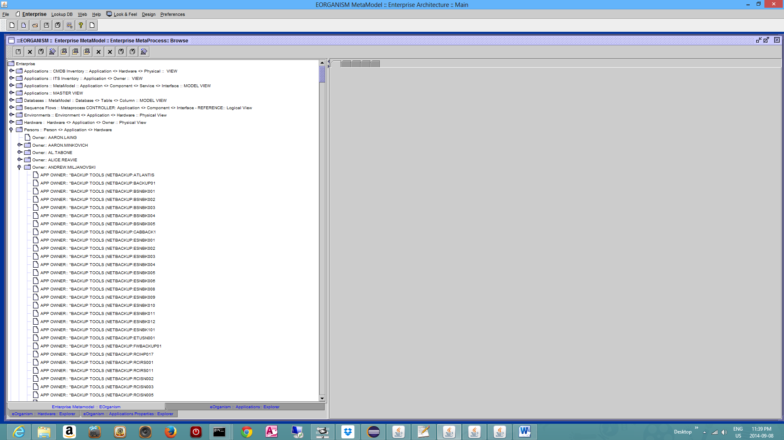

Also one adition and extra function: I can see the model directly:
Application >> App DB >> Schema; previously was not done this way.

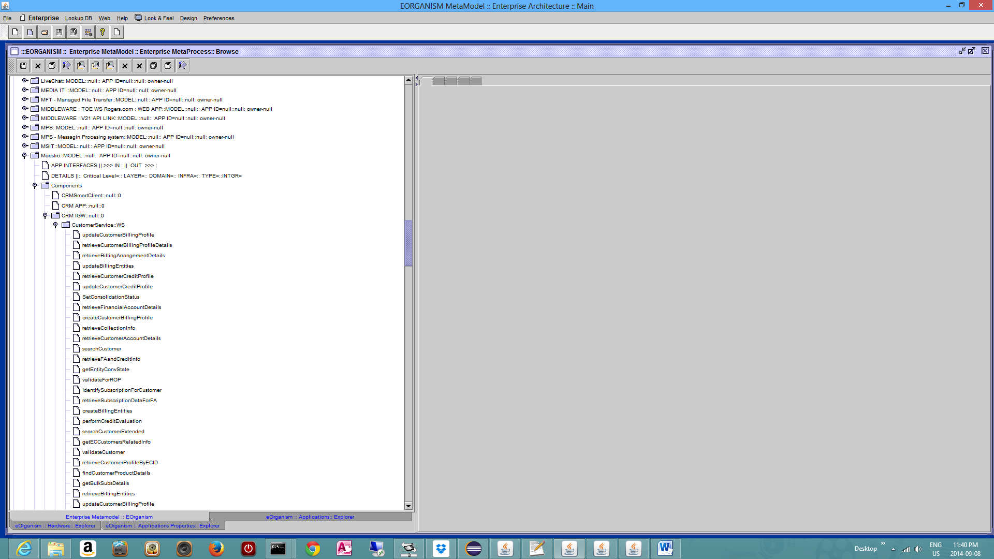

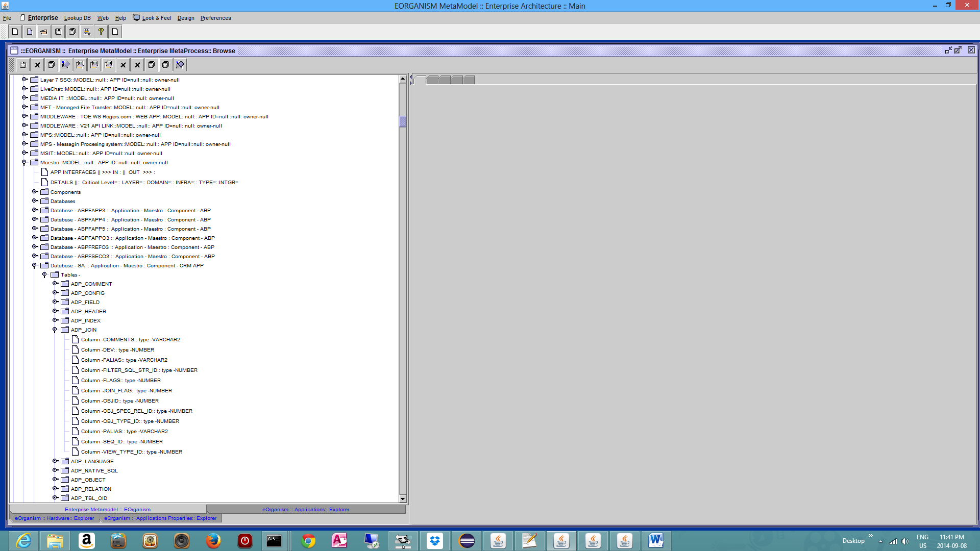

I am very happy we have also something for search and visualization. Cheers

