The threat posed by MathEd and what we can do about it

By Alex Iosevich

June 24, 2005

This article is dedicated to my children, Joshua and Nathan, who will be entering the educational system in a few years…
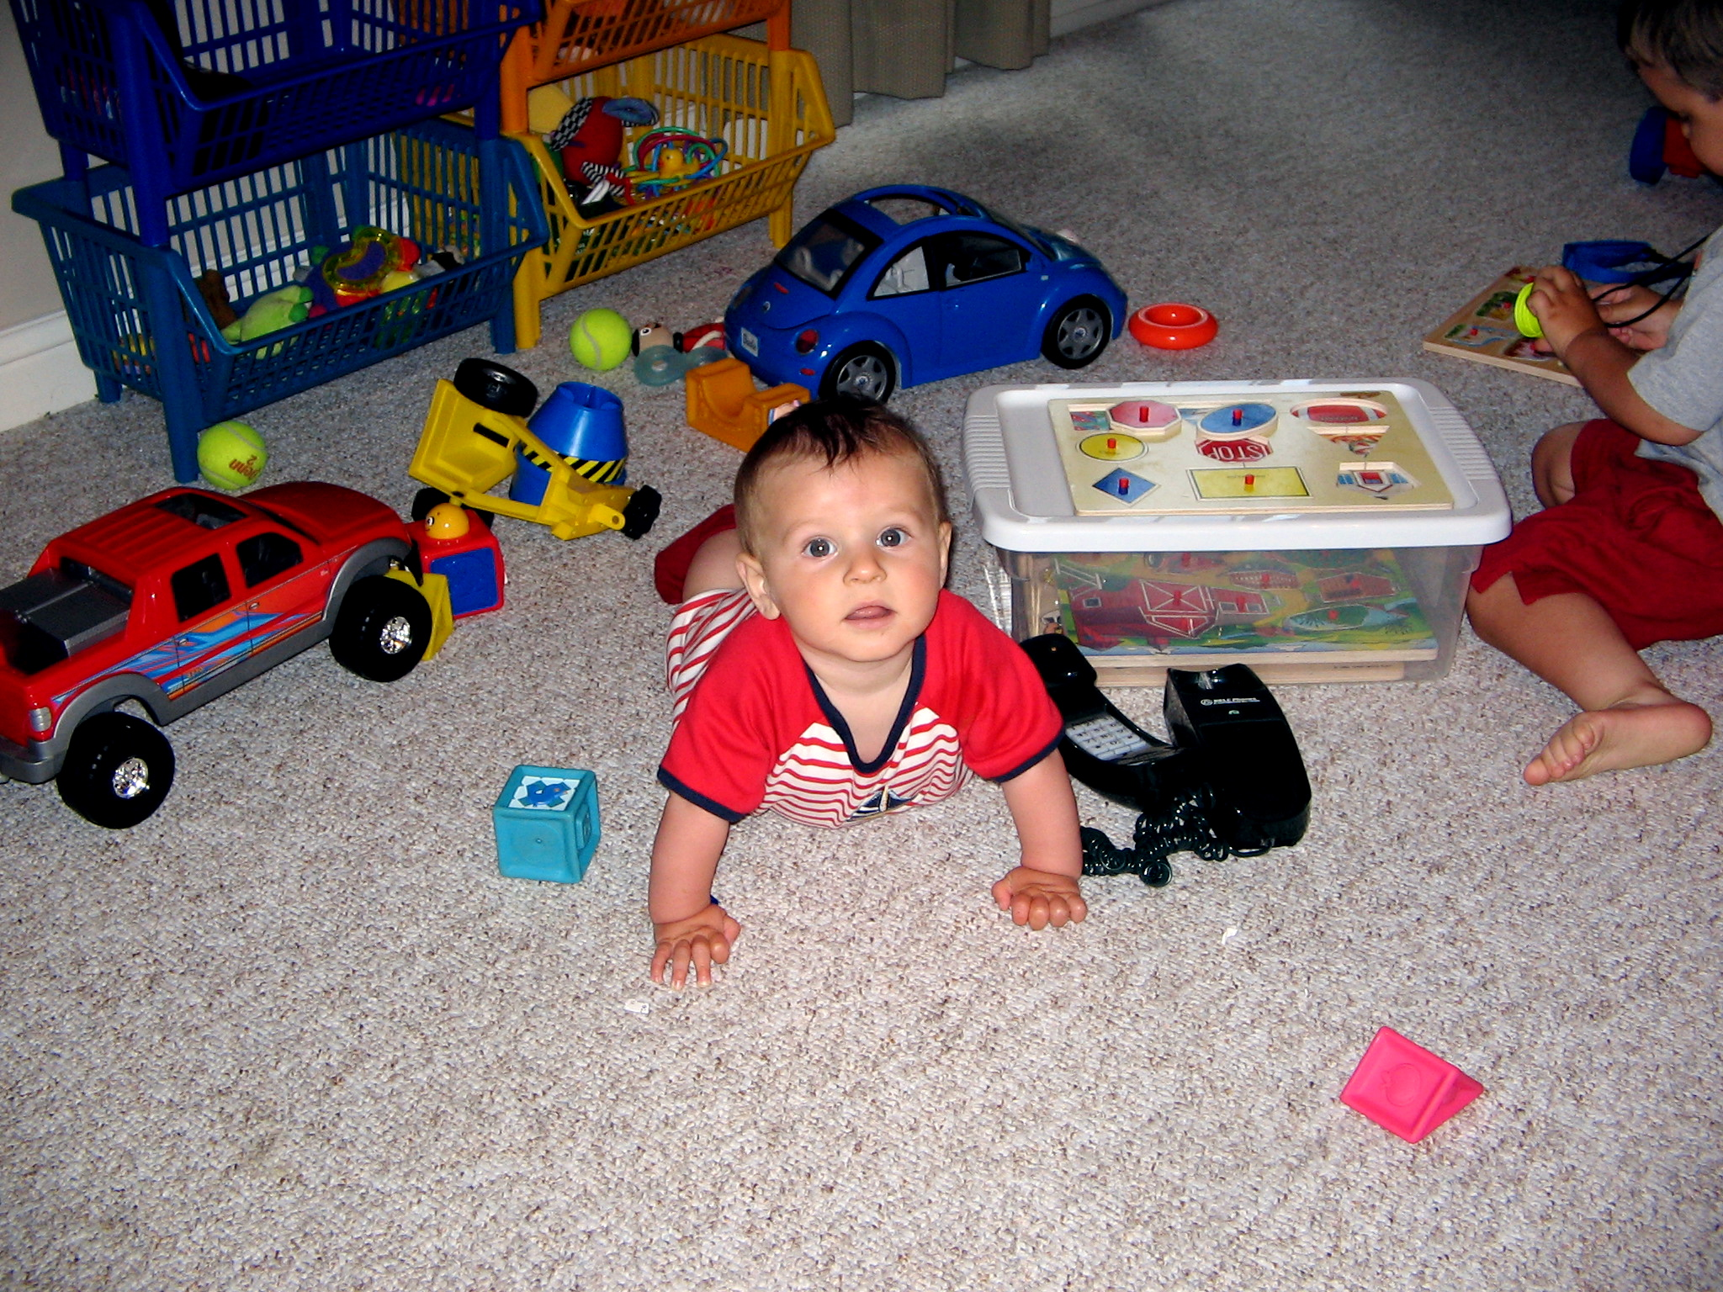

Mathematics Education, or MathEd for short, has generated much controversy in research mathematics circles for many years. Many pure mathematicians believe that most practitioners of MathEd have weak mathematics backgrounds along with hidden, and sometimes open, contempt for serious mathematics. The presence of a small numbers of prominent mathematicians in MathEd does little to assuage these concerns for reasons too obvious to mention. The fact that many people involved in MathEd are honest and hardworking people also, unfortunately, does not help much in the grand scheme of things, because the movement they represent is flawed at its core. The purpose of this essay is to make a case that MathEd establishment is a threat to mathematics education, and also to the research mathematics community. I also wish to propose some possible methods for dealing with this problem.

Before entering the main body of this essay, I wish to make a quick and obvious point, which seems to be lost on many people in this age of deteriorating intellectual freedom. No academic discipline is immune from criticism. Furthermore, even the validity of a discipline as a whole is open to question and even ridicule. Several MathEd practitioners I have communicated with urged me to engage in “constructive” criticism, but this is difficult, if not impossible, to do if one views the whole discipline as a form of unashamed charlatanism.

The main reason MathEd establishment and most of the practitioners constitute a threat to mathematics education is because they have created a bureaucratically complex research discipline out of a methodologically simple and honorable art. Teaching is very simple and very difficult at the same time. It is difficult in that it requires much patience, organization, love, and dedication. At the same time, teaching is simple in that beyond the knowledge of the subject, willingness to understand the needs of the students, flexibility, common sense and open mind, no other prerequisites or techniques are required. From my personal experience, interaction with the students give a much better feel for teaching than any of the formal “training” programs mathematicians are often subjected to as a teaching assistants or junior faculty members. By turning education into a research discipline, its promoters have created an environment where publication pressure and a drive for “innovation” inevitably replaces common sense and result oriented thinking. To put it simply, I believe that sustained research effort into the question of how breakfast cereal is best served would inevitably lead to plates of corn flakes filled with garden greens, cherry preserve, and multi-colored whipped cream on top. It is my view that this is precisely what happened to mathematics education under the tutelage of MathEd.

A less significant but a nevertheless annoying threat that MathEd poses to theoretical mathematics is within the research mathematics departments. With the usual token number of exceptions, most theoretical mathematicians who are involved in MathEd do not have stellar research credentials, to put it mildly. With the infusion of grant money that often comes from their participation in MathEd, it is tempting for these individuals to bully their departments for pay raises and other symbols of respect and recognition. Unfortunately, the amounts of money MathEd commands at the National Science Foundation is so huge, it may become increasingly difficult for university administrators to ignore the demands of these nouveau riches of the academic world. This may result in the increased intrusion of MathEd into research mathematics departments and the resulting chaos and lack of prestige that will inevitably follow.

I recently attended a K-8 conference at Asilomar, sponsored by MSRI. I do not know what the individuals who run MSRI are thinking, but it is possible that they have fallen victim to the “if you cannot beat them, join them” mentality, which in this case seeks to take advantage of popularity of MathEd with governmental funding agencies, and expanding the reach and influence of pure mathematics in the process. This is an age- old trap, and falling into it will have the inevitable eventual consequence of hogtying the research mathematics world to the insatiable beast of MathEd. While association with MathEd may bring us some good publicity and funding in the short run, it may destroy us in the long run because we are not yet ready to withstand a direct comparison with the so-called educators in the public eye and our funding will suffer as a result. Not to mention the fact that association with MathEd is fundamentally problematic because we should not lend any credibility to the movement that is actively contributing to keeping mathematics education in this country well behind that of many other developed nations.

As destructive the association with MathEd is, the idea of improving the image of the research mathematics world, and fulfilling our duties to the community, by increasing our profile in educational activities is a good one. However, I believe that a very different approach must be taken. Instead of associating ourselves with MathEd, we should make our contributions at the local level by working with teachers, organizing mathematics related activities, and fostering a positive interaction between local schools and the university. By rejecting the ridiculous notion that MathEd experts necessarily provide credibility and essential expertise for such activities, and by exposing it for what it is, we will both increase our own positive profile and will rid ourselves of a dangerous and disingenuous association. This is not to say that cooperation with individuals from the MathEd world should always be rejected- not at all! I can imagine many instances where joint projects with competent and well-meaning MathEd experts could be very useful, but the point is to avoid being subordinate to their agenda and serving under their banner.

Over the years, I had the honor and the pleasure of teaching many talented and hard working individuals majoring in mathematics education. I always took particular pride in teaching them because they are the future mathematics teachers of America, people who will teach our children. Several of these students complained that instead of taking mathematics courses they need to understand the subject and teach it effectively, their curriculum is filled with courses full of psychobabble and pedagogical gobbledygook. These students are also victims of the MathEd establishment, and their sub-standard training, unworthy of their talents, portends a bleak future for the mathematics education system in our country.

And what should be done about elementary and high school teacher training after MathEd is relegated to the trash bin of academic history? The solution is simple because many developed countries have already successfully addressed this problem. Prospective teachers will be asked to get a degree in mathematics, and, in addition, will be asked to take one or two courses in general pedagogy offered by the school of education. Summer internships geared towards hands on teaching will complete the process that will result in a degree in mathematics with specialization in teaching.

I propose a creation of a web page to catalog educational activities by research mathematicians. Such a site could be setup without much difficulty and bureaucratic hassles. A group of moderators would probably be needed to keep track of the incoming reports and screen their content to a reasonable extent. We can also use his web page to facilitate discussions among research mathematicians about how they can get actively involved in educational activities depending on their inclinations and the amount of time they are willing to spend. By proceeding in this way we can not only create interesting and rewarding opportunities for students and teachers, but we can also demonstrate the usefulness and relevance of theoretical mathematics in education and community work.

In the end, the strongest case we could possibly make against MathEd that the public at large will be able to appreciate is that we can get things done and they cannot. In order to be able to make such an argument, we need to go out and get results in a way that shows that our training in pure mathematics gives us a clear in edge in passing on knowledge and inspiring scientific interest and learning. Once we have a body of work to point to, our case may well gain unexpected support from the public and the political establishment.

I do not blame those who wish to reform MathEd from within. It is possible that I am being overly pessimistic and the current trend of psychobabble and watered-down non-sense in mainstream MathEd will eventually be replaced by more intelligent and constructive approaches already advocated by some of its practitioners. My gut instinct tells me that this is not going to happen, however. The spirit of social activism that pervades MathEd, combined with widespread ignorance of mathematics renders this discipline unsalvageable. Another way must be found to address the many shortcomings of mathematics education in this country and pure mathematicians can and should play an important role in this process

Two types of people will likely read my essay- those who already agree with the basic theme, and those who want me tarred and feathered. This essay is not meant as a source of information, however, but rather as a (figurative) call to arms. If MathEd were simply a source of pitiful incompetence and garden-variety buffoonery, I would be content to sit back and laugh about it with my friends. Unfortunately, the growing influence of MathEd is destroying mathematics education in this country and endangering our children’s future. Therefore, sitting idly by is not an option.

Please let me know your thoughts on the matters expressed here at iosevich@math.missouri.edu. A description of some of my teaching activities may be found on my web page at http://www.math.missouri.edu/~iosevich. I look forward to your comments and suggestions. Please let me know if it would be all right to have your comments posted on my web page, either anonymously or with your name attached. I pledge to honor your wishes in this regard to the letter. It is all too easy to laugh at the MathEd shenanigans, but unfortunately the situation is not particularly funny. Let us do something about it and improve elementary and high school mathematics education in the process.

