SUPPLEMENTARY TABLES
Table S1. Studies investigating the impact of agricultural practices on phyllosphere bacterial and fungal communities.
Reference | Plant | Type of study | Impact of agricultural practices on diversity
Reference | Plant | Type of study | Bacteria |  | Fungi
Reference | Plant | Type of study | α | β | α | β
Karlsson et al. (2017) | Wheat | Field | NA | NA | Yes* | Yes
Castañeda et al. (2018) | Grapevine | Field | NA | NA | No | Yes
Knorr et al. (2019) | Wheat | Field | NA | NA | No | Yes
Katsoula et al. (2020) | Pepper | Field | No | Yes | Yes | Yes
Wu et al. (2023) | Cucumber | Greenhouse | No | No | No | Yes
*Richness

Table S2. Description of cultivars sampled at each site.
SITES | Practices | CULTIVARS
SITES | Practices | Cortland | Paulared | Honeycrisp | Spartan | Sunrise | Liberty | Empire | Freedom
A | Conventional | X | X | X | X |  | X | X
B1 | Conventional | X | X | X | X | X | X | X
B2 | Organic |  |  | X | X | X |  | X
C | Organic | X | X | X | X |  | X |  | X
D1 | Conventional | X |  | X | x |  | X | X
D2 | Organic | X |  | X | X |  | X | X

Table S3. Pre and post rarefaction dataset descriptive statistics.
 |  | ITS | ITS_rarefied
Total number of | Sequence | 5,022,964 | 822,500
Total number of | ASV | 2,812 | 2,795
Total number of | Sample | 329 | 329
Sequence per sample | Mean | 15,267 | 2,500
Sequence per sample | SD | 8,189 | 0
Sequence per sample | Min | 2,508 | 2,500
Sequence per sample | Max | 47,875 | 2,500
ASV  per sample | Mean | 216 | 146
ASV  per sample | SD | 144 | 112
ASV  per sample | Min | 22 | 12
ASV  per sample | Max | 643 | 437
ASV prevalence | Mean | 25 | 17
ASV prevalence | SD | 39 | 31
ASV prevalence | Min | 1 | 1
ASV prevalence | Max | 329 | 329

Table S4. Metadata of samples removed during bioinformatic processing.
sample | time | code | practice | cultivar | type | replicate | susceptibility | sequences
2023-1-ASB-CL-LE-1 | May | A | Conventional | Cortland | Leaf | 1 | High | 41
2023-1-ASB-EM-FL-2 | May | A | Conventional | Empire | Flower | 2 | Low | 518
2023-1-ASB-HC-FL-1 | May | A | Conventional | Honeycrisp | Flower | 1 | Moderate | 226
2023-1-ASB-LI-FL-3 | May | A | Conventional | Liberty | Flower | 3 | Low | 1347
2023-1-COM-EM-FL-3 | May | B2 | Organic | Empire | Flower | 3 | Low | 0
2023-1-COM-SP-FL-1 | May | B2 | Organic | Spartan | Flower | 1 | Moderate | 2
2023-1-COM-SP-FL-3 | May | B2 | Organic | Spartan | Flower | 3 | Moderate | 38
2023-1-COM-SR-FL-1 | May | B2 | Organic | Sunrise | Flower | 1 | Moderate | 3
2023-1-COM-SR-FL-3 | May | B2 | Organic | Sunrise | Flower | 3 | Moderate | 1255
2023-1-MIB-CL-LE-1 | May | D2 | Organic | Cortland | Leaf | 1 | High | 679
2023-1-MIB-EM-LE-3 | May | D2 | Organic | Empire | Leaf | 3 | Low | 881
2023-1-MIB-LI-LE-1 | May | D2 | Organic | Liberty | Leaf | 1 | Low | 14
2023-1-MIC-CL-LE-1 | May | D1 | Conventional | Cortland | Leaf | 1 | High | 390
2023-1-MIC-CL-LE-2 | May | D1 | Conventional | Cortland | Leaf | 2 | High | 1050
2023-1-MIC-CL-LE-3 | May | D1 | Conventional | Cortland | Leaf | 3 | High | 4
2023-1-MIC-EM-LE-1 | May | D1 | Conventional | Empire | Leaf | 1 | Low | 6
2023-1-MIC-EM-LE-3 | May | D1 | Conventional | Empire | Leaf | 3 | Low | 26
2023-1-MIC-LI-LE-2 | May | D1 | Conventional | Liberty | Leaf | 2 | Low | 690
2023-1-MIC-LI-LE-3 | May | D1 | Conventional | Liberty | Leaf | 3 | Low | 1404
2023-1-PMB-CL-FL-2 | May | B1 | Conventional | Cortland | Flower | 2 | High | 0
2023-1-PMB-LI-LE-2 | May | B1 | Conventional | Liberty | Leaf | 2 | Low | 179
2023-1-VBS-LI-FL-2 | May | C | Organic | Liberty | Flower | 2 | Low | 3
2023-1-VBS-LI-FL-3 | May | C | Organic | Liberty | Flower | 3 | Low | 5
2023-1-VBS-LI-LE-1 | May | C | Organic | Liberty | Leaf | 1 | Low | 1
2023-1-VBS-SP-FL-3 | May | C | Organic | Spartan | Flower | 3 | Moderate | 2039
2023-1-VBS-SP-LE-2 | May | C | Organic | Spartan | Leaf | 2 | Moderate | 8
2023-2-ASB-CL-LE-3 | July | A | Conventional | Cortland | Leaf | 3 | High | 16
2023-2-ASB-HC-LE-2 | July | A | Conventional | Honeycrisp | Leaf | 2 | Moderate | 97
2023-2-ASB-PR-LE-3 | July | A | Conventional | Paulared | Leaf | 3 | High | 1563
2023-2-MIC-CL-LE-1 | July | D1 | Conventional | Cortland | Leaf | 1 | High | 30
2023-2-MIC-CL-LE-3 | July | D1 | Conventional | Cortland | Leaf | 3 | High | 39
2023-2-MIC-HC-LE-2 | July | D1 | Conventional | Honeycrisp | Leaf | 2 | Moderate | 25
2023-2-VBS-CL-LE-3 | July | C | Organic | Cortland | Leaf | 3 | High | 6
2023-3-VBS-HC-LE-3 | August | C | Organic | Honeycrisp | Leaf | 3 | Moderate | 1

Table S5. Factors explaining the variation within Honeycrisp and Spartan flower samples (PERMANOVA on Bray-Curtis dissimilarities)
 | R²(%) | F | Pr(>F)
practice | 29.2 | 6.8 | 0.001 | ***
cultivar | 5.3 | 1.2 | 0.235 | ns
practice:site^{*1} | 11.9 | 2.8 | 0.015 | *
practice:cultivar | 4.9 | 1.1 | 0.252 | ns
practice:site:cultivar | 5.6 | 1.3 | 0.177 | ns
Residual | 43.2
Total explained | 56.8

^{*1} Site is nested within practice

Table S6. Factors explaining the variation within Honeycrisp and Spartan leaf samples (PERMANOVA on Bray-Curtis dissimilarities)
 | R²(%) | F | Pr(>F)
practice | 14.1 | 49.9 | 0.001 | ***
time | 20.6 | 36.5 | 0.001 | ***
cultivar | 1.3 | 4.5 | 0.001 | ***
practice:site^{*1} | 20.2 | 17.9 | 0.001 | ***
practice:time | 6.6 | 11.7 | 0.001 | ***
practice:cultivar | 0.7 | 2.5 | 0.001 | ***
practice:site:time | 10.5 | 4.6 | 0.001 | ***
practice:site:cultivar | 3.4 | 3.0 | 0.001 | ***
Residual | 22.6
Total explained | 77.4

Table S7. Results of the tests for homogeneity of variance (betadisper) across groups for each PERMANOVA variables and their corresponding tables.
Table | Data subset | Variable | Groups | F | P | Homogeneity
1 | Flowers  (all cultivars) | Practice | 2 | 10.091 | 0.0025 | No
1 | Flowers  (all cultivars) | Cultivar | 8 | 11.690 | <0.0001 | No
1 | Flowers  (all cultivars) | Site | 4 | 34.338 | <0.0001 | No
S1 | Flowers (Honeycrisp & Spartan) | Practice | 2 | 54.635 | 0.0000 | No
S1 | Flowers (Honeycrisp & Spartan) | Cultivar | 2 | 0.001 | 0.9825 | Yes
S1 | Flowers (Honeycrisp & Spartan) | Site | 3 | 39.738 | <0.0001 | No
2A | Leaves  (all cultivars) | Practice | 2 | 0.002 | 0.9646 | Yes
2A | Leaves  (all cultivars) | Time | 3 | 5.769 | 0.0035 | No
2A | Leaves  (all cultivars) | Cultivar | 8 | 4.114 | 0.0003 | No
2A | Leaves  (all cultivars) | Site | 6 | 3.274 | 0.0069 | No
2B | Leaves  (May) | Practice | 2 | 3.324 | 0.0719 | Yes
2B | Leaves  (May) | Cultivar | 8 | 5.497 | <0.0001 | No
2B | Leaves  (May) | Site | 6 | 2.488 | 0.0381 | No
2C | Leaves  (July) | Practice | 2 | 12.768 | 0.0006 | No
2C | Leaves  (July) | Cultivar | 8 | 7.321 | <0.0001 | No
2C | Leaves  (July) | Site | 6 | 3.133 | 0.0120 | Yes
2D | Leaves (August) | Practice | 2 | 26.373 | <0.0001 | No
2D | Leaves (August) | Cultivar | 8 | 3.588 | 0.0019 | No
2D | Leaves (August) | Site | 6 | 4.787 | 0.0006 | No
S2 | Leaves (Honeycrisp & Spartan) | Practice | 2 | 0.857 | 0.3569 | Yes
S2 | Leaves (Honeycrisp & Spartan) | Time | 3 | 2.154 | 0.1213 | Yes
S2 | Leaves (Honeycrisp & Spartan) | Cultivar | 2 | 0.090 | 0.7649 | Yes
S2 | Leaves (Honeycrisp & Spartan) | Site | 6 | 2.551 | 0.0325 | No

SUPPLEMENTARY FIGURES
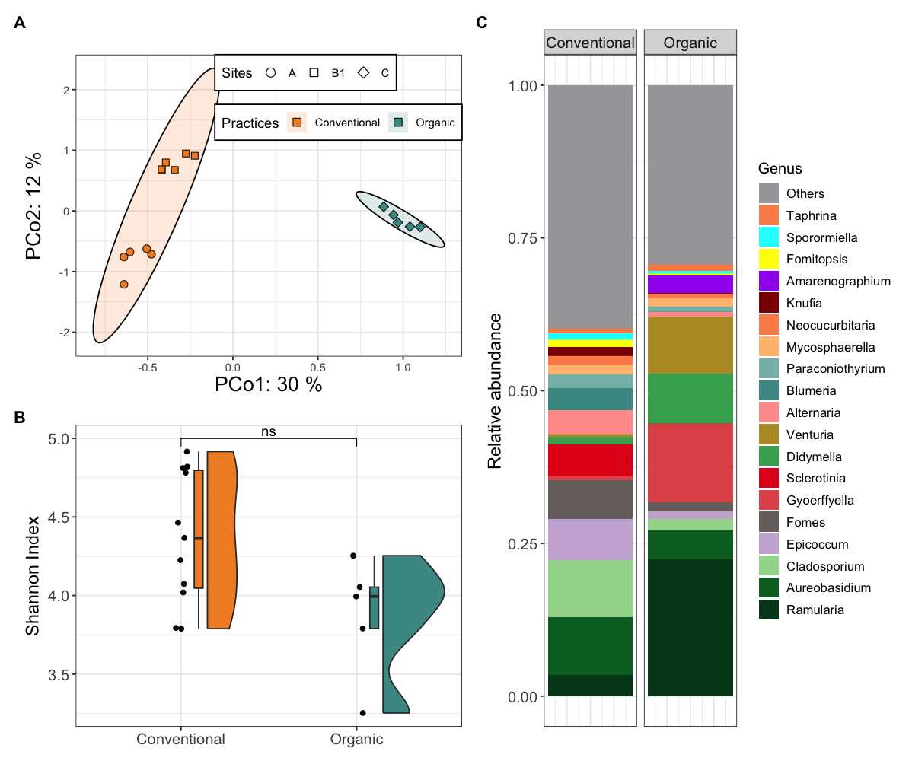
Figure S1. Flower Fungal composition and diversity from Honeycrisp and Spartan cultivars. (A) Principal Coordinates Analysis (PCoA) based on Bray-Curtis dissimilarities among flower samples. Point shapes and colors indicate site and agricultural practice. Ellipses represent 95% confidence intervals. (B) Shannon diversity index across conventional (n = 11) and organic (n = 5) sites. Asterisks denote significance levels from Wilcoxon-Mann-Whitney (ns, P > 0.05). (C) Average relative abundance of the 20 most abundant fungal genera across flower samples. Taxa not among the top 20 are grouped under “Others.” Bar charts are separated by agricultural practice.
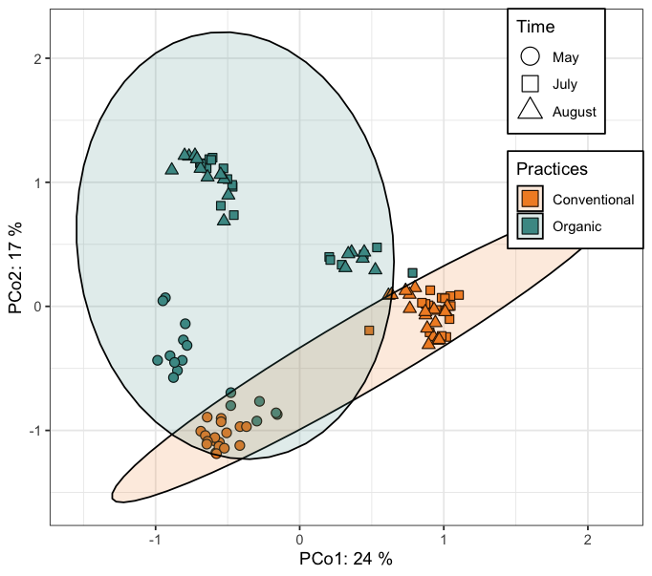
Figure S2. Principal Coordinates Analysis (PCoA) based on Bray-Curtis dissimilarities among leaf samples from Honeycrisp and Spartan cultivars. Point shapes represent sampling time, while point colors indicate agricultural practices. Ellipses denote 95% confidence intervals.
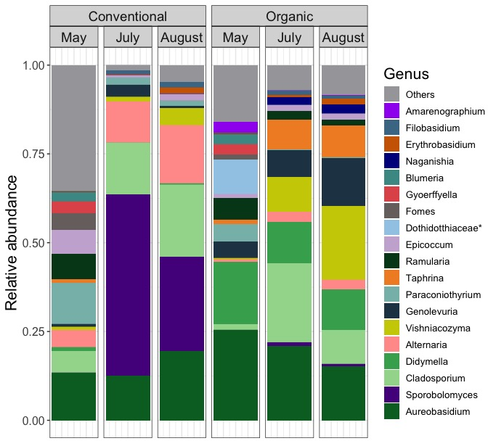
Figure S3. Fungal community composition in leaf samples from Honeycrisp and Spartan cultivars. Average relative abundance of the 20 most abundant fungal genera. Taxa not among the top 20 are grouped under “Others.” Bar charts are organized by agricultural practice and sampling month (Conventional: n = 18, 16, 18; Organic: n = 17, 18, 17). Asterisks indicate taxa identified at the family level but with unknown genus.

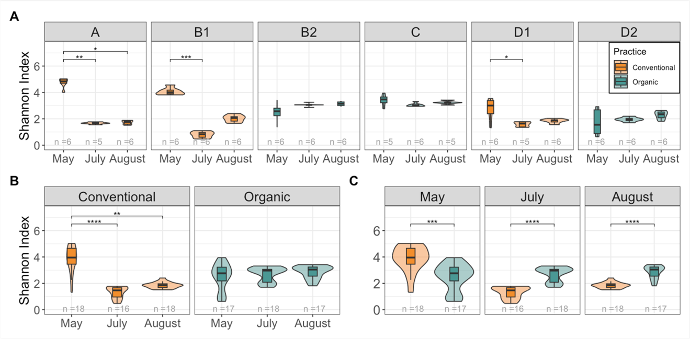
Figure S4. Shannon alpha diversity of leaf samples from Honeycrisp and Spartan cultivars. (A) Alpha diversity across sampling times for each individual site. (B) Alpha diversity across sampling times grouped by agricultural practice. (C) Comparison of alpha diversity between conventional and organic practices at each sampling time point. Asterisks indicate significance levels from post-hoc Dunn tests following a Kruskal-Wallis test (P ≤ 0.05; P ≤ 0.01; P ≤ 0.001; P ≤ 0.0001).
Figure S5. Principal Coordinates Analysis (PCoA) based on Bray–Curtis dissimilarities among phyllosphere samples collected from apple trees under conventional and organic agricultural practices. Each point represents a sample, colored by agricultural practice. Arrows along the plot margins indicate fungal classes whose relative abundances are significantly correlated (p < 0.001, Bonferroni-corrected) with the ordination axes, as determined by envfit analysis.

