The dataset has 17705 images. There are images of seven types of skin lesions. [Melanoma](https://dermoscopedia.org/Melanoma), [Melanocytic nevus](https://dermoscopedia.org/Benign_Melanocytic_lesions) , [Basal cell carcinoma](https://dermoscopedia.org/Basal_cell_carcinoma) ,[Actinic keratosis / Bowen’s disease (intraepithelial carcinoma)](https://dermoscopedia.org/Actinic_keratosis_/_Bowen%27s_disease_/_keratoacanthoma_/_squamous_cell_carcinoma), [Benign keratosis (solar lentigo / seborrheic keratosis / lichen planus-like keratosis)](https://dermoscopedia.org/Solar_lentigines_/_seborrheic_keratoses_/_lichen_planus-like_keratosis), [Dermatofibroma](https://dermoscopedia.org/Dermatofibromas), [Vascular lesion](https://dermoscopedia.org/Vascular_lesions). The pre-processing of the images involves resizing the images to (150,150) and normalizing the images. Data Augmentation is applied on the images. Data Augmentation significantly increase the diversity of data available for training models, without actually collecting new data. Data augmentation makes the model more **robust** to slight variations, and hence **prevents**the model from **overfitting**.

Transfer Learning is employed in the model. It is a popular approach in deep learning where pre-trained models are used as the starting point on computer vision tasks given the vast compute and time resources required to develop neural network models on these problems and from the huge jumps in skill that they provide on related problems. One way to increase performance is to train (or "fine-tune") the weights of the top layers of the pre-trained model alongside the training of the classifier added. The training process will force the weights to be tuned from generic feature maps to features associated specifically with the dataset. That’s why the base model which is the DenseNet 201 model is taken and a neural network with a few layers is added on top of this base model. All the layers of the base model, that is the DenseNet 201 model are trained along with the layers of the neural network added to this base model.

The optimizer that is used is Adam. Adam realizes the benefits of both AdaGrad and RMSProp. Instead of adapting the parameter learning rates based on the average first moment (the mean) as in RMSProp, Adam also makes use of the average of the second moments of the gradients (the uncentered variance). The loss function used is categorical cross entropy. The commonly used loss function for multi-class classification.

Learning rate finder is employed. It is an algorithm that can be used to automaticallyfind optimal learning rates for the deep neural network. From this we obtain the maximum and minimum learning rate for employing in the Cyclic Learning Rate implementation. Cyclic Learning Rate is employed.There are two problems with basic learning rate schedules Firstly, the optimal initial learning rate is unknown. Secondly, monotonically decreasing our learning rate may lead to our network getting “stuck” in plateaus of the loss landscape. Cyclical Learning Rates take a different approach. Using CLRs a minimum learning rate and a maximum learning rate is defined. The learning rate is allowed to cyclically oscillate between the two bounds. That is, between 1e-6 and 1e-3. These values were obtained from the Learning rate finder algorithm. In practice, using Cyclical Learning Rates leads to faster convergence and with fewer experiments/hyperparameter updates.

The dataset is an imbalanced dataset. Hence to combat the imbalanced dataset problem, we collected more images. Hence 7690 images were collected from the BCN_20000 Dataset: (c) Department of Dermatology, Hospital Clínic de Barcelona. Initially we had 10,015 images and we were able to increase our dataset to 17705 images. By using cyclic learning rate and collecting more images for our dataset the weighted precision, weighted recall, weighted F1-Score, weighted ROC-AUC score and balanced multi-class accuracy are all achieving good values. Weighted metrics are used for imbalanced datasets, and hence these metrics are used to evaluate our model. Currently, the value of the metrics on the test/validation set is as follows:

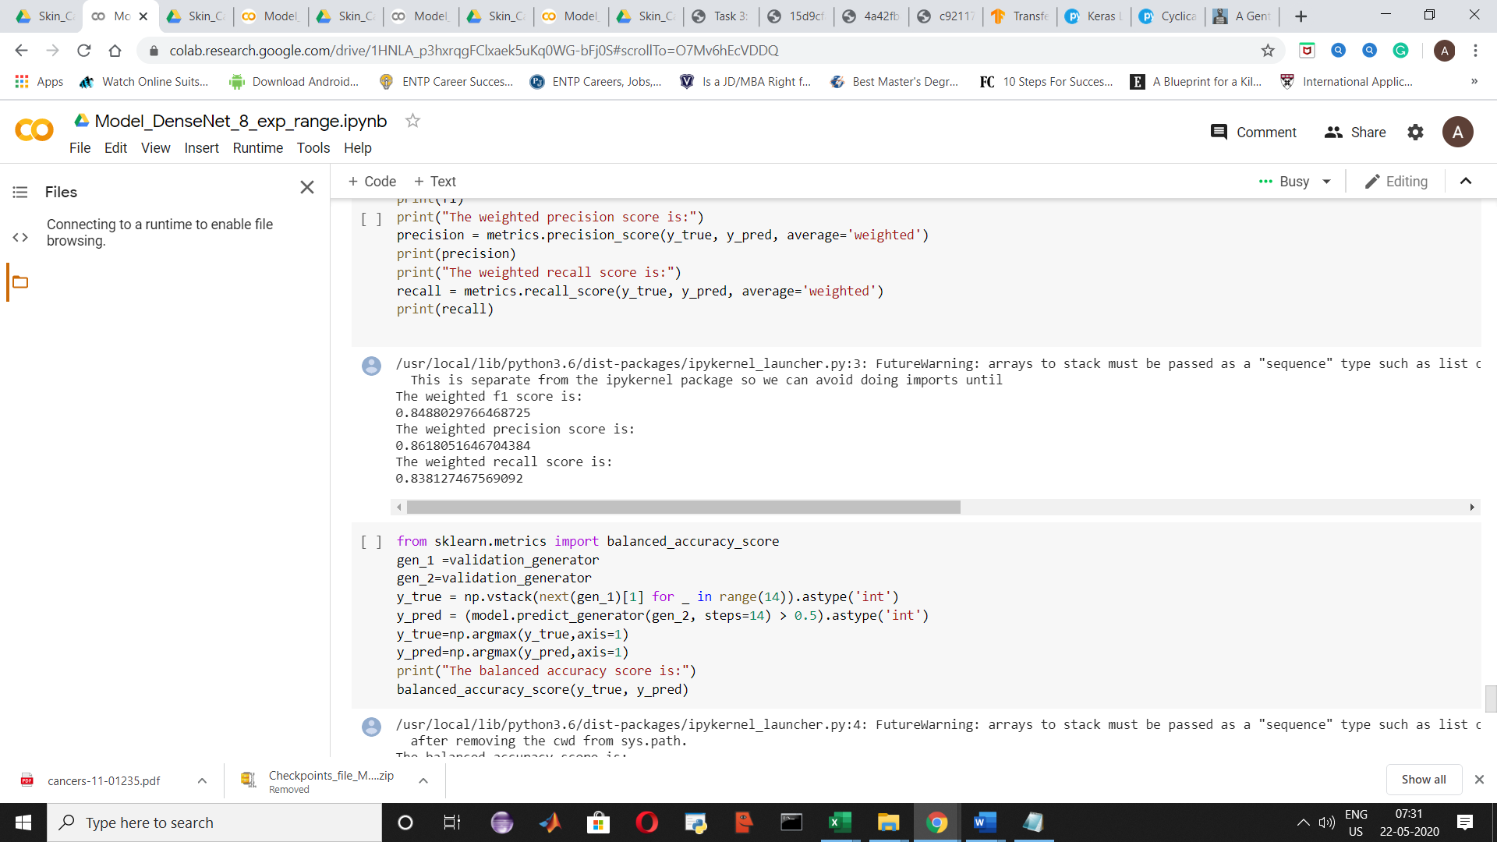

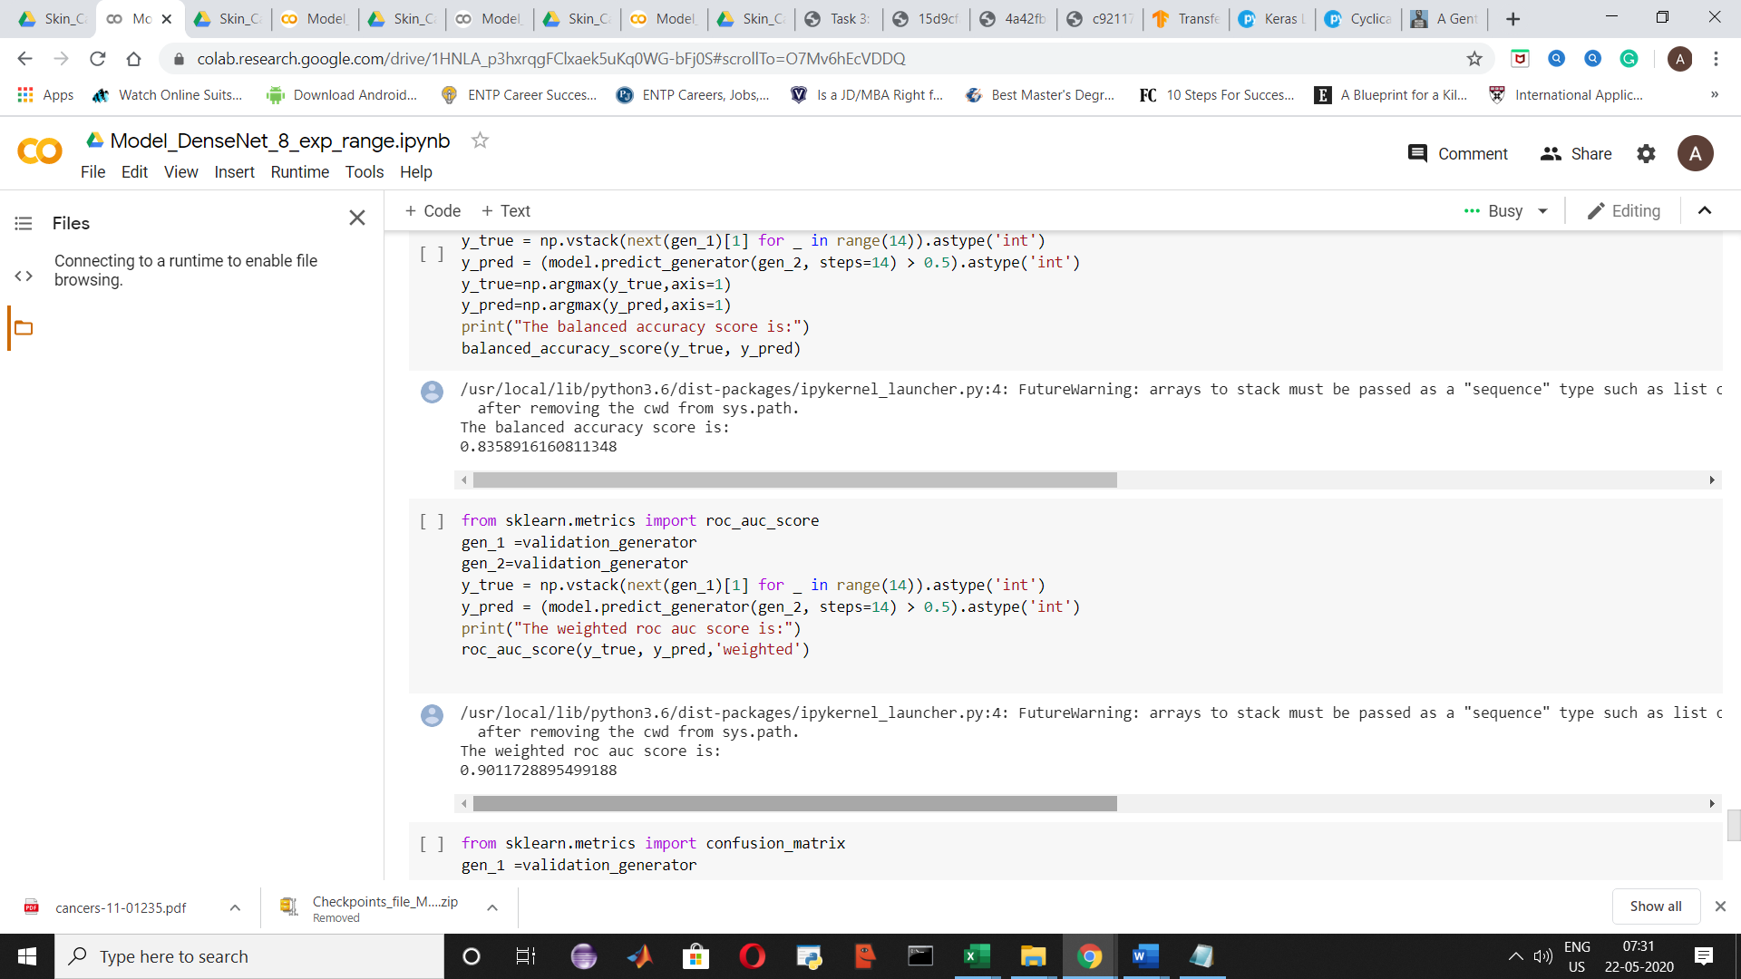

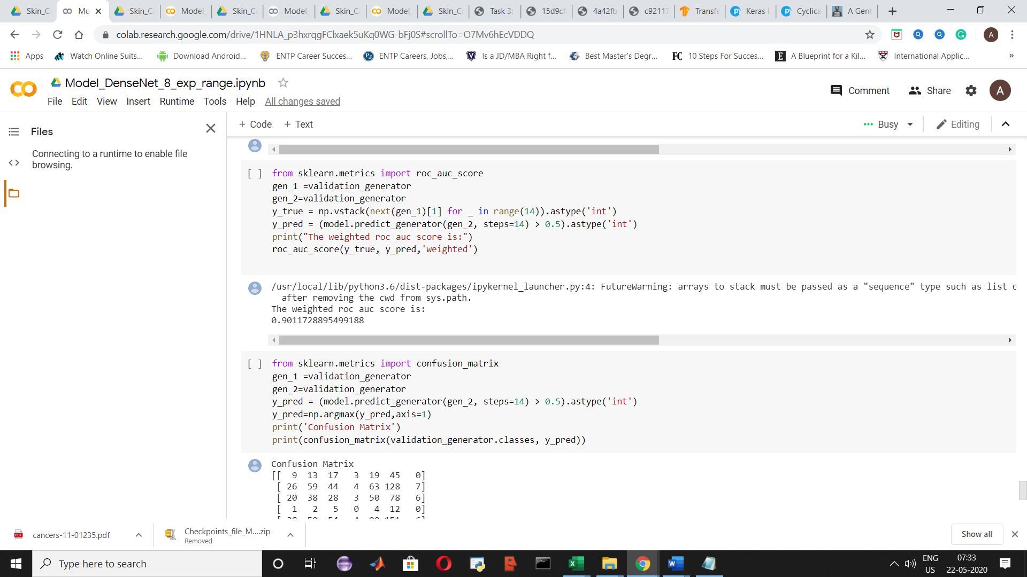

CLASSIFICATION REPORT

