Digital Image Analysis

Alexis Baudron

abe3897

**Installing all dependencies**

Ubuntu 16.04 Linux machine with python3.5 or +

$ python3 -m venv venv

$ unset PYTHONPATH

$ source venv/bin/activate

$ pip install -r requirements.txt

**Run the code**

Activate virtual environment ($ source venv/bin/activate)

$ python image_analysis.py

**Histogram Equalization**

We start by creating the histogram of the original image which is done by iterating over the pixels and adding one to that pixel value’s corresponding entry in a new array. We end up with a new array of 256 elements.

We then normalize this array and take it’s cumulative sum using numpy’s cumsum function. The resulting normalized cumulative sum histogram is used to create our transfer function which is achieved by multiplying our new histogram by 255. We then apply our transfer function to each pixel in our old image, therefore defining our new image after Histogram Equalization.

I have attached images below showing the progress :

Normalized Cumulative sum Histogram

Normalized Histogram

Original Picture

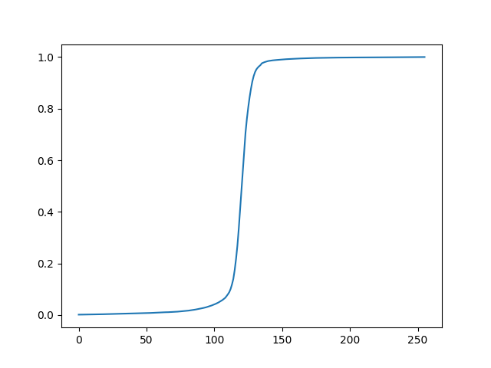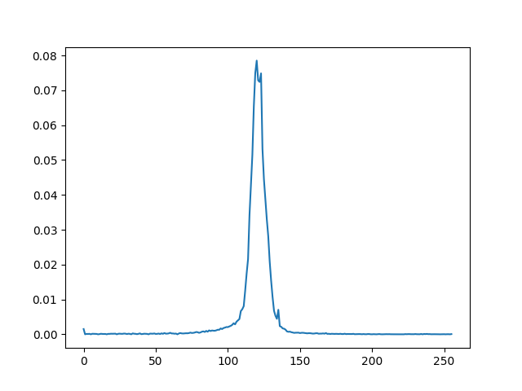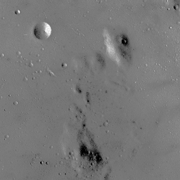

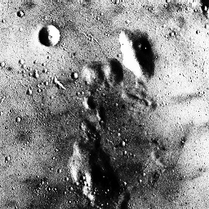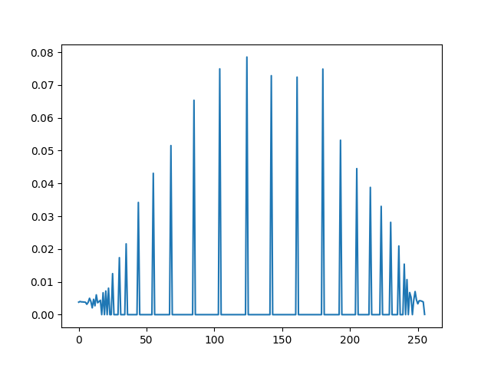

Adjusted picture

Normalized Histogram of new picture

From the results we can see that the picture has greatly improved. Histogram equalization has allowed the previously occulted and shaded parts of the picture to re-appear.