EMPLOYEE INCIDENT / VIOLATION REPORT

Date Filed | «DATE» | Department | «DEPARTMENT»
Employee Name | «EMPLOYEE_NAME» | Immediate Manager | «IMMEDIATE_MANAGER»
Position | «POSITION» | Position | «POSITION1»

INCIDENT:
Description of the Incident / Violation:

Tardiness – Accumulated more than 120 minutes late in a month.

Total Number of Minutes Late for the Month of «MONTH» : «TOTAL»
Breakdown of Tardiness:
«BREAKDOWN»

TYPE OF WARNING
◯ 1st Written Reprimand ◯ 2nd Written Reprimand ◯ Final Written Warning

REASON(S) FOR WARNING
◯ Absenteeism ◯ Tardiness/Leaving Early ◯ Timekeeping / Record Keeping Violation
◯ Theft/Dishonesty ◯ Unprofessional Behavior ◯ Insubordination ◯ Quality of Work
◯ Safety Violation ◯ Damage to property ◯ Poor Performance ◯ Policy Violation
◯ Others ______________________

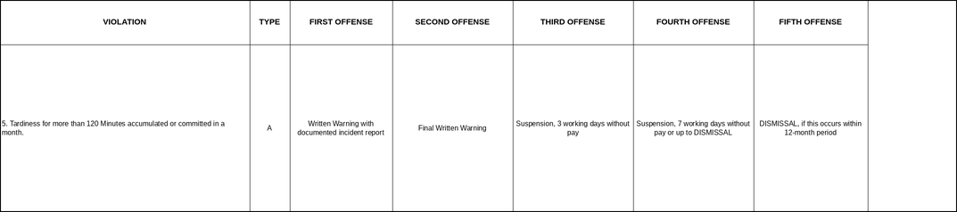

CORRECTIVE ACTION/CONSEQUENCE IF FURTHER VIOLATIONS OCCUR
This memorandum serves as a First Written Warning regarding your accumulated tardiness of more than 120 minutes in a single month, in violation of the Company’s Attendance and Timekeeping Policy (Type A – Light Offense, Section 5).

Records show that you incurred instances of tardiness during the period stated above. Reporting late for work without valid justification disrupts operations and affects overall team productivity. These incidents constitute a violation of the Company’s Attendance and Timekeeping Policy.

You are hereby reminded to strictly observe your official working hours and to report for work on time moving forward. Punctuality is expected of all employees as part of maintaining professionalism and operational efficiency.

Please be advised that any further instances may result in more severe disciplinary action, up to and including suspension or termination of employment, in accordance with company policy and applicable labor laws.

ACKNOWLEDGEMENT AND SIGNATURES
By signing this document, I acknowledge receipt of this First Written Warning and confirm that its contents have been explained to me. I further acknowledge that I have read and understood the information contained herein and that any future violation of the company’s attendance and punctuality policies may result in further disciplinary action, up to and including termination of employment.

Prepared by: | JOHANSON MEDIL | 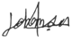 | Date:
Checked by: | XANDERS OLARTE |  | Date:
Approved by: | MARIA NIÑA MELROSE JUMAO-AS |  | Date:
Noted by | «IMMEDIATE_MANAGER» |  | Date:

«EMPLOYEE_NAME» Date:

