EMPLOYEE INCIDENT / VIOLATION REPORT

Date Filed | «DATE» | Department | «DEPARTMENT»
Employee Name | «EMPLOYEE_NAME» | Immediate Manager | «IMMEDIATE_MANAGER»
Position | «POSITION» | Position | «POSITION1»«POSITION1»

INCIDENT:
Description of the Incident / Violation:

No Biometric Attendance Record – The employee failed to register attendance using the official biometric timekeeping system for more than three (3) instances in a month (excluding system-verified glitches).

Total Number of No Bio Instances for the Month of «MONTH» : «TOTAL»
Breakdown of Dates:
«BREAKDOWN»

TYPE OF WARNING
◯ 1st Written Reprimand ◯ 2nd Written Reprimand ◯ Final Written Warning

REASON(S) FOR WARNING
◯ Absenteeism ◯ Tardiness/Leaving Early ◯ Timekeeping / Record Keeping Violation
◯ Theft/Dishonesty ◯ Unprofessional Behavior ◯ Insubordination ◯ Quality of Work
◯ Safety Violation ◯ Damage to property ◯ Poor Performance ◯ Policy Violation
◯ Others ______________________

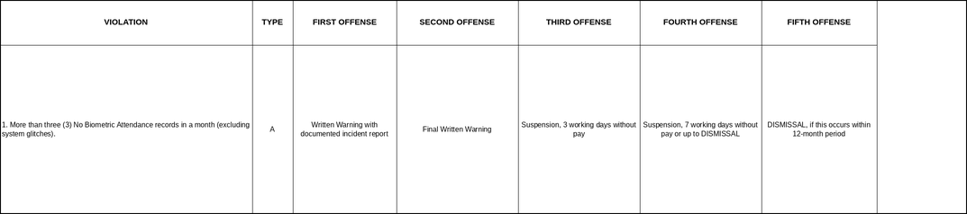

CORRECTIVE ACTION/CONSEQUENCE IF FURTHER VIOLATIONS OCCUR
This memorandum serves as a First Written Warning for failure to register biometric attendance for more than three (3) instances in a month, in violation of the Company’s Attendance and Timekeeping Policy (Type A – Light Offense, Neglect of Duties, Section 1).

Proper recording of attendance is a fundamental employee responsibility. Failure to do so undermines the integrity of the Company’s timekeeping records and payroll accuracy.

You are reminded to ensure that your attendance is properly registered in the biometric system at all times.

Further violations may result in escalating disciplinary action up to and including termination of employment.

ACKNOWLEDGEMENT AND SIGNATURES
By signing this document, I acknowledge receipt of this First Written Warning and confirm that its contents have been explained to me. I further acknowledge that I have read and understood the information contained herein and that any future violation of the company’s attendance and punctuality policies may result in further disciplinary action, up to and including termination of employment.

Prepared by: | JOHANSON MEDIL | 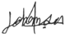 | Date:
Checked by: | XANDERS OLARTE |  | Date:
Approved by: | MARIA NIÑA MELROSE JUMAO-AS |  | Date:
Noted by | «IMMEDIATE_MANAGER» |  | Date:

«EMPLOYEE_NAME» Date:

