EMPLOYEE INCIDENT / VIOLATION REPORT

Date Filed | March 6, 2026 | Department | «DEPARTMENT»
Employee Name | «EMPLOYEE_NAME» | Immediate Manager | «IMMEDIATE_MANAGER»
Position | «POSITION» | Position | «POSITION1»

INCIDENT:
Description of the Incident / Violation:

Frequency of Tardiness – More than eight (8) instances of tardiness in a month.

Total Number of Tardiness Instances for the Month of ________________________________ : ________________
Breakdown of Dates:

TYPE OF WARNING
◯ 1st Written Reprimand ◯ 2nd Written Reprimand ◯ Final Written Warning

REASON(S) FOR WARNING
◯ Absenteeism ◯ Tardiness/Leaving Early ◯ Timekeeping / Record Keeping Violation
◯ Theft/Dishonesty ◯ Unprofessional Behavior ◯ Insubordination ◯ Quality of Work
◯ Safety Violation ◯ Damage to property ◯ Poor Performance ◯ Policy Violation
◯ Others ______________________

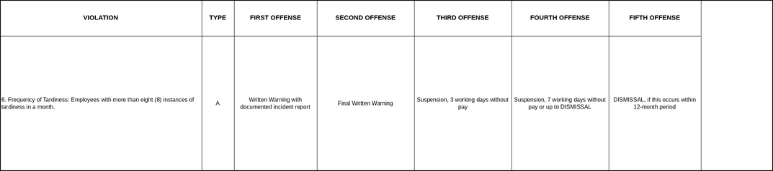

CORRECTIVE ACTION/CONSEQUENCE IF FURTHER VIOLATIONS OCCUR
This memorandum serves as a First Written Warning for incurring more than eight (8) instances of tardiness within a single month, in violation of the Company’s Attendance and Timekeeping Policy (Type A – Light Offense, Section 6).

Records show that you incurred more than 8 instances of tardiness during the period stated above. Habitual tardiness affects team coordination and overall operational efficiency.

You are reminded to report to work on time without fail. Punctuality is expected of all employees as part of maintaining professionalism and operational efficiency.

Continued violations will result in escalating disciplinary action as provided under the Company’s progressive discipline framework.

ACKNOWLEDGEMENT AND SIGNATURES
By signing this document, I acknowledge receipt of this First Written Warning and confirm that its contents have been explained to me. I further acknowledge that I have read and understood the information contained herein and that any future violation of the company’s attendance and punctuality policies may result in further disciplinary action, up to and including termination of employment.

Prepared by: | JOHANSON MEDIL | 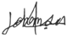 | Date:
Checked by: | XANDERS OLARTE |  | Date:
Approved by: | MARIA NIÑA MELROSE JUMAO-AS |  | Date:
Noted by | «IMMEDIATE_MANAGER» |  | Date:

«EMPLOYEE_NAME» Date:

