EMPLOYEE INCIDENT / VIOLATION REPORT

Date Filed | March 6, 2026 | Department | «DEPARTMENT»
Employee Name | «EMPLOYEE_NAME» | Immediate Manager | «IMMEDIATE_MANAGER»
Position | «POSITION» | Position | «POSITION1»

INCIDENT:
Description of the Incident / Violation:

Unauthorized Absence – The employee was absent from work without prior approval, proper notice, or a valid reason as required by Company policy.

Date(s) of Absence: ________________________________________________ Total Days: ________________
Details:

TYPE OF WARNING
◯ 1st Written Reprimand ◯ 2nd Written Reprimand ◯ Final Written Warning

REASON(S) FOR WARNING
◯ Absenteeism ◯ Tardiness/Leaving Early ◯ Timekeeping / Record Keeping Violation
◯ Theft/Dishonesty ◯ Unprofessional Behavior ◯ Insubordination ◯ Quality of Work
◯ Safety Violation ◯ Damage to property ◯ Poor Performance ◯ Policy Violation
◯ Others ______________________

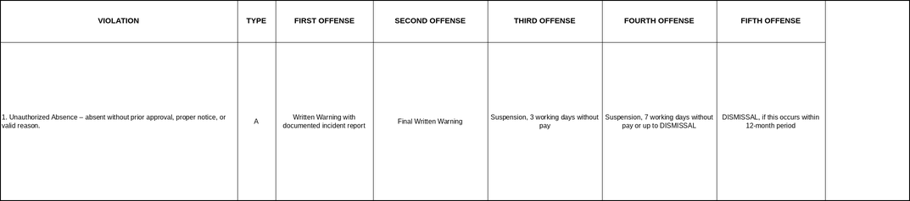

CORRECTIVE ACTION/CONSEQUENCE IF FURTHER VIOLATIONS OCCUR
This memorandum serves as a First Written Warning for incurring unauthorized absence, in violation of the Company’s Attendance and Timekeeping Policy (Type A – Light Offense, Section 1).

Failure to report to work without proper notification or approval disrupts business operations and is a serious breach of professional responsibility.

You are reminded that all absences require prior approval or immediate notification to your supervisor. Punctuality and attendance are expected of all employees.

Further violations may result in escalating disciplinary action — including suspension or dismissal — in accordance with the Company’s progressive discipline policy.

ACKNOWLEDGEMENT AND SIGNATURES
By signing this document, I acknowledge receipt of this First Written Warning and confirm that its contents have been explained to me. I further acknowledge that I have read and understood the information contained herein and that any future violation of the company’s attendance and punctuality policies may result in further disciplinary action, up to and including termination of employment.

Prepared by: | JOHANSON MEDIL | 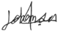 | Date:
Checked by: | XANDERS OLARTE |  | Date:
Approved by: | MARIA NIÑA MELROSE JUMAO-AS |  | Date:
Noted by | «IMMEDIATE_MANAGER» |  | Date:

«EMPLOYEE_NAME» Date:

