EMPLOYEE INCIDENT / VIOLATION REPORT

Date Filed | March 6, 2026 | Department | «DEPARTMENT»
Employee Name | «EMPLOYEE_NAME» | Immediate Manager | «IMMEDIATE_MANAGER»
Position | «POSITION» | Position | «POSITION1»

INCIDENT:
Description of the Incident / Violation:

Unauthorized Undertime – Failure to complete full required working hours (2 hours or more) at the start or end of shift without prior approval or valid justification.

Date(s) of Incident: ________________________________________________ Total Incidents: ________________
Details:

TYPE OF WARNING
◯ 1st Written Reprimand ◯ 2nd Written Reprimand ◯ Final Written Warning

REASON(S) FOR WARNING
◯ Absenteeism ◯ Tardiness/Leaving Early ◯ Timekeeping / Record Keeping Violation
◯ Theft/Dishonesty ◯ Unprofessional Behavior ◯ Insubordination ◯ Quality of Work
◯ Safety Violation ◯ Damage to property ◯ Poor Performance ◯ Policy Violation
◯ Others ______________________

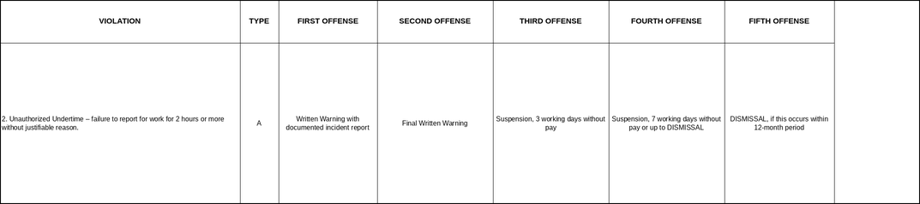

CORRECTIVE ACTION/CONSEQUENCE IF FURTHER VIOLATIONS OCCUR
This memorandum serves as a First Written Warning for unauthorized undertime, in violation of the Company’s Attendance and Timekeeping Policy (Type A – Light Offense, Section 2).

Leaving work early or arriving significantly late without proper notice affects team productivity and operational continuity.

You are reminded to complete your required working hours and to seek prior approval for any necessary schedule adjustments.

Any further incidents may result in escalating disciplinary action in accordance with the Company’s progressive discipline framework.

ACKNOWLEDGEMENT AND SIGNATURES
By signing this document, I acknowledge receipt of this First Written Warning and confirm that its contents have been explained to me. I further acknowledge that I have read and understood the information contained herein and that any future violation of the company’s attendance and punctuality policies may result in further disciplinary action, up to and including termination of employment.

Prepared by: | JOHANSON MEDIL | 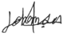 | Date:
Checked by: | XANDERS OLARTE |  | Date:
Approved by: | MARIA NIÑA MELROSE JUMAO-AS |  | Date:
Noted by | «IMMEDIATE_MANAGER» |  | Date:

«EMPLOYEE_NAME» Date:

