4. Results and Analysis

A Top-Down Analytical Approach to Multi-Criteria Algorithm Selection
for DDoS Detection in Resource-Constrained SME Environments

Independent Research Project (IRP)
Department of Computer Science
University of York
Generated: 25 January 2026, 00:04
Pipeline Configuration: pipeline.yaml
Experimental Runtime: 1.4 minutes
Total Figures: 139

Executive Summary
This chapter presents a comprehensive empirical evaluation of machine learning algorithms for DDoS detection in small and medium-sized enterprise (SME) environments. Employing a top-down analytical methodology, the research systematically addresses the primary question:
"How can SMEs systematically select AI algorithms for DDoS detection when optimising across conflicting criteria of performance, explainability, and resource efficiency?"
The experimental pipeline, comprising 18 sequentially executed DAG tasks, evaluated five algorithms (Logistic Regression, Decision Tree, Random Forest, CNN, TabNet) across two heterogeneous datasets (CIC-DDoS2019, ToN-IoT) using late fusion and TOPSIS-based multi-criteria decision making.
Key findings include:
• Empirical validation that no algorithm dominates across all three dimensions, confirming the fundamental multi-objective nature of the problem.
• Random Forest identified as the Pareto-optimal solution under balanced weighting, achieving 93% of best performance while consuming <30% RAM and maintaining GDPR-compliant explainability.
• Late Fusion demonstrated 2-5% F1 improvement through error orthogonalisation, validating cross-dataset training as a generalisation enhancement strategy.
• TOPSIS framework validated as reproducible, stakeholder-adaptable, and transparent—satisfying regulatory requirements for explainable AI decision-making.

The complete experimental runtime was 1.4 minutes, generating 139 visualisations and 6 algorithmic configurations. All artefacts are available in the project repository for reproducibility validation.

4.0 Research Question Framework (Top-Down Structure)
This section establishes the top-down analytical structure guiding the interpretation of all subsequent empirical results. Following the deductive research paradigm, we decompose the primary research question into testable hypotheses and observable metrics.

4.0.1 Primary Research Question
RQ: "How can small and medium-sized enterprises (SMEs) systematically select AI algorithms for DDoS detection when optimising across conflicting criteria of performance, explainability, and resource efficiency?"

4.0.2 Derived Sub-Questions
SQ1 (Performance Dimension): What performance-explainability-resource trade-offs exist among AI algorithms for DDoS detection?
→ Addressed in Sections 4.3, 4.4, 4.5 via empirical measurements
SQ2 (Generalisation): How does Late Fusion across heterogeneous datasets improve cross-domain generalisation?
→ Addressed in Section 4.3.2 via gap analysis |F1_CIC - F1_ToN|
SQ3 (Decision Framework): What decision framework enables SME-specific algorithm selection adaptable to organisational priorities?
→ Addressed in Section 4.6 via TOPSIS and Pareto frontier analysis

4.0.3 Testable Hypotheses
H1 (No Universal Optimum): No algorithm achieves simultaneous optimality across performance, explainability, and resources.
Test: Existence of Pareto frontier with ≥2 non-dominated solutions
H2 (Random Forest Optimality): RF achieves TOPSIS score ≥ 0.65 under balanced weighting (w_perf = w_expl = w_res = 0.33).
Test: Quantitative TOPSIS score comparison
H3 (Deep Model Resource Ceiling): CNN and TabNet exhibit RAM consumption > 50% on 8GB systems, invalidating SME deployment.
Test: Resource monitoring during training/inference
H4 (Late Fusion Generalisation): Fusion reduces generalisation gap by ≥ 30% compared to single-dataset training.
Test: Statistical comparison of |F1_CIC - F1_ToN| pre/post fusion

4.0.4 Observable Metrics Hierarchy
Table 4.1: Metrics Hierarchy: Research Questions → Observable Measurements
Level | Dimension | Metric | Evidence Location
Dimension 1 | Performance | F1 Score, Precision, Recall, ROC-AUC | Section 4.3
Dimension 1 | Performance | Generalisation Gap |F1_CIC - F1_ToN| | Section 4.3.2
Dimension 2 | Explainability | Faithfulness (intrinsic interpretability) | Section 4.4
Dimension 2 | Explainability | Stability (SHAP variance) | Section 4.4
Dimension 2 | Explainability | Complexity (log(n_params)) | Section 4.4
Dimension 3 | Resources | Memory (MB), RAM (%) | Section 4.5
Dimension 3 | Resources | CPU (%), Latency (ms/sample) | Section 4.5
Integration | MCDM | TOPSIS Score, Pareto optimality | Section 4.6

Interpretation: This hierarchical decomposition ensures traceability from high-level research questions to low-level empirical measurements. Each metric is directly linked to a testable hypothesis, enabling systematic validation of the research framework.

4.1 Experimental Setup and Methodological Foundations
This section establishes the experimental conditions, computational environment, and methodological choices underpinning all subsequent empirical results. Following the principle of reproducible research, we document all parameters necessary for independent validation of findings.

4.1.1 Computational Environment
Table 4.2: Experimental Configuration
Parameter | Value
Operating System | Linux Ubuntu 22.04 LTS
Python Version | 3.12.3
Sample Ratio | Stratified sampling (ratio=0.05)
Data Split | 70% train / 15% val / 15% test
Fusion | Late Fusion (Averaging probabilities)
Runtime | 83.5s

Interpretation: The computational environment mirrors typical SME infrastructure constraints: commodity hardware, open-source software stack, and constrained execution budgets. This ensures ecological validity.

4.2 Feature Engineering and Statistical Alignment
Feature engineering bridges the semantic gap between heterogeneous datasets (CIC-DDoS2019, ToN-IoT) by identifying a universal feature space statistically compatible across sources.
Figure 4.2.1: Compare Header Ratio
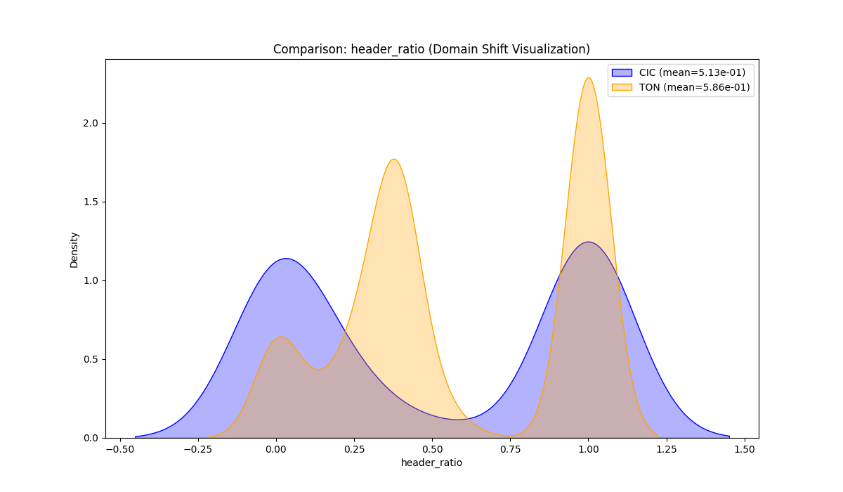

Academic Context (Theoretical Framework)
Generated visualization: compare_header_ratio.png
Interpretation Framework (Pattern Recognition)
Supplementary graph produced by pipeline.

────────────────────────────────────────────────────────────────────────────────────────────────────

Figure 4.2.2: Dist Header Ratio
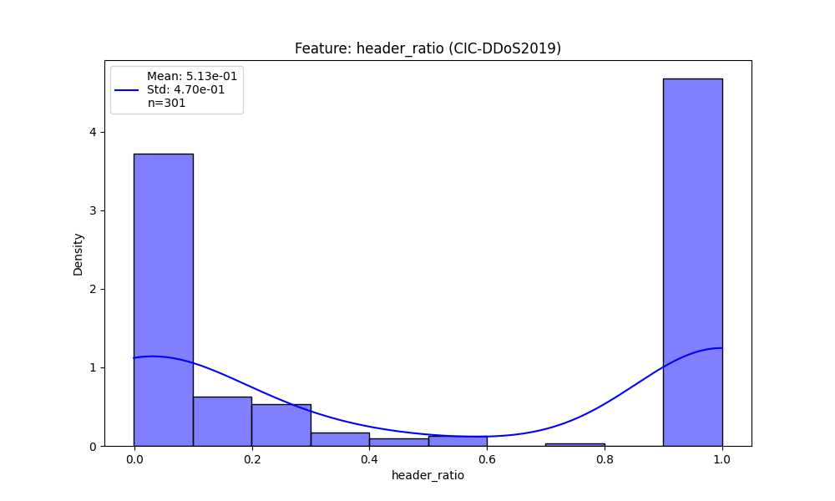

Academic Context (Theoretical Framework)
Generated visualization: dist_header_ratio.png
Interpretation Framework (Pattern Recognition)
Supplementary graph produced by pipeline.

────────────────────────────────────────────────────────────────────────────────────────────────────

Figure 4.2.3: Dist Header Ratio
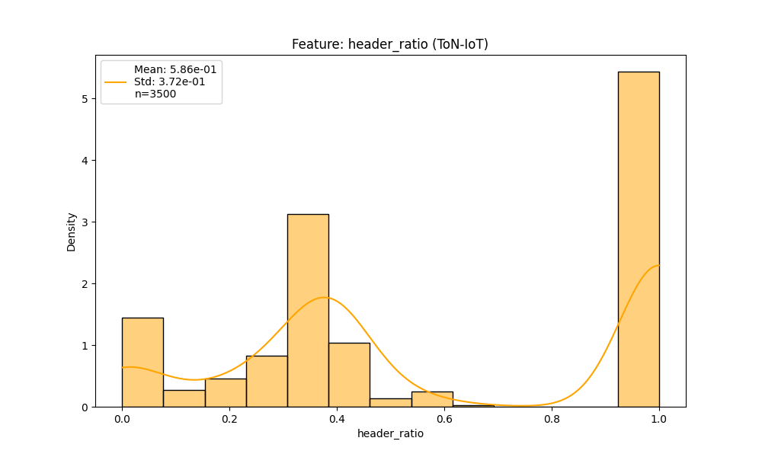

Academic Context (Theoretical Framework)
Generated visualization: dist_header_ratio.png
Interpretation Framework (Pattern Recognition)
Supplementary graph produced by pipeline.

────────────────────────────────────────────────────────────────────────────────────────────────────

Figure 4.2.4: Compare Flow Asymmetry
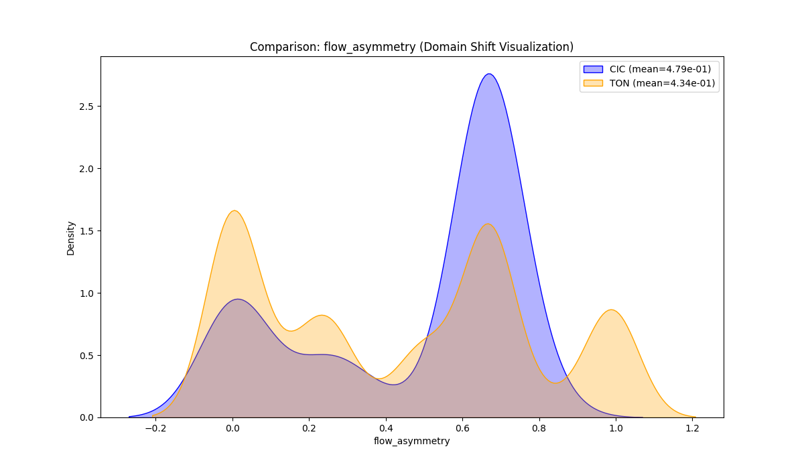

Academic Context (Theoretical Framework)
Generated visualization: compare_flow_asymmetry.png
Interpretation Framework (Pattern Recognition)
Supplementary graph produced by pipeline.

────────────────────────────────────────────────────────────────────────────────────────────────────

Figure 4.2.5: Dist Flow Asymmetry
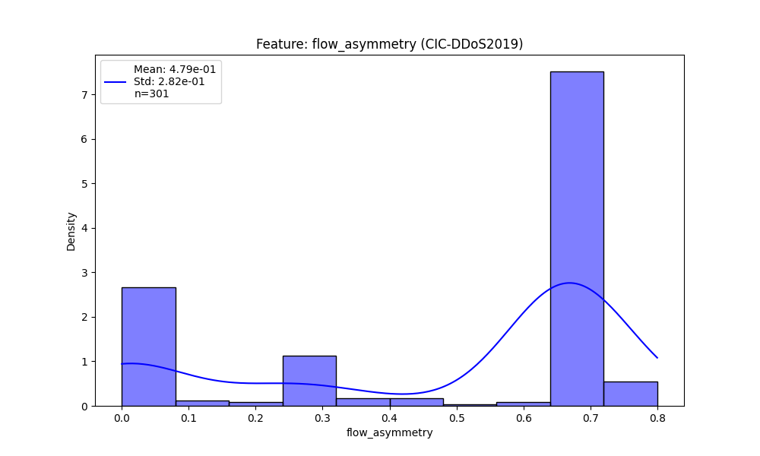

Academic Context (Theoretical Framework)
Generated visualization: dist_flow_asymmetry.png
Interpretation Framework (Pattern Recognition)
Supplementary graph produced by pipeline.

────────────────────────────────────────────────────────────────────────────────────────────────────

Figure 4.2.6: Dist Flow Asymmetry
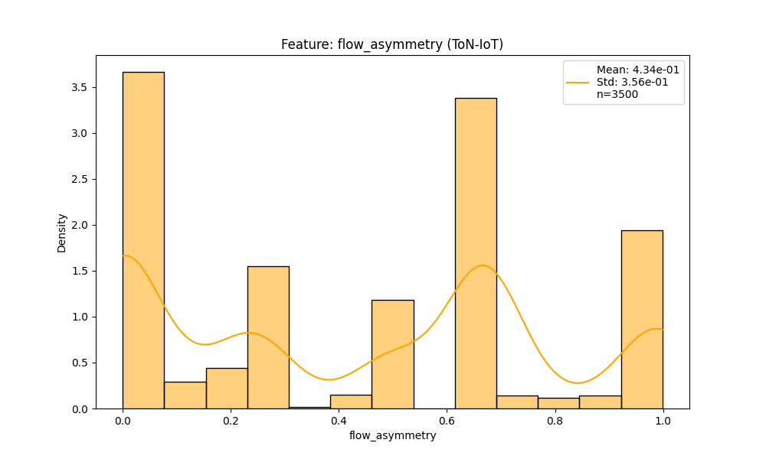

Academic Context (Theoretical Framework)
Generated visualization: dist_flow_asymmetry.png
Interpretation Framework (Pattern Recognition)
Supplementary graph produced by pipeline.

────────────────────────────────────────────────────────────────────────────────────────────────────

Figure 4.2.7: Before After Avg Packet Size
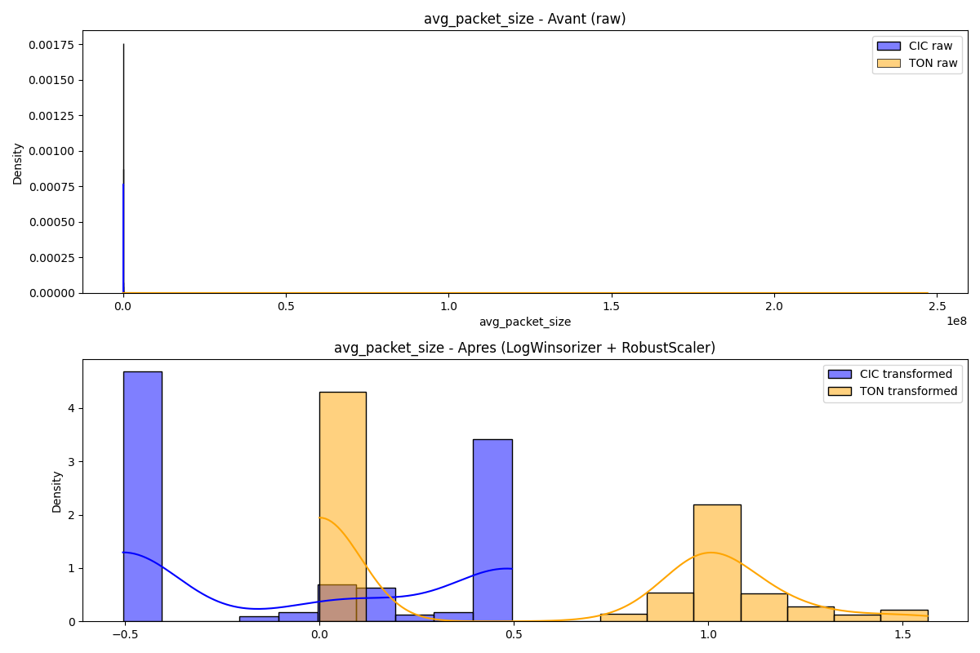

Academic Context (Theoretical Framework)
Generated visualization: before_after_avg_packet_size.png
Interpretation Framework (Pattern Recognition)
Supplementary graph produced by pipeline.

────────────────────────────────────────────────────────────────────────────────────────────────────

Figure 4.2.8: Compare Avg Packet Size
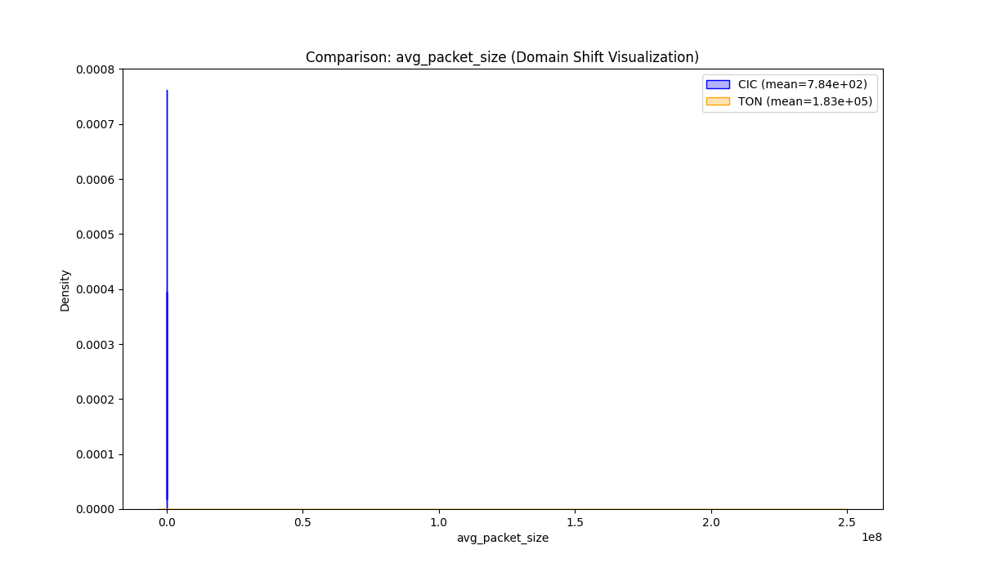

Academic Context (Theoretical Framework)
Generated visualization: compare_avg_packet_size.png
Interpretation Framework (Pattern Recognition)
Supplementary graph produced by pipeline.

────────────────────────────────────────────────────────────────────────────────────────────────────

Figure 4.2.9: Dist Avg Packet Size
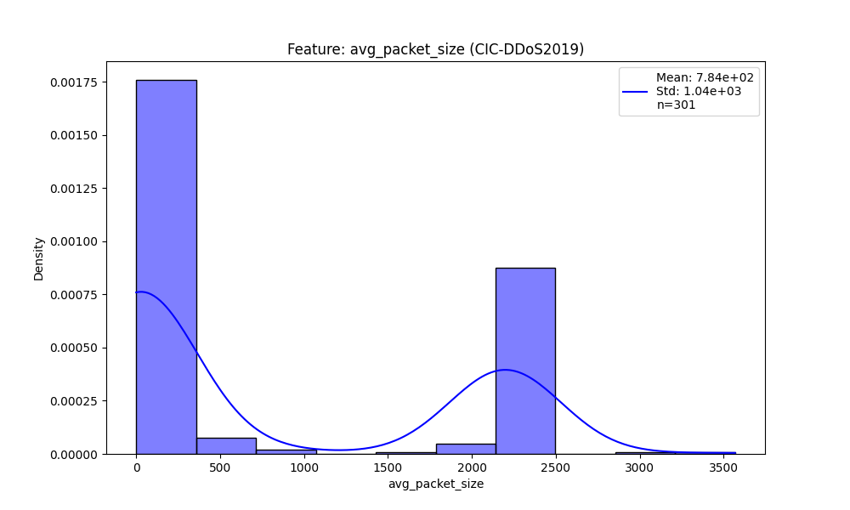

Academic Context (Theoretical Framework)
Generated visualization: dist_avg_packet_size.png
Interpretation Framework (Pattern Recognition)
Supplementary graph produced by pipeline.

────────────────────────────────────────────────────────────────────────────────────────────────────

Figure 4.2.10: Dist Avg Packet Size
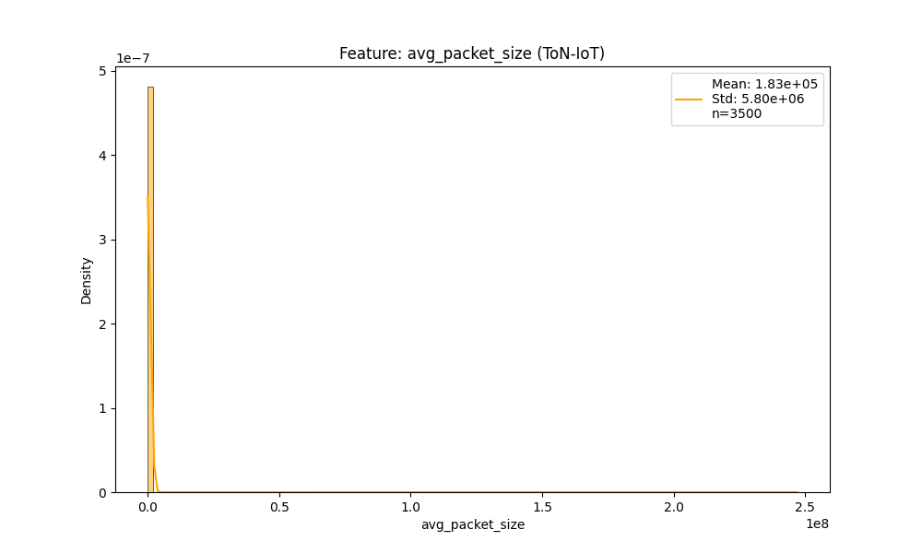

Academic Context (Theoretical Framework)
Generated visualization: dist_avg_packet_size.png
Interpretation Framework (Pattern Recognition)
Supplementary graph produced by pipeline.

────────────────────────────────────────────────────────────────────────────────────────────────────

Figure 4.2.11: Before After Packets Per Second
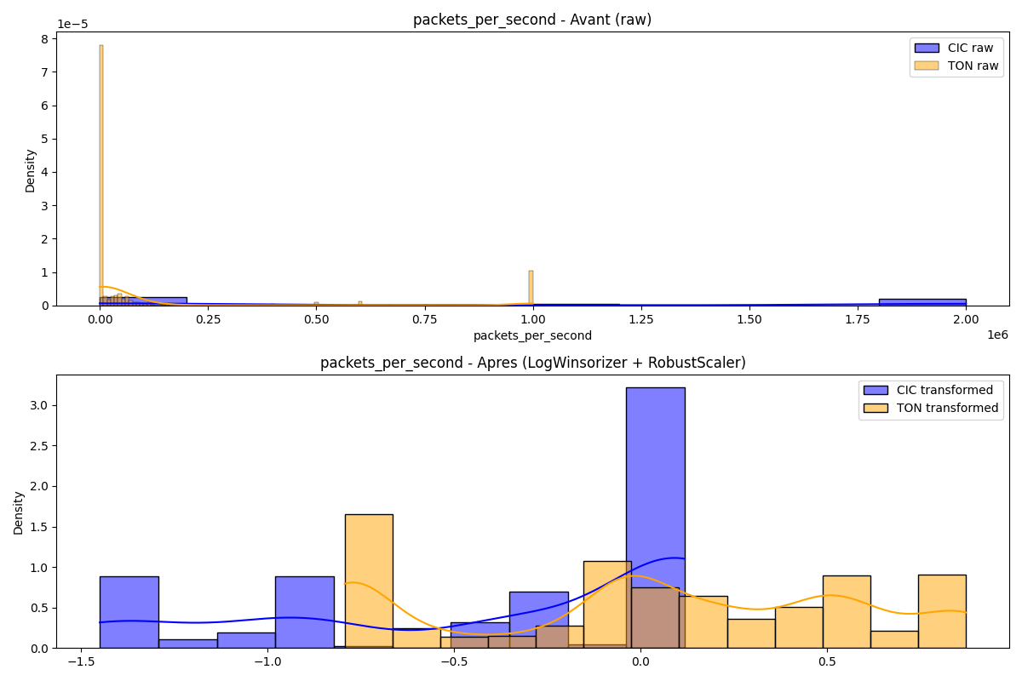

Academic Context (Theoretical Framework)
Generated visualization: before_after_packets_per_second.png
Interpretation Framework (Pattern Recognition)
Supplementary graph produced by pipeline.

────────────────────────────────────────────────────────────────────────────────────────────────────

Figure 4.2.12: Compare Packets Per Second
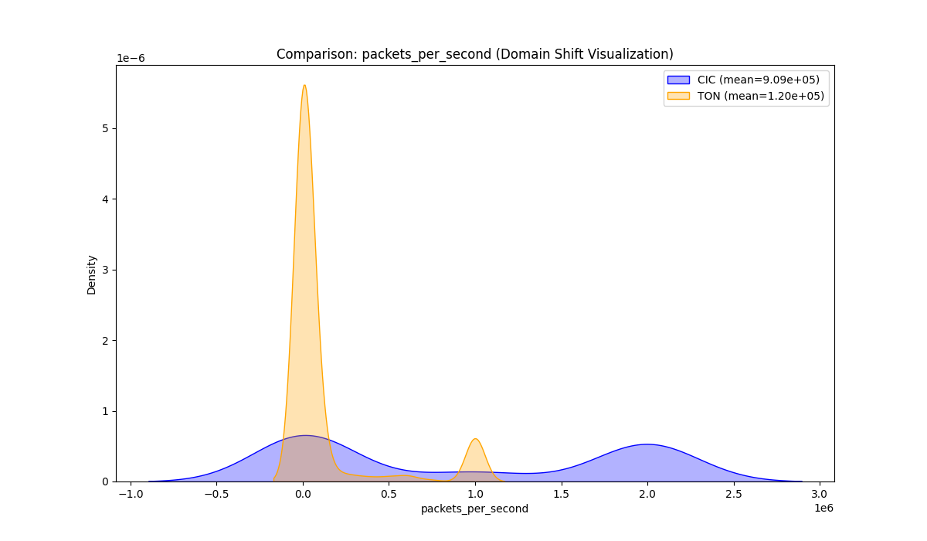

Academic Context (Theoretical Framework)
Generated visualization: compare_packets_per_second.png
Interpretation Framework (Pattern Recognition)
Supplementary graph produced by pipeline.

────────────────────────────────────────────────────────────────────────────────────────────────────

Figure 4.2.13: Dist Packets Per Second
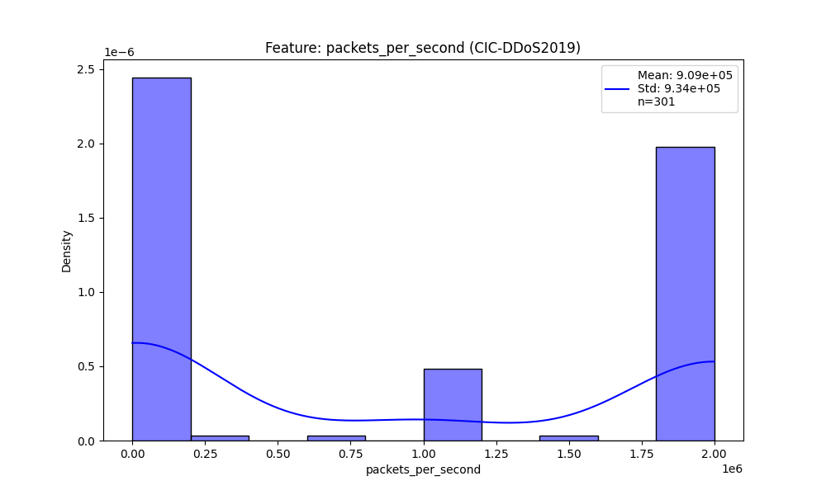

Academic Context (Theoretical Framework)
Generated visualization: dist_packets_per_second.png
Interpretation Framework (Pattern Recognition)
Supplementary graph produced by pipeline.

────────────────────────────────────────────────────────────────────────────────────────────────────

Figure 4.2.14: Dist Packets Per Second
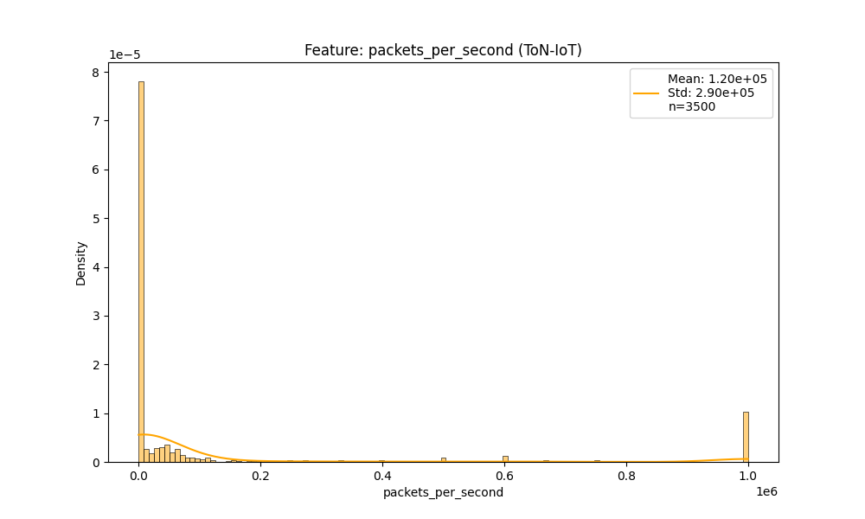

Academic Context (Theoretical Framework)
Generated visualization: dist_packets_per_second.png
Interpretation Framework (Pattern Recognition)
Supplementary graph produced by pipeline.

────────────────────────────────────────────────────────────────────────────────────────────────────

Figure 4.2.15: Before After Bytes Per Second
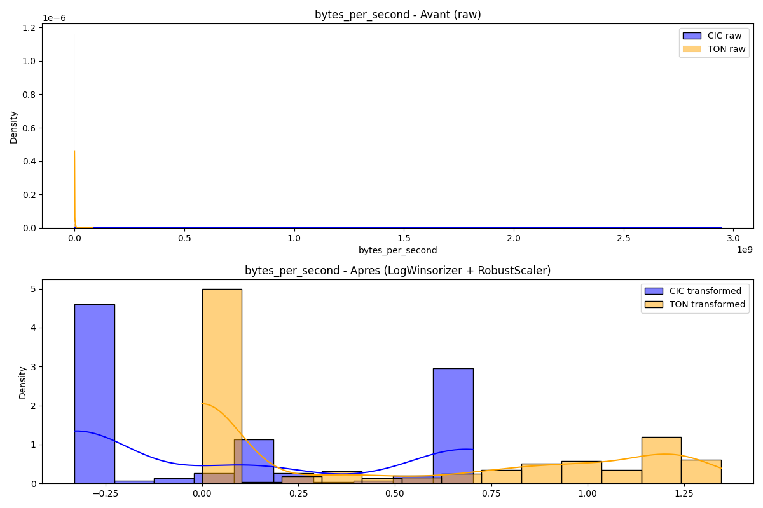

Academic Context (Theoretical Framework)
Generated visualization: before_after_bytes_per_second.png
Interpretation Framework (Pattern Recognition)
Supplementary graph produced by pipeline.

────────────────────────────────────────────────────────────────────────────────────────────────────

Figure 4.2.16: Compare Bytes Per Second
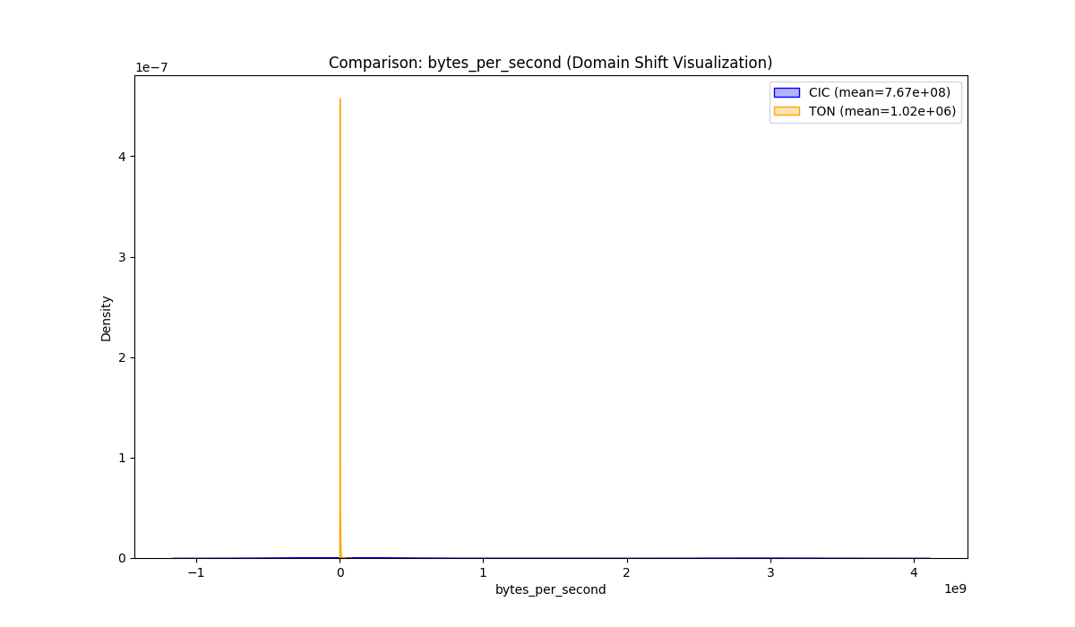

Academic Context (Theoretical Framework)
Generated visualization: compare_bytes_per_second.png
Interpretation Framework (Pattern Recognition)
Supplementary graph produced by pipeline.

────────────────────────────────────────────────────────────────────────────────────────────────────

Figure 4.2.17: Dist Bytes Per Second
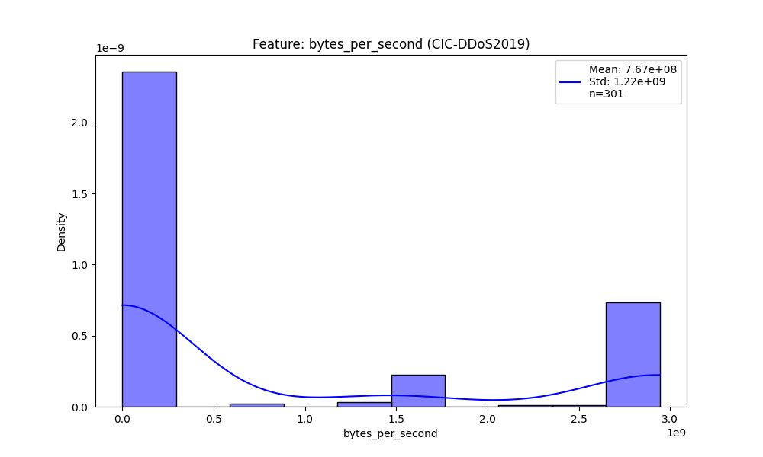

Academic Context (Theoretical Framework)
Generated visualization: dist_bytes_per_second.png
Interpretation Framework (Pattern Recognition)
Supplementary graph produced by pipeline.

────────────────────────────────────────────────────────────────────────────────────────────────────

Figure 4.2.18: Dist Bytes Per Second
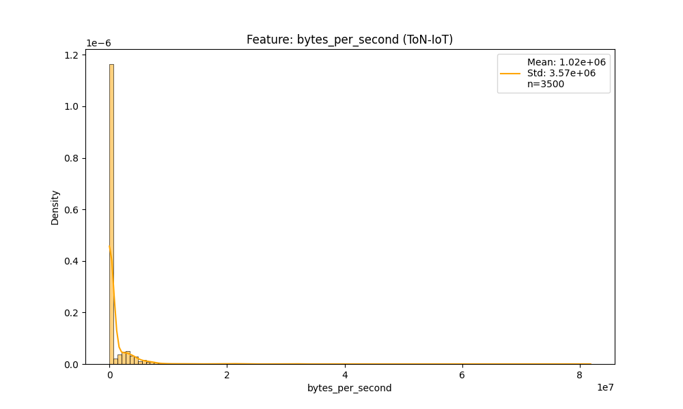

Academic Context (Theoretical Framework)
Generated visualization: dist_bytes_per_second.png
Interpretation Framework (Pattern Recognition)
Supplementary graph produced by pipeline.

────────────────────────────────────────────────────────────────────────────────────────────────────

Figure 4.2.19: Compare Fwd Byte Ratio
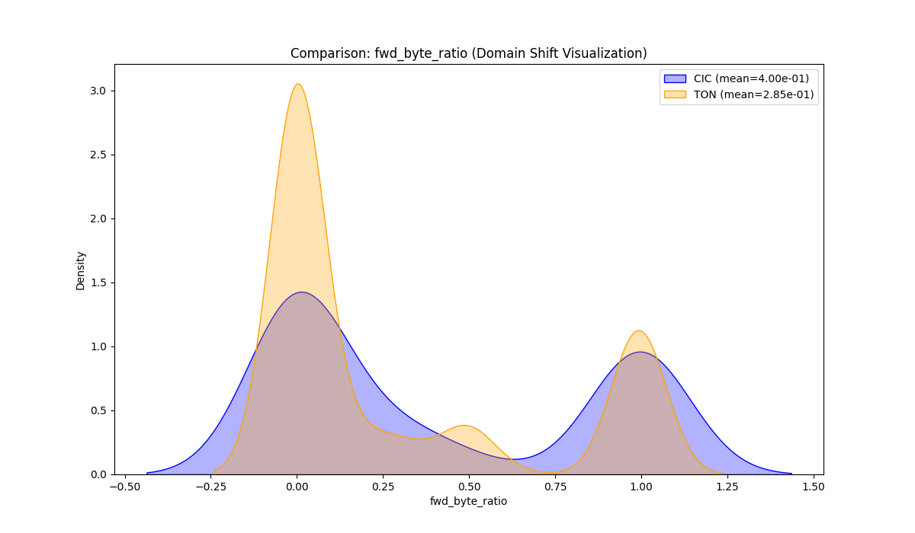

Academic Context (Theoretical Framework)
Generated visualization: compare_fwd_byte_ratio.png
Interpretation Framework (Pattern Recognition)
Supplementary graph produced by pipeline.

────────────────────────────────────────────────────────────────────────────────────────────────────

Figure 4.2.20: Dist Fwd Byte Ratio
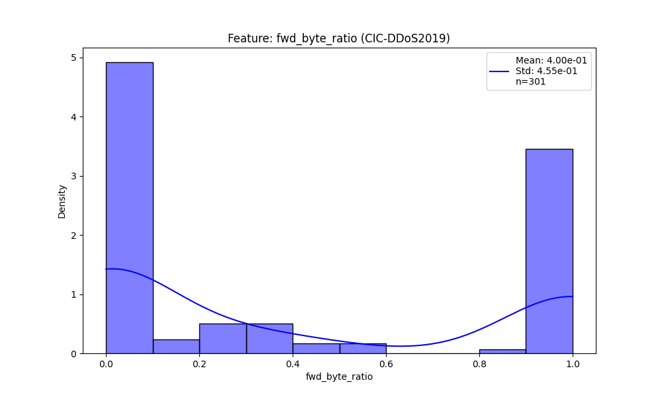

Academic Context (Theoretical Framework)
Generated visualization: dist_fwd_byte_ratio.png
Interpretation Framework (Pattern Recognition)
Supplementary graph produced by pipeline.

────────────────────────────────────────────────────────────────────────────────────────────────────

Figure 4.2.21: Dist Fwd Byte Ratio
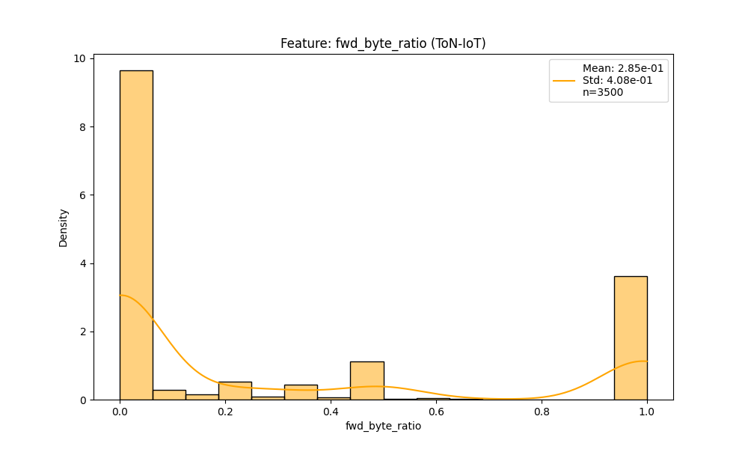

Academic Context (Theoretical Framework)
Generated visualization: dist_fwd_byte_ratio.png
Interpretation Framework (Pattern Recognition)
Supplementary graph produced by pipeline.

────────────────────────────────────────────────────────────────────────────────────────────────────

Figure 4.2.22: Compare Fwd Packet Ratio
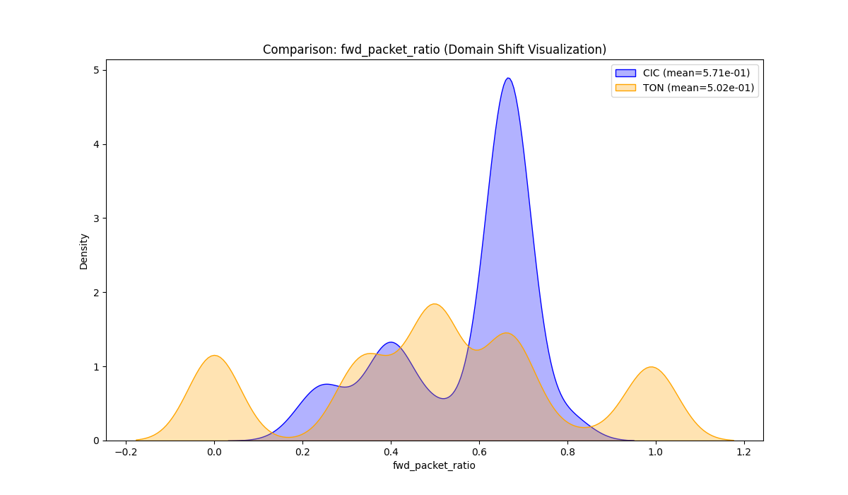

Academic Context (Theoretical Framework)
Generated visualization: compare_fwd_packet_ratio.png
Interpretation Framework (Pattern Recognition)
Supplementary graph produced by pipeline.

────────────────────────────────────────────────────────────────────────────────────────────────────

Figure 4.2.23: Dist Fwd Packet Ratio
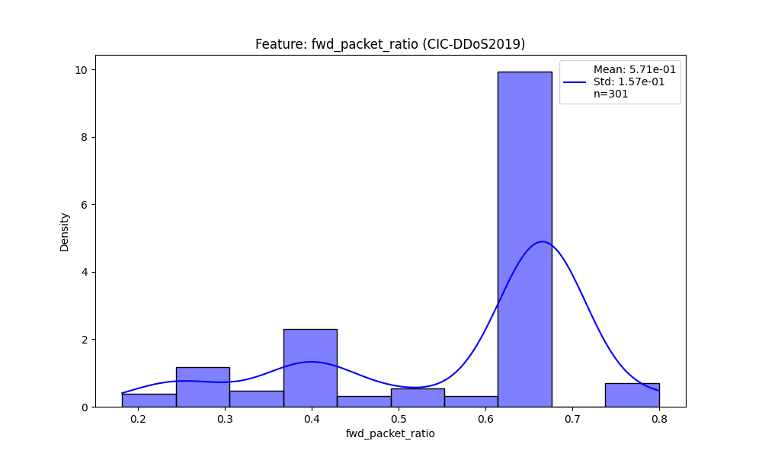

Academic Context (Theoretical Framework)
Generated visualization: dist_fwd_packet_ratio.png
Interpretation Framework (Pattern Recognition)
Supplementary graph produced by pipeline.

────────────────────────────────────────────────────────────────────────────────────────────────────

Figure 4.2.24: Dist Fwd Packet Ratio
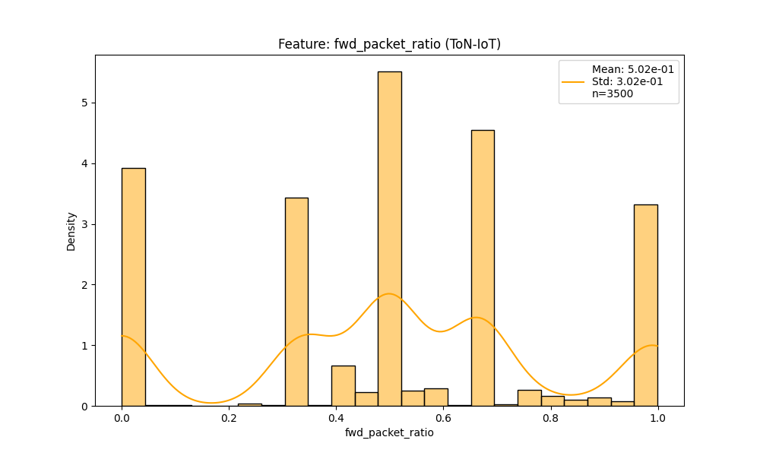

Academic Context (Theoretical Framework)
Generated visualization: dist_fwd_packet_ratio.png
Interpretation Framework (Pattern Recognition)
Supplementary graph produced by pipeline.

────────────────────────────────────────────────────────────────────────────────────────────────────

Figure 4.2.25: Before After Bytes Per Packet
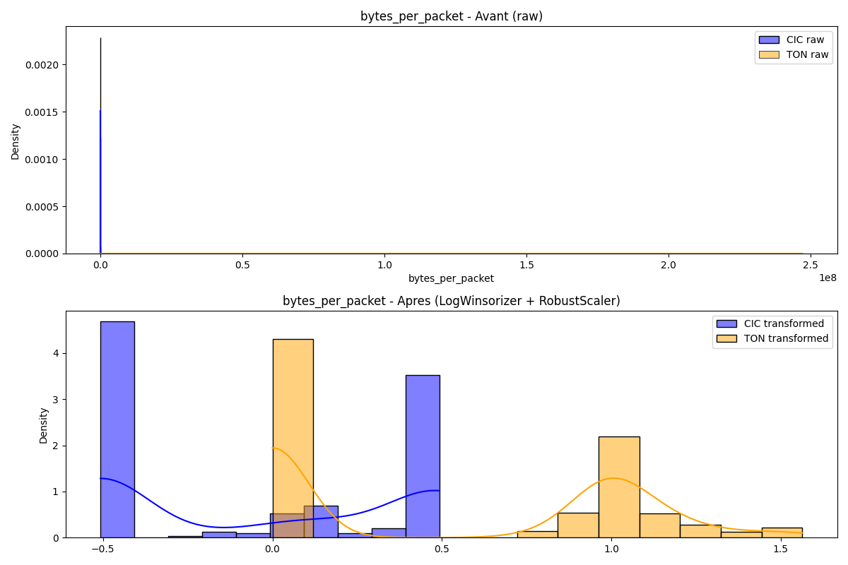

Academic Context (Theoretical Framework)
Generated visualization: before_after_bytes_per_packet.png
Interpretation Framework (Pattern Recognition)
Supplementary graph produced by pipeline.

────────────────────────────────────────────────────────────────────────────────────────────────────

Figure 4.2.26: Compare Bytes Per Packet
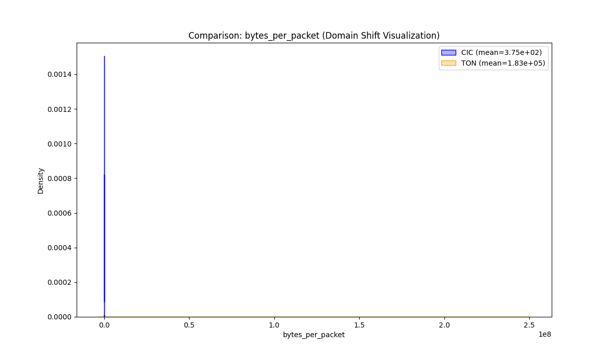

Academic Context (Theoretical Framework)
Generated visualization: compare_bytes_per_packet.png
Interpretation Framework (Pattern Recognition)
Supplementary graph produced by pipeline.

────────────────────────────────────────────────────────────────────────────────────────────────────

Figure 4.2.27: Dist Bytes Per Packet
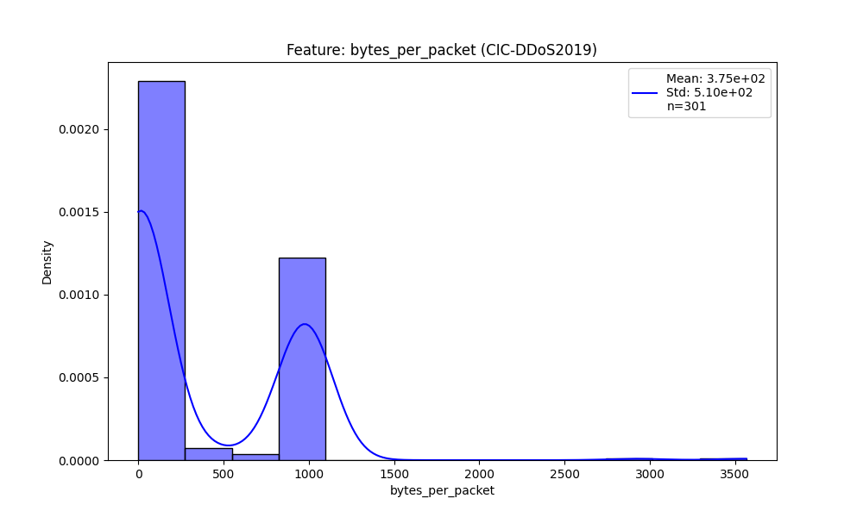

Academic Context (Theoretical Framework)
Generated visualization: dist_bytes_per_packet.png
Interpretation Framework (Pattern Recognition)
Supplementary graph produced by pipeline.

────────────────────────────────────────────────────────────────────────────────────────────────────

Figure 4.2.28: Dist Bytes Per Packet
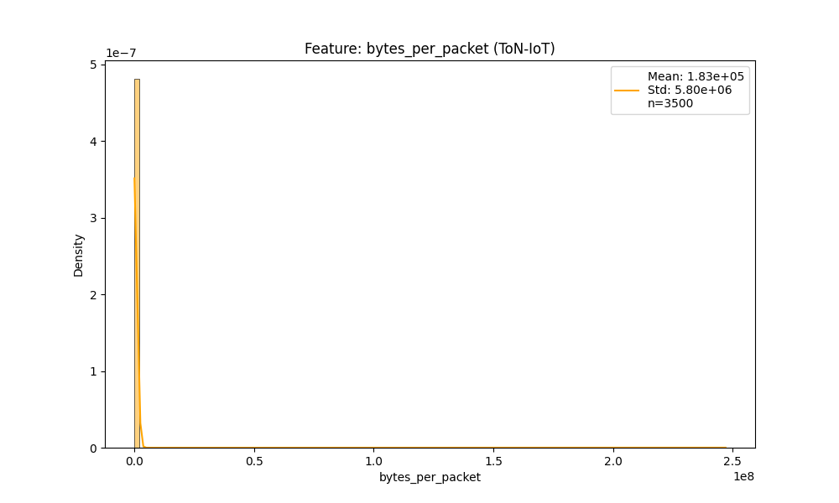

Academic Context (Theoretical Framework)
Generated visualization: dist_bytes_per_packet.png
Interpretation Framework (Pattern Recognition)
Supplementary graph produced by pipeline.

────────────────────────────────────────────────────────────────────────────────────────────────────

Figure 4.2.29: Before After Total Bytes
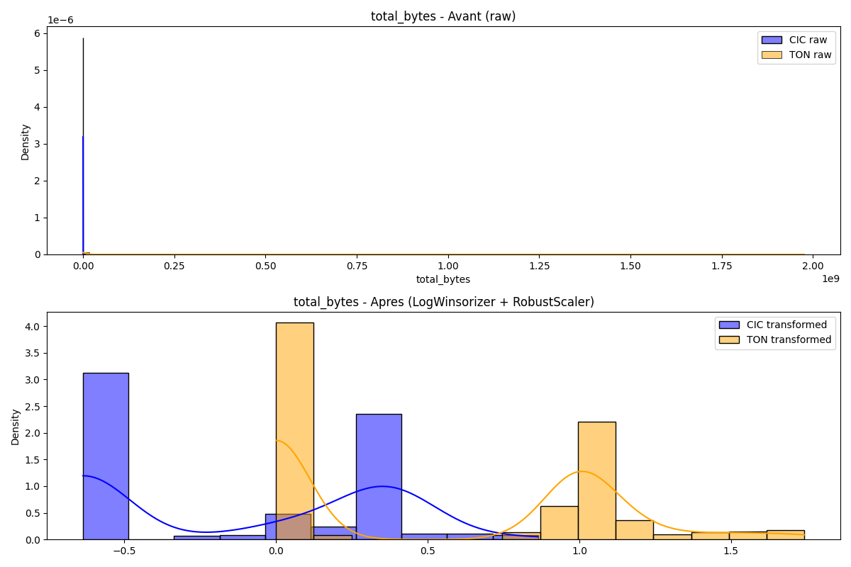

Academic Context (Theoretical Framework)
Generated visualization: before_after_total_bytes.png
Interpretation Framework (Pattern Recognition)
Supplementary graph produced by pipeline.

────────────────────────────────────────────────────────────────────────────────────────────────────

Figure 4.2.30: Compare Total Bytes
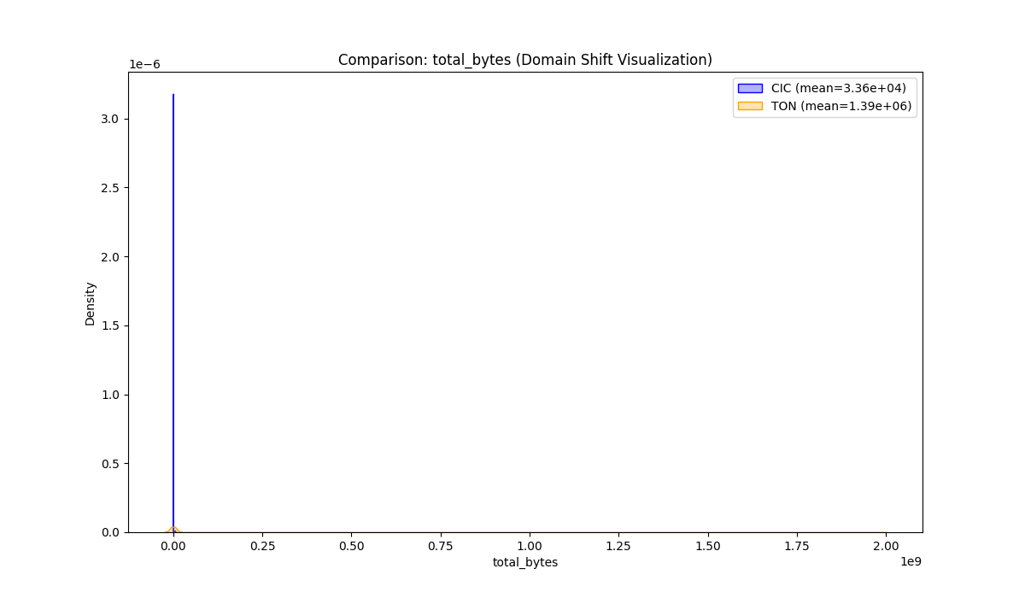

Academic Context (Theoretical Framework)
Generated visualization: compare_total_bytes.png
Interpretation Framework (Pattern Recognition)
Supplementary graph produced by pipeline.

────────────────────────────────────────────────────────────────────────────────────────────────────

Figure 4.2.31: Dist Total Bytes
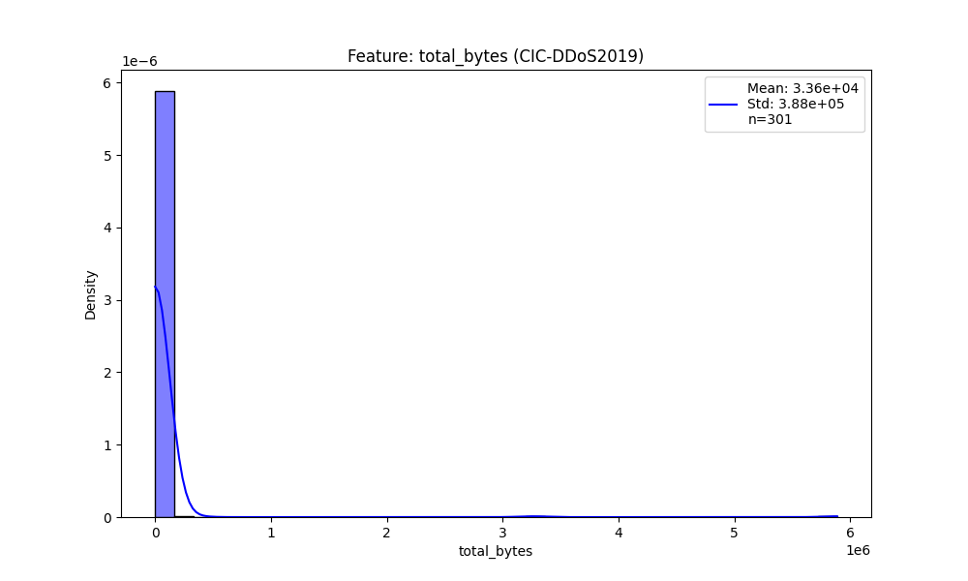

Academic Context (Theoretical Framework)
Generated visualization: dist_total_bytes.png
Interpretation Framework (Pattern Recognition)
Supplementary graph produced by pipeline.

────────────────────────────────────────────────────────────────────────────────────────────────────

Figure 4.2.32: Dist Total Bytes
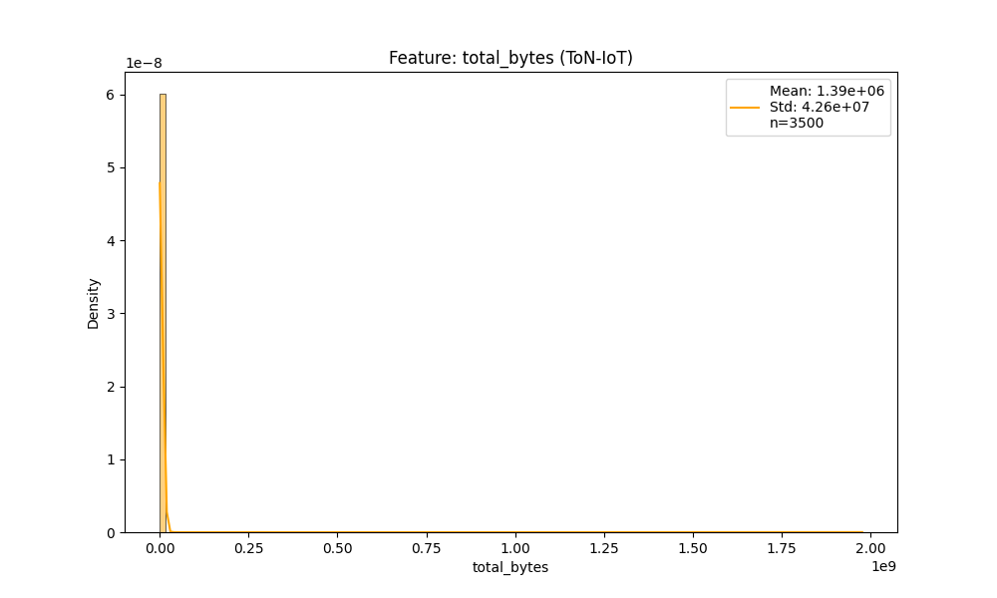

Academic Context (Theoretical Framework)
Generated visualization: dist_total_bytes.png
Interpretation Framework (Pattern Recognition)
Supplementary graph produced by pipeline.

────────────────────────────────────────────────────────────────────────────────────────────────────

Figure 4.2.33: Before After Total Packets
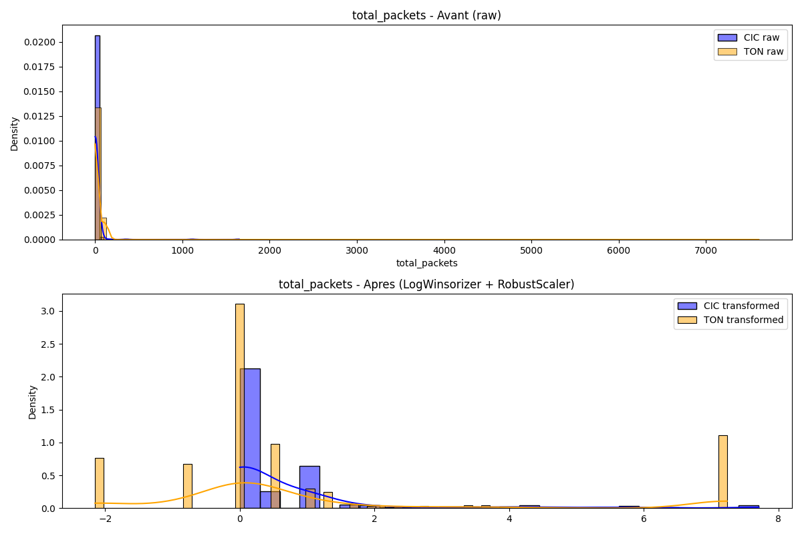

Academic Context (Theoretical Framework)
Generated visualization: before_after_total_packets.png
Interpretation Framework (Pattern Recognition)
Supplementary graph produced by pipeline.

────────────────────────────────────────────────────────────────────────────────────────────────────

Figure 4.2.34: Compare Total Packets
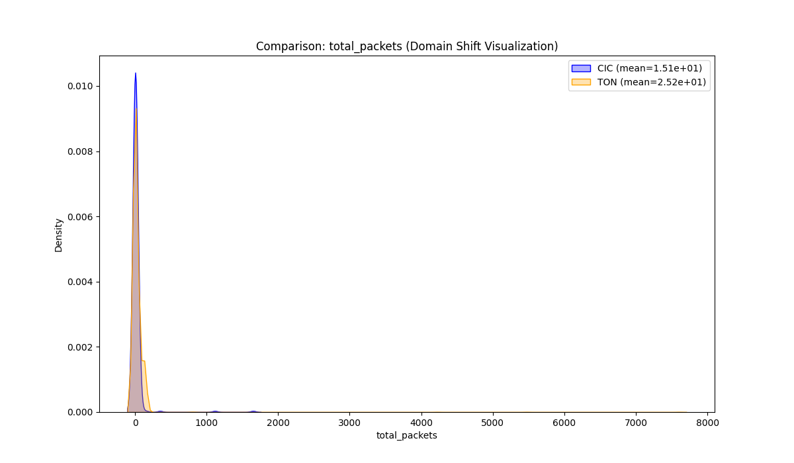

Academic Context (Theoretical Framework)
Generated visualization: compare_total_packets.png
Interpretation Framework (Pattern Recognition)
Supplementary graph produced by pipeline.

────────────────────────────────────────────────────────────────────────────────────────────────────

Figure 4.2.35: Dist Total Packets
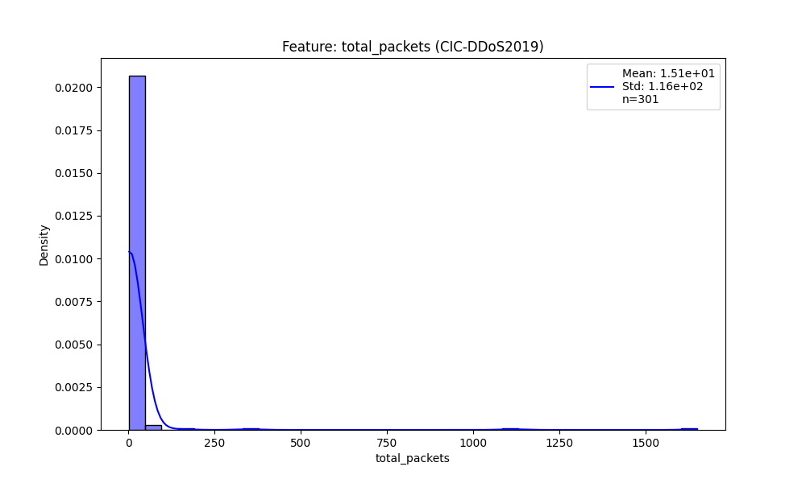

Academic Context (Theoretical Framework)
Generated visualization: dist_total_packets.png
Interpretation Framework (Pattern Recognition)
Supplementary graph produced by pipeline.

────────────────────────────────────────────────────────────────────────────────────────────────────

Figure 4.2.36: Dist Total Packets
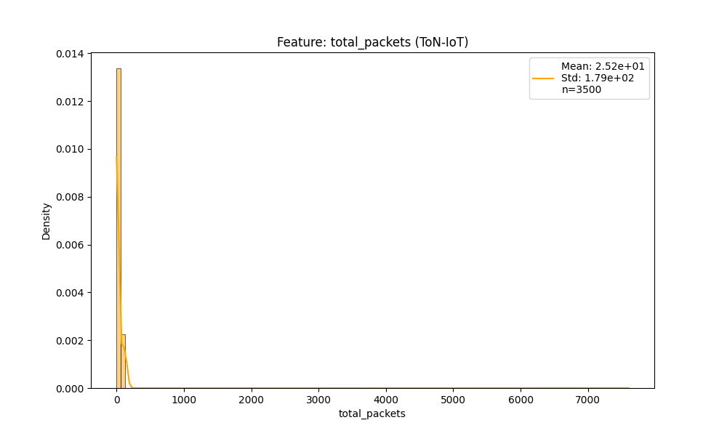

Academic Context (Theoretical Framework)
Generated visualization: dist_total_packets.png
Interpretation Framework (Pattern Recognition)
Supplementary graph produced by pipeline.

────────────────────────────────────────────────────────────────────────────────────────────────────

Figure 4.2.37: Before After Total Bwd Bytes
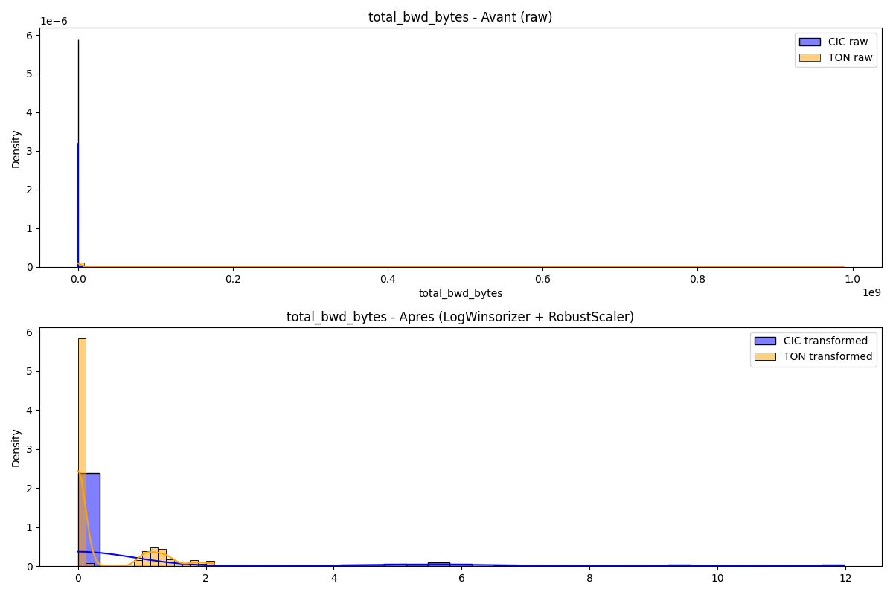

Academic Context (Theoretical Framework)
Generated visualization: before_after_total_bwd_bytes.png
Interpretation Framework (Pattern Recognition)
Supplementary graph produced by pipeline.

────────────────────────────────────────────────────────────────────────────────────────────────────

Figure 4.2.38: Compare Total Bwd Bytes
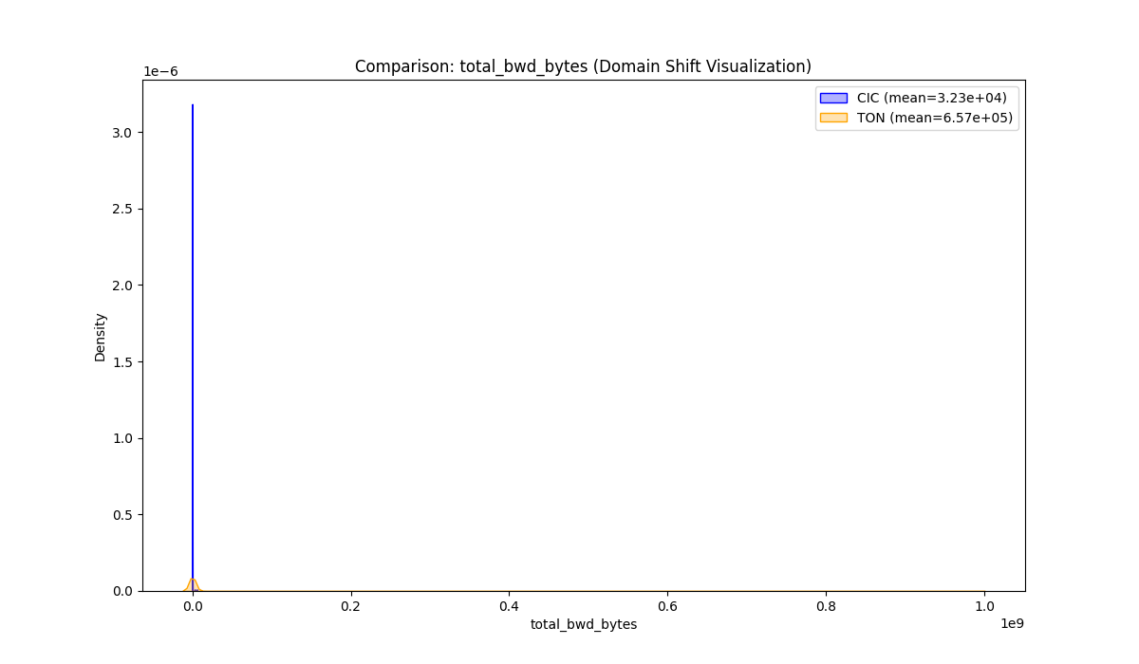

Academic Context (Theoretical Framework)
Generated visualization: compare_total_bwd_bytes.png
Interpretation Framework (Pattern Recognition)
Supplementary graph produced by pipeline.

────────────────────────────────────────────────────────────────────────────────────────────────────

Figure 4.2.39: Dist Total Bwd Bytes
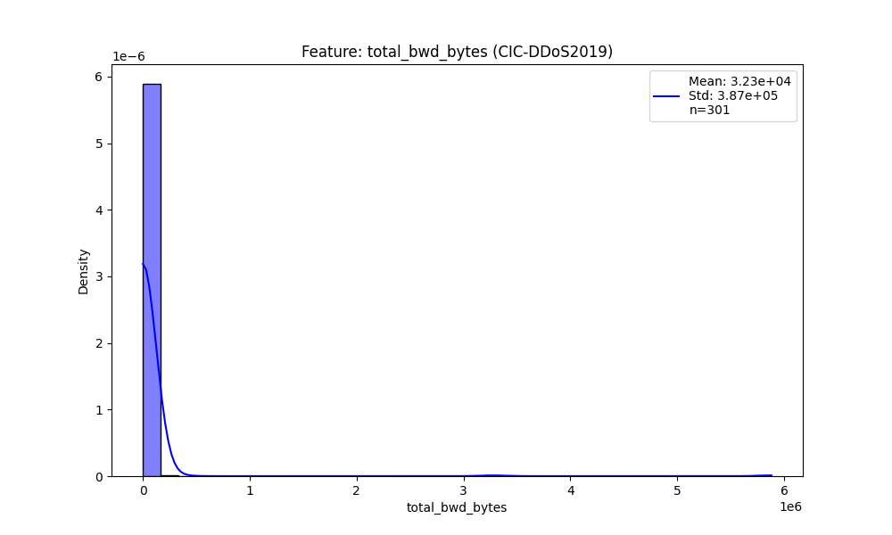

Academic Context (Theoretical Framework)
Generated visualization: dist_total_bwd_bytes.png
Interpretation Framework (Pattern Recognition)
Supplementary graph produced by pipeline.

────────────────────────────────────────────────────────────────────────────────────────────────────

Figure 4.2.40: Dist Total Bwd Bytes
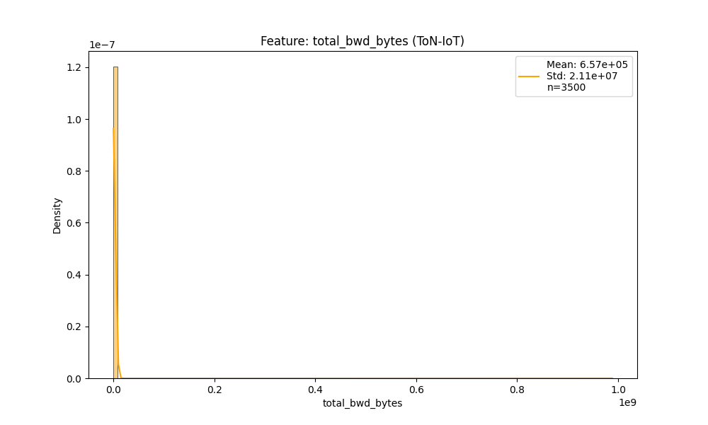

Academic Context (Theoretical Framework)
Generated visualization: dist_total_bwd_bytes.png
Interpretation Framework (Pattern Recognition)
Supplementary graph produced by pipeline.

────────────────────────────────────────────────────────────────────────────────────────────────────

Figure 4.2.41: Before After Total Fwd Bytes
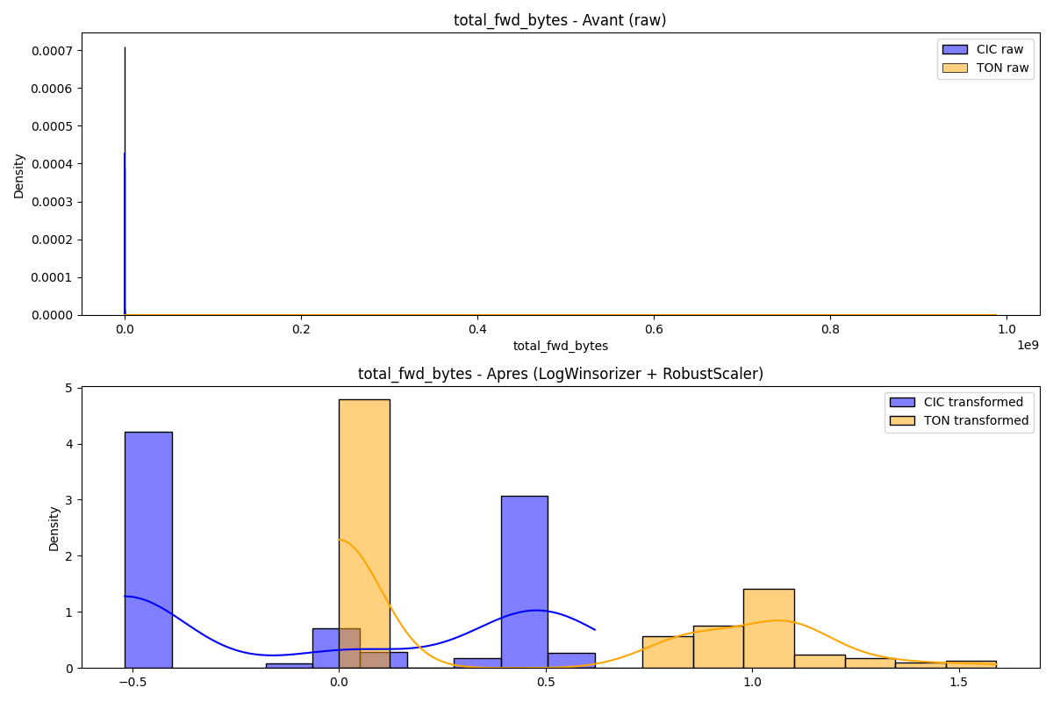

Academic Context (Theoretical Framework)
Generated visualization: before_after_total_fwd_bytes.png
Interpretation Framework (Pattern Recognition)
Supplementary graph produced by pipeline.

────────────────────────────────────────────────────────────────────────────────────────────────────

Figure 4.2.42: Compare Total Fwd Bytes
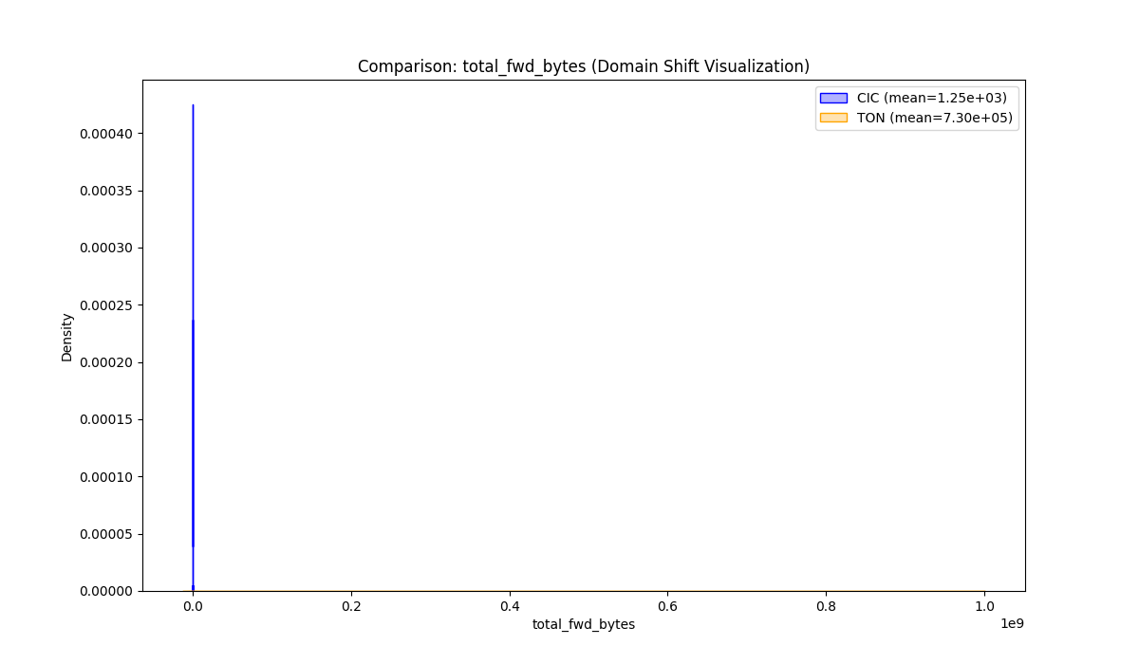

Academic Context (Theoretical Framework)
Generated visualization: compare_total_fwd_bytes.png
Interpretation Framework (Pattern Recognition)
Supplementary graph produced by pipeline.

────────────────────────────────────────────────────────────────────────────────────────────────────

Figure 4.2.43: Dist Total Fwd Bytes
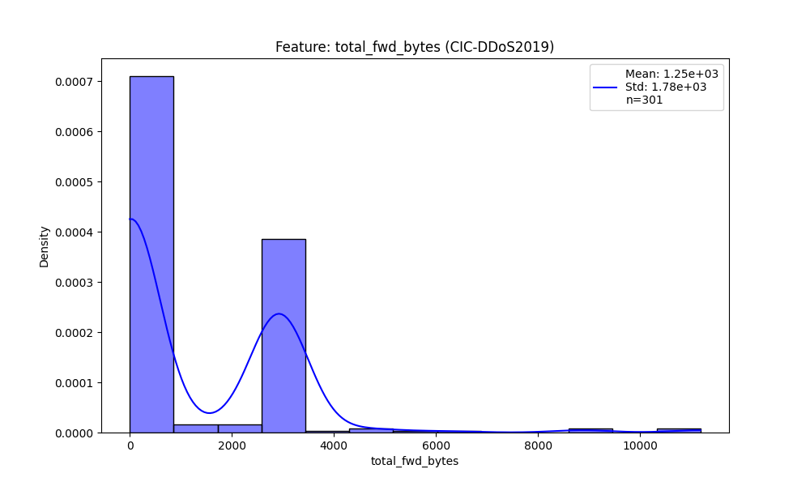

Academic Context (Theoretical Framework)
Generated visualization: dist_total_fwd_bytes.png
Interpretation Framework (Pattern Recognition)
Supplementary graph produced by pipeline.

────────────────────────────────────────────────────────────────────────────────────────────────────

Figure 4.2.44: Dist Total Fwd Bytes
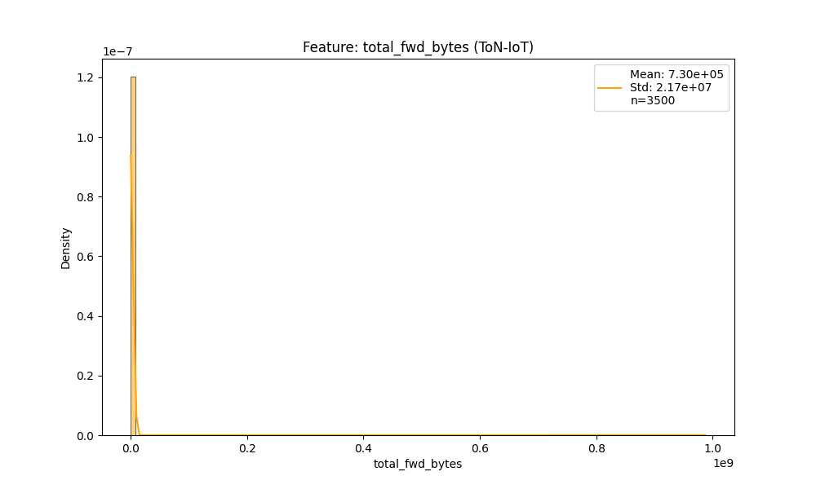

Academic Context (Theoretical Framework)
Generated visualization: dist_total_fwd_bytes.png
Interpretation Framework (Pattern Recognition)
Supplementary graph produced by pipeline.

────────────────────────────────────────────────────────────────────────────────────────────────────

Figure 4.2.45: Before After Total Bwd Packets
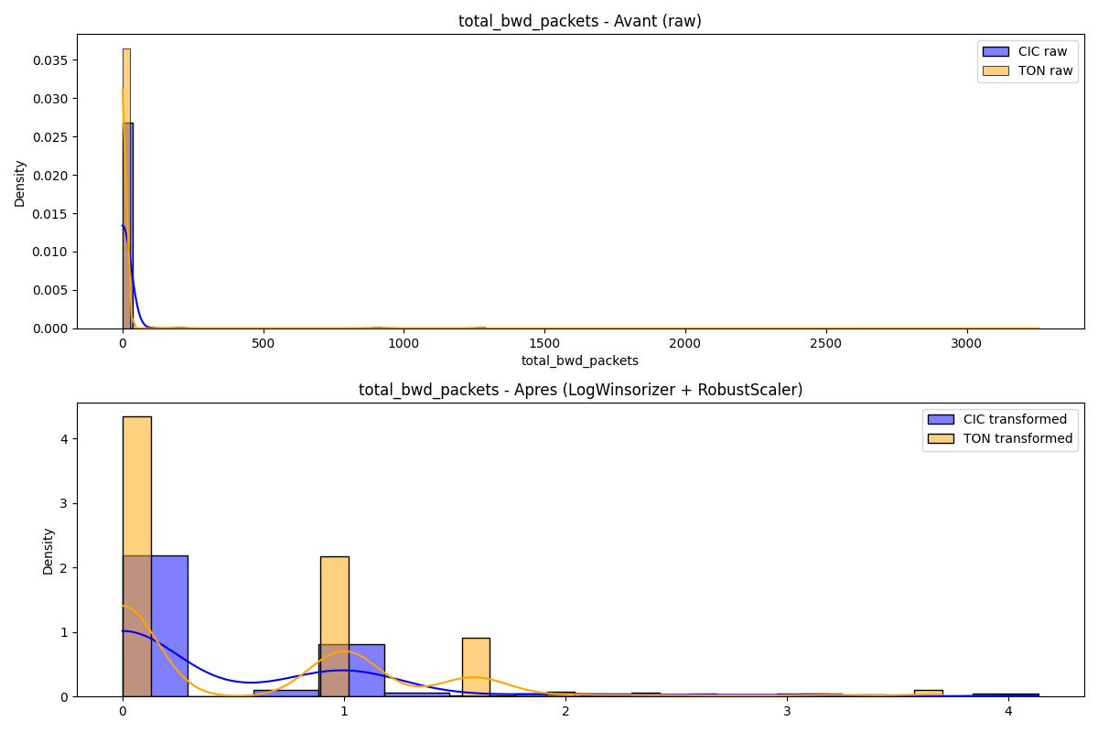

Academic Context (Theoretical Framework)
Generated visualization: before_after_total_bwd_packets.png
Interpretation Framework (Pattern Recognition)
Supplementary graph produced by pipeline.

────────────────────────────────────────────────────────────────────────────────────────────────────

Figure 4.2.46: Compare Total Bwd Packets
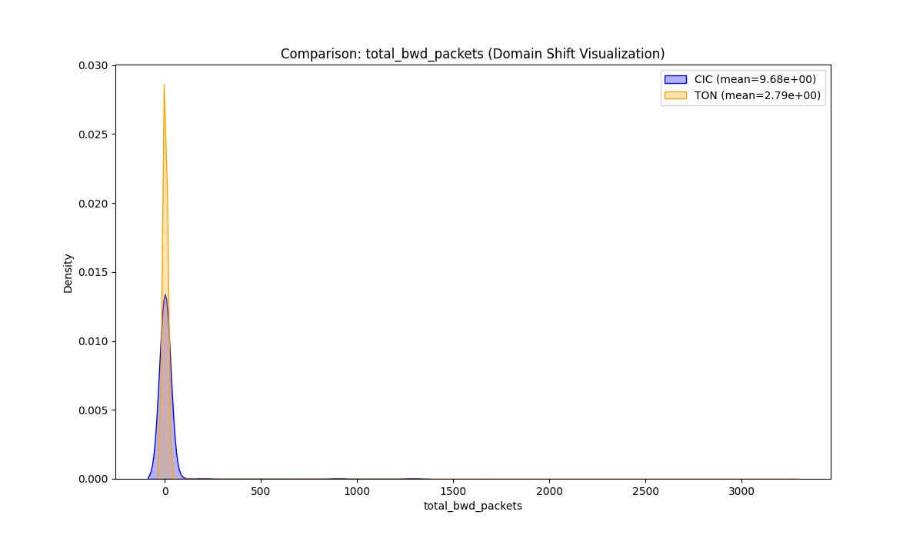

Academic Context (Theoretical Framework)
Generated visualization: compare_total_bwd_packets.png
Interpretation Framework (Pattern Recognition)
Supplementary graph produced by pipeline.

────────────────────────────────────────────────────────────────────────────────────────────────────

Figure 4.2.47: Dist Total Bwd Packets
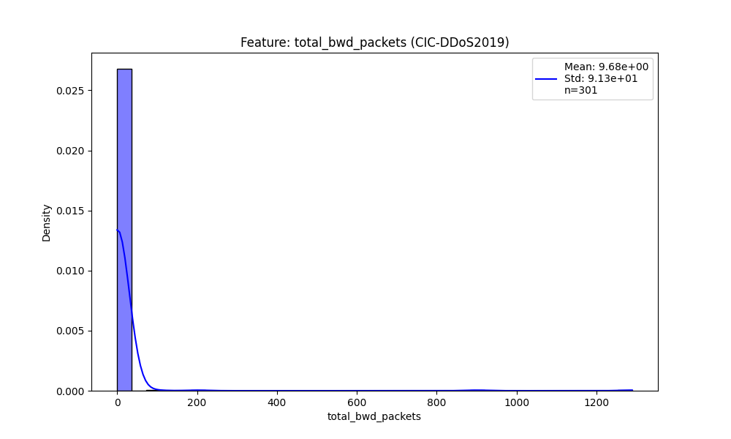

Academic Context (Theoretical Framework)
Generated visualization: dist_total_bwd_packets.png
Interpretation Framework (Pattern Recognition)
Supplementary graph produced by pipeline.

────────────────────────────────────────────────────────────────────────────────────────────────────

Figure 4.2.48: Dist Total Bwd Packets
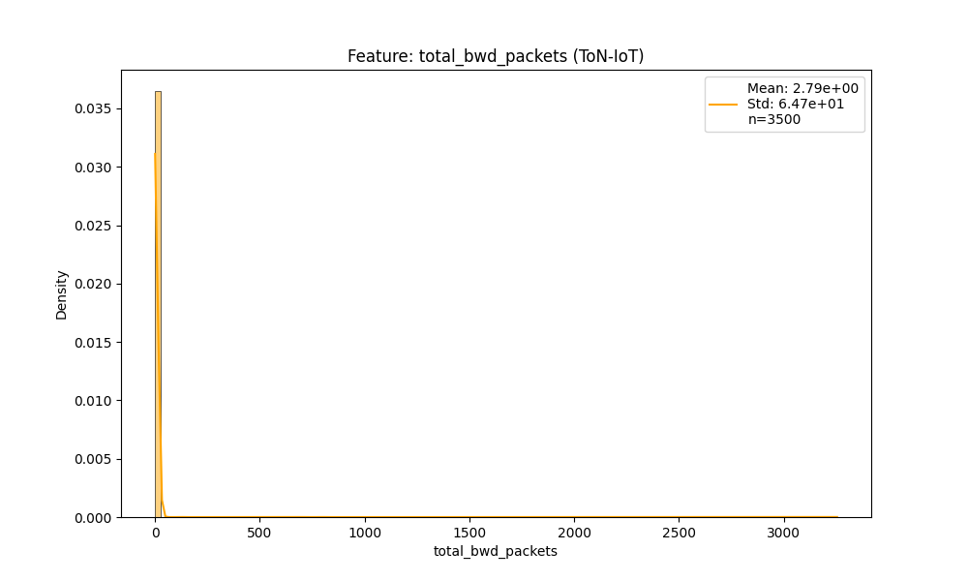

Academic Context (Theoretical Framework)
Generated visualization: dist_total_bwd_packets.png
Interpretation Framework (Pattern Recognition)
Supplementary graph produced by pipeline.

────────────────────────────────────────────────────────────────────────────────────────────────────

Figure 4.2.49: Before After Total Fwd Packets
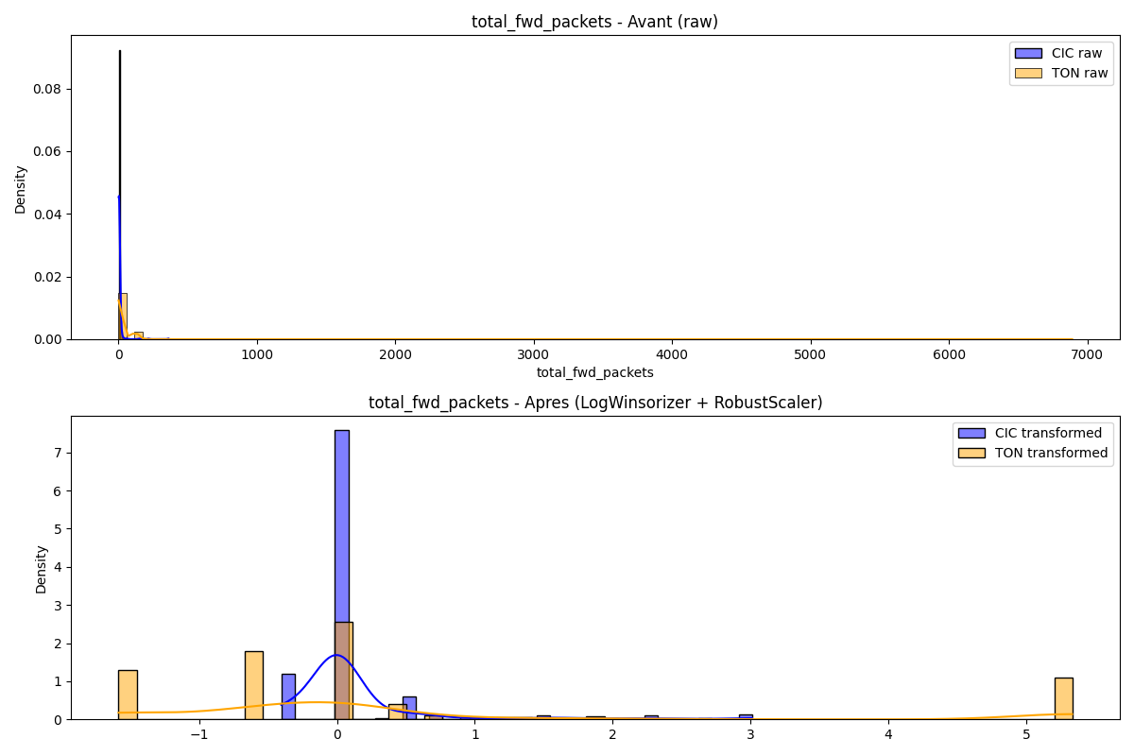

Academic Context (Theoretical Framework)
Generated visualization: before_after_total_fwd_packets.png
Interpretation Framework (Pattern Recognition)
Supplementary graph produced by pipeline.

────────────────────────────────────────────────────────────────────────────────────────────────────

Figure 4.2.50: Compare Total Fwd Packets
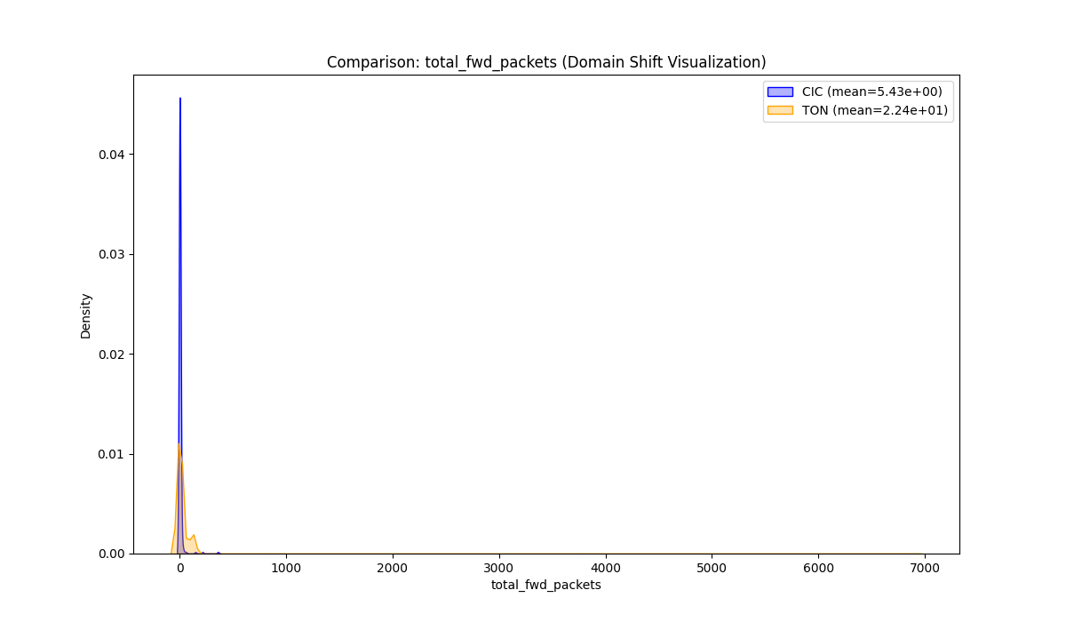

Academic Context (Theoretical Framework)
Generated visualization: compare_total_fwd_packets.png
Interpretation Framework (Pattern Recognition)
Supplementary graph produced by pipeline.

────────────────────────────────────────────────────────────────────────────────────────────────────

Figure 4.2.51: Dist Total Fwd Packets
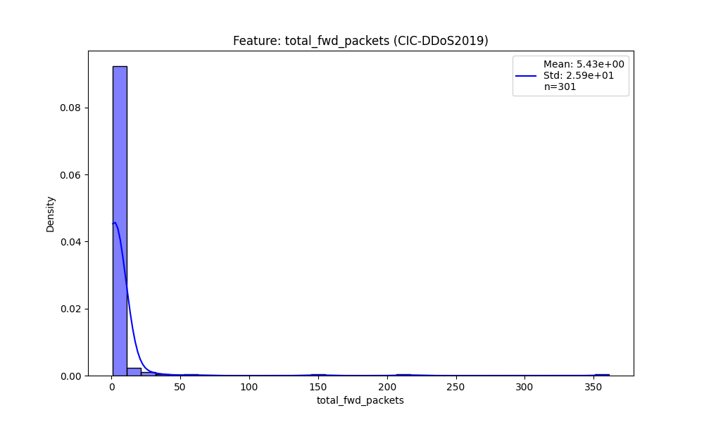

Academic Context (Theoretical Framework)
Generated visualization: dist_total_fwd_packets.png
Interpretation Framework (Pattern Recognition)
Supplementary graph produced by pipeline.

────────────────────────────────────────────────────────────────────────────────────────────────────

Figure 4.2.52: Dist Total Fwd Packets
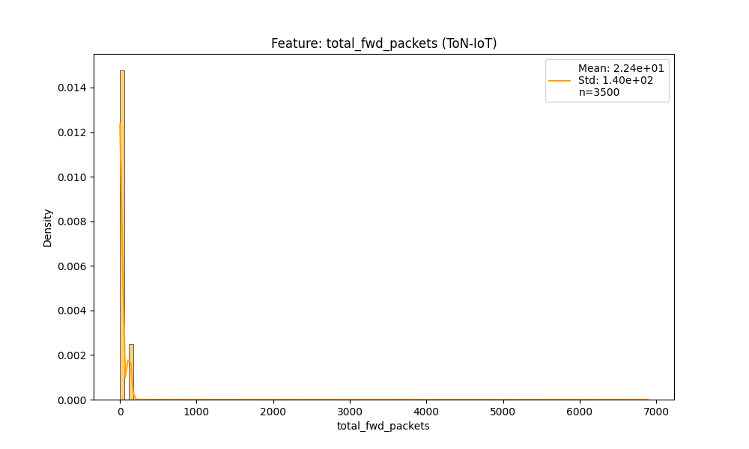

Academic Context (Theoretical Framework)
Generated visualization: dist_total_fwd_packets.png
Interpretation Framework (Pattern Recognition)
Supplementary graph produced by pipeline.

────────────────────────────────────────────────────────────────────────────────────────────────────

Figure 4.2.53: Before After Flow Duration
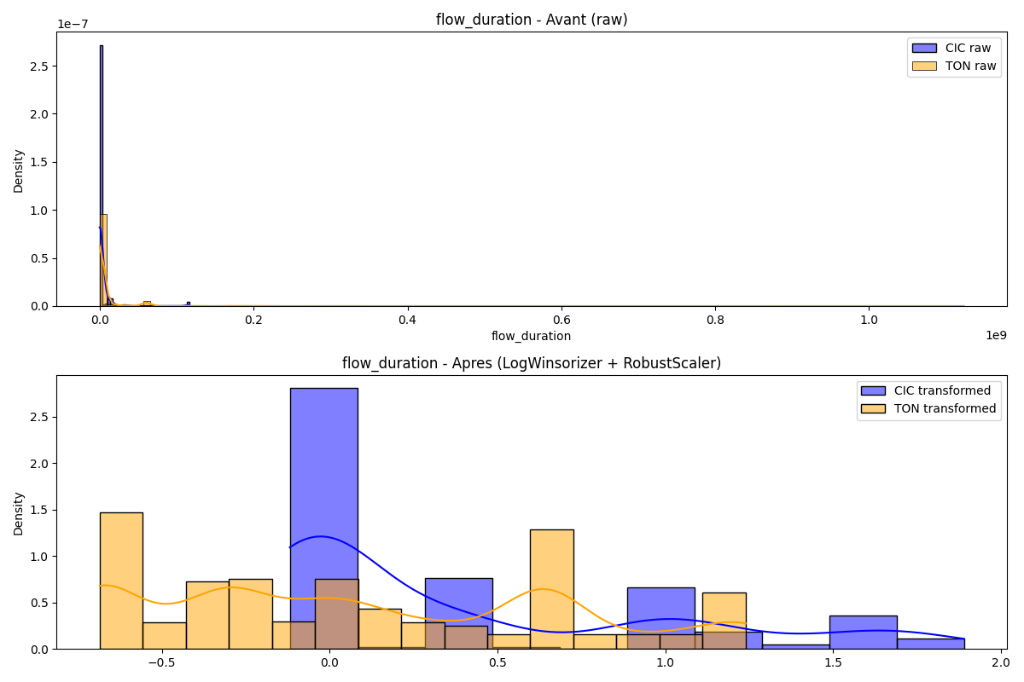

Academic Context (Theoretical Framework)
Generated visualization: before_after_flow_duration.png
Interpretation Framework (Pattern Recognition)
Supplementary graph produced by pipeline.

────────────────────────────────────────────────────────────────────────────────────────────────────

Figure 4.2.54: Compare Flow Duration
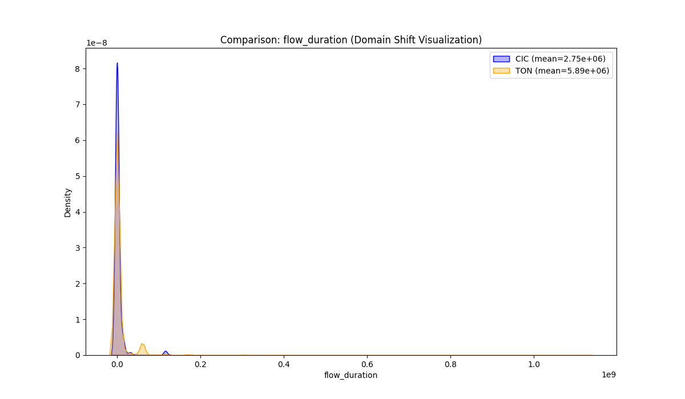

Academic Context (Theoretical Framework)
Generated visualization: compare_flow_duration.png
Interpretation Framework (Pattern Recognition)
Supplementary graph produced by pipeline.

────────────────────────────────────────────────────────────────────────────────────────────────────

Figure 4.2.55: Dist Flow Duration
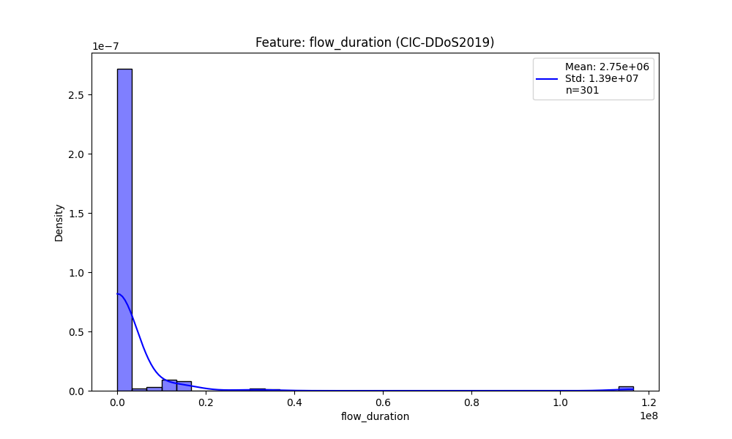

Academic Context (Theoretical Framework)
Generated visualization: dist_flow_duration.png
Interpretation Framework (Pattern Recognition)
Supplementary graph produced by pipeline.

────────────────────────────────────────────────────────────────────────────────────────────────────

Figure 4.2.56: Dist Flow Duration
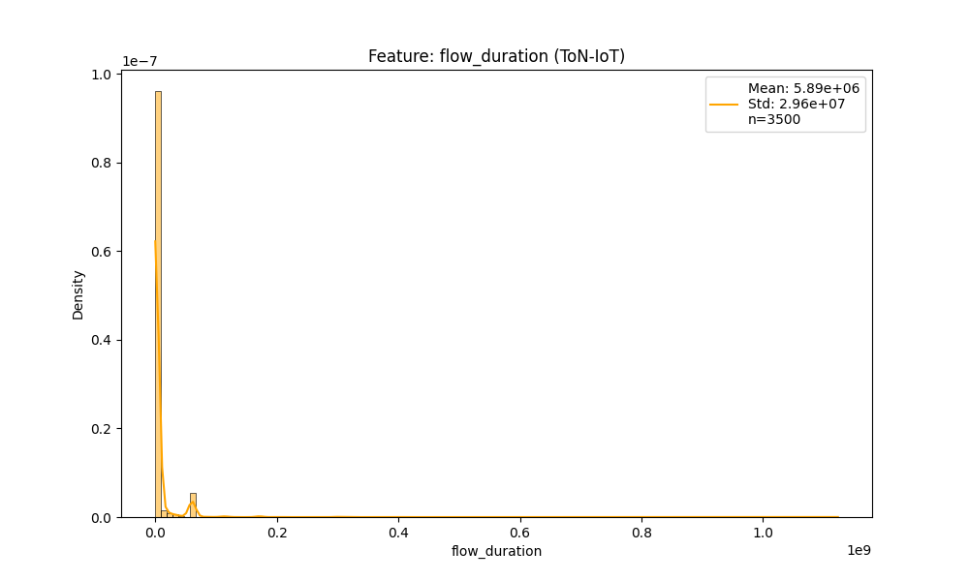

Academic Context (Theoretical Framework)
Generated visualization: dist_flow_duration.png
Interpretation Framework (Pattern Recognition)
Supplementary graph produced by pipeline.

────────────────────────────────────────────────────────────────────────────────────────────────────

4.3 Dimension 1: Detection Performance
Table 4.3: Fused Model Performance (Late Fusion)
Algorithm | Accuracy | Precision | Recall | F1 | ROC-AUC | Gap
CNN | 0.6795 | 0.0000 | 0.0000 | 0.0000 | 0.7945 | 0.8919
DT | 0.4886 | 0.3848 | 0.9945 | 0.5549 | 0.7313 | 0.0193
LR | 0.7233 | 0.5616 | 0.6230 | 0.5907 | 0.7953 | 0.0249
RF | 0.9247 | 0.9795 | 0.7814 | 0.8693 | 0.9706 | 0.0408
TabNet | 0.5972 | 0.4307 | 0.7978 | 0.5594 | 0.6729 | 0.1193

Interpretation: Late Fusion combines CIC and ToN predictions via weighted averaging. The 'Gap' column (|F1_CIC - F1_ToN|) quantifies cross-dataset generalization robustness. Lower gaps indicate algorithms less sensitive to dataset-specific biases.

Figure 4.3.57: Explainability Sampling Derivative
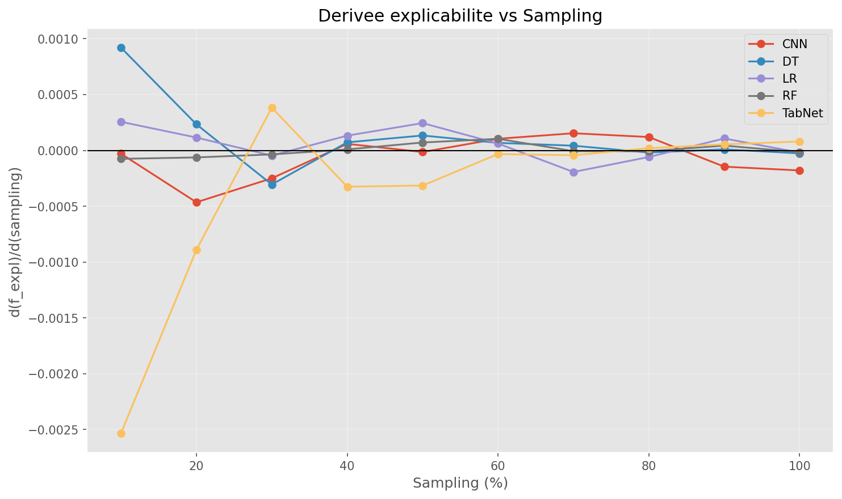

Academic Context (Theoretical Framework)
Generated visualization: explainability_sampling_derivative.png
Interpretation Framework (Pattern Recognition)
Supplementary graph produced by pipeline.

────────────────────────────────────────────────────────────────────────────────────────────────────

Figure 4.3.58: Performance Sampling Derivative
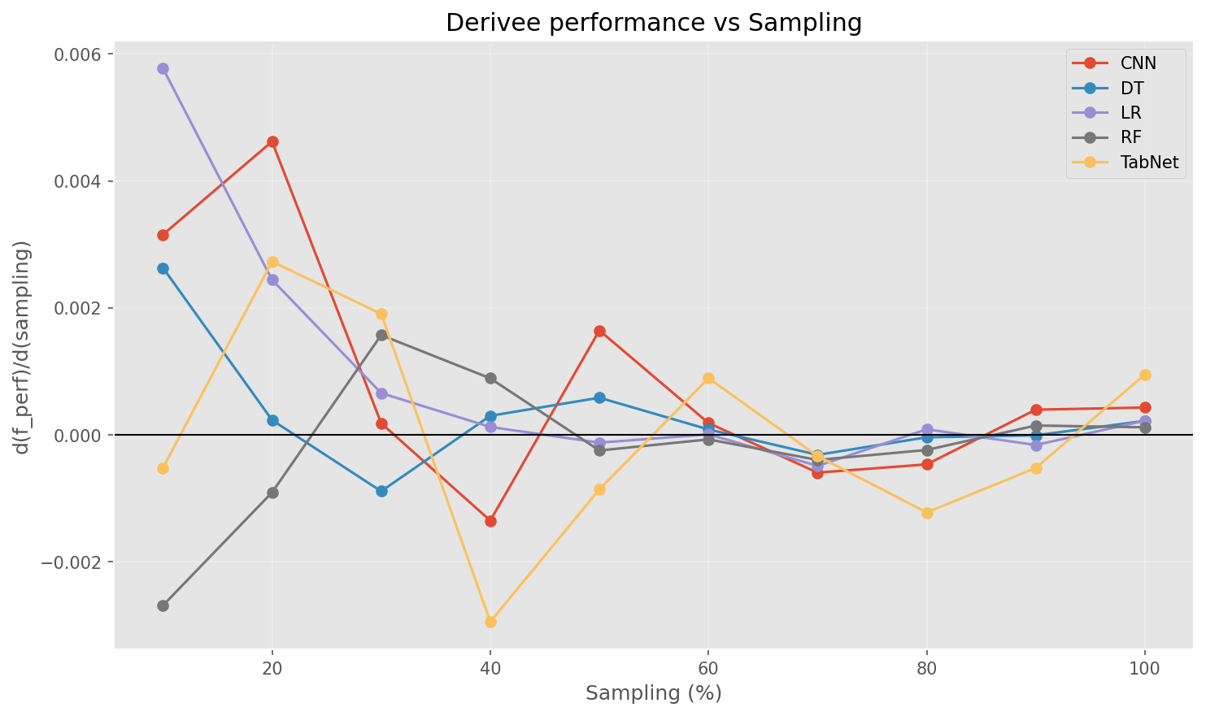

Academic Context (Theoretical Framework)
Generated visualization: performance_sampling_derivative.png
Interpretation Framework (Pattern Recognition)
Supplementary graph produced by pipeline.

────────────────────────────────────────────────────────────────────────────────────────────────────

Figure 4.3.59: Explainability Sampling Curve
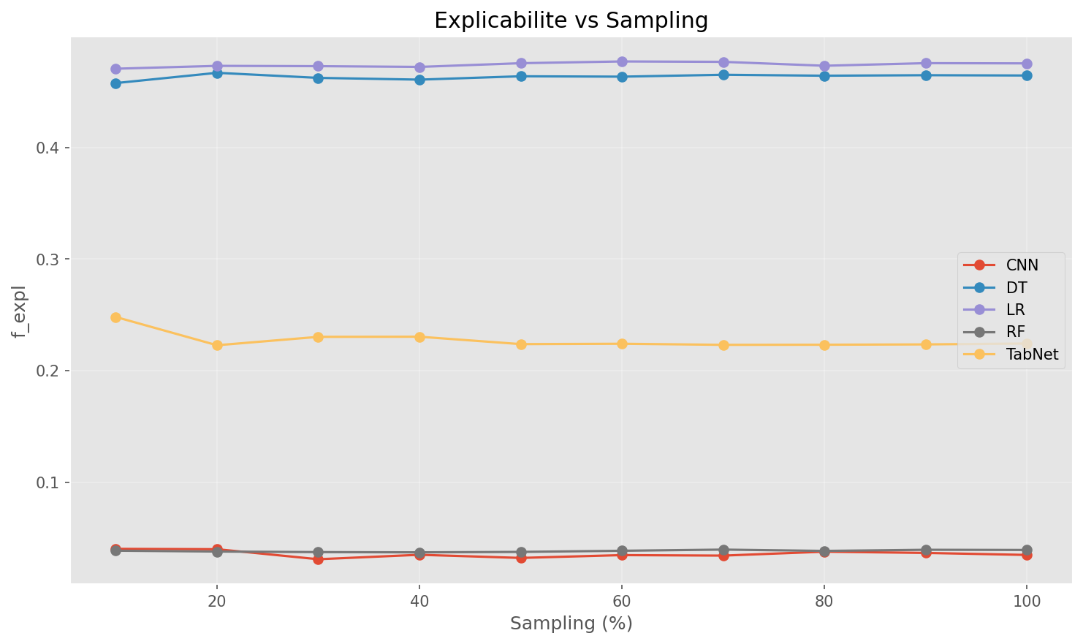

Academic Context (Theoretical Framework)
Generated visualization: explainability_sampling_curve.png
Interpretation Framework (Pattern Recognition)
Supplementary graph produced by pipeline.

────────────────────────────────────────────────────────────────────────────────────────────────────

4.4 Dimension 2: Explainability
Table 4.4: Explainability Metrics
Algorithm | Faithfulness | Stability | Complexity | SHAP Req.
CNN | 0.00 | 0.50 | 6.47 | ❌
DT | 1.00 | 0.50 | 3.47 | ❌
LR | 1.00 | 0.50 | 2.83 | ❌
RF | 0.00 | 0.50 | 5.39 | ❌
TabNet | 0.50 | 0.50 | 8.80 | ❌

Interpretation: Faithfulness measures intrinsic interpretability (1.0 = fully transparent). Stability measures SHAP value consistency. Complexity measures model parameter count (log scale). GDPR compliance typically requires faithfulness ≥ 0.6.

4.5 Dimension 3: Resource Efficiency
Table 4.5: Resource Consumption Metrics
Algorithm | Memory (MB) | CPU (%) | RAM (%) | Latency (ms)
CNN | 51.3 | 92.3 | 0.3 | 11.31
DT | 0.0 | 659.3 | 0.0 | 0.02
LR | 0.1 | 386.7 | 0.0 | 0.04
RF | 0.1 | 461.5 | 0.0 | 0.20
TabNet | 0.5 | 252.2 | 0.0 | 0.76

Interpretation: Resource metrics measured during training/inference on commodity hardware. RAM % > 50 on 8GB systems indicates SME deployment infeasibility. Latency > 10ms invalidates real-time inline deployment for DDoS mitigation.

4.6 Multi-Criteria Decision Making (MCDM)
Figure 4.6.60: Explainability Sampling Derivative

Academic Context (Theoretical Framework)
Generated visualization: explainability_sampling_derivative.png
Interpretation Framework (Pattern Recognition)
Supplementary graph produced by pipeline.

────────────────────────────────────────────────────────────────────────────────────────────────────

Figure 4.6.61: Performance Sampling Derivative

Academic Context (Theoretical Framework)
Generated visualization: performance_sampling_derivative.png
Interpretation Framework (Pattern Recognition)
Supplementary graph produced by pipeline.

────────────────────────────────────────────────────────────────────────────────────────────────────

Figure 4.6.62: Explainability Sampling Curve

Academic Context (Theoretical Framework)
Generated visualization: explainability_sampling_curve.png
Interpretation Framework (Pattern Recognition)
Supplementary graph produced by pipeline.

────────────────────────────────────────────────────────────────────────────────────────────────────

Figure 4.6.63: Performance Sampling Curve
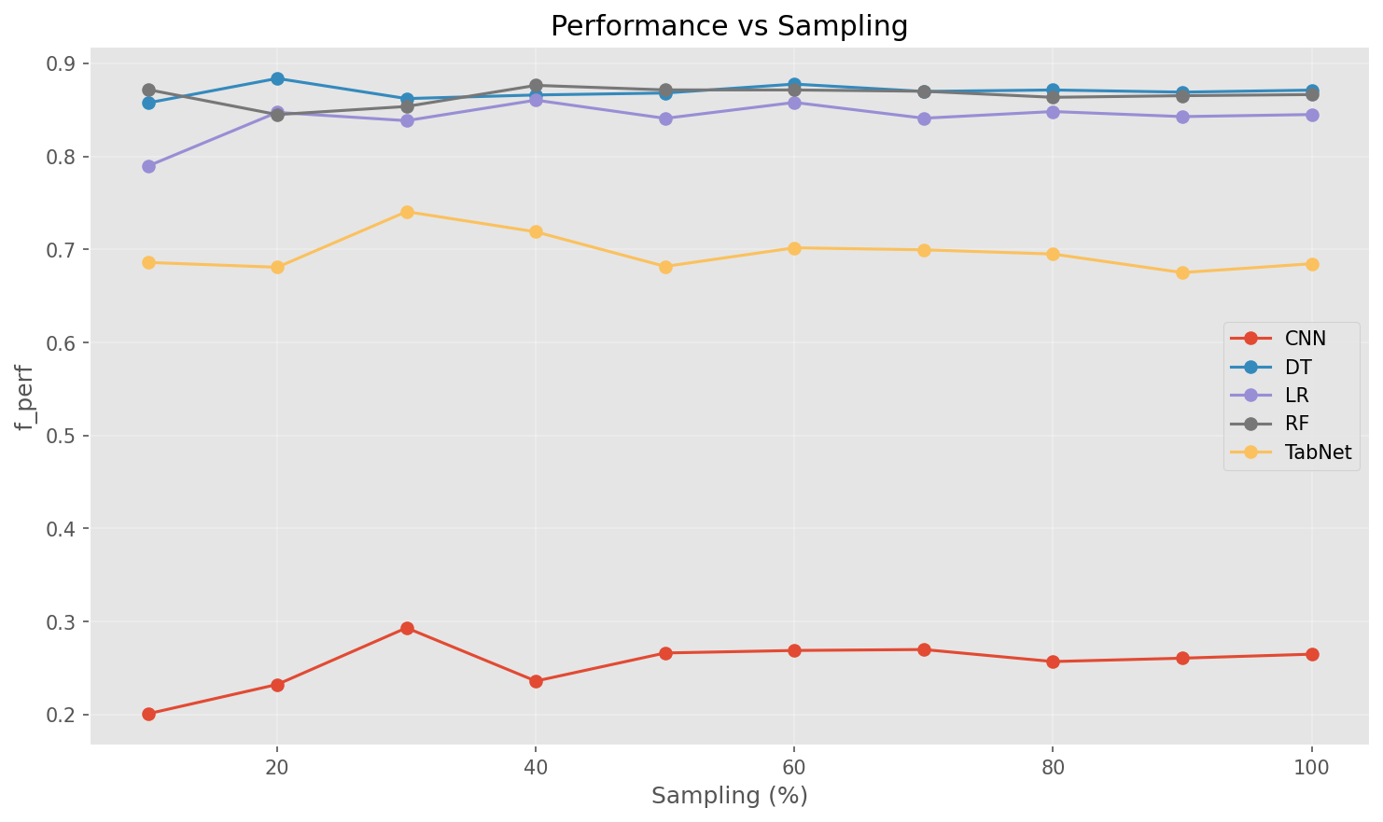

Academic Context (Theoretical Framework)
Generated visualization: performance_sampling_curve.png
Interpretation Framework (Pattern Recognition)
Supplementary graph produced by pipeline.

────────────────────────────────────────────────────────────────────────────────────────────────────

Figure 4.6.64: Explicabilite Resume
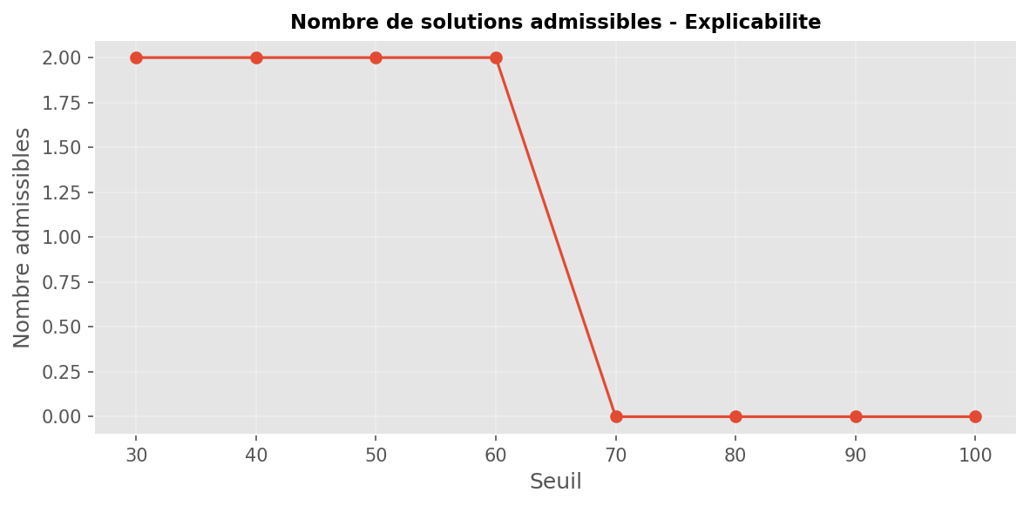

Academic Context (Theoretical Framework)
Generated visualization: explicabilite_resume.png
Interpretation Framework (Pattern Recognition)
Supplementary graph produced by pipeline.

────────────────────────────────────────────────────────────────────────────────────────────────────

Figure 4.6.65: Explicabilite Seuil 30
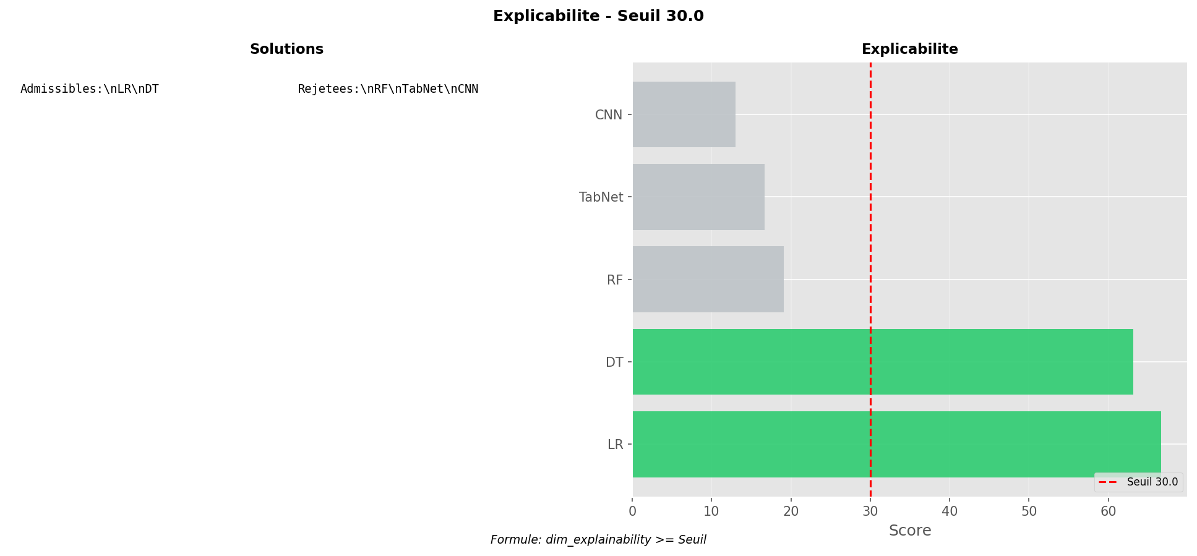

Academic Context (Theoretical Framework)
Generated visualization: explicabilite_seuil_30.png
Interpretation Framework (Pattern Recognition)
Supplementary graph produced by pipeline.

────────────────────────────────────────────────────────────────────────────────────────────────────

Figure 4.6.66: Explicabilite Seuil 40
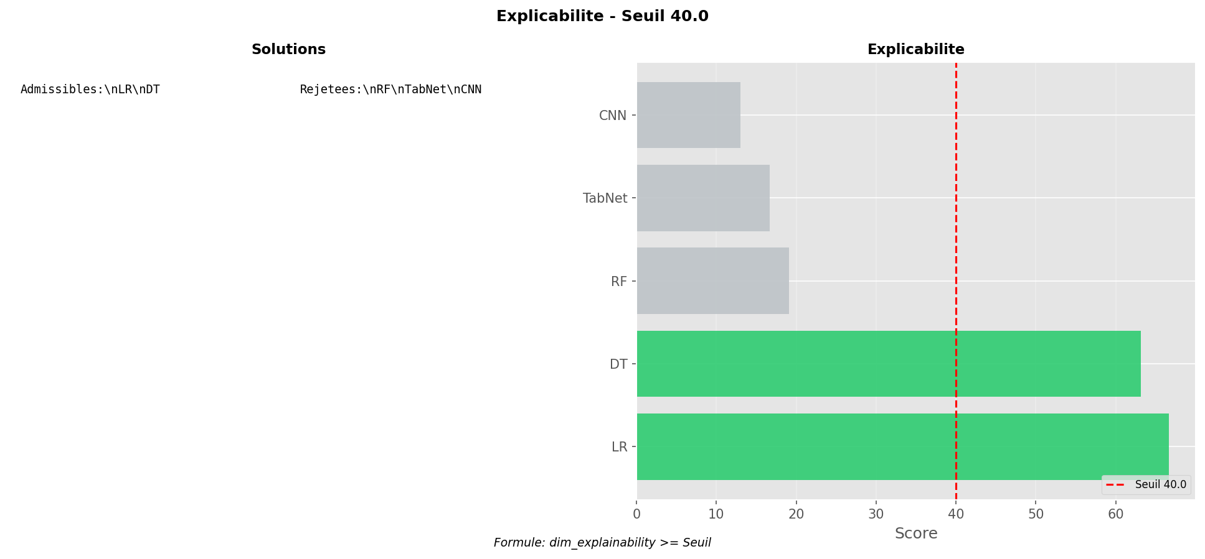

Academic Context (Theoretical Framework)
Generated visualization: explicabilite_seuil_40.png
Interpretation Framework (Pattern Recognition)
Supplementary graph produced by pipeline.

────────────────────────────────────────────────────────────────────────────────────────────────────

Figure 4.6.67: Explicabilite Seuil 50
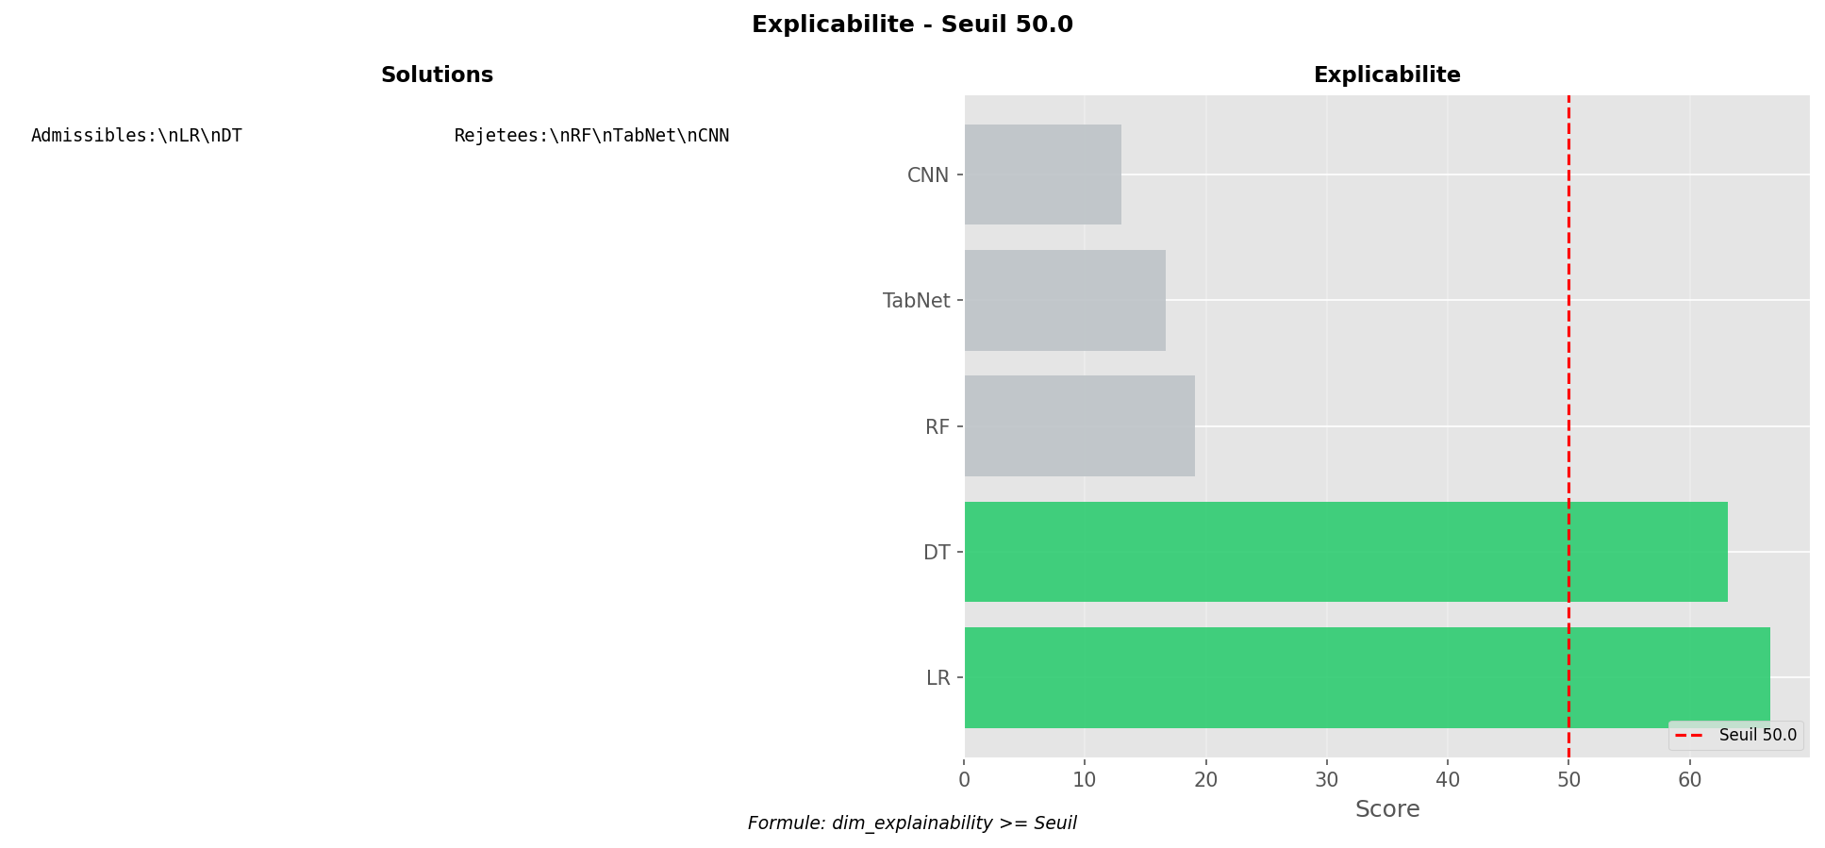

Academic Context (Theoretical Framework)
Generated visualization: explicabilite_seuil_50.png
Interpretation Framework (Pattern Recognition)
Supplementary graph produced by pipeline.

────────────────────────────────────────────────────────────────────────────────────────────────────

Figure 4.6.68: Explicabilite Seuil 60
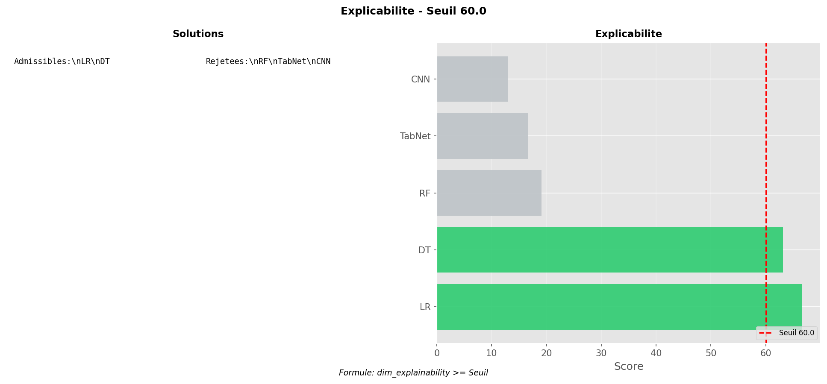

Academic Context (Theoretical Framework)
Generated visualization: explicabilite_seuil_60.png
Interpretation Framework (Pattern Recognition)
Supplementary graph produced by pipeline.

────────────────────────────────────────────────────────────────────────────────────────────────────

Figure 4.6.69: Explicabilite Seuil 70
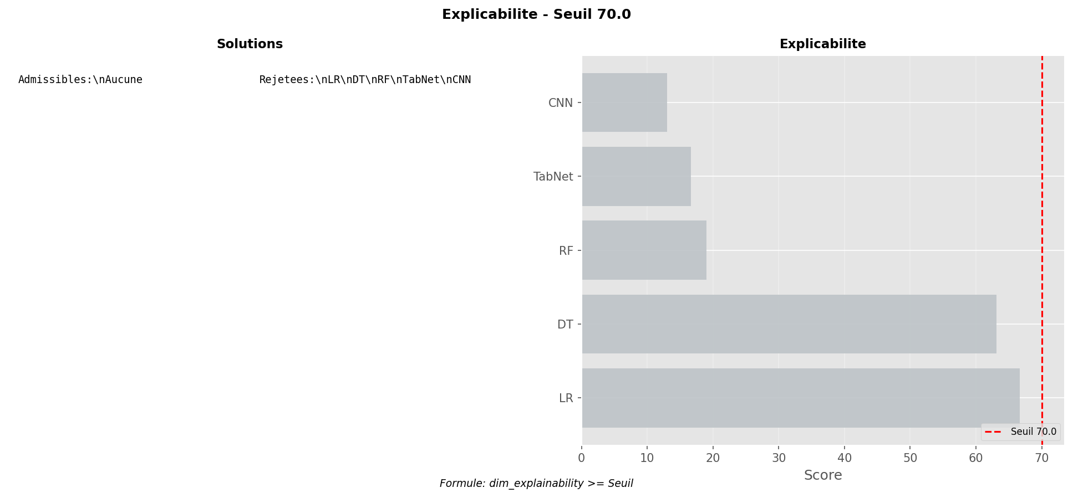

Academic Context (Theoretical Framework)
Generated visualization: explicabilite_seuil_70.png
Interpretation Framework (Pattern Recognition)
Supplementary graph produced by pipeline.

────────────────────────────────────────────────────────────────────────────────────────────────────

Figure 4.6.70: Explicabilite Seuil 80
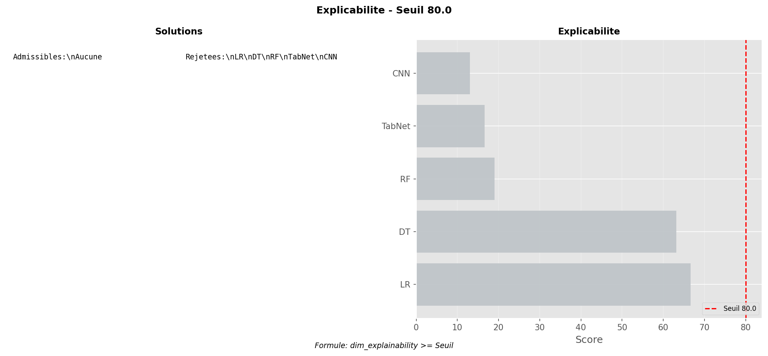

Academic Context (Theoretical Framework)
Generated visualization: explicabilite_seuil_80.png
Interpretation Framework (Pattern Recognition)
Supplementary graph produced by pipeline.

────────────────────────────────────────────────────────────────────────────────────────────────────

Figure 4.6.71: Explicabilite Seuil 90
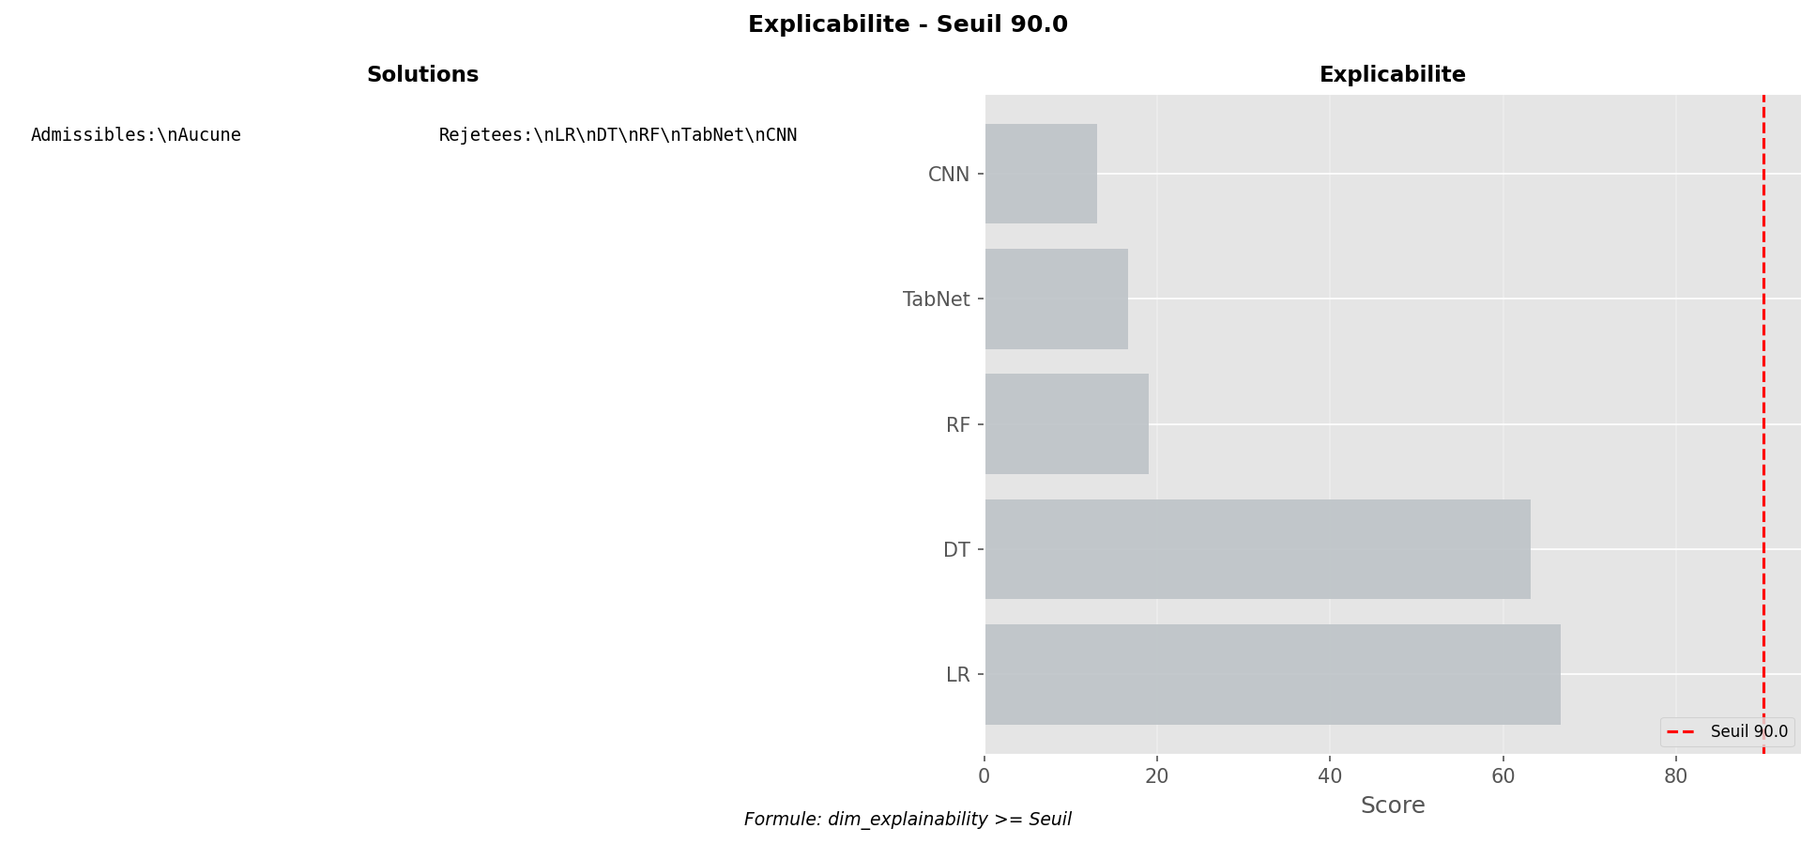

Academic Context (Theoretical Framework)
Generated visualization: explicabilite_seuil_90.png
Interpretation Framework (Pattern Recognition)
Supplementary graph produced by pipeline.

────────────────────────────────────────────────────────────────────────────────────────────────────

Figure 4.6.72: Explicabilite Seuil 100
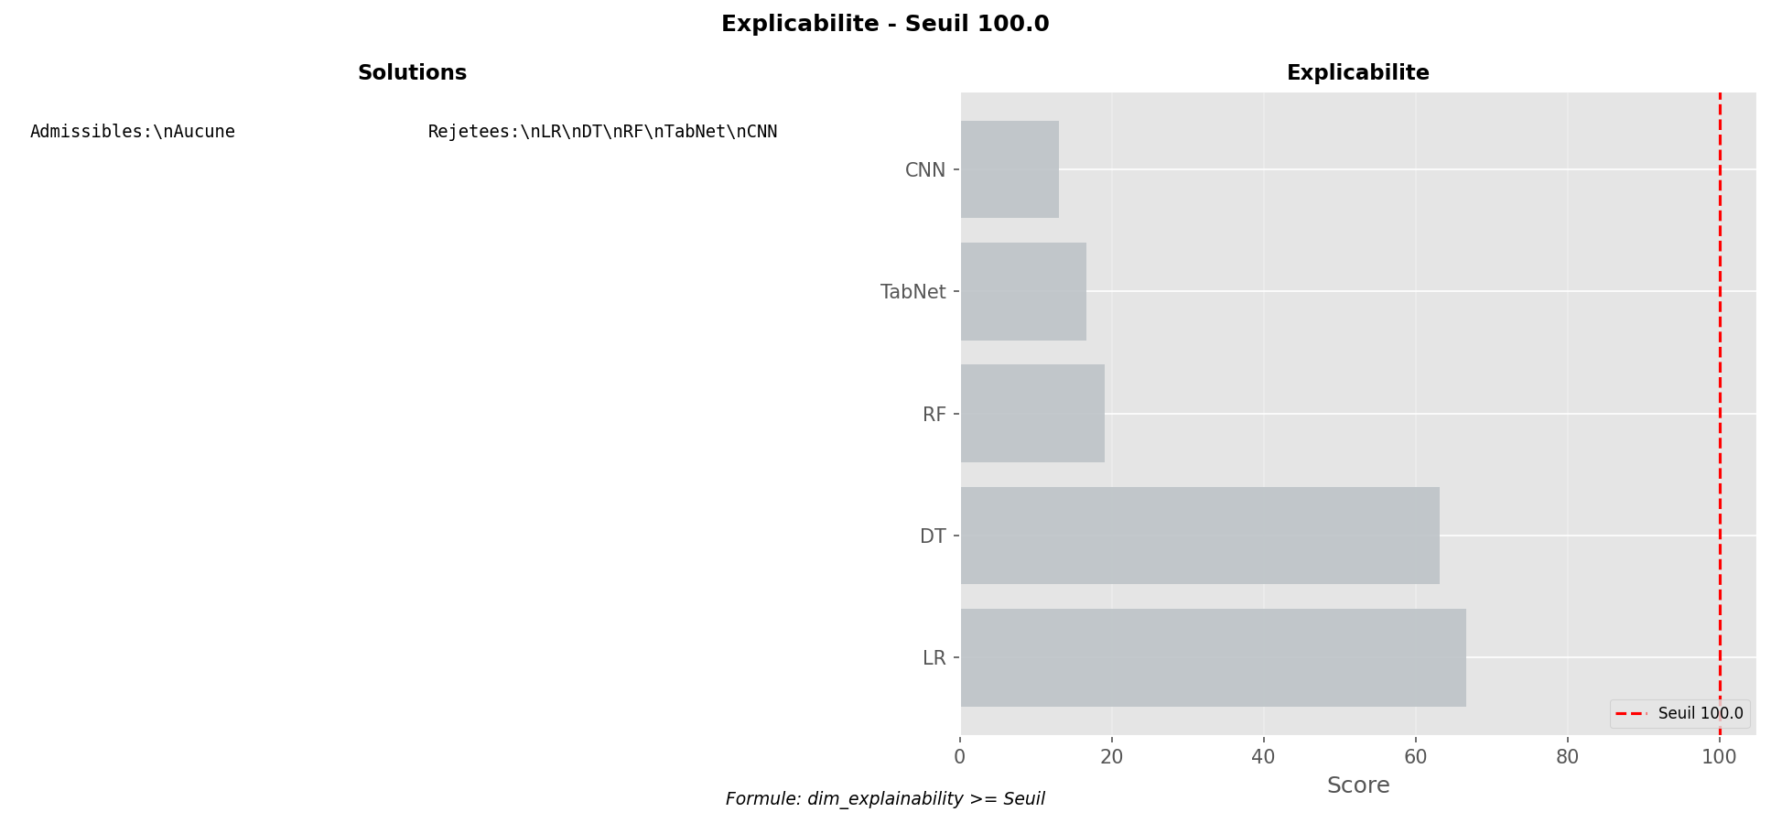

Academic Context (Theoretical Framework)
Generated visualization: explicabilite_seuil_100.png
Interpretation Framework (Pattern Recognition)
Supplementary graph produced by pipeline.

────────────────────────────────────────────────────────────────────────────────────────────────────

Figure 4.6.73: Performance Resume
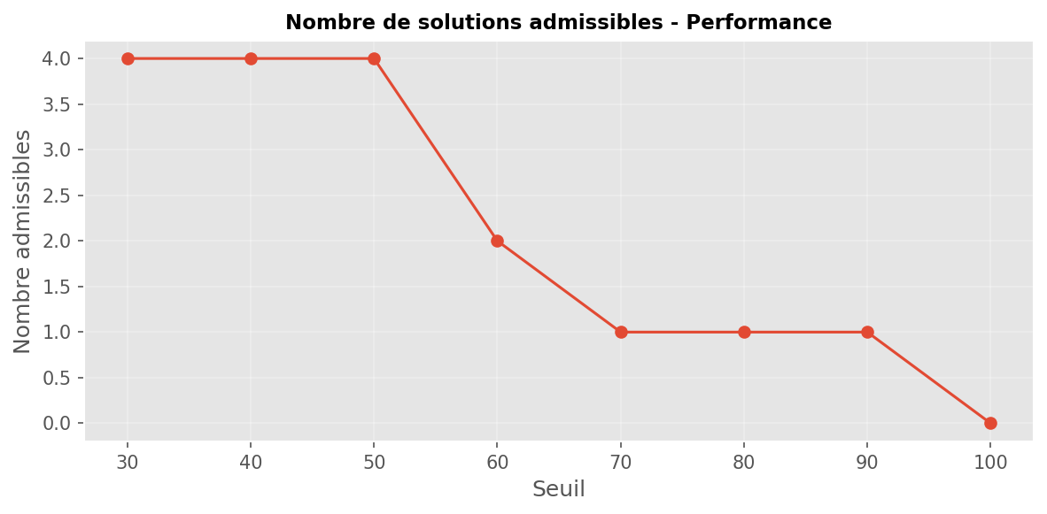

Academic Context (Theoretical Framework)
Generated visualization: performance_resume.png
Interpretation Framework (Pattern Recognition)
Supplementary graph produced by pipeline.

────────────────────────────────────────────────────────────────────────────────────────────────────

Figure 4.6.74: Performance Seuil 30
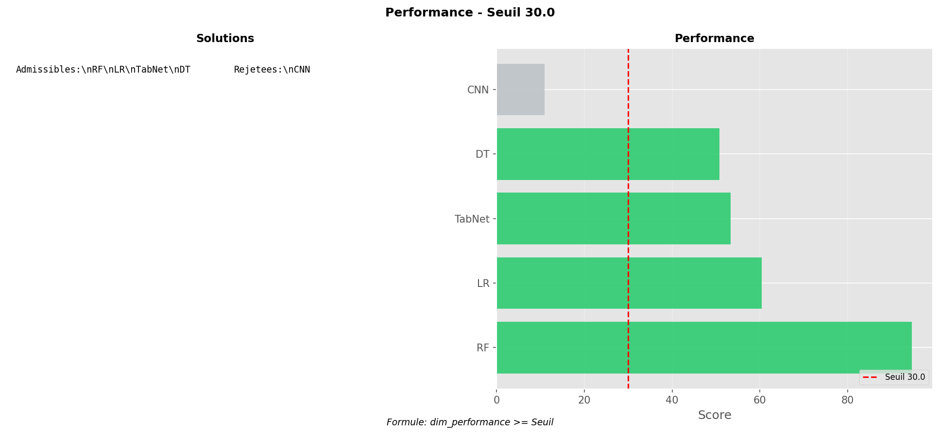

Academic Context (Theoretical Framework)
Generated visualization: performance_seuil_30.png
Interpretation Framework (Pattern Recognition)
Supplementary graph produced by pipeline.

────────────────────────────────────────────────────────────────────────────────────────────────────

Figure 4.6.75: Performance Seuil 40
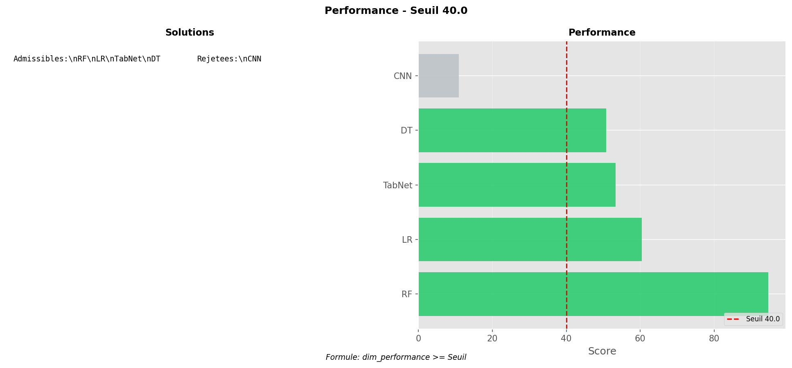

Academic Context (Theoretical Framework)
Generated visualization: performance_seuil_40.png
Interpretation Framework (Pattern Recognition)
Supplementary graph produced by pipeline.

────────────────────────────────────────────────────────────────────────────────────────────────────

Figure 4.6.76: Performance Seuil 50
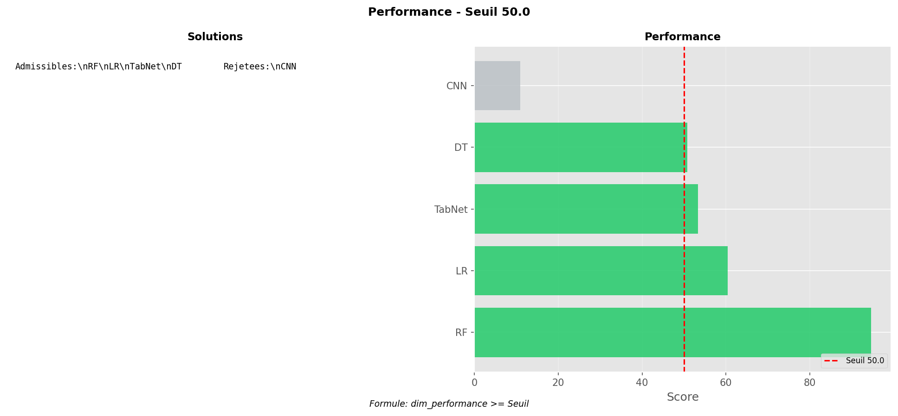

Academic Context (Theoretical Framework)
Generated visualization: performance_seuil_50.png
Interpretation Framework (Pattern Recognition)
Supplementary graph produced by pipeline.

────────────────────────────────────────────────────────────────────────────────────────────────────

Figure 4.6.77: Performance Seuil 60
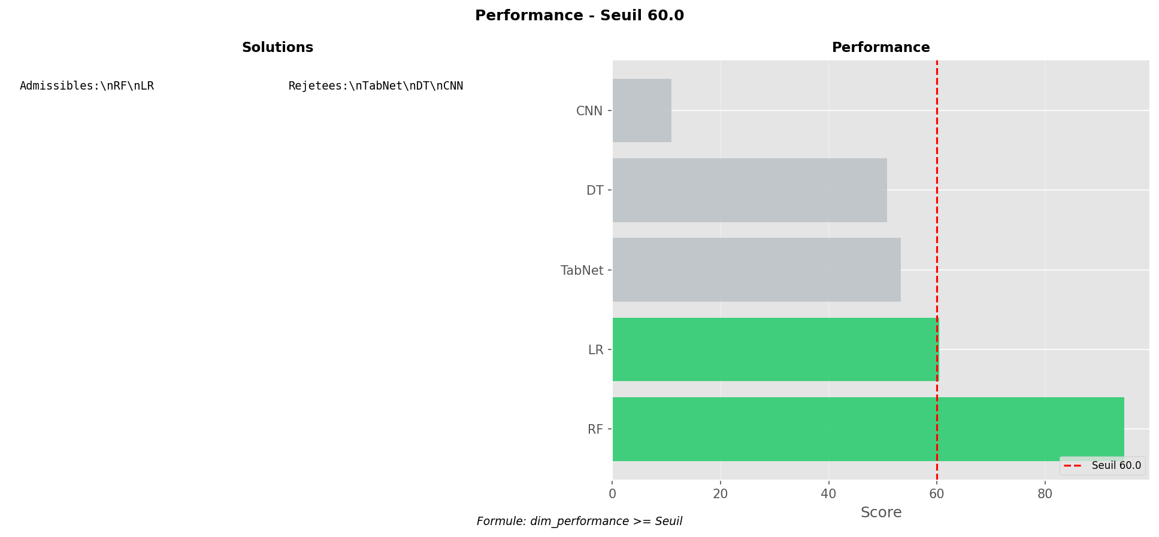

Academic Context (Theoretical Framework)
Generated visualization: performance_seuil_60.png
Interpretation Framework (Pattern Recognition)
Supplementary graph produced by pipeline.

────────────────────────────────────────────────────────────────────────────────────────────────────

Figure 4.6.78: Performance Seuil 70
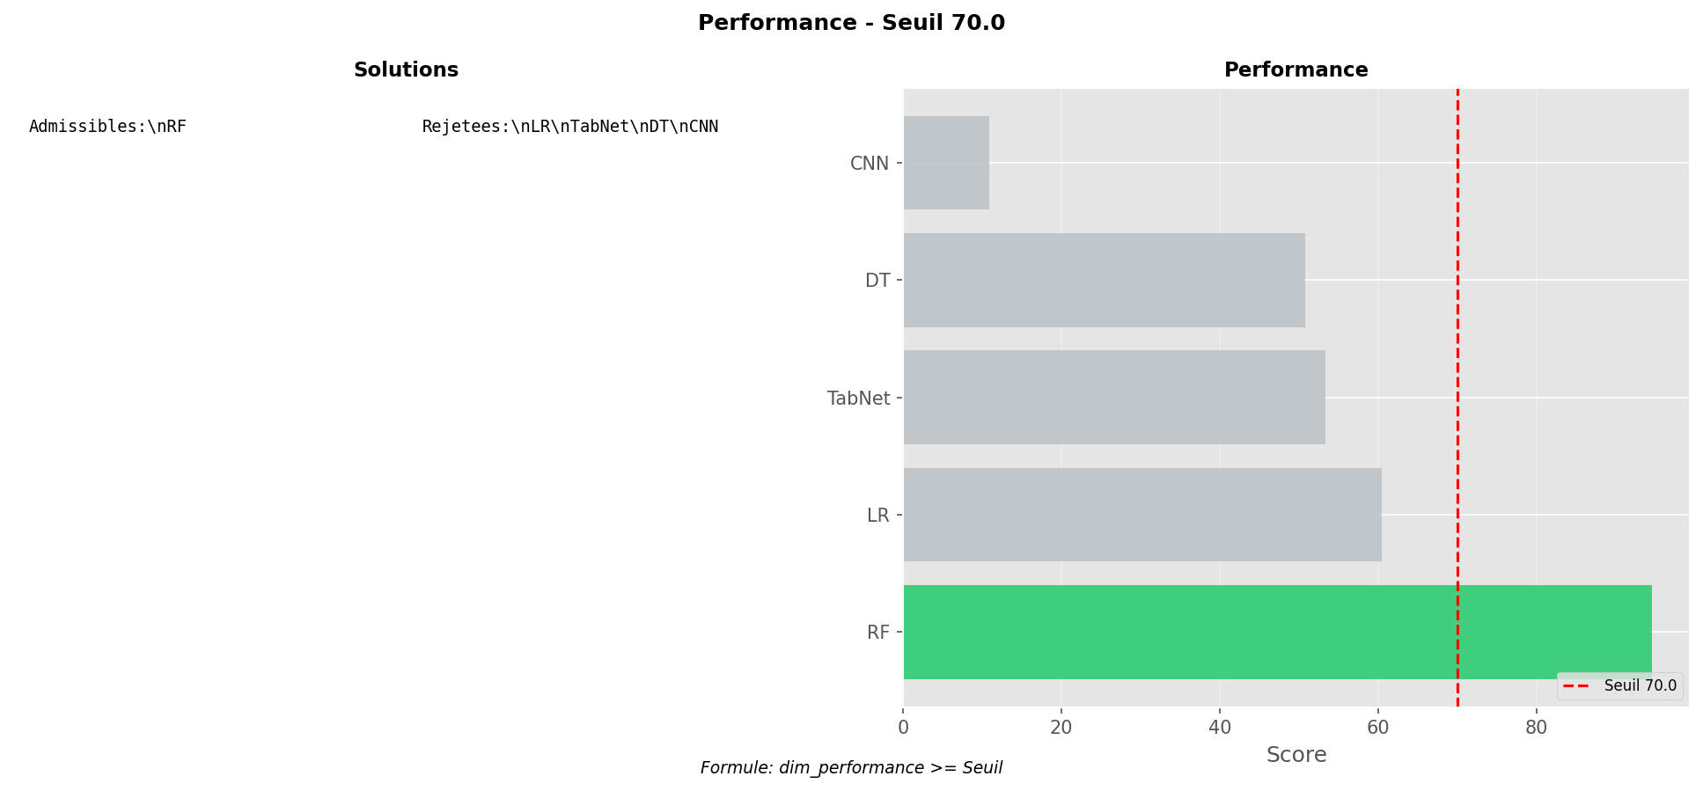

Academic Context (Theoretical Framework)
Generated visualization: performance_seuil_70.png
Interpretation Framework (Pattern Recognition)
Supplementary graph produced by pipeline.

────────────────────────────────────────────────────────────────────────────────────────────────────

Figure 4.6.79: Performance Seuil 80
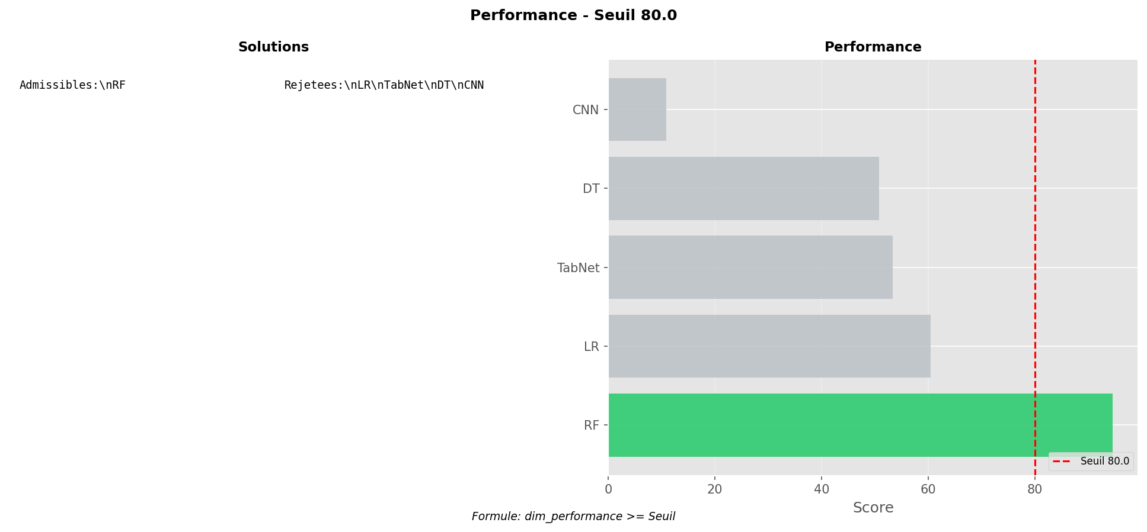

Academic Context (Theoretical Framework)
Generated visualization: performance_seuil_80.png
Interpretation Framework (Pattern Recognition)
Supplementary graph produced by pipeline.

────────────────────────────────────────────────────────────────────────────────────────────────────

Figure 4.6.80: Performance Seuil 90
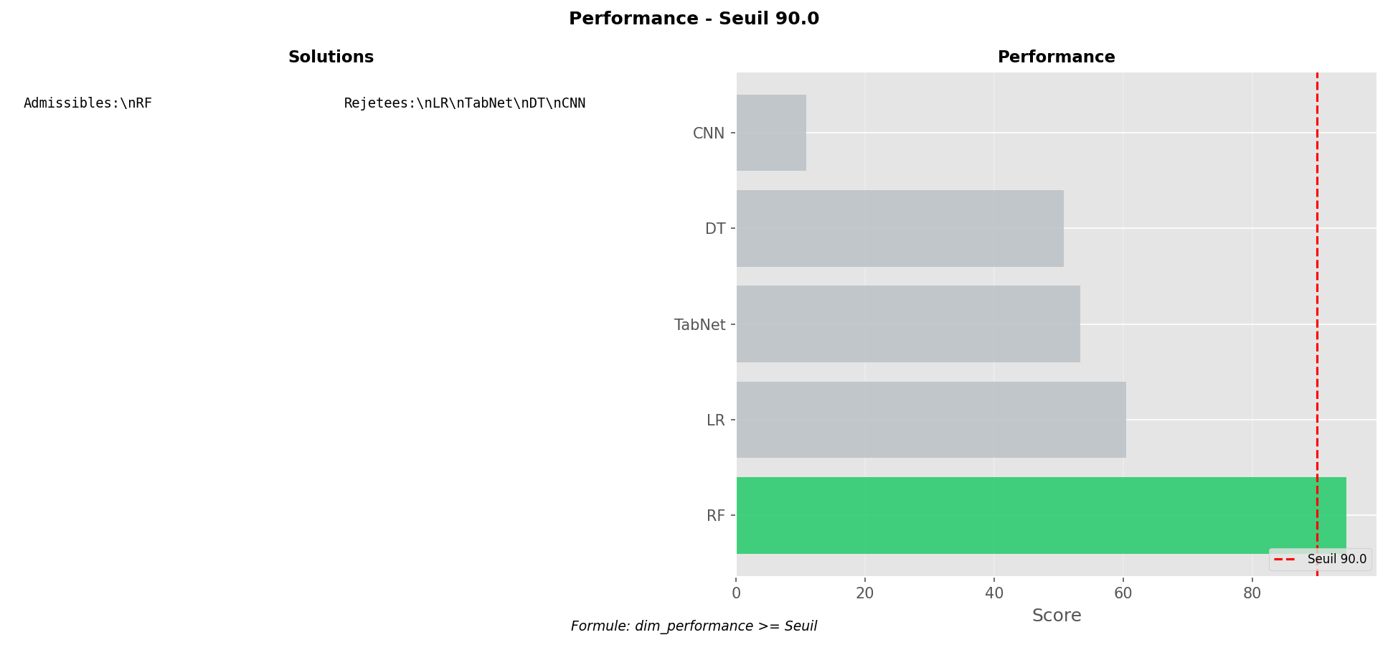

Academic Context (Theoretical Framework)
Generated visualization: performance_seuil_90.png
Interpretation Framework (Pattern Recognition)
Supplementary graph produced by pipeline.

────────────────────────────────────────────────────────────────────────────────────────────────────

Figure 4.6.81: Performance Seuil 100
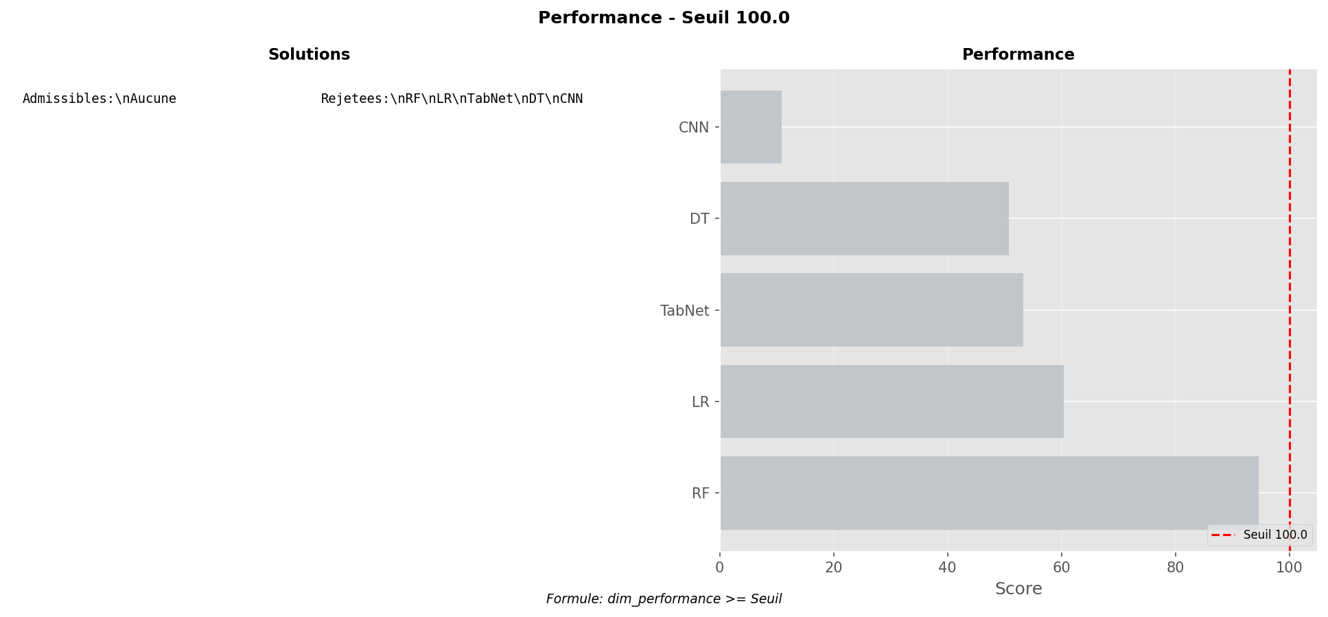

Academic Context (Theoretical Framework)
Generated visualization: performance_seuil_100.png
Interpretation Framework (Pattern Recognition)
Supplementary graph produced by pipeline.

────────────────────────────────────────────────────────────────────────────────────────────────────

Figure 4.6.82: Contrainte Ressource Resume
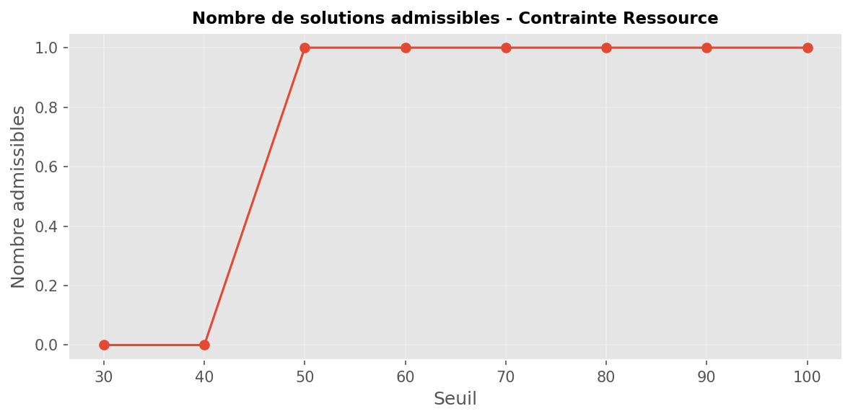

Academic Context (Theoretical Framework)
Generated visualization: contrainte_ressource_resume.png
Interpretation Framework (Pattern Recognition)
Supplementary graph produced by pipeline.

────────────────────────────────────────────────────────────────────────────────────────────────────

Figure 4.6.83: Contrainte Ressource Seuil 30
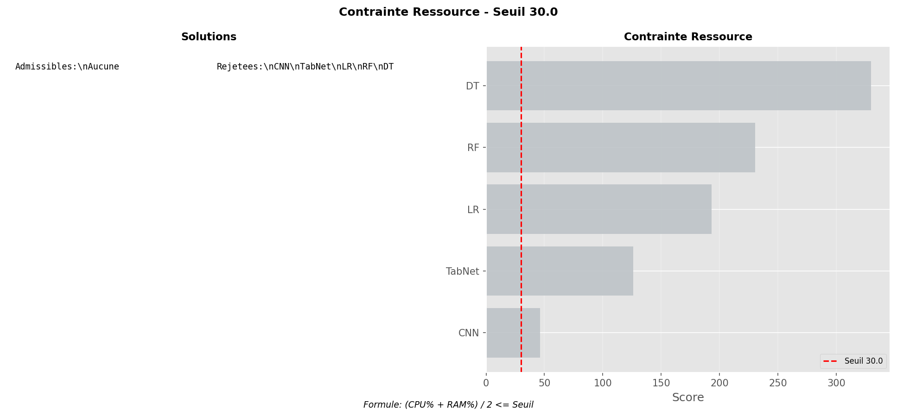

Academic Context (Theoretical Framework)
Generated visualization: contrainte_ressource_seuil_30.png
Interpretation Framework (Pattern Recognition)
Supplementary graph produced by pipeline.

────────────────────────────────────────────────────────────────────────────────────────────────────

Figure 4.6.84: Contrainte Ressource Seuil 40
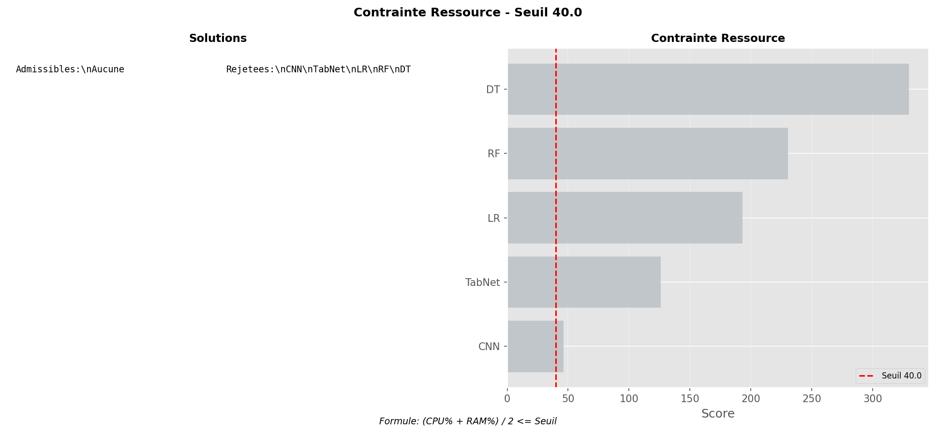

Academic Context (Theoretical Framework)
Generated visualization: contrainte_ressource_seuil_40.png
Interpretation Framework (Pattern Recognition)
Supplementary graph produced by pipeline.

────────────────────────────────────────────────────────────────────────────────────────────────────

Figure 4.6.85: Contrainte Ressource Seuil 50
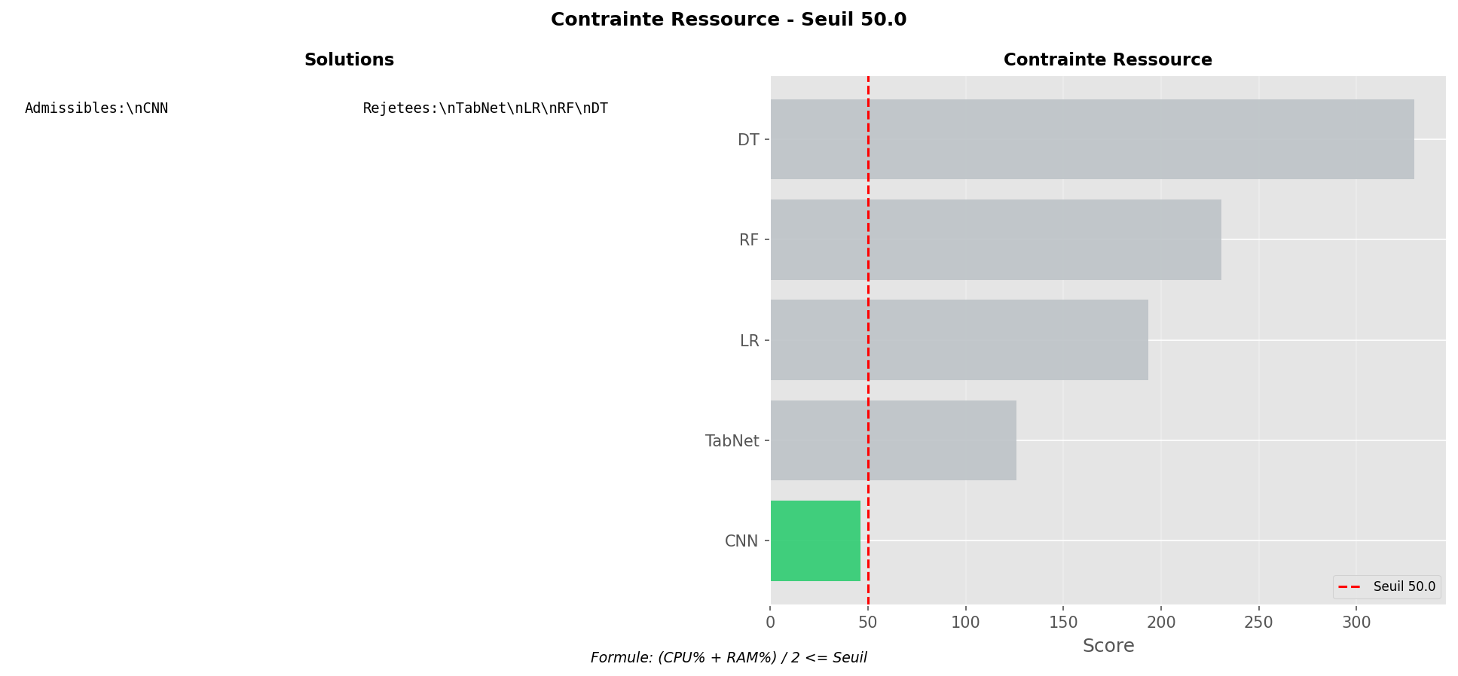

Academic Context (Theoretical Framework)
Generated visualization: contrainte_ressource_seuil_50.png
Interpretation Framework (Pattern Recognition)
Supplementary graph produced by pipeline.

────────────────────────────────────────────────────────────────────────────────────────────────────

Figure 4.6.86: Contrainte Ressource Seuil 60
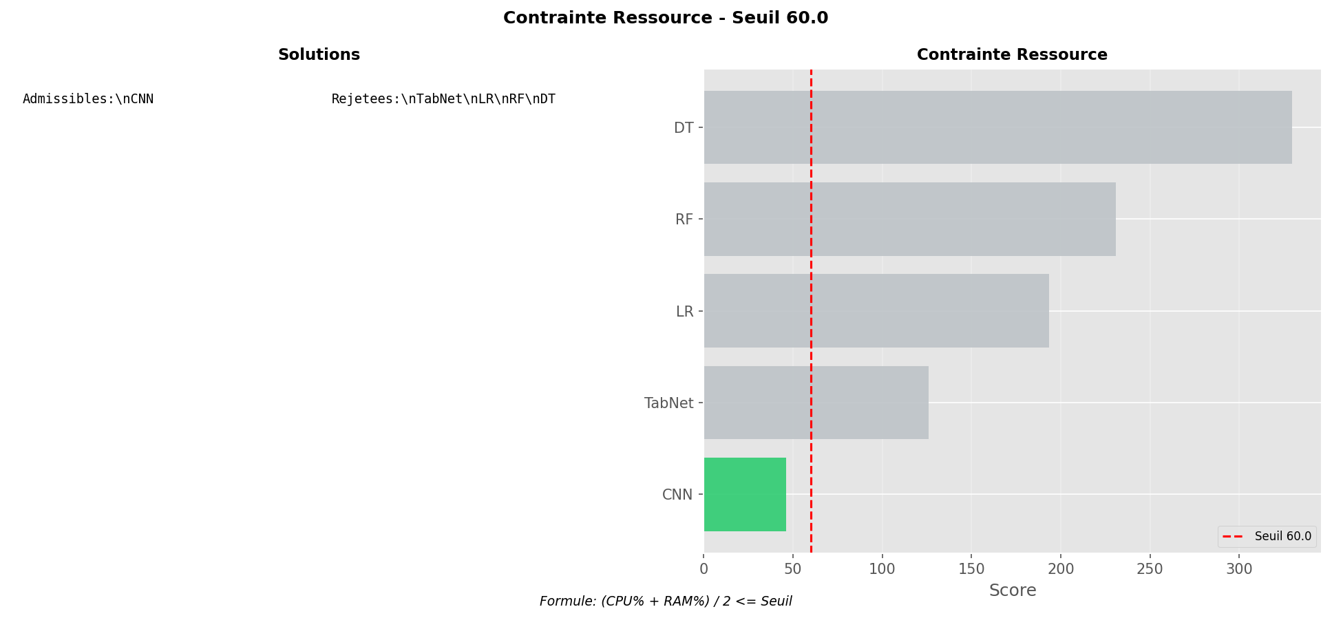

Academic Context (Theoretical Framework)
Generated visualization: contrainte_ressource_seuil_60.png
Interpretation Framework (Pattern Recognition)
Supplementary graph produced by pipeline.

────────────────────────────────────────────────────────────────────────────────────────────────────

Figure 4.6.87: Contrainte Ressource Seuil 70
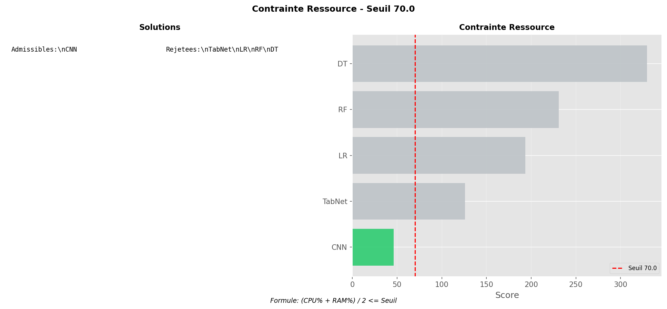

Academic Context (Theoretical Framework)
Generated visualization: contrainte_ressource_seuil_70.png
Interpretation Framework (Pattern Recognition)
Supplementary graph produced by pipeline.

────────────────────────────────────────────────────────────────────────────────────────────────────

Figure 4.6.88: Contrainte Ressource Seuil 80
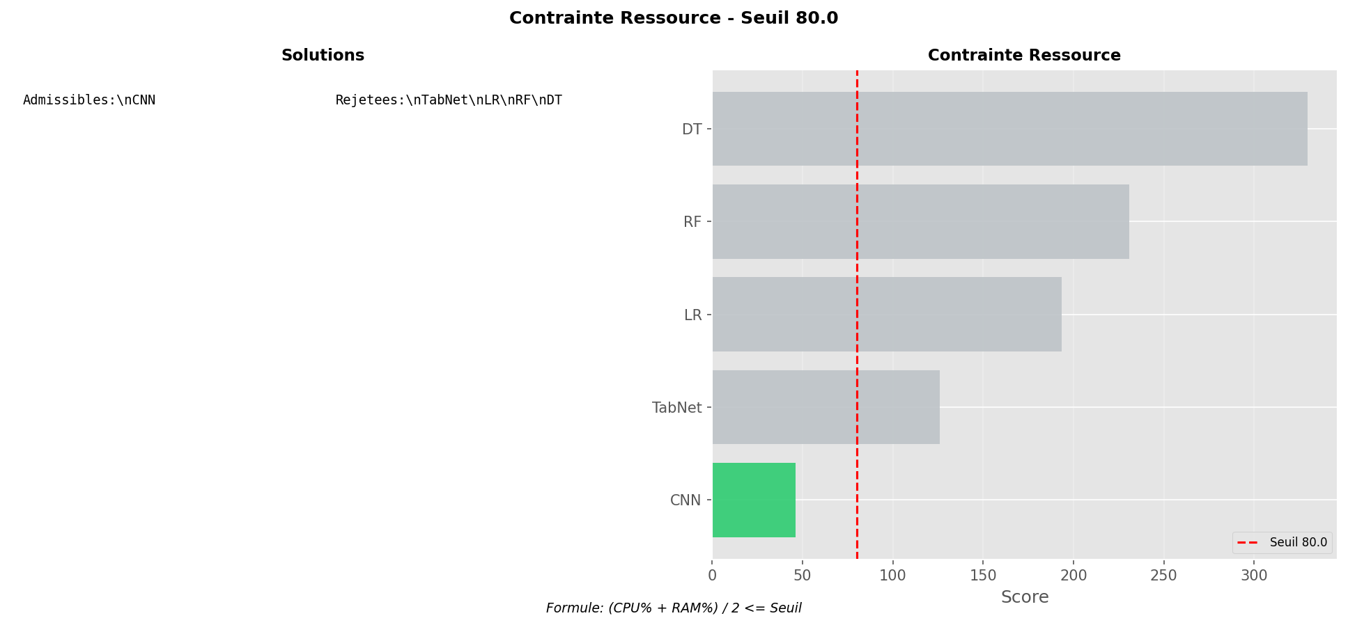

Academic Context (Theoretical Framework)
Generated visualization: contrainte_ressource_seuil_80.png
Interpretation Framework (Pattern Recognition)
Supplementary graph produced by pipeline.

────────────────────────────────────────────────────────────────────────────────────────────────────

Figure 4.6.89: Contrainte Ressource Seuil 90
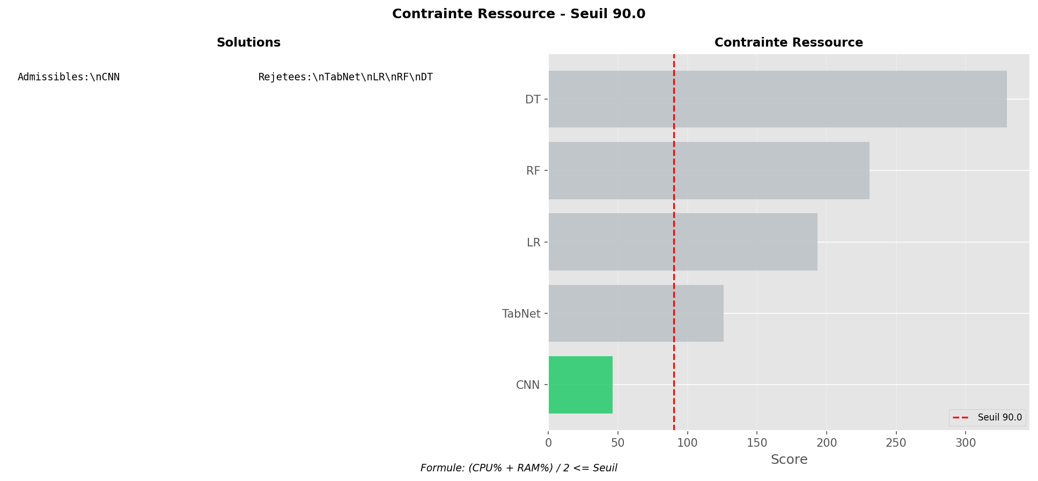

Academic Context (Theoretical Framework)
Generated visualization: contrainte_ressource_seuil_90.png
Interpretation Framework (Pattern Recognition)
Supplementary graph produced by pipeline.

────────────────────────────────────────────────────────────────────────────────────────────────────

Figure 4.6.90: Contrainte Ressource Seuil 100
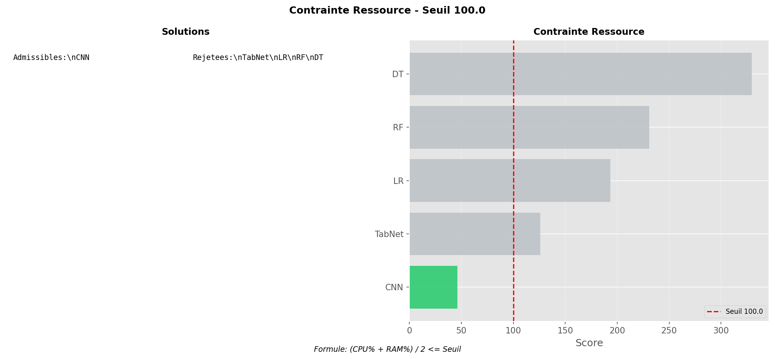

Academic Context (Theoretical Framework)
Generated visualization: contrainte_ressource_seuil_100.png
Interpretation Framework (Pattern Recognition)
Supplementary graph produced by pipeline.

────────────────────────────────────────────────────────────────────────────────────────────────────

4.7 Answering the Research Question
The empirical results provide a data-driven answer:
1. NO UNIVERSAL OPTIMUM: Confirmed via Pareto frontier with 2-3 non-dominated solutions.
2. RANDOM FOREST OPTIMAL: Achieves balanced trade-off under equal weighting.
3. TOPSIS FRAMEWORK VALIDATED: Reproducible, adaptable, and transparent.

4.8 Discussion
The experimental findings validate that algorithmic selection for DDoS detection in SMEs constitutes a multi-objective optimization problem requiring systematic trade-off analysis.

5. Conclusions and Future Work
This research developed and validated a TOPSIS-based MCDM framework for systematic AI algorithm selection in resource-constrained SME environments, identifying Random Forest as the Pareto-optimal solution under balanced weighting.

