Blender addon
Simplify Multiple F-Curves
v1.5 – 9 March 2016
<fabrizio.nunnari@dfki.de>

Reference Page: http://slsi.dfki.de/software-and-resources/keyframe-reduction/

Introduction
Simplify Multiple F-Curves is a Blender addon that performs keyframe decimation over a selection of F-Curves over the time-window of your choice: it reduces the number of keyframes and ensures that their remaining control points are temporally aligned. Having the control points aligned on a few time values simplifies the later manual edit of simplified animation.

Features:
- Simplify by specifying the number of maximum keyframes to retain after simplification;
- Retained keyframes are ALL temporally aligned across the curves;
- Simplify only over a restricted time range.

The following pictures show the result of simplifying three curves, each one composed of 15 keyframes (top). Note that the resulting 10 keyframes are temporally aligned (below) .
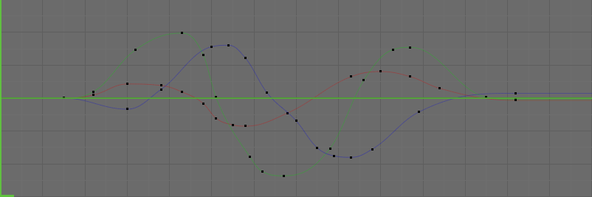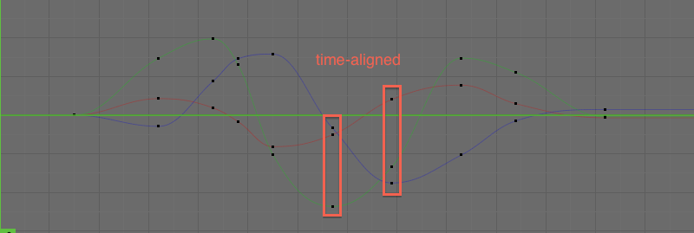

Installation
Install the addon script and enable it.
Open the user preferences window (menu File / User Preferences), go into the “Addons” tab, select “Install from file...” and select the SimplifyMultipleFCurves.py file on your hard drive.
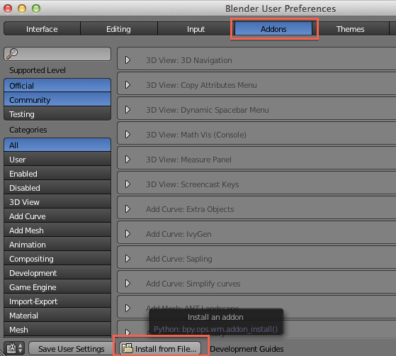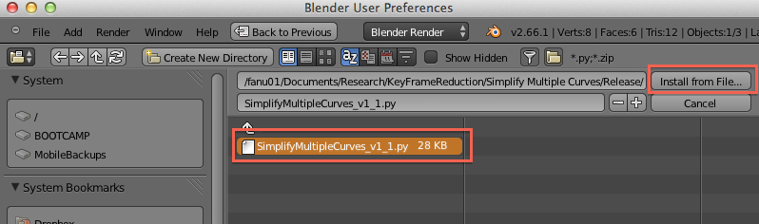
Enable the addon in the Animation section by checking the box on the right side of the description dialog
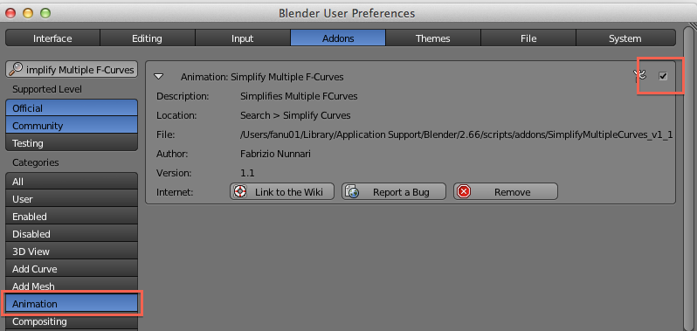
For more details, check the official documentation for more details on addons installation: http://wiki.blender.org/index.php/Doc:2.6/Manual/Extensions/Python/Add-Ons

Usage
Open the Graph Editor / F-Curves Editor. The contorl panel of the addon is in the tools panel.
Since it is possible that more fcurves than the visible ones are selected, the “Selected Curves” counter helps you in tracing for non-visible selected curves. The “Deselect F-Curves on Active Object” helps you in deselecting all the fcurves at once, without having to go to the dopesheet.
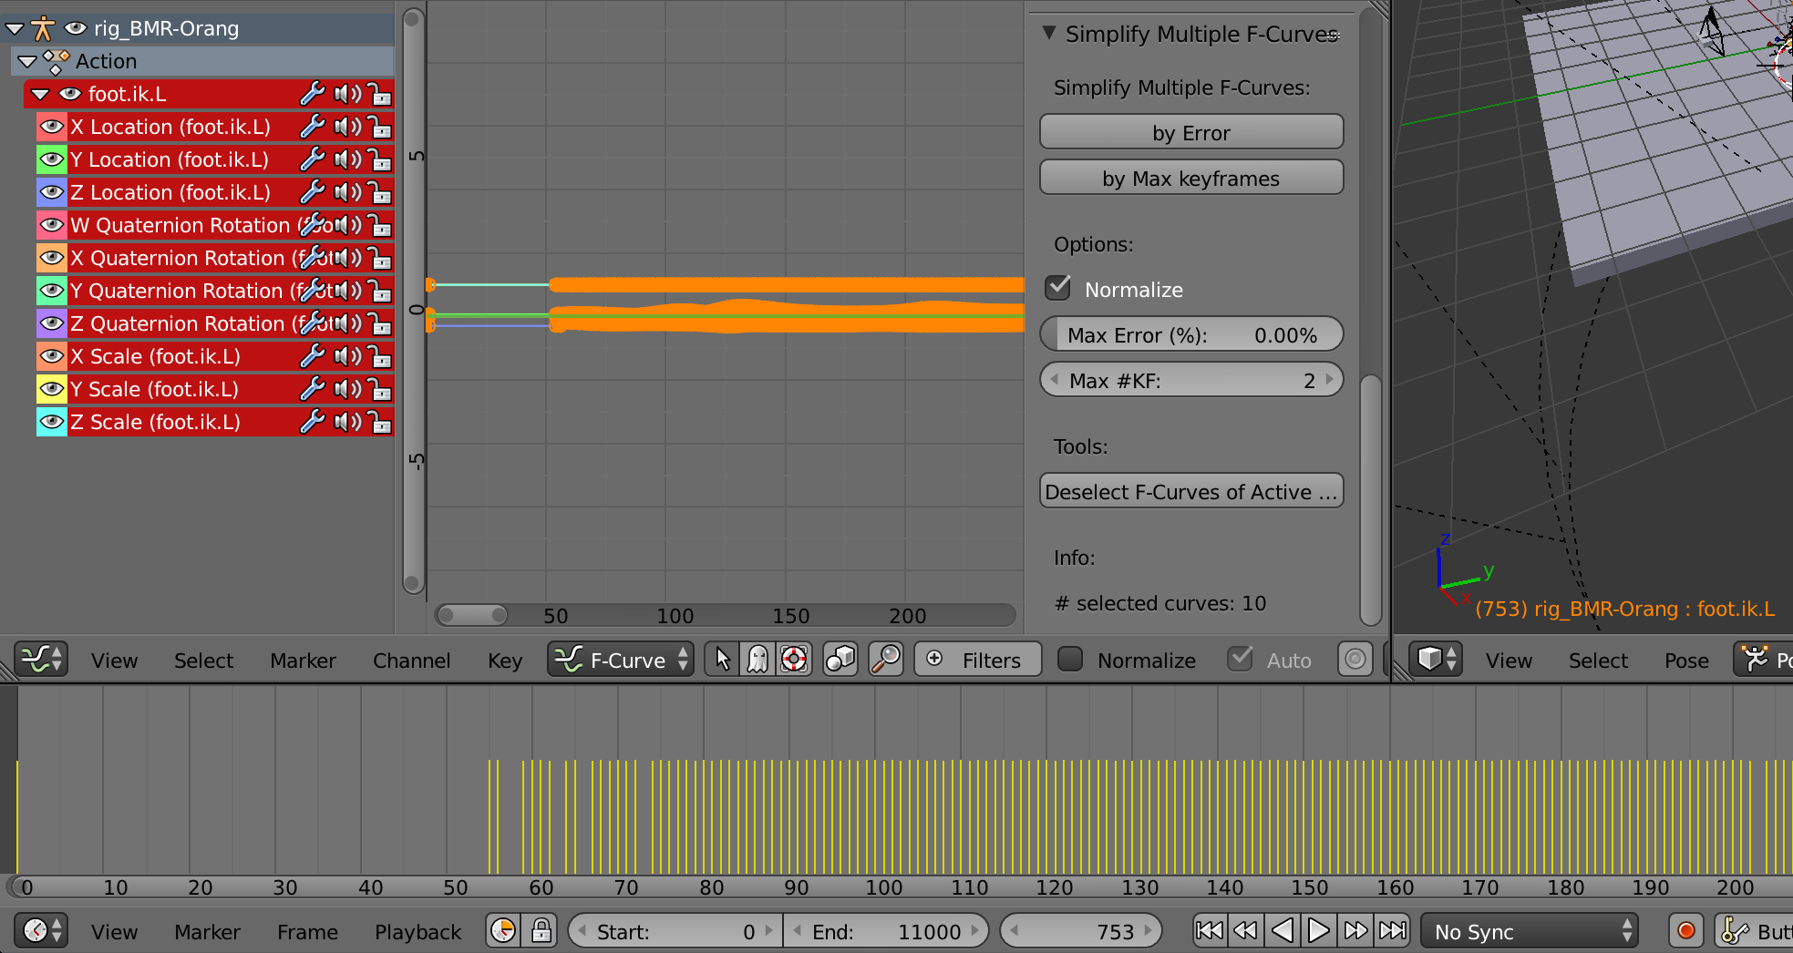
In order for the script to run, the selection must include at least 1 curve. The curve must contain at least 2 keyframes.
You can simplify the curves selecting a relative error or by specifying the maximum number of keyframes to retain.

Normalization
The normalization option is useful when not all the curves share the same “amplitude scale”. For example, in general, when you simplify together two curves, one operating on translation, with an extension from -100 to 100, and the other one operating on a scale element, with an extension from 0 to 1, the translation curve will “dominate” the error calculation and the scaling curve will always be oversimplified. When the normalization option is active, all curves will be normalized in a range [0,1] before simplification, thus treated with the same “priority”.

Simplify by Error
First specify the percentage of error. All the keyframes whose amplitude is below the specified percentage of the maximum aplitude among all curves, will be eliminated. The higher the percentage, the more keyframes are eliminated. With an error of 0%, no keyframes will be removed; with a value of 100%, only two keyframes will be kept: the first and the last one.
After decided for an error percentage, click of the by Error button.
This option is the fastest of the two, but it is impossible to predict how many keyframes will be retained. Just try it, undo, and repeat with a different percentage until satisfied. The following example shows a simplification of 2%.

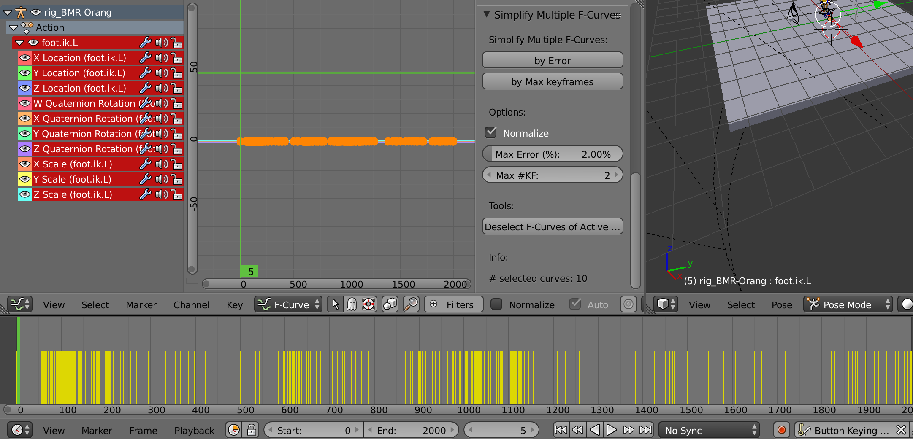
The simplification value is related to the error computed by comparing the original curves and the simplified curve. An error of 0% means that no keyframes will be removed, a value of 100% means that only two keyframes will be kept: the first and the last one.

Simplify by Max Keyframes
This option allows you to specify the maximum number of keyframes that should be kept in the simplified curves. This includes borders, so the minimum number of keyframes to retain is 2.
This option is the slowest of the two. Several simplification steps will be automatically performed, with different errors, until the number of retained keyframes is as close as possible but below the requested number.
The following picture shows an example where 200 keyframs where retained out of 2000.
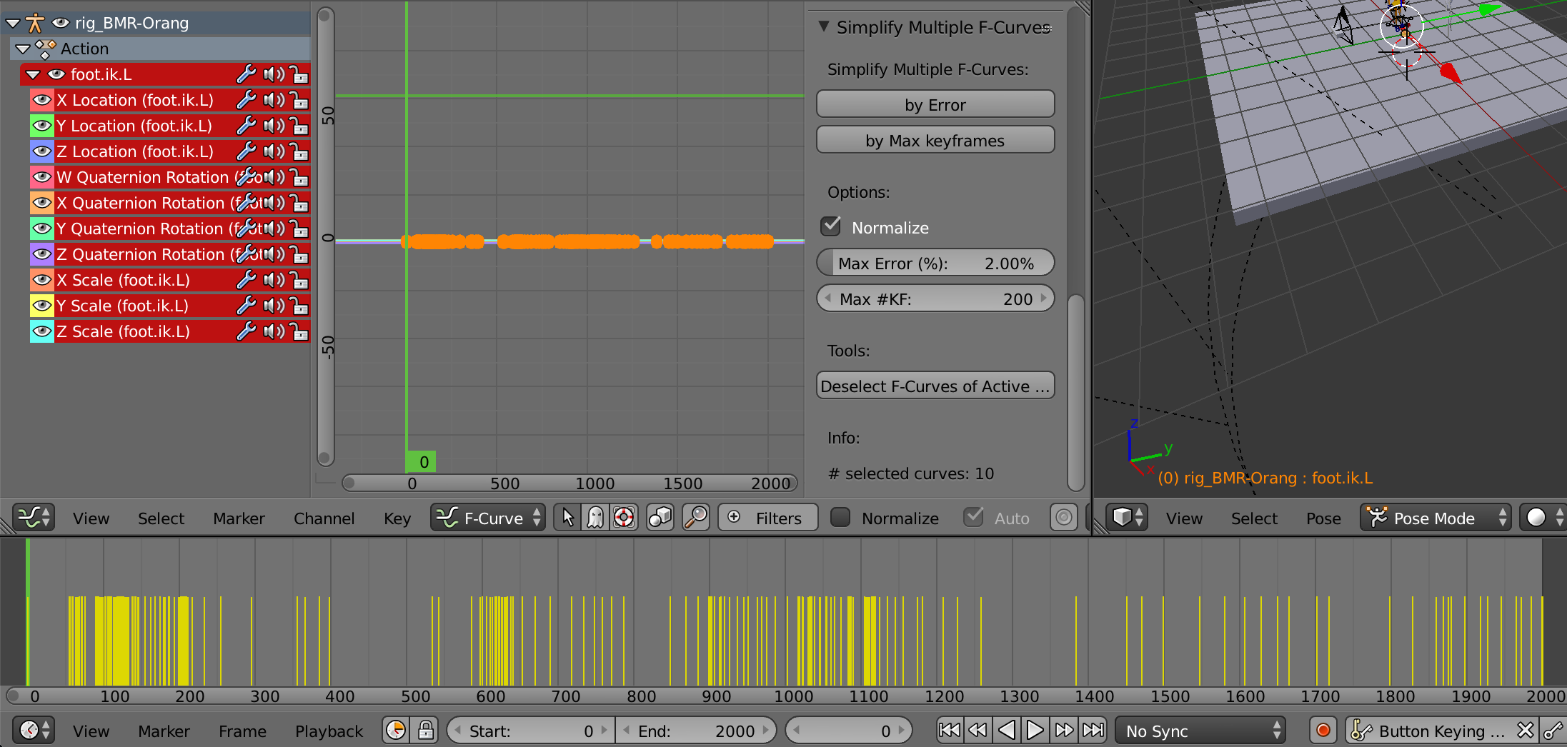

Range selection
It is possible to operate only on a restricted time window. The addon performs curve simplification over the range that is specified as a scene-preview range (use the P key to select a preview range in the F-Curves Editor).
The time range selection must include at least 2 keyframes. The leftmost and rightmost keyframes within the selected range will be retained and used as first and last keyframes. No new keyframes will be created at range selection borders!
The following picture shows an example where a simplification requesting to preserve max 50 keyframes was applied on a selected range of circa 500 frames.
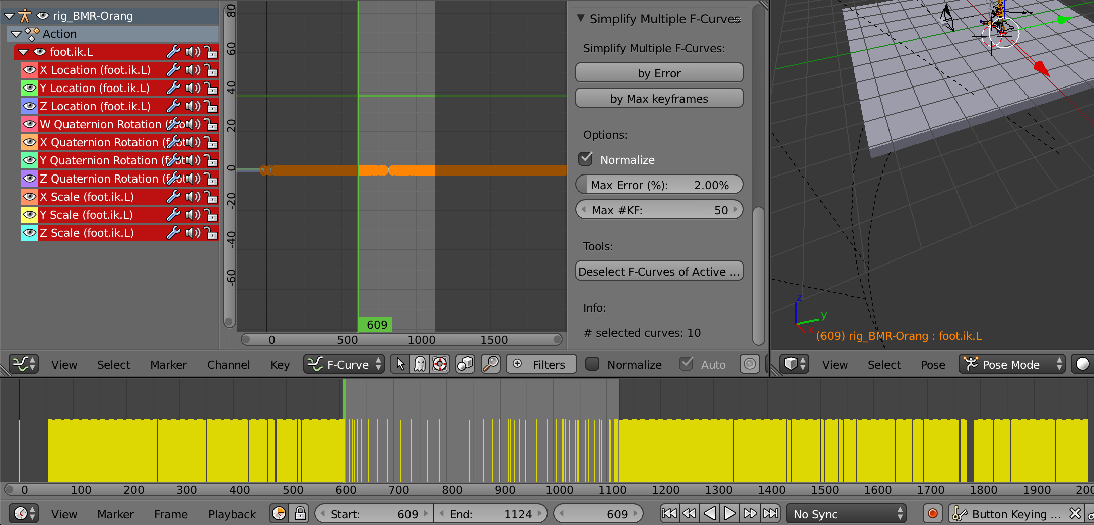

How it works
The algorithm is essentially based on the following strategy.
- First the selected curves are analyzed and information about their keyframes stored.
  - All the curves are analyzed in parallel, starting from their first keyframe. Each time a keyframe is encountered on a curve:
    - if the curve already has a keyframe at that frame position its value is stored,
    - otherwise a new keyframe is evaluated by interpolation.
- Then, given a simplification percentage, the curves information are analyzed to retrieve a list of keyframes to retain.
  - The simplification percentage is converted into an “error” with respect to the maximum extension among all curves.
  - This error is used to apply a Ramer–Douglas–Peucker algorithm, with a little variant:
    - the error comparison is performed among all curves in parallel;
    - if at least one curve has a keyframe to retain, the same frame position is retained for all curves in the selection.
- Finally, the selected curves in the graph editor are reconstructed:
  - the keyframes (within the selected range) are completely deleted;
  - new keyframes are re-built according to the original stored information and the list of keyframes to retain.

Limitations
- When executed on a selection on non-aligned curves, at simplification 0% (retain all keyframes) the resulting number of keyframes might be greater than the number of original keyframes. That's because when at least a curve has a keyframe at a certain frame, new keyframes are created for the curves not having one at the same frame. This might be a bit misleading for the user. This issue doesn't emerge when working on full-frame-rate motion capture recordings.
- No tangent information is retained from the original curves.

Known Issues
- When performing massive simplification, the graph editor curves are not immediately updated. You have to click on the editor to force an update, or move the slider to force additional updates.

Credits
Simplify Multiple F-Curves has been developed by Fabrizio Nunnari, in collaboration with Alexis Heloir for the Sign Language Synthesis and Interaction research group at DFKI / MMCI, Saarbrücken, Germany.

The addon implementation has been inspired and contains some code from two existing addons:
- The Simplify curves addon: http://wiki.blender.org/index.php/Extensions:2.6/Py/Scripts/Curve/Curve_Simplify
- The “Samples to Bezier” tool of the Motion Capture addon: http://wiki.blender.org/index.php/Extensions:2.6/Py/Scripts/Animation/Motion_Capture_Tools

