

Vertriebstrans-formation alpla industrial
Transformationsnarrativ

FehrAdvice & Partners AG
November 2025

Change Story

1. Starting Point – Recognition & Belonging
"I’ve been part of ALPLA for many years now – and I know what these plants and these people are capable of. I’ve spoken to many of you – in Hungary, Romania, Austria. And I’ve experienced something powerful: trust. Trust in the work. Trust in each other. Trust in the responsibility you carry on the ground."

2. Why Change? – Building the Bridge to Necessity
In recent weeks, I’ve had countless conversations – with people who know their plants, their teams and their customers inside out. With colleagues who carry responsibility with passion. What I heard was impressive – but also unmistakable: Everyone is giving their all. Fighting hard. But often, fighting alone.
One story in particular stayed with me: Someone told me about a potential new customer in Germany. The interest was there. The requirements were clear. Everything was prepared. Then – silence. No one followed up. Eventually, someone else got in touch – with a different approach, without coordination. The customer was confused. The opportunity? Lost. Not because we weren’t good enough. But because we weren’t aligned.
And this wasn’t an isolated case. We don’t have a shared view of the customer. No systematic feedback processes. No clear responsibility across sites. Knowledge remains local. Ideas fade. Energy gets lost – not due to a lack of commitment, but due to a lack of structure.
But just imagine what would be possible if we could harness that energy. A key account in Poland asks for an innovative, recycled packaging solution. Within 48 hours, colleagues from Austria, Hungary and Romania meet digitally – sales, engineering and customer service. Together, they develop a proposal. Not off-the-shelf, but tailor-made. The presentation is integrated, the messaging is consistent, the offer is on point. And the customer senses: This is a partner who understands what I’ll need tomorrow – not just what I want today.
In that moment, we’re not just fast. Not just reliable. We are partners on equal footing. Drivers of innovation. Enablers of progress. And this is no fantasy. The know-how is here. The people are here. The energy is here. What comes next is the structure that turns all of this into a learning, connected, courageous system. A system that speaks with one voice to the market.

3. What Stays – What Changes
"We’re holding on to what has made us strong: closeness, pragmatism, a strong will to find solutions. But we are building a structure that helps us scale these strengths – together. With a centrally guided sales organization – but regionally grounded. With clearly defined roles – but local know-how. With new segment-based approaches – but the same people who already take responsibility today."

4. Emotional Reassurance – Especially for Plant Leadership
"I know this isn’t easy. Letting go of responsibility – or living it differently – can feel like losing something. But I see it differently: We’re creating space. For more focus, more clarity, more shared impact. And to make that happen, we need you – not less, but more than ever before."

5. Activation – Perspective for Sales & Customer Service
"At the same time, we are creating new opportunities: For our sales teams to grow within segments. For customer service to be closer to the customer – while remaining strategically connected. For everyone who wants to shape the future: This new sales model is not a machine. It’s a system that comes alive through people."

6. Involvement – Dialogue & Responsibility
"Change doesn’t work by decree. And it takes more than good plans – it takes good people to bring those plans to life. That’s exactly why I want to say clearly today: The new structure is coming. The direction is set. But how we walk this path together – that’s in our hands. We know: The details will make the difference. And that’s where we need you – your experience, your judgement, your concerns and your ideas.
We will speak personally with all key stakeholders, clarify responsibilities through dialogue, establish concrete formats for exchange, and create feedback loops that truly make a difference.
We won’t get everything right from the start – but we will move forward pragmatically and together. Not everything will fit perfectly right away. But we are building a system that can adapt – if we stay open, support each other, and keep our shared goal in sight."

7. Closing – Attitude & Outlook
"I’m convinced: We can do this. Because we’re building on a strong foundation. Because we think together. And because we don’t work against each other – but for each other. For our customers. For our future. For ALPLA Industrial."


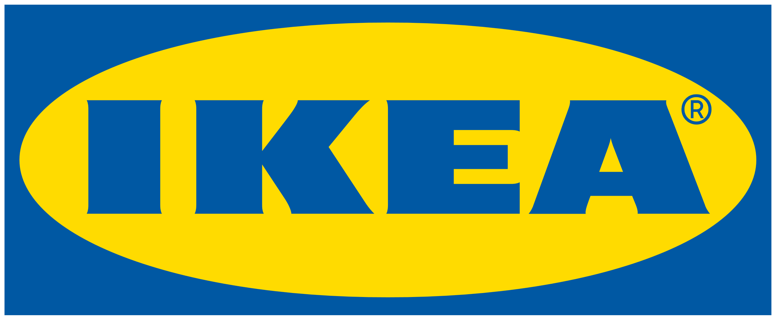



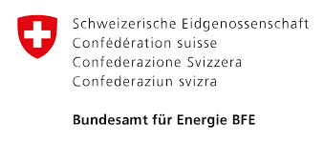

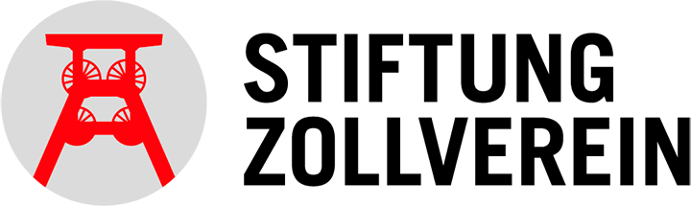


Über 6000+ experimente
400+ erfolgreiche Projekte für unsere Kunden
18 Branchen vertrauen unserer Expertise
Zu unseren Kunden zählen:

