ChatGPT
Purpose: To size the main passive components of an LT1959 buck converter to generate 3.3 V / 200 mA from a rated 7.4 V 2S LiPo battery, with a maximum requested output ripple of 50 mV and an inductor current ripple of 30%.

1. Data and assumptions
Size | Value | Comment
Vin | 7.4 V | Rated Voltage 2S LiPo Battery
Vout | 3.3 V | Microprocessor power supply
Is | 200 mA | Rated Current
ΔVS max | 50 mV peak-to-peak | Maximum Allowable Ripple at the STM32 Input
ΔIL | 30% Is = 60 mA i.e. | Inductor Current Ripple
fs | 500 kHz | LT1959 Fixed Frequency
VFB | 1.21 V | FB Pin Reference
Important note: the calculations below are made at the ratted point Vin = 7.4 V. For a series design, it is also necessary to check the fully charged battery, typically 8.4 V for a 2S LiPo, and the dead battery. As the LT1959 is greatly oversized in current for 200 mA, the dominant constraints will be more ripple, stability, choice of output capacitor and routing.

2. Principle Electrical Diagram
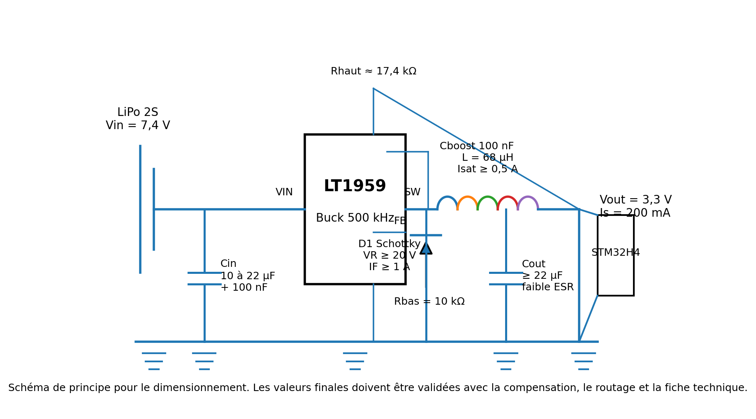
Figure 1 - Schematic diagram of the LT1959 to 3.3 V buck converter.

3. Duty cycle
As a first approximation, neglecting the drops in the internal switch and in the freewheel diode:
D = Vout / Wine = 3.3 / 7.4 = 0.446, i.e. 44.6%.
At 500 kHz, the switching period is T = 1 / fs = 2.00 μs. We obtain Ton = D.T = 0.89 μs and Toff = (1-D). T = 1.11 μs.

4. Inductor Sizing
For a buck in continuous conduction mode, the peak-to-peak ripple of the inductor current is:
ΔIL = (Vin - Vout). D / (L.fs)
So L = (Vin - Vout). D / (fs.ΔIL) = (7.4 - 3.3) × 0.446 / (500 kHz × 60 mA) = 60.9 μH.
Recommended normalized value: 68 μH. With 68 μH, the ripple is about 53.8 mA p-to-p, or about 26.9% of the rated current.
Peak current in the inductor: Ipk = Is + ΔIL/2 = 200 mA + 30 mA = 230 mA. Minimum current: Imin = 170 mA. Choose an inductor with a much higher saturation current, e.g. Isat ≥ 0.5 A, and a low series resistor to limit losses at low voltages.

5. Output capacitor
The output ripple has two main contributions: capacitive load/discharge and ESR drop of the capacitor. The ideal capacitive component is:
ΔVcap = ΔIL / (8.fs. Cout)
Imposing ΔVcap ≤ 50 mV: Cout≥ ΔIL / (8.fs.ΔV) = 60 mA / (8 × 500 kHz × 50 mV) = 0.30 μF.
The purely capacitive stress is therefore very low. The ESR constraint gives: ESR ≤ ΔV / ΔIL = 50 mV / 60 mA = 0.83 Ω.
Recommended practical choice: at least 22 μF ceramic X7R in the output, supplemented if necessary by 100 nF close to the load. The actual value of a ceramic capacitor decreases with DC polarization, so the effective capacitance at 3.3 V must be checked. For a microprocessor, the goal is not only ripple at 500 kHz, but also to withstand fast current demands.

6. Input capacitor
The input capacitor must provide the pulsed current from the converter and remain close to the VIN/GND pins of the LT1959. Its approximate RMS current is:
Icin,rms ≈ Is.sqrt(D.(1-D)) = 0,2 × sqrt(0.446 × 0.554) = 99 mA RMS.
To aim, for example, for 100 mV of low-frequency switching input ripple, an estimate gives Cin ≥ Is.D. (1-D)/(fs.ΔVin) = 0.99 μF. In practice, retain 10 to 22 μF low ESR, with a ceramic 100 nF directly as close as possible to VIN and GND.

7. FB Return Bridge
The output voltage is set by: Vout = VFB × (1 + Rhaut/Rbas).
By choosing Rbas = 10 kΩ: Rhaut = 10 kΩ × (3.3/1.21 - 1) = 17.27 kΩ.
Normalized value: Rhaut = 17.4 kΩ and Rbas = 10 kΩ, which gives Vout ≈ 3.32 V. An alternative is Rhaut = 17.2 kΩ to obtain about 3.29 V.

8. Freewheel Diode and Boost Capacitor
The freewheel LED drives during Toff. Its average current is Id,avg ≈ Is. (1-D) = 0.2 × 0.554 = 111 mA. Its peak current is close to the inductance peak current, i.e. about 230 mA at the ratted point.
Choose a fast Schottky diode with 20 V VRRM and IF ≥ 1 for a comfortable headroom. The reverse voltage must at least support Vin, and the routing must minimize the LT1959 loop - diode - input capacitor.
The boost capacitor used by the internal control is typically 100 nF, placed as close as possible to the BOOST and SW pins, according to the application diagram of the data sheet.

9. Expected Waveforms
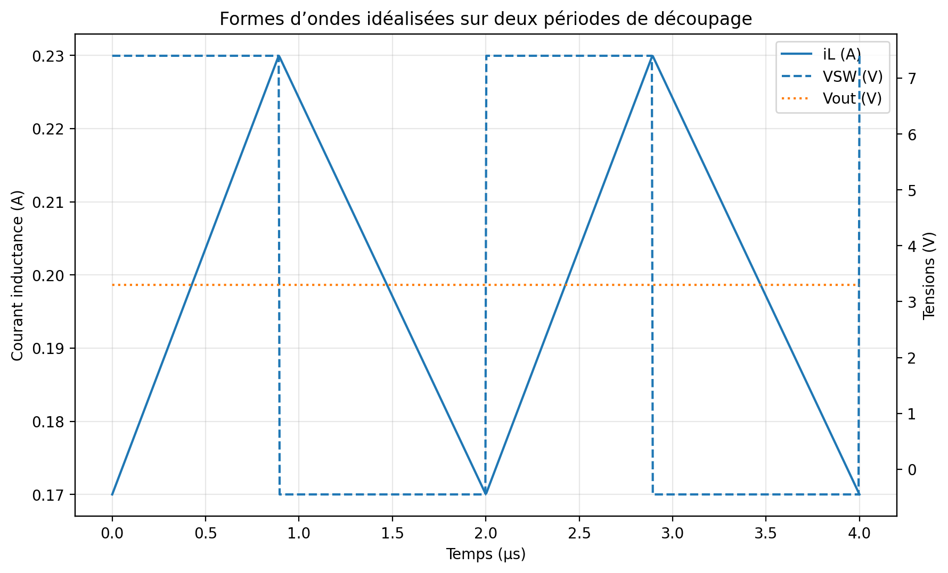
Figure 2 - Current in the inductor, SW voltage and output ripple idealized.
The inductance current is triangular in continuous conduction. The SW pin switches between a value close to Vin during Ton and a slightly negative voltage during Toff, limited by the freewheel diode. The output voltage is almost continuous, with residual ripple dependent on ΔIL, Cout, ESR and routing.

10. Summary of the proposed values
Component | Calculated Value / Constraint | Proposed choice
L | 60.9 μH for ΔIL = 60 mA | 68 μH, Isat ≥ 0.5 A
Cout | ≥ 0.30 μF and ESR ≤ 0.83 Ω | 22 μF X7R + 100 nF, low ESR
Cin | Irms≈ 99 mA; Low minimum capacity | 10 to 22 μF low ESR + 100 nF near LT1959
Rhaut/Rbas | Rhaut = 17.27 kΩ as Rbas = 10 kΩ | 17.4 kΩ / 10 kΩ
D1 | Id,avg≈ 111 mA; Peak ≈ 230 mA | Schottky ≥ 20 V, ≥ 1 A
Cboost | According to LT1959 application | 100 nF near BOOST-SW
Conclusion: At the ratted point 7.4 V to 3.3 V / 200 mA, a 68 μH inductance and a 22 μF ceramic output capacitor give a comfortable margin with respect to the 50 mV ripple. However, loop stability must be validated with VC pin compensation, actual capacitor characteristics, and PCB routing.

References
Analog Devices, LT1959 product page and data sheet: 500 kHz buck regulator, 1.21 V FB adjustable output, 4.5 A switch, 4 V minimum input, VIN/GND/SW/diode routing recommendations.

