Claude
Parameter | Value
Input voltage (LiPo 2S battery) | VIN = 7.4 V
Output voltage | VOUT = 3.3 V
Nominal output current | IS = 200 mA
Inductor current ripple | ΔIL = 30% of IS
Max output voltage ripple | ΔVS = 50 mV
Switching frequency (LT1959) | f = 500 kHz

1. Duty Cycle
For an ideal buck converter in continuous mode:
D = VOUT / VIN
D = 3,3 / 7,4
D = 0,446 → ton = 0,892 µs / toff = 1,108 µs
Check : D = 44,6 % < 50 % → peak current IP = 4,5 A guaranteed by LT1959.

2. Inductor L1

2.1 Target current ripple
The peak-to-peak current ripple in the inductor is set to 30% of the output current:
ΔIL = 0,30 × IS = 0,30 × 200 mA
ΔIL = 60 mA

2.2 Minimum value of L
The formula from the datasheet LT1959 for continuous conduction mode is:
L = (VOUT × (VIN - VOUT)) / (VIN × ΔIL × f)
L = (3,3 × (7,4 - 3,3)) / (7,4 × 0,060 × 500×10³)
L = (3,3 × 4,1) / (7,4 × 30 000)
L = 13,53 / 222 000
L_min = 60,9 µH
Standard value: L1 = 10 µH (standard serie, available with Isat > 500 mA).
Note: with L = 10 µH, the actual ripple will be lower than the 30% target:
ΔIL_réel = (VOUT × (VIN - VOUT)) / (VIN × L × f)
ΔIL_réel = (3,3 × 4,1) / (7,4 × 10×10⁻⁶ × 500×10³)
ΔIL_real ≈ 365 mA → 18 % ok IS ✓ (< 30 %)

3. peak and valley currents in the inductor
IL_peak = IS + ΔIL_real/2 = 200 + 183 = 383 mA
IL_valley = IS - ΔIL_real/2 = 200 - 183 = 17 mA
Continuous conduction mode check: IL_valley > 0 ✓
Saturation current required: Isat > IL_peak = 383 mA → inductor standard 10 µH ok.

4. Output capacitor C3

4.1 ESR constraint (voltage ripple)
The output voltage ripple is mainly determined by the capacitor’s ESR:
ΔVS ≈ ΔIL_real × ESR
ESR_max = ΔVS / ΔIL_real = 50×10⁻³ / 0,365
ESR_max = 136 mΩ
Chosen capacitor: AVX TPS 100 µF / 10 V (tantalum solide, ESR typ. 100 mΩ < 136 mΩ) ✓

4.2 Capacitance value
The value in µF is not critical. With C3 = 100 µF:
Capacitive ripple = ΔIL / (8 × f × C3)
= 0,365 / (8 × 500×10³ × 100×10⁻⁶)
= 0,91 mV (negligible compared to the ESR contribution)

5. Input capacitor C1
The RMS current in the input capacitor is:
I_C1_rms = IS × √(VOUT × (VIN - VOUT)) / VIN
I_C1_rms = 0,200 × √(3,3 × 4,1 / 7,4)
I_C1_rms = 0,200 × √(0,183)
I_C1_rms ≈ 85,5 mA
Chosen capacitor: C1 = 100 µF / 10 V, tantalum AVX TPS (Iripple ≥ 0,7 A) ✓

6. Freewheel diode D1
Average current in D1 :
ID1_avg = IS × (VIN - VOUT) / VIN
ID1_avg = 0,200 × (7,4 - 3,3) / 7,4
ID1_avg = 110 mA
Max reverse voltage = VIN = 7,4 V
Selected Diode: MBRS330T3 (Schottky, 3 A / 30 V, VF typ. 0,5 V @ 3 A) ✓

7. Capacitor BOOST C2
The capacitor BOOST supplies the switch NPN driver to saturate it. The minimum value is:
C2_min = (IS/50) / (f × 0,6)
C2_min = (0,200/50) / (500×10³ × 0,6)
C2_min ≈ 13 nF → C2 selected = 0,68 µF (datasheet standard value) ✓
Diode D2 : 1N914 or 1N4148, anode connected to VOUT.

8. Feedback network (R1, R2)
The internal voltage is VREF = 1,21 V. The resistive divider R1/R2 fixes VOUT :
VOUT = VREF × (1 + R1/R2)
→ R1/R2 = (VOUT/VREF) - 1 = (3,3/1,21) - 1 = 1,727
Choice of R2 ≤ 2,5 kΩ (datasheet recommandation) : R2 = 2,49 kΩ
R1 = R2 × (VOUT/VREF - 1) = 2490 × 1,727
R1 = 4 298 Ω → standard value: R1 = 4,32 kΩ (E96, 1 %)
Verification:
VOUT = 1,21 × (1 + 4320/2490) = 1,21 × 2,735
VOUT = 3,309 V ✓ (error < 0,3 %)

9. Compensation capacitor VC (CC)
The default compensation recommended by the datasheet for most applications is:
CC = 1,5 nF (condensateur seul, RC = 0)
This network creates a pole at:
f_pole = 1 / (2π × ROUT_EA × CC) ≈ 530 Hz
The loop phase margin remains > 60° at the crossover frequency (≈ 100 kHz), ensuring stability.

10. Components summary
Reference | Value / Type | Role | Design criterion
L1 | 10 µH, Isat > 400 mA | Filtering inductor | ΔIL ≈ 18 %
C1 | 100 µF / 10 V Tant. | Input capacitor | Iripple ≥ 86 mA
C2 | 0,68 µF ceramic | Capacitor BOOST | Charge driver NPN
C3 | 100 µF / 10 V Tant. | Output capacitor | ESR ≤ 136 mΩ
CC | 1,5 nF ceramic | Compensation VC | Loop stability
D1 | MBRS330T3 (3A/30V) | Freewheel Diode | VF low, Schottky
D2 | 1N914 / 1N4148 | Diode BOOST | Fast, low VF
R1 | 4,32 kΩ 1 % | Divider FB (haut) | Set VOUT
R2 | 2,49 kΩ 1 % | Divider FB (bas) | Set VOUT

11. Electrical Schematic
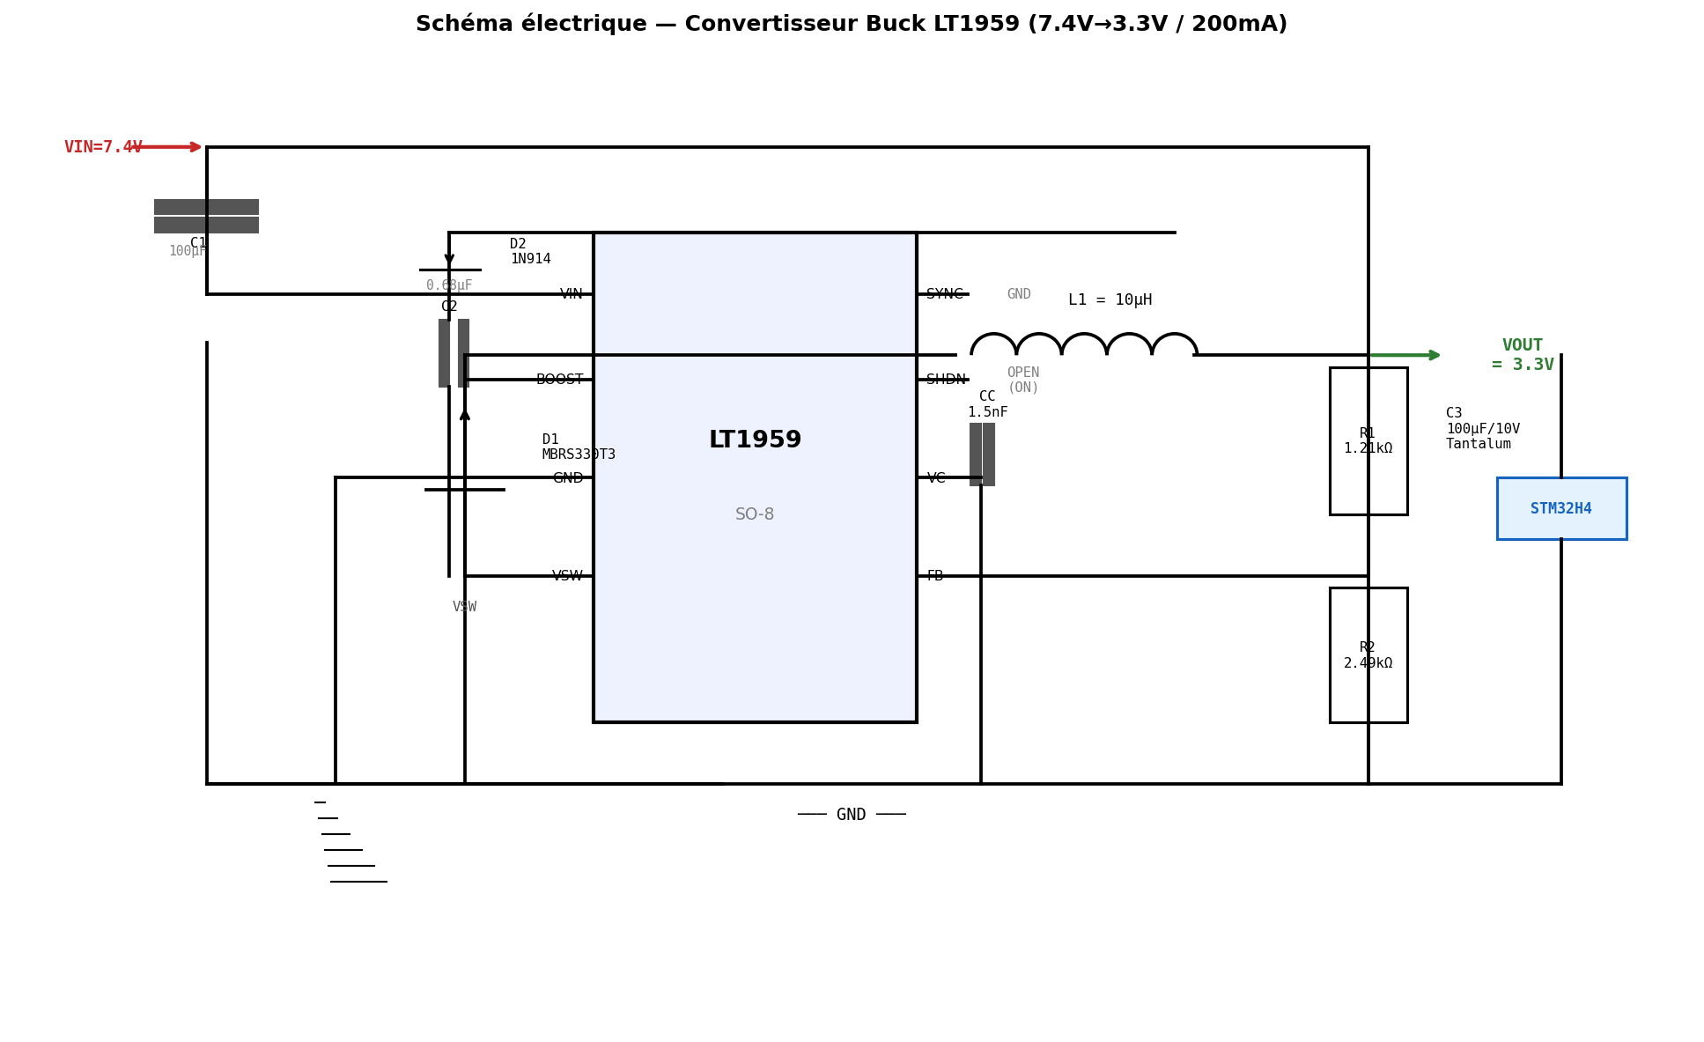
Figure 1 — Schematic of Buck LT1959 converter (7,4 V → 3,3 V / 200 mA)

12. Simulated waveforms
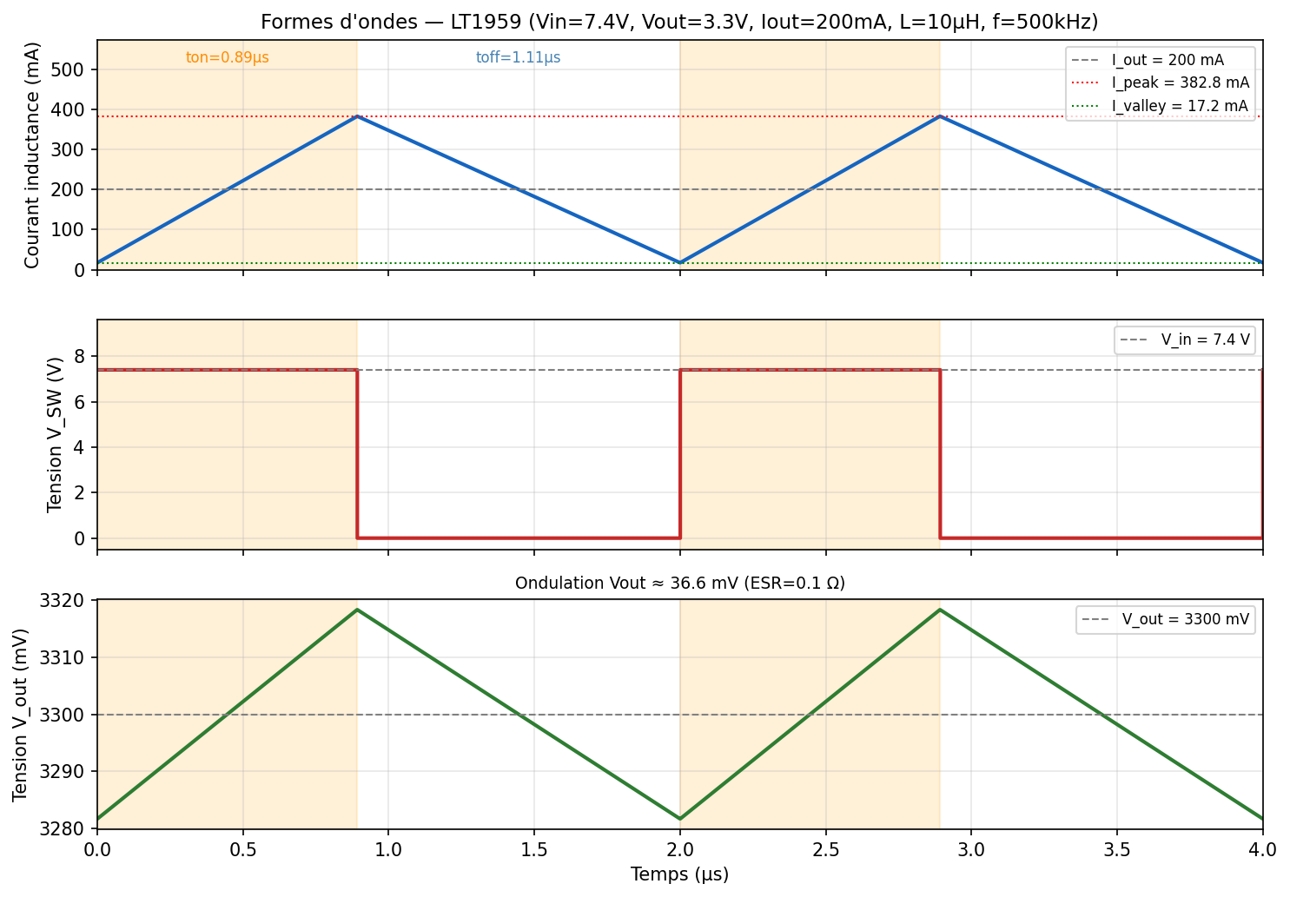
Figure 2 — Inductor current IL, voltage VSW and output voltage VOUT over 2 periods (f = 500 kHz)
The orang area represents the conduction time of the switch (ton ≈ 0,892 µs).
VOUT ripple is mainly due to the ESR of the capacitor C3 (≈ 36 mV < 50 mV spec) ✓

Reference : Linear Technology — LT1959 Datasheet, Rev. A.
Calculus realized for IS = 200 mA nominal. Check thermal parameters for higher currents.

