Copilot

1. Specifications
Vin = 7.4 V (LiPo 2S)
Vout = 3.3 V
Iout = 200 mA
Current ripple ΔIL = 30%
Output voltage ripple ΔVout max = 50 mV

2. Duty cycle
D = Vout / Vin = 3.3/7.4 = 0.446

3. Inductor Sizing
Formula : L = Vout*(Vin - Vout) / (Vin * ΔIL * fs)
ΔIL = 0.3 × 0.2 = 0.060 A
L = 60.95 µH → standard value : 68 µH
Maximum current = 0.230 A → choose > 0.5 A

4. Output capacitor
Formula: Cout = ΔIL / (8 × fs × ΔVout)
Cout = 0.30 µF → choice : 47 µF low ESR ceramic

5. Input capacitor
Recommended choice: 10 µF à 22 µF ceramic

6. Voltage divider
Vout = Vref (1 + R1/R2)
R2 = 10 kΩ → R1 = 16.83 kΩ → standard value: 16.9 kΩ

7. Electric schematic
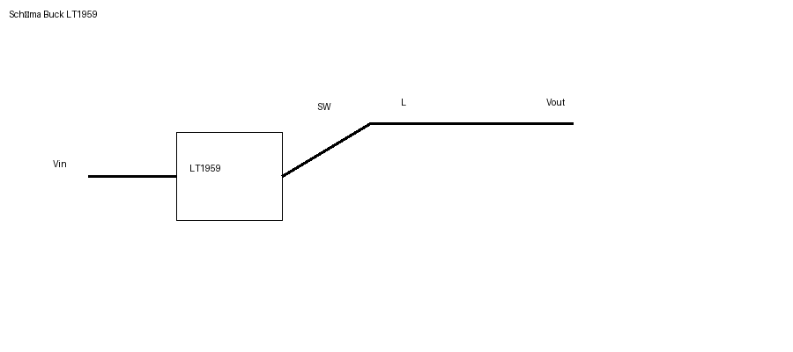

8. Waveforms
