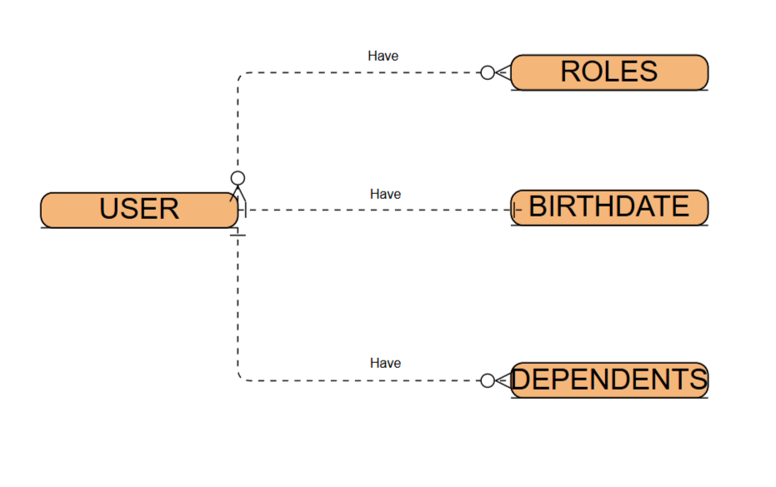

**NoSQL Sequence**

{

“Username”: “John Doe”,

“Birthdate”: “06-03-1995”

“Roles” : [

{

“Rolename”: “Parent”

}

],

“Dependents”: [

{

“Name”: “Jane Doe”,

“Relationship”: “Spouse”,

}

{

“Name”: “Jack Doe”,

“Relationship”: “Child”,

}

]

}