The UPPER command converts text to uppercase. This might be useful for standardizing input or comparing case-insensitive values. This is commonly used in financial analysis because they often import data from external sources.

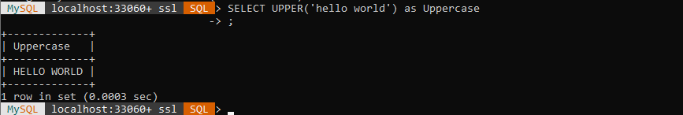

The LENGTH command counts how many characters are in a string. This is used for verifying data and preventing invalid responses. This is commonly seen when checking if a username or password meets a minimum length requirement.

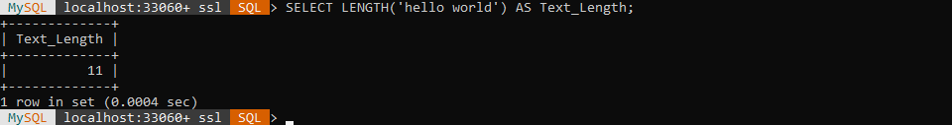

The REVERSE command reverses a string. This can be used to create puzzles or check for palindrome words.

