Heroes of Pymoli Analysis and Findings

Alexis Perumal, 12/3/19

UCSD Data Science Bootcamp, HW#4 Pandas, Ex. 1

**Summary**

The Heroes of Pymoli assignment involves analyzing a dataset of computer game player and in game purchase information around the “Heroes of Pymoli” computer game.

The assignment doesn’t specify the type of insights the company is hoping to achieve from the analysis, but presumably it involves:

1. Derive better insights on who their customers are.
2. Understand what their customers are doing in the game, particularly purchase patterns.
3. Uncover overall insights that can lead to greater monetization and profitability.

Findings about customer demographics and spend patterns are below. They provide an initial look at customer demographics and transaction patterns and suggest further analysis that can enable increased revenue and profit maximization.

**Approach**

Analysis involved creating a jupyter notebook file and using Python and Pandas to analyze the CSV dataset, generating tabular outputs.

**Findings**

1. Our customers are primarily male (84%) and young: 45% between 20 and 24, 83% under 30.
2. Although young males make up most of the customers, famales spend more than males ($4.47 per purchase for females vs. $4.07 for males), with “Other/Non-Disclosed” having the highest total purchase per person at $4.56.

Similarly, although 20-24 makes up the biggest age range by volume, 45% of the customers, it is the 35-39 age group that has the highest average total purchase price per person, $4.76, vs. $4.32 for 20-24.

Note: Analysis of the statistical significance of these differences is beyond the scope of this assignment but should be done before any interventions based on these findings.

1. The highest revenue product (mis-labeled most *profitable* in the assignment) is “Oathbreaker, Last Hope of the Breaking Storm” of with 12 were purchased. No other product sold more than 9. As a result, although it wasn’t the highest priced item, the purchase quantity drove it to be the highest revenue product at $50.76.

**Recommendations**

1. Continue to focus the product on the core market, young males, particularly those between 20-24, but also consider opportunities to serve the highest value customers (females and those age 35-39). As a first step, analysis of statistical significance of the finding is recommended before spending significant resources on those potential maximum value customer segments.
2. Attempt to find cost data, which may require cost modeling, in order to calculate gross margin and overall profitability by product. This will help focus attention on the potential highest impact products.
3. Expand the top spender analysis to attempt to understand attributes correlated with bigger spenders as a first step toward further attracting big spenders, knowing which current customers to target with extra attention, and driving product design to be more appealing to such customers.

**Appendix: Required Tabular Reports**

Player Count

Purchasing Analysis

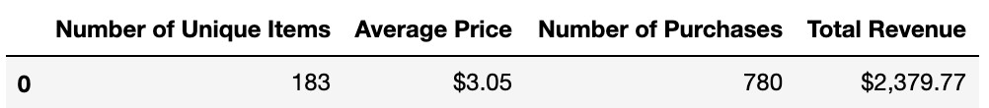

Gender Demographics

Purchasing Analysis (Gender)

Age Demographics

Purchasing Analysis (Age)

Top Spenders

Most Popular Items

Most Profitable Items

