**Preliminary Report**: The Association Between Income and Life Expectancy in Pennsylvania: 2014

**Date: 8/23/2018**

**Version: 1**

Alexis R. Santos, PhD

Demographic Data Fellow, Administrative Data Accelerator

In consultation with:

Michael Donovan, Director of Policy and Outreach

Dr. Daniel Max Crowley, Director, Administrative Data Accelerator

**Introduction**

This preliminary report is based on the article “[The Association Between Income and Life Expectancy in the United States, 2001-2014](https://jamanetwork.com/journals/jama/fullarticle/2513561)” published in JAMA and shared with us by David Saunders.

**Data**

Life Expectancy at birth for the counties of the Commonwealth of Pennsylvania were obtained from the Institute of Health Metrics and Evaluation (<http://www.healthdata.org/>). The data presented in this preliminary report uses the Life Expectancy at birth for 2014 and we calculate differences between county level and average life expectancy at the state level (see formula below):

Difference in life expectancy = county level life expectancy – average life expectancy for PA in 2014

**Correlates**

We accessed data from the American Community Survey 5-year file (2011-2015) to calculate the following variables (**not shown in this order in the preliminary report**):

* Poverty Rate
* Percent of the Population non-Hispanic Black
* Percent of the Population Hispanic
* Educational Attainment (percent of the adult population without a High School Diploma)
* Unemployment Rate
* Percent of Female Headed Households
* Percent of the Population 65 years and older
* Gini Index of Income Inequality
* Poverty Segregation Index – measured as the interaction index. The interaction index measured the exposure of minority group members (poor) to members of a majority group (non-poor).
* Percent of the Population without a health insurance
* Median Household Income
* Median House Value (for houses occupied by the owner)

We also obtained data to account for:

* Social Capital Index for 2014: [The Pennsylvania State University](https://aese.psu.edu/nercrd/community/social-capital-resources)
* Rural Urban Continuum Codes for 2013: [United Stated Department of Agriculture](https://www.ers.usda.gov/data-products/rural-urban-continuum-codes.aspx)

**Methods**

This is a correlation analysis of the variables listed previously and life expectancy differences at the county level in comparison the state average (78.82). We calculate Pearson Correlations for each of the variables and life expectancy differentials.

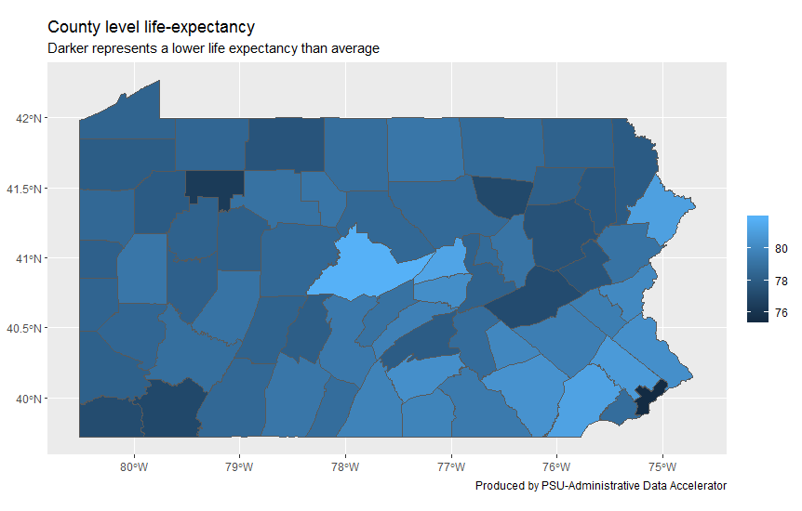

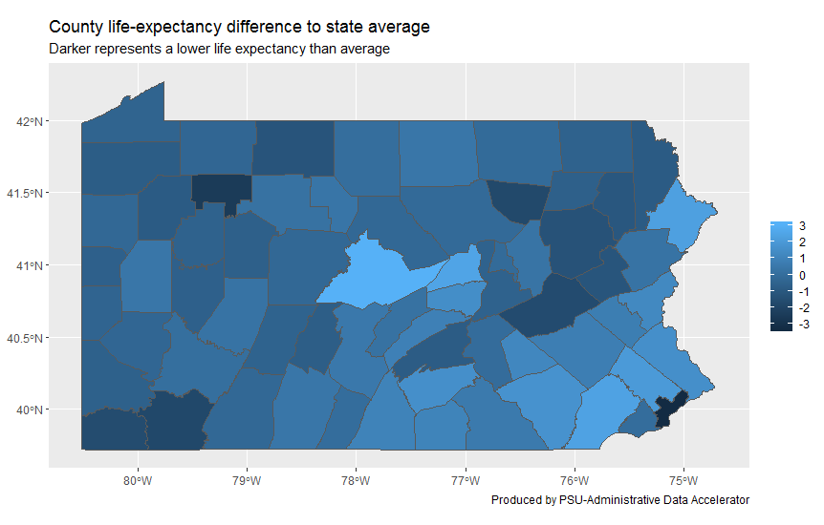

Based on the maps presented previously, the highest life expectancy is that of Centre County, PA and the lower is Philadelphia County, PA.

**Preliminary Results**

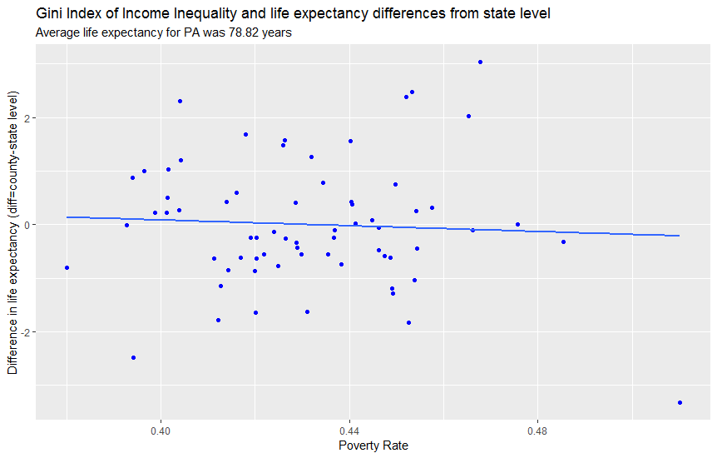

**95% Confidence Interval for the Correlation:** -0.29; 0.19 (No Correlation)

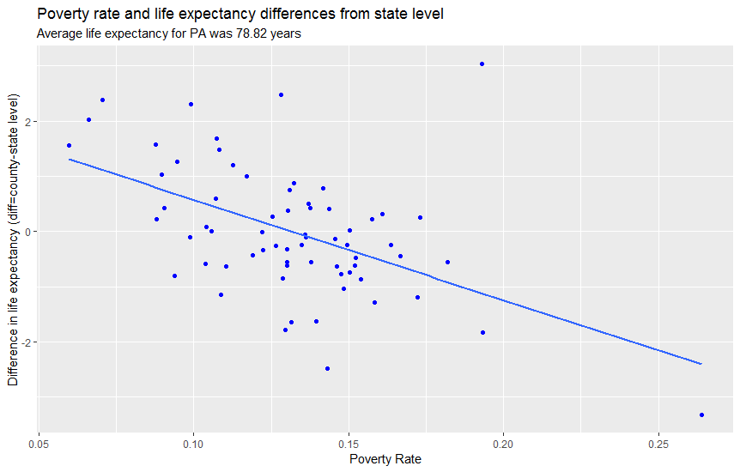

**95% Confidence Interval for the Correlation:** -0.67; -0.30 (Negative Correlation, Higher Poverty Lower Life Expectancy)

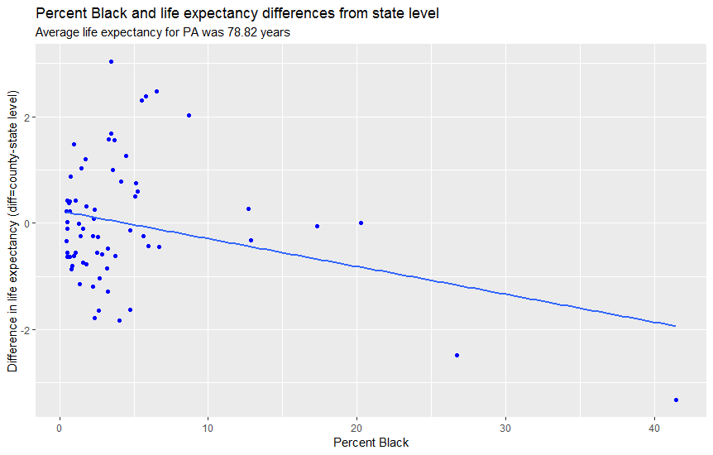

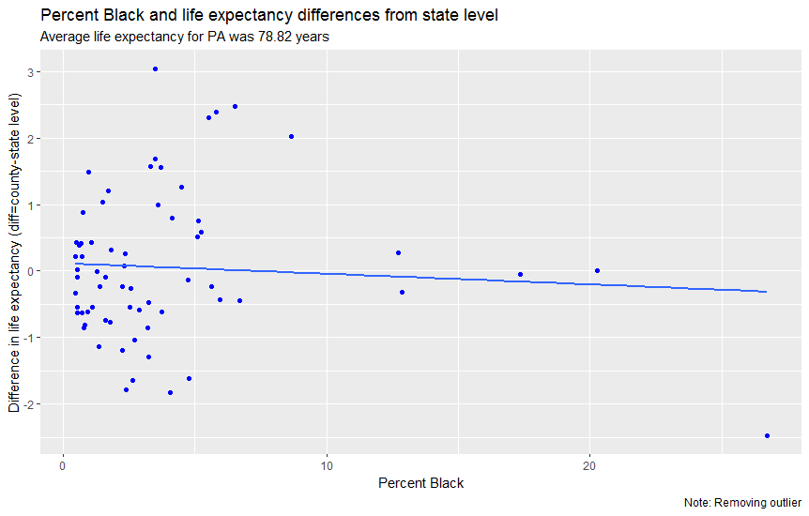

**95% Confidence Interval for the Correlation:** -0.30; 0.18 (No Correlation)

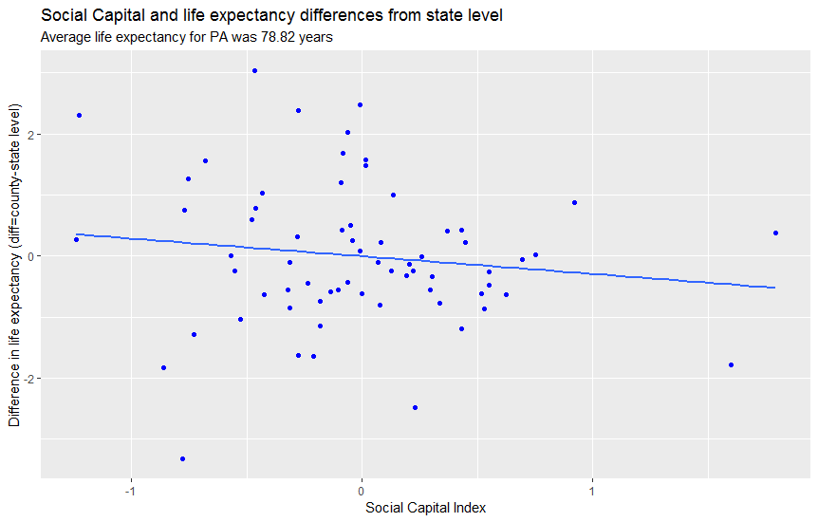

**95% Confidence Interval for the Correlation:** -0.36; 0.11 (No Correlation)

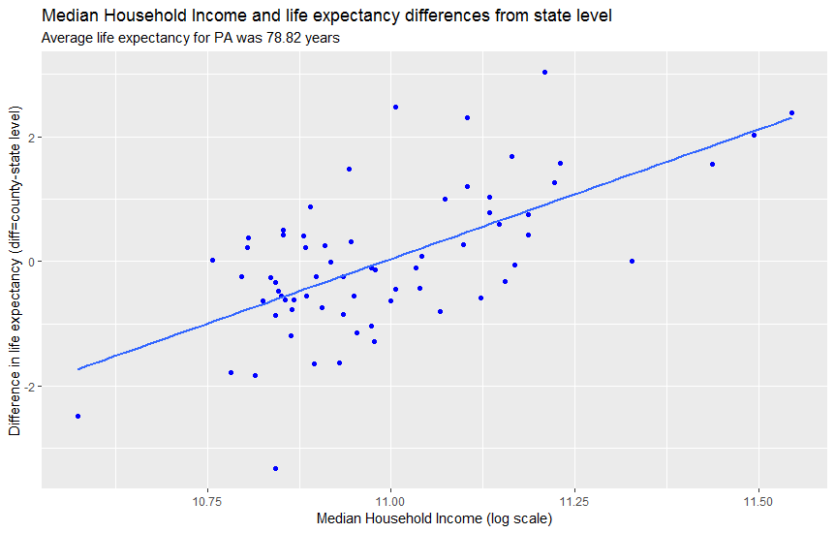

**95% Confidence Interval for the Correlation:** 0.46; 0.76 (Positive Correlation)

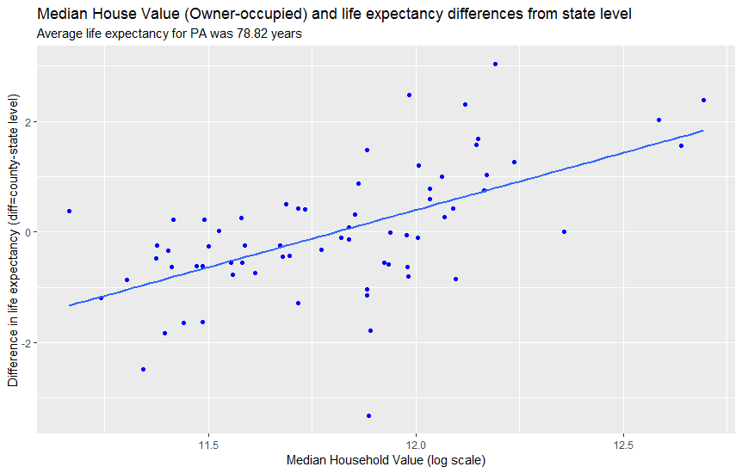

**95% Confidence Interval for the Correlation:** 0.40; 0.73 (Positive Correlation)

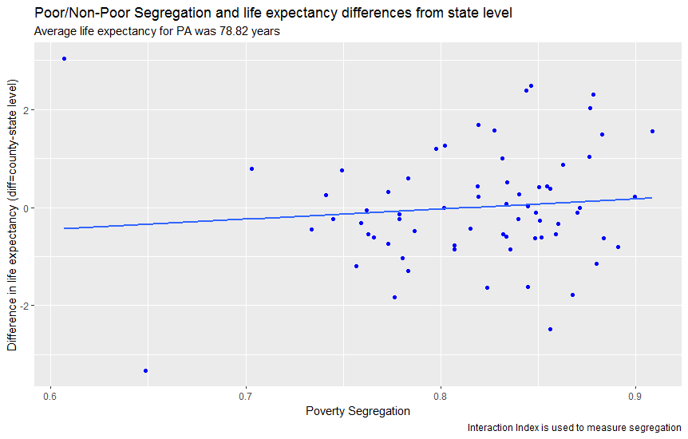

**95% Confidence Interval for the Correlation:** -0.16; 0.32 (No Correlation)

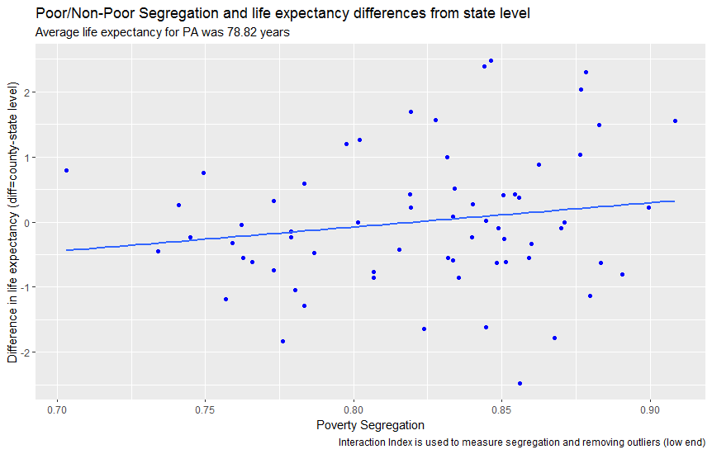

**95% Confidence Interval for the Correlation:** -0.09; 0.39 (No Correlation)

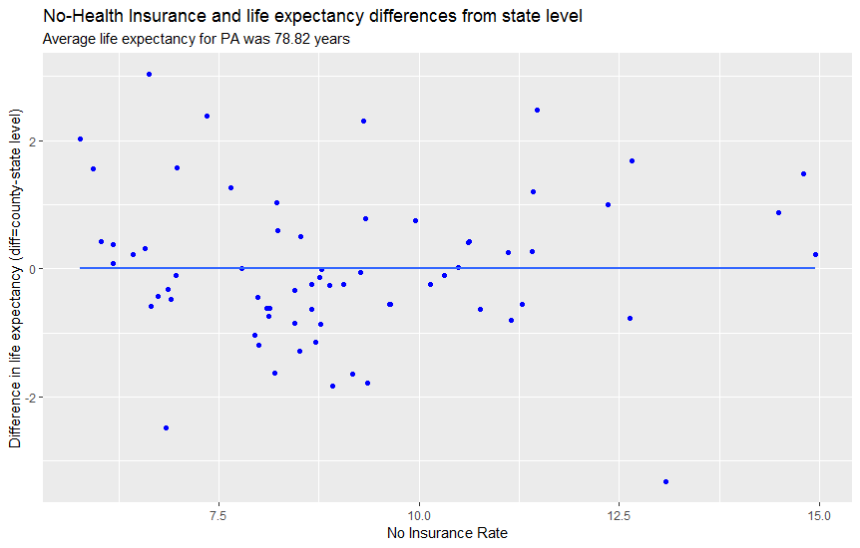

**95% Confidence Interval for the Correlation:** -0.24; 0.24 (No Correlation)

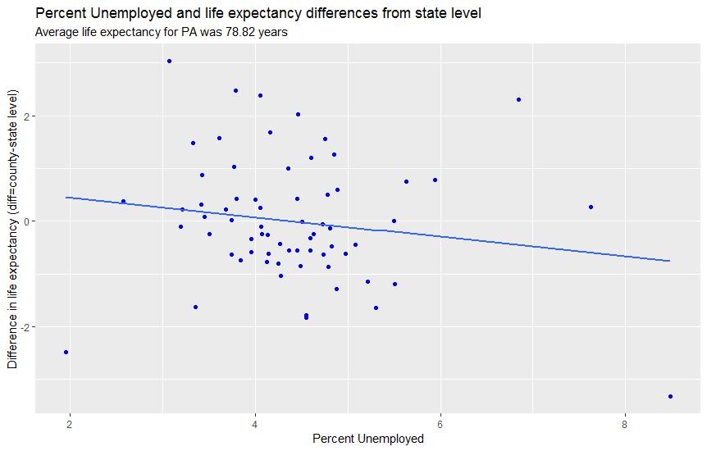

**95% Confidence Interval for the Correlation**: -0.39; 0.08 (No Correlation)

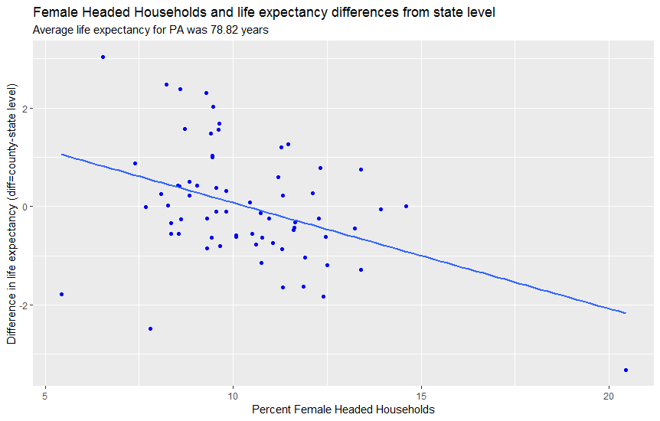

**95% Confidence Interval for the Correlation**: -0.59; -0.18 (Negative Correlation, higher female headed households percentages and lower life expectancy)

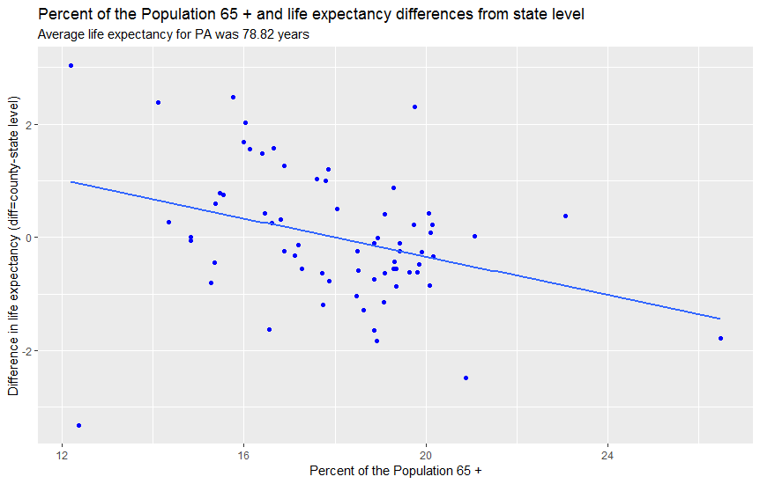

**95% Confidence Interval for the Correlation**: -0.53; -0.10 (Negative Correlation)

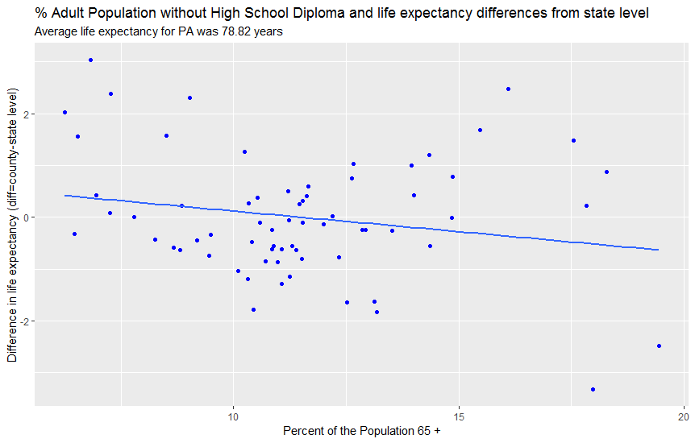

**95% Confidence Interval for the Correlation**: -0.42; 0.04 (No Correlation)

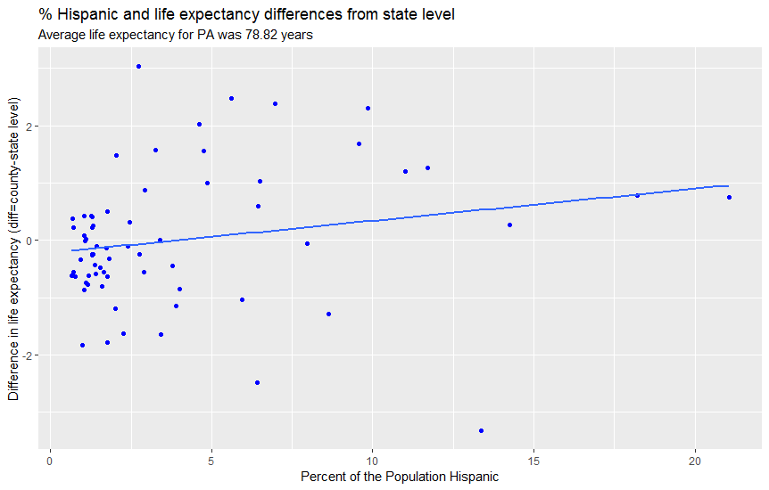

**95% Confidence Interval for the Correlation**: -0.04; 0.42 (No Correlation)

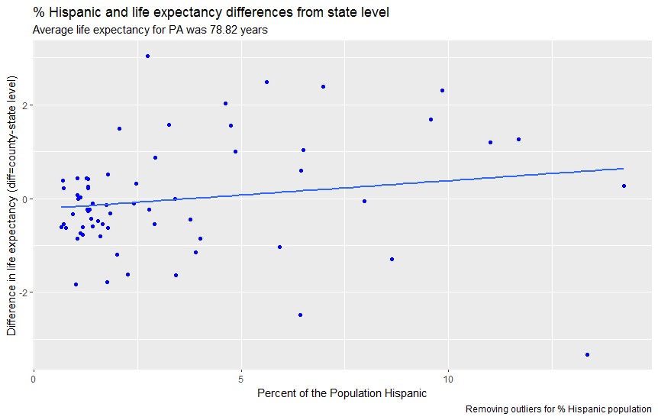

**95% Confidence Interval for the Correlation**: -0.08; 0.40 (No Correlation)

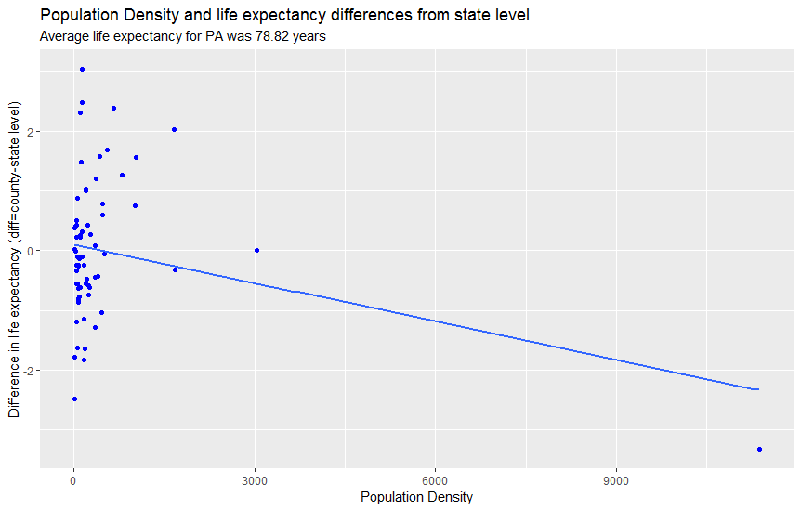

**95% Confidence Interval for the Correlation**: -0.47; 0.02

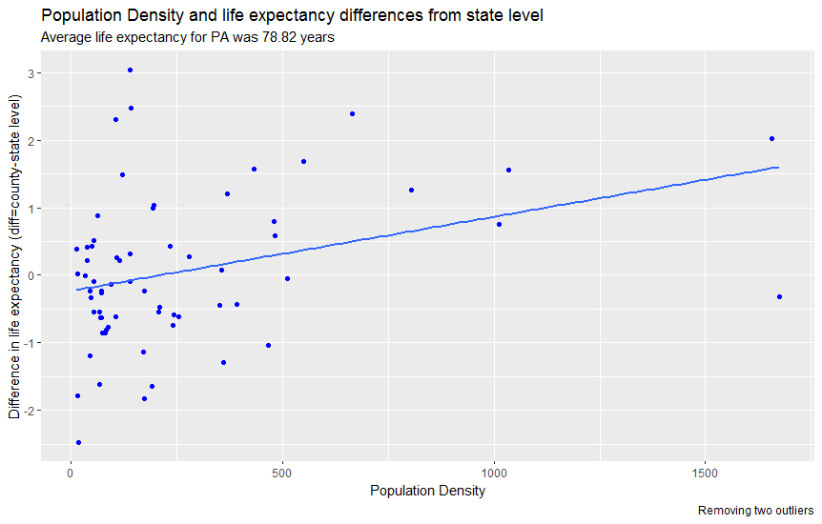

**95% Confidence Interval for the Correlation**: 0.09; 0.53

**Preliminary Discussion**

* The average life expectancy for the Commonwealth of Pennsylvania for 2014 was 78.82 years.
* The highest life expectancies are found in: Centre County (81.86 years), Union County (81.30 years), Chester County (81.21 years), Pike County (81.12 years), and Montgomery County (80.85 years).
* The lowest life expectancies are found in: Philadelphia County (75.49 years), Forest County (76.34 years), Fayette County (76.99 years), Sullivan County (77.04 years) and Schuylkill County (77.18 years).
* Strongest correlations are found for:
  + Highest poverty rate is correlated with lower life expectancy.
  + Highest Median Household Income is correlated with higher life expectancy.
  + Highest Median House Value (for owner-occupied houses) is correlated with higher life expectancy.
  + Highest percent of female headed households is correlated with lower life expectancy.
  + Highest percent of population 65 years and over is correlated with lower life expectancy.
  + Higher Population Density is correlated with higher life expectancy, this when the outliers are taken eliminated from the analysis (see two different figures).
* No association was found for:
  + Percent non-Hispanic Blacks
  + Percent Hispanics
  + Social Capital Index
  + Poor/Non-Poor Segregation
  + Unemployment Rate
  + No High School Attainment for Adults
  + Health Insurance Coverage

The strongest correlations are found for variables related to income level (see above).