// challenge brief
Challenge Brief
Since AI Hackathon 2026 · 6–8 November 2026, Turku · Version of 3 November 2026
00 Challenge partner
Elisa Oyj
Elisa is a Finnish, internationally operating telecommunications and technology company. With over 140 years of experience, it offers sustainable solutions for more than 2.8 million consumer, corporate and public administration customers in its core markets of Finland and Estonia, and software services globally. In 2025, revenue was EUR 2.3 billion. Elisa employs over 6,200 professionals in 35 countries and is listed on Nasdaq Helsinki.
01 Challenge title
Capturing and Linking Human-Generated Contextual Metadata for Autonomous Network Operations
02 Problem statement
What business or technical problem should be solved? The context, why it matters, and the main pain points.
Elisa's goal is to build the world's first and most advanced autonomous network. AI already supports network operations such as root-cause analysis and fault correction, and a large share of faults can already be identified with AI. One of the biggest remaining barriers to end-to-end autonomy is silent metadata: critical operational knowledge that is created in calls, emails, Teams chats and other discussions between experts, but is not stored in any centralised system.
When this context is missing, an otherwise autonomous workflow stops and a human has to step in. Two real examples from Elisa:
• Access information. AI correctly identified a faulty device in Northern Finland and a field engineer was dispatched. A locked barrier at the start of a private road stopped the engineer from reaching the site. The location of the key existed only in an email, so the autonomous cycle was interrupted until a human found it.
• Expert troubleshooting knowledge. After an SFP (optical module) replacement on transmission node TRN-042, the interface is UP, optical levels are normal and alarms have cleared, but traffic does not recover. The field engineer suspects the SFP. A senior expert knows from experience that on these older units this pattern means a forwarding-state issue: disable and re-enable the interface before replacing hardware or rebooting. The fix works, but the knowledge is not in any field instruction. It lives only in the expert's memory, a Teams chat and an email (full example in Appendix A).
The challenge: capture this human-generated knowledge with minimal or no additional work for specialists, bind it to the right network context, and make it available to AI agents, so that autonomous operational workflows can continue end to end and the organisation can move towards an agentic operations model.
03 Guiding question
How could we collect silent metadata without creating additional work for our specialists?
04 Recommended AI approaches
Optional. Relevant technologies, models or methods.
Knowledge graphs, agents, graph databases (Neo4j or Google Spanner).
Elisa's reference model (figure below): the network is described in time-aware layers — intent/design (as-designed), physical/passive (as-built), runtime/active (as-running: topology snapshots and telemetry), context (as-experienced) and the event stream (as-observed). Each context assertion is bound to a graph entity and carries valid_from / valid_to timestamps (valid_to defaults to “still believed true”), so all layers can be cross-referenced for any point in time.
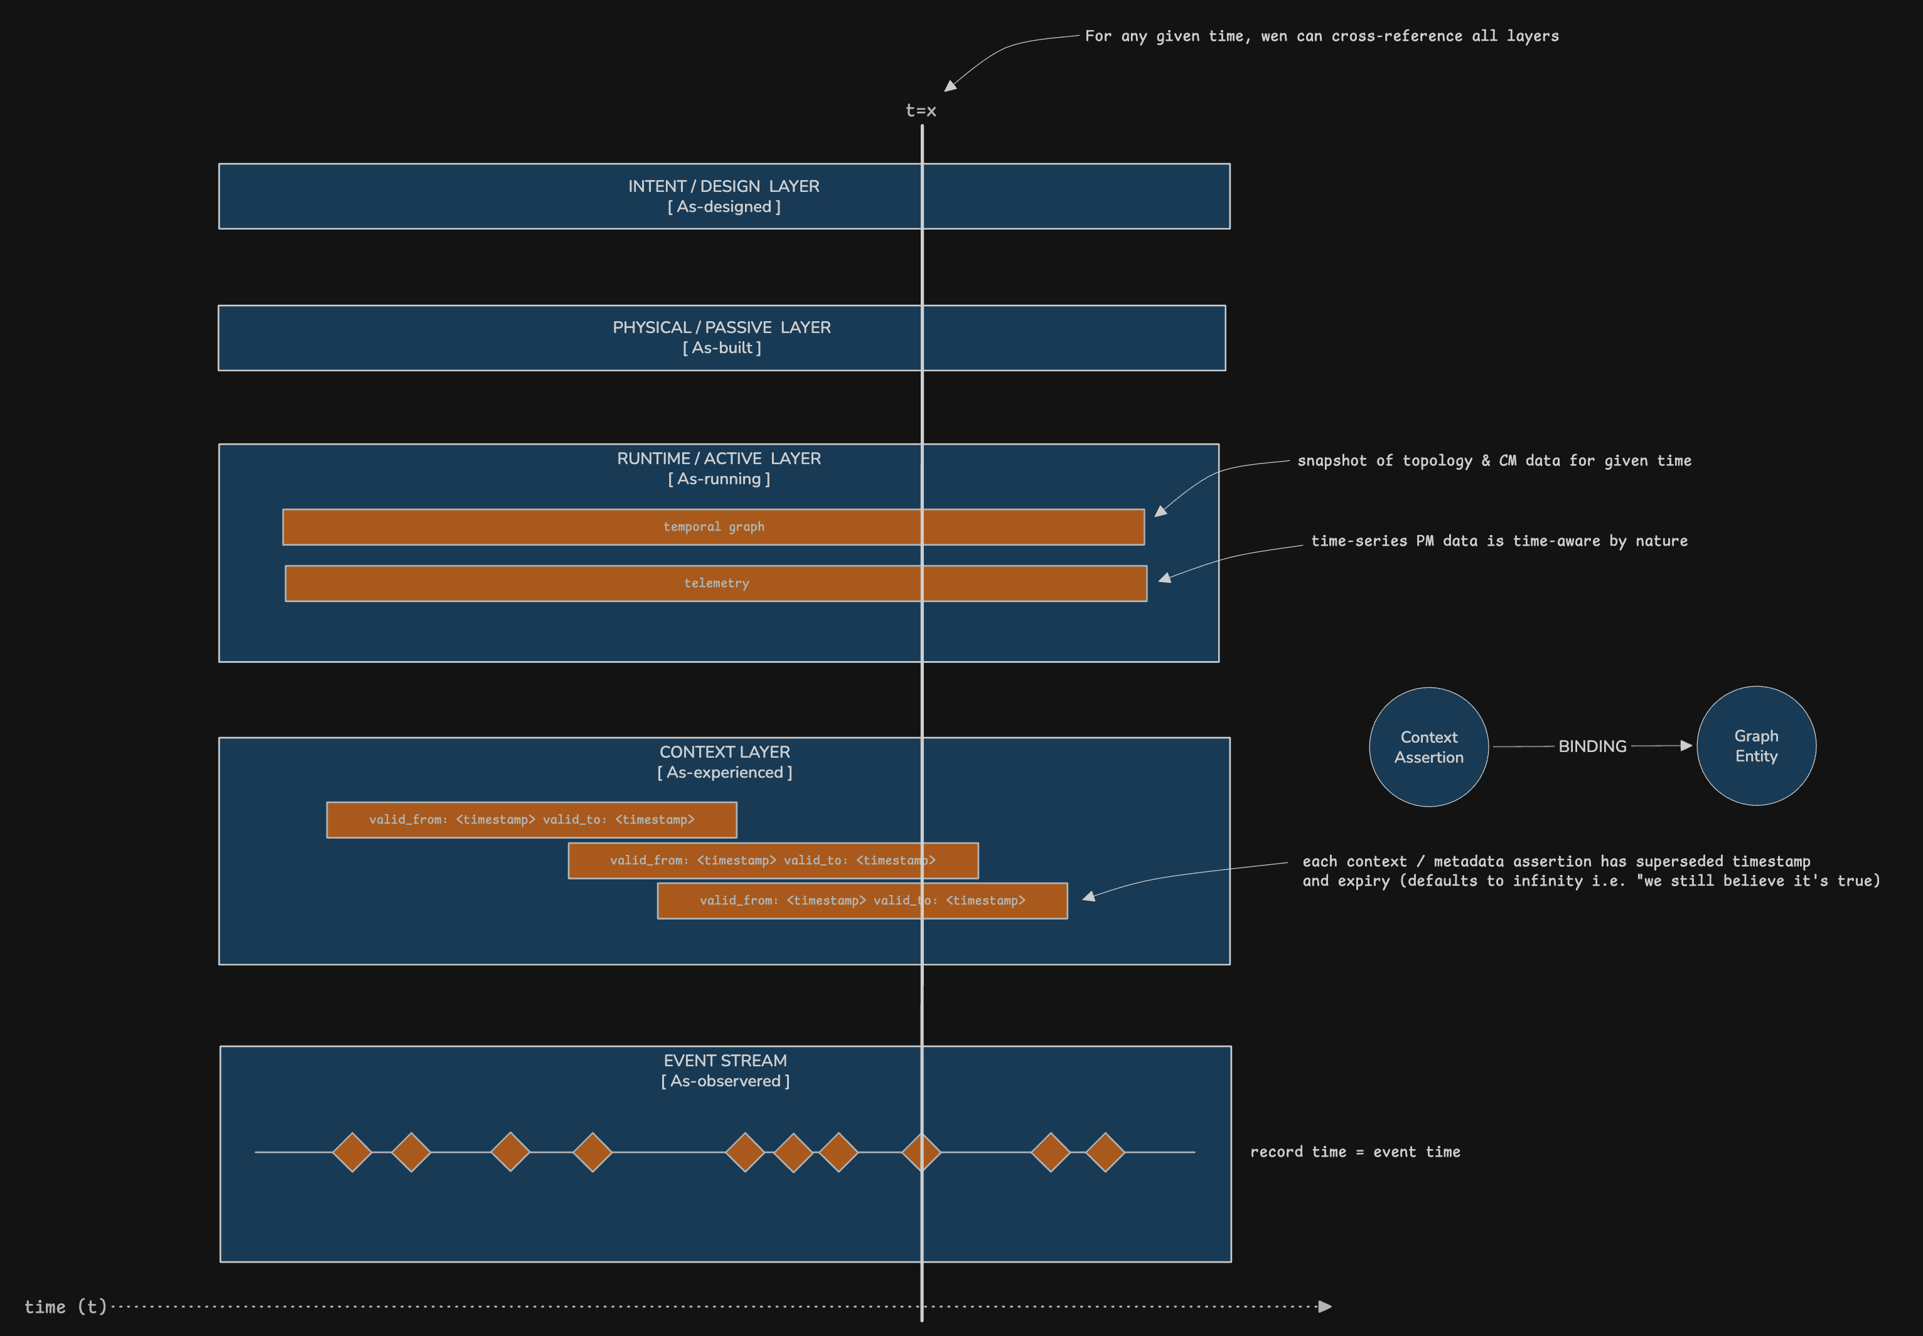
Reference: Elisa data-layer and context architecture.
05 Dataset or API provided
At Since AI, challenges can be built with synthetic, anonymised or public data — no personal data is required.
Elisa provides a deliberately simple example that shows the real problem (Appendix A, also distributed as plain-text and JSON files with this brief):
• the hidden-expert-knowledge use case described in plain language;
• the same case as a Teams conversation between a field engineer and a network expert;
• the same case as an email;
• the access-information example (locked barrier) and the reference architecture above.
Names, node IDs and messages are illustrative. No production data, customer data or personal data is included, and no access to Elisa systems is provided or needed.
Teams are encouraged to create additional synthetic conversations, emails and simple network records in the same style to test their solution — for example other devices, advice that later becomes outdated, or conflicting advice from two experts. Describe in the documentation what you generated and how.
06 Evaluation criteria
How should solutions be judged? What matters most?
Usability is the primary criterion: the solution captures and connects useful contextual metadata with minimal additional work for specialists — ideally from the channels they already use, such as Teams and email.
Secondary criteria: relevance of the captured context, correctness of linking (right entity, right time validity), technical feasibility, and suitability for agentic network operations.
EXAMPLE OF A STRONG DEMO, USING THE APPENDIX A CASE
1. The expert's knowledge is captured from the chat or email without a separate documentation task.
2. It is stored as a context assertion linked to the relevant entities (e.g. node TRN-042, older transmission units, SFP replacement) with its source and validity period.
3. When a similar case occurs, an AI agent retrieves the knowledge and proposes the right next step (check the traffic counters, disable and re-enable the interface) before hardware is replaced or the unit is rebooted.
07 Submission format
Working demo, pitch slides, documentation and code repository.
Submit through the Since AI app (sinceai.app) by Sunday 8 November 2026 at 10:00. Elisa reviews the submissions on Sunday between 10:00 and 13:00.
Outputs remain the property of the team that created them. By entering this challenge, teams grant Elisa a perpetual, worldwide, non-exclusive and royalty-free licence to use, modify, further develop and exploit the outputs, as set out in the Since AI participation terms.
08 Point of contact
Joni Nuvola · joni.nuvola@elisa.fi · Discord: jnuvola
Matti Penttilä, Head of Autonomous Network Operations · matti.s.penttila@elisa.fi · Discord: mattipenttila_26920
Joni presents the challenge and answers technical questions during the weekend. Elisa's team is available at the Elisa stand and on the Since AI Discord.
Questions about this brief: Riku Lauttia · riku.lauttia@sinceai.fi · +358 40 938 8820

// appendix a
Example material from Elisa
Use case: turning hidden expert knowledge into operational intelligence
A1 The situation
A field engineer encounters unusual network behaviour that cannot be resolved using existing documentation or standard procedures. The field engineer contacts Erkki Expert, who recognises the situation from previous experience. Erkki knows how to interpret the combination of symptoms and which action should be taken, but this knowledge has never been formally documented. It exists only in:
• expert experience and memory
• Teams conversations
• emails
• informal expert-to-expert discussions
• previous troubleshooting cases
EXAMPLE
• A network interface shows UP, optical levels are normal and alarms have cleared, but traffic has not recovered after an SFP replacement.
• The field engineer assumes that the SFP may still be faulty.
• Erkki knows from experience: Interface UP + normal optical levels + zero traffic counters after SFP replacement → likely a forwarding-state issue rather than a faulty SFP.
• He advises the field engineer to disable and re-enable the interface before replacing hardware or rebooting the device. The problem is resolved.
A2 Discussion in Teams
Veikko Vikkelä | Field Engineer · 09:14
Hi Erkki, I'm at the site now. Changed the SFP on transmission node TRN-042.
Link is up and alarms cleared, but traffic is still not coming back. Have you seen this before?
Erkki Expert | Network Expert · 09:16
Yes. Is this one of the older units?
Veikko · 09:16
Yes, installed around 2019 I think.
Erkki · 09:18
Ok. Don't trust the green link status on those.
Sometimes after changing the SFP the interface comes up normally, but the forwarding state doesn't recover correctly.
Veikko · 09:18
So another SFP?
Erkki · 09:19
No. Usually the SFP is fine.
Check whether the traffic counters are actually increasing. If they stay at zero even though the interface is UP, it's probably the issue I've seen before.
Veikko · 09:21
Yes. Link UP. RX power looks normal. Counters basically zero.
Erkki · 09:22
That's it.
Disable the interface, wait a little, then enable it again. Don't reboot the whole unit unless that fails.
Veikko · 09:25
Did that. Traffic is back 👍
Erkki · 09:25
Good. These old units sometimes behave like this after an optical module replacement.
Veikko · 09:26
Is this documented somewhere?
Erkki · 09:27
Not that I know of 😄
We've just learned it over the years.
A3 Same use case in email
From: Erkki Expert
To: Veikko Vikkelä
Subject: RE: TRN-042 traffic not recovering after SFP replacement
Hi Veikko,
That sounds like the behaviour we have seen with some of the older transmission units.
The confusing part is that everything can look normal after replacing the optical module:
• interface status = UP
• optical levels = OK
• alarms = cleared
...but traffic still doesn't recover.
Before replacing the SFP again or rebooting the unit, check the traffic counters. If the interface is UP but the counters remain at zero, try disabling and enabling the interface once. This has solved the issue in several cases I've seen.
I don't think this is written in the normal field instructions. It is one of those things we have learned from experience.
Regards,
Erkki

