HW#8 due November 15

1. (a) Rewrite the expression for the total free energy change for nucleation (Equation 10.1) for the case of a cubic nucleus of edge length a (instead of a sphere of radius r). Now solve for both the critical cube edge length, a\*, and G\*.

(b) Is G\* greater for a cube or a sphere? Why?

2. (a) For the solidification of Ni, calculate the critical radius r\* and the activation free energy G\*, if nucleation is homogeneous. Values for the latent heat of fusion and surface free energy are -2.53x109 and 0.255 J/m2, respectively. Use the supercooling value found in Table 10.1.

(b) Now calculate the number of atoms found in a nucleus of critical size. Assume a lattice parameter of 0.360 nm for solid nickel at its melting temperature.

Table 10.1

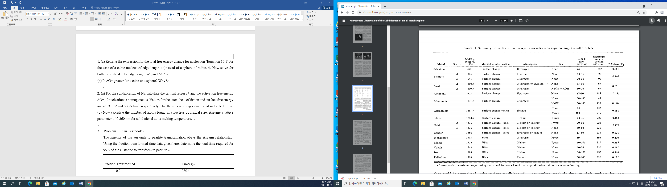

3. The kinetics of the austenite-to pearlite transformation obeys the Avrami relationship. Using the fraction transformed-time data given here, determine the total time required for 95% of the austenite to transform to pearlite.

Fraction Transformed Time (s)

0.2 280

0.6 425

4. Briefly describe the simplest heat treatment procedure that would be used in converting a 0.76 wt.% C steel from one microstructure to the other, as follows:

(a) Martensite to spheroidite

(b) Bainite to pearlite

(c) Spheroidite to pearlite

(d) Tempered martensite to martensite

