HW#7 due November 15

1. A 50 wt% Ni–50 wt% Cu alloy is slowly cooled from 1400°C to 1200°C. (a) At what temperature does the first solid phase form? (b) What is the composition of this solid phase? (c) At what temperature does the liquid solidify? (d) What is the composition of this last remaining liquid phase?

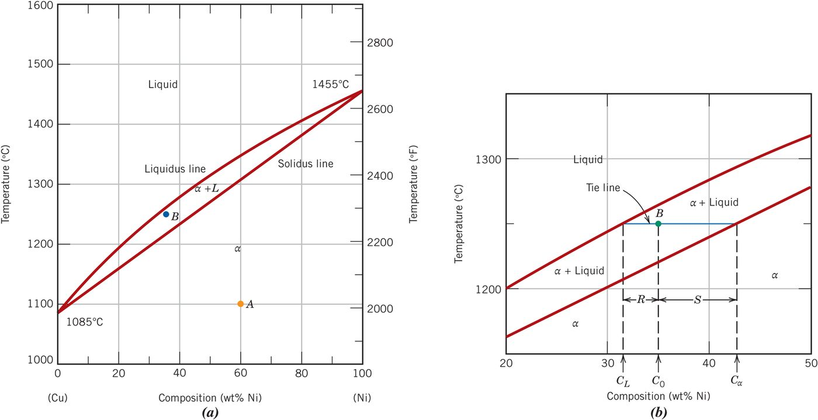

2. For a lead–tin alloy of composition 80 wt% Sn–20 wt% Pb and at 180°C, do the following: (a) Determine the mass fractions of the α and β phases. (b) Determine the mass fractions of primary β and eutectic microconstituents. (c) Determine the mass fraction of eutectic β.

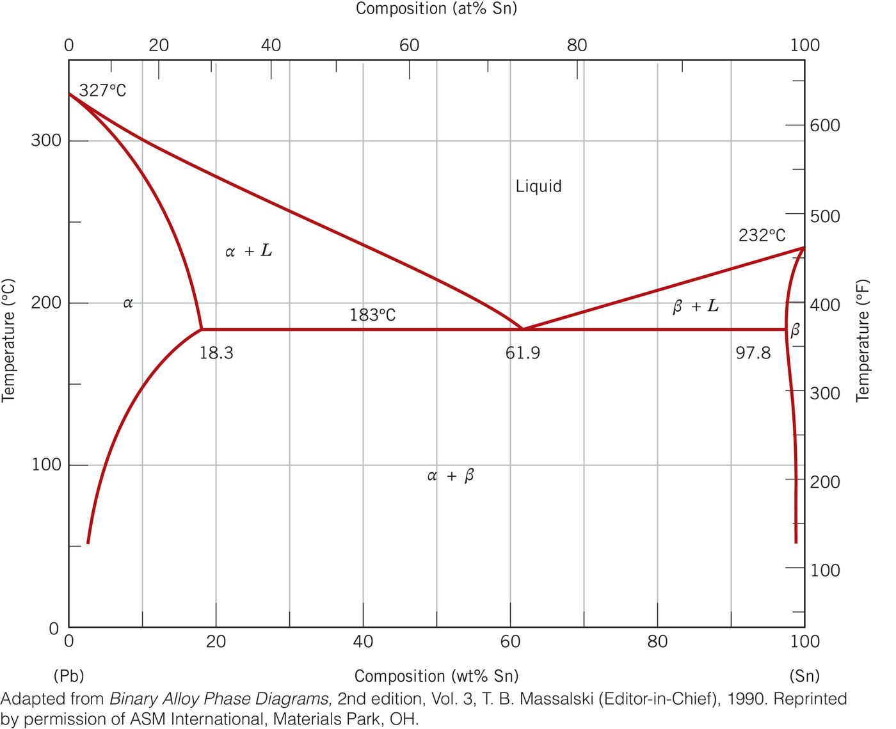

3. For an iron–carbon alloy of composition 3 wt% C–97 wt% Fe, make schematic sketches of the microstructure that would be observed for conditions of very slow cooling at the following temperatures: 1250°C, 1145°C, and 700°C. Label the phases and indicate their compositions (approximate).

