HW#3 due October 11

1. (a) Calculate the fraction of atom sites that are vacant for copper (Cu) at its melting temperature of 1084°C (1357 K). Assume an energy for vacancy formation of 0.90 eV/atom.

(b) Repeat this calculation at room temperature (298 K).

(c) What is ratio of Nv /N(1357 K) and Nv /N(298 K)?

2. Atomic radius, crystal structure, electronegativity, and the most common valence are given in the following table for several elements; for those that are nonmetals, only atomic radii are indicated.

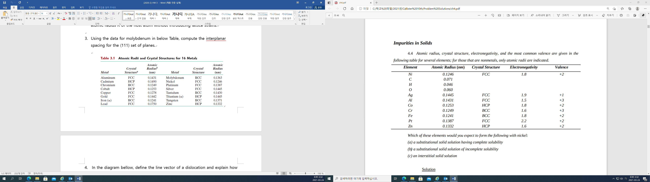

Which of these elements would you expect to form the following with nickel:

(a) a substitutional solid solution having complete solubility

(b) a substitutional solid solution of incomplete solubility

(c) an interstitial solid solution

3. (a) Compare interstitial and vacancy atomic mechanisms for diffusion.

(b) Cite two reasons why interstitial diffusion is normally more rapid than vacancy diffusion.

4. The diffusion coefficients for carbon in nickel are given at two temperatures are as follows:

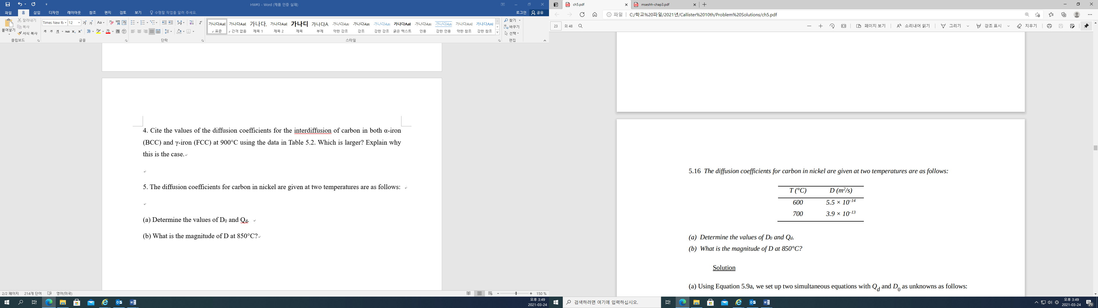

(a) Determine the values of D0 and Qd.

(b) What is the magnitude of D at 850°C?