HW#2 due October 4

1. Determine the indices for the directions shown in the following cubic unit cell.

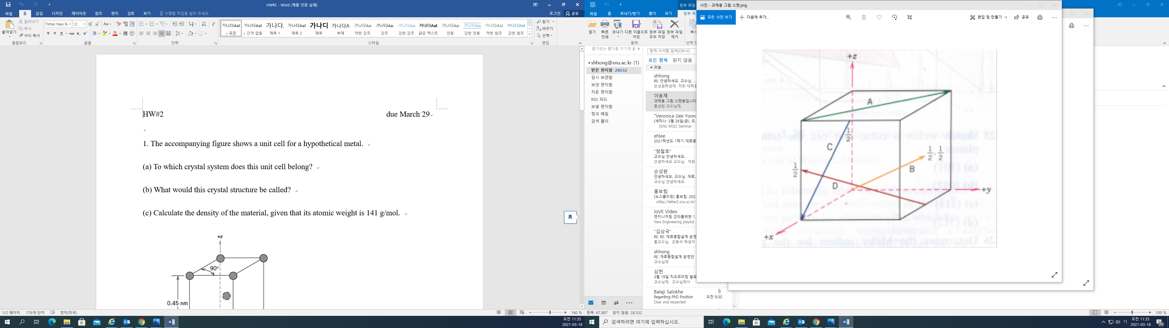

2. Determine the Miller indices for the planes shown in the following unit cell.

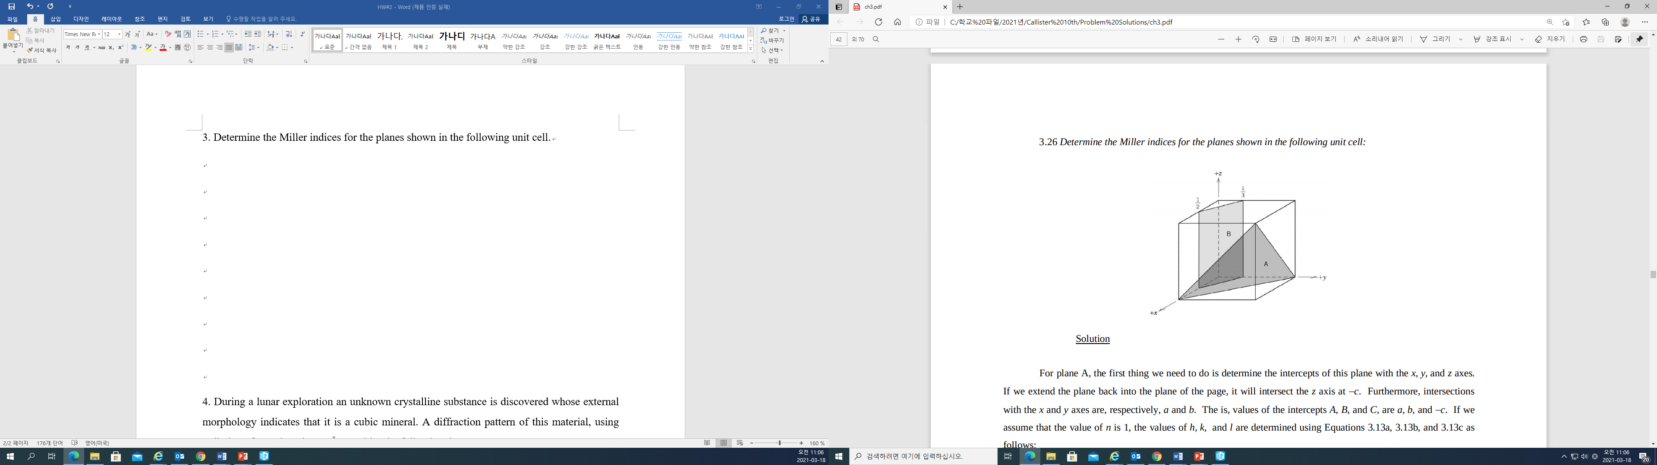

3. Explain why the properties of polycrystalline materials are most often isotropic.