HW#4 due October 23

1. In Section 2.6, it was noted that the net bonding energy EN between two isolated positive and negative ions is a function of interionic distance *r* as follows:

 (6.30)

where A, B, and n are constants for the particular ion pair. Equation 6.30 is also valid for the bonding energy between adjacent ions in solid materials. The modulus of elasticity E is proportional to the slope of the interionic force–separation curve at the equilibrium interionic separation; that is,



Derive an expression for the dependence of the modulus of elasticity on these A, B, and n parameters (for the two-ion system), using the following procedure:

(a) Establish a relationship for the force F as a function of r, realizing that



(b) Now take the derivative *dF/dr*.

(c) Develop an expression for *r0*, the equilibrium separation. Because *r0* corresponds to the value of *r* at the minimum of the EN-versus-r curve (Figure 2.10b), take the derivative *dEN/dr*, set it equal to zero, and solve for *r*, which corresponds to *r0*.

(d) Finally, substitute this expression for *r0* into the relationship obtained by taking *dF/dr*.

2. A cylindrical specimen of steel having a diameter of 15.2 mm and length of 250 mm is deformed elastically in tension with a force of 48,900 N. Using the data contained in Table 6.1, determine the following:

(a) The amount by which this specimen will elongate in the direction of the applied stress.

(b) The change in diameter of the specimen. Will the diameter increase or decrease?

(Table 6.1

steel modulus of elasticity- 207 GPa, shear modulus-83 GPa, Poisson’s ratio-0.30)

3. Figure 6.22 shows the tensile engineering stress–strain behavior for a steel alloy.

(a) What is the modulus of elasticity?

(b) What is the proportional limit?

(c) What is the yield strength at a strain offset of 0.002?

(d) What is the tensile strength?

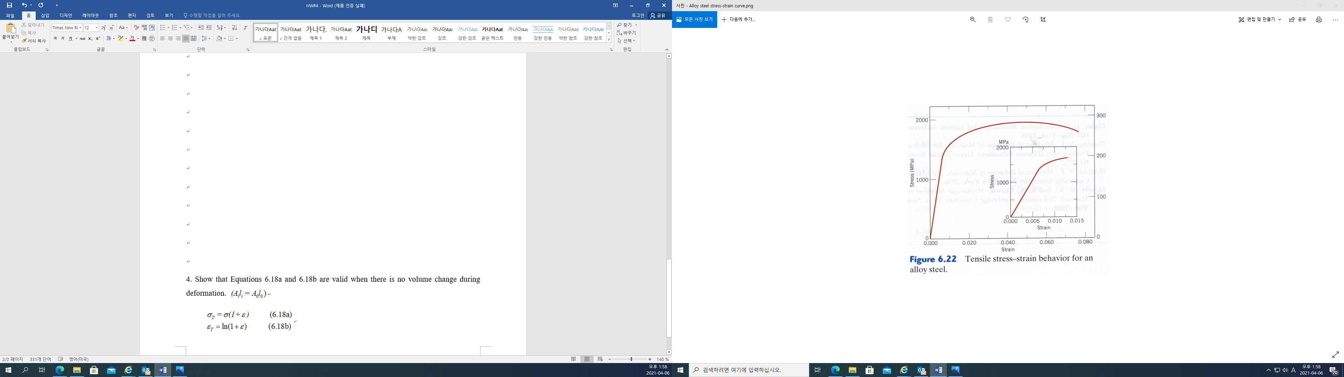

4. Show that Equations 6.18a and 6.18b are valid when there is no volume change during deformation. 

