HW#6 due November 13

1. Estimate the theoretical fracture strength of a brittle material if it is known that fracture occurs by the propagation of an elliptically shaped surface crack of length 0.5 mm and a tip radius of curvature of 5 × 10–3 mm, when a stress of 1035 MPa is applied.

2. Suppose that a wing component on an aircraft is fabricated from an aluminum alloy that has a plane-strain fracture toughness of 26.0 MPa m1/2. It has been determined that fracture results at a stress of 112 MPa when the maximum internal crack length is 8.6 mm. For this same component and alloy, compute the stress level at which fracture will occur for a critical internal crack length of 6.0 mm.

3. The fatigue data for a brass alloy are given as follows:

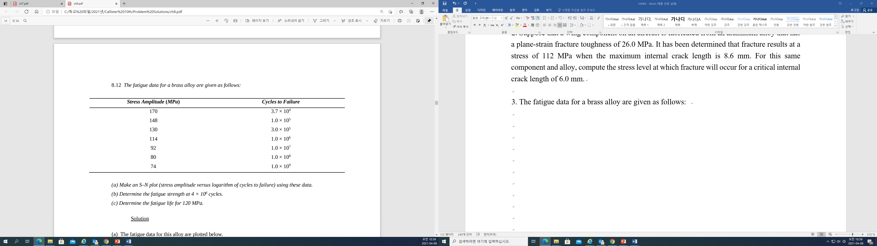

(a) Make an S–N plot (stress amplitude versus logarithm of cycles to failure) using these data. (b) Determine the fatigue strength at 4 × 106 cycles.

(c) Determine the fatigue life for 120 MPa.