Alex Janiak, NJIT Provost Research Program

Outline of Research on the Physical Parameters of Magnetic Drug Targeting

**Outline:**

Given a probability function that simulates the trajectory of magnetically targeted ferro-fluid drug clusters in the blood stream, several physical parameters were modeled to determine the most optimal conditions. The probability function includes a Brownian motion term that creates stochastic noise, which, in addition to random seeds, means that machine learning models need to be used to generalize the probability instead of just using the function itself. Using these functions, physical parameters can be optimized to increase the chance that the drug clusters reach their target.

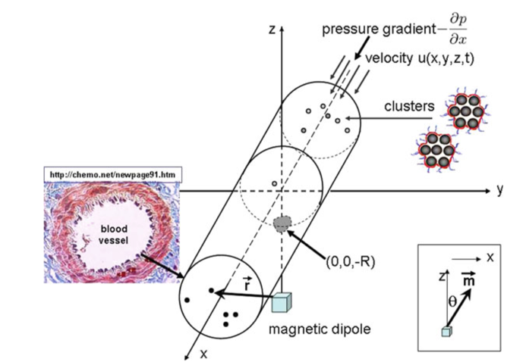

The main physical parameter explored was the injection position or initial drug cluster position. Initially, a separate model was created to explore the effects of initial cluster position for each axis. In the final part of the analysis, a model encompassing all 3 axes is created and instead of calculating an optimal injection position – an optimal injection “slice” or range is estimated.

**Models 1,2, & 3:**

For model 1, the initial position along the length of the vein (the x axis) was varied for along the domain [-0.065,0.0075 ] for 750 instances (Fig.1). The radius of the vein was held constant at 1e-4 meters. The capture probability was found to be consistently 0 on the domain (-∞, -0.065) 𝖴 (0.0075, ∞). A smoothing spline (piecewise polynomial) was used to model the relationship between x0 and P. where the smoothing parameter (p) was 0.99999975 (Fig. 2). The highest capture probability (0.6656), predicted by the model, is at x0 = -0.0134Chart, scatter chart

Fig 2.

For model 2 and 3, the initial position from the center of the vein (the y and z axis respectively) was varied for 100 instances along the domain [-1e-4.1e-4] where 1e-4 meters was the pipe radius (Fig 3&4). A 4th degree ridge regression was used the model the relationship between y0 and P as well as between z0 and P where α = 0.01 (Fig 5&6). Although these models seem inapplicable due to the difficulty in controlling the depth on injection with modern technology, they were used as confirmation to the observations found in model 4. Further into the research, it was found that the relationship is most similar to that of a gaussian function.

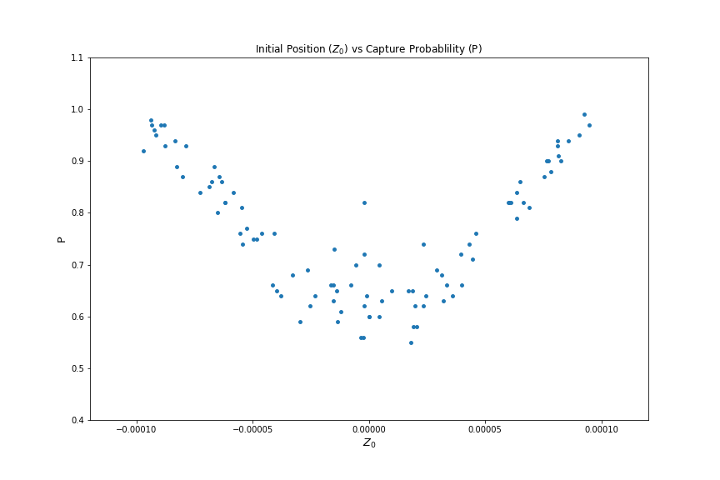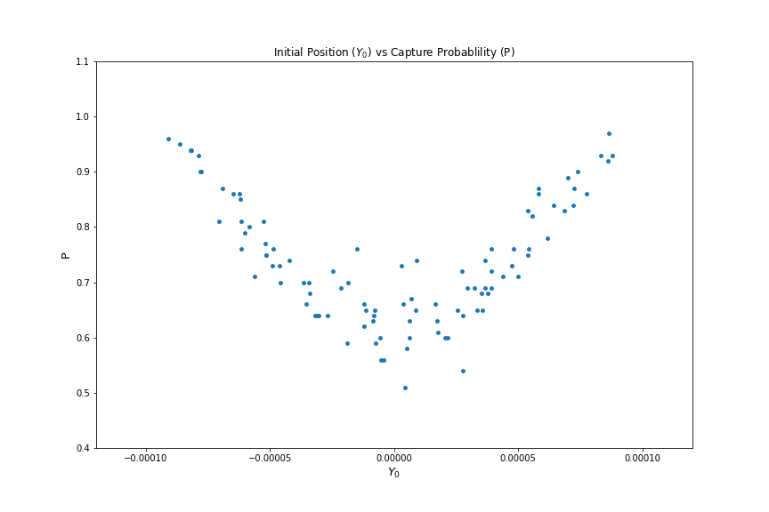

Fig 3. & 4.

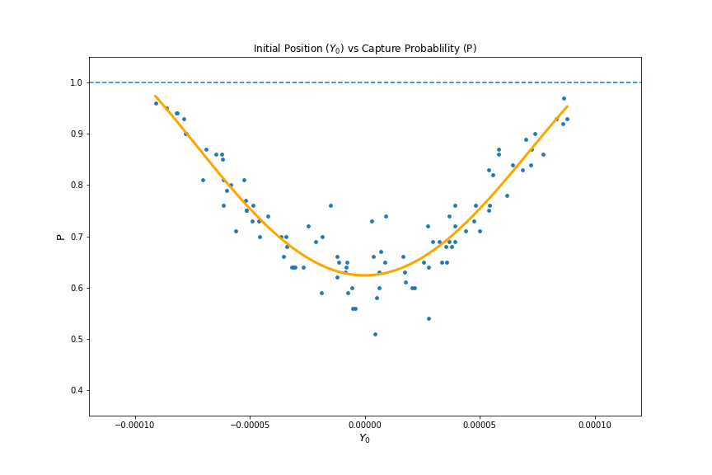

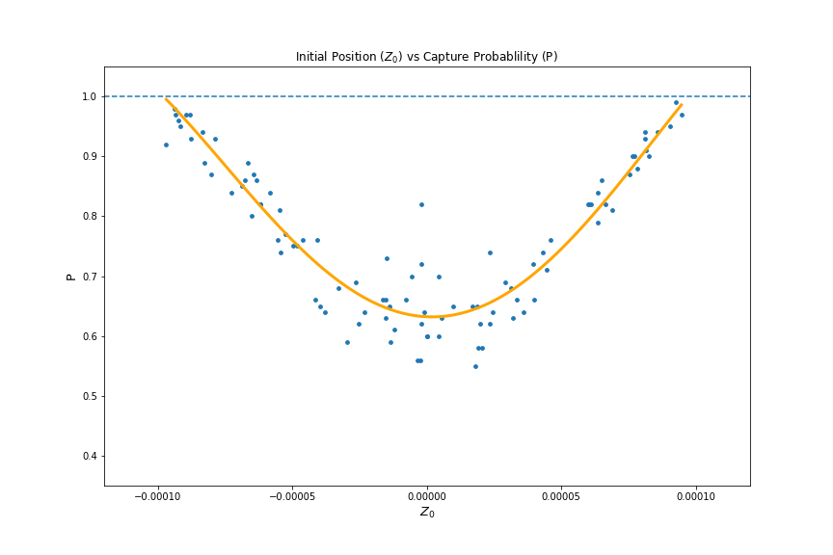

Fig 5. & 6.

**Model 4:**

Model 4 is the overarching model to models 1,2&3. 2000 random points were generated in the shape of a cylinder with a radius of 1e-4 and length of 0.05 meters (-0.04-0.01) in order to test the relationship between the capture probability and initial positions along the x, y, & z axes (Fig 7). The result is a paraboloid of high probability with a vertex at around -0.015 along the x axis. The probability increases directly with the particles distance from the x axis. The shape of the high capture probability areas is most similar to a paraboloid or a gaussian function. Unsurprisingly, a gaussian process regressor had the best fit on the data. More specifically, a gaussian process regressor using a rational quadratic kernel (a scale mixture of RBF kernels with different characteristic length-scales) was used to model this relationship (Fig 8). This model was then mapped onto 10,000 random points in the same cylinder size to create a clear visualization of the relationships (Fig 9).

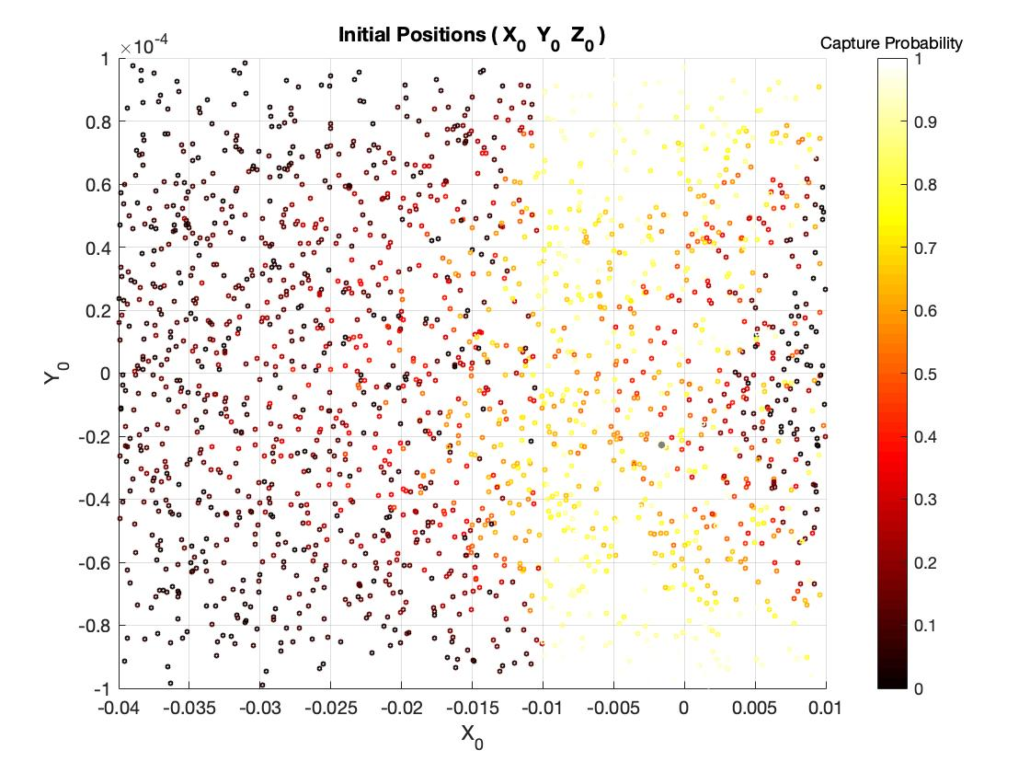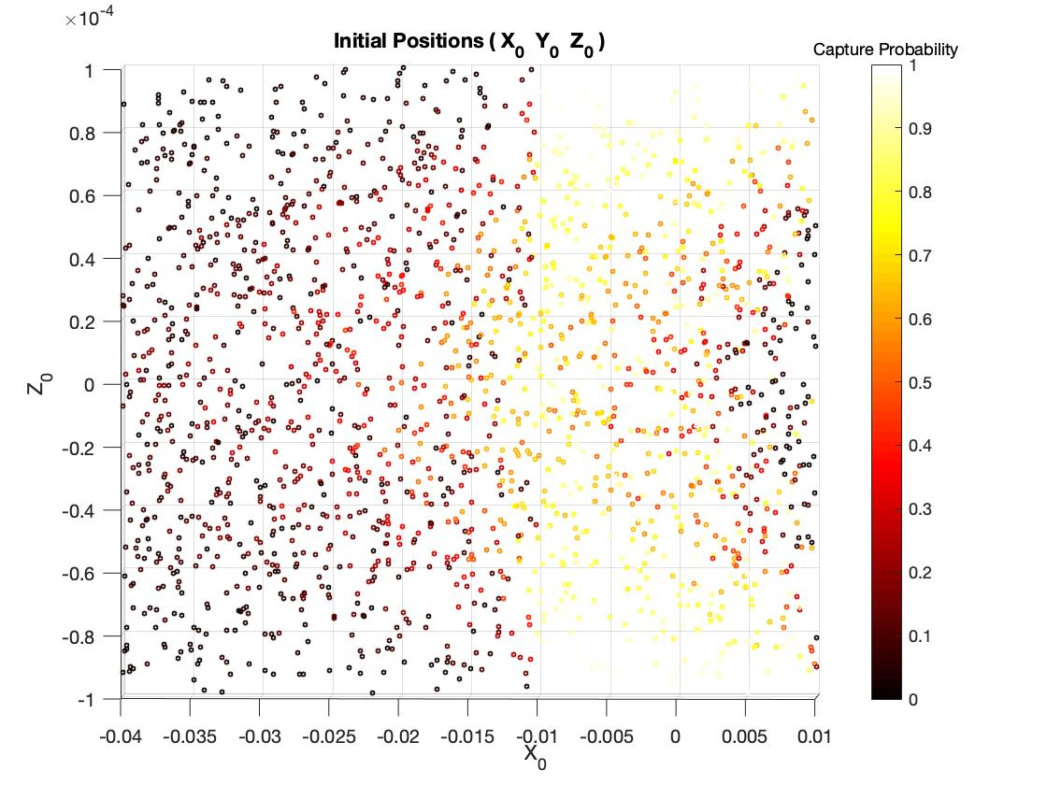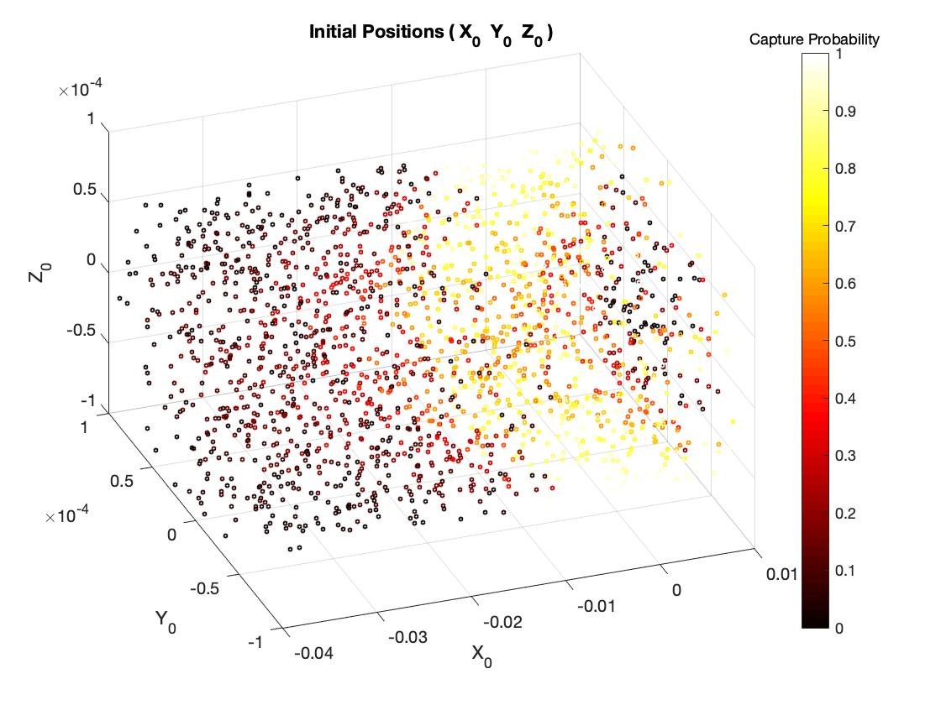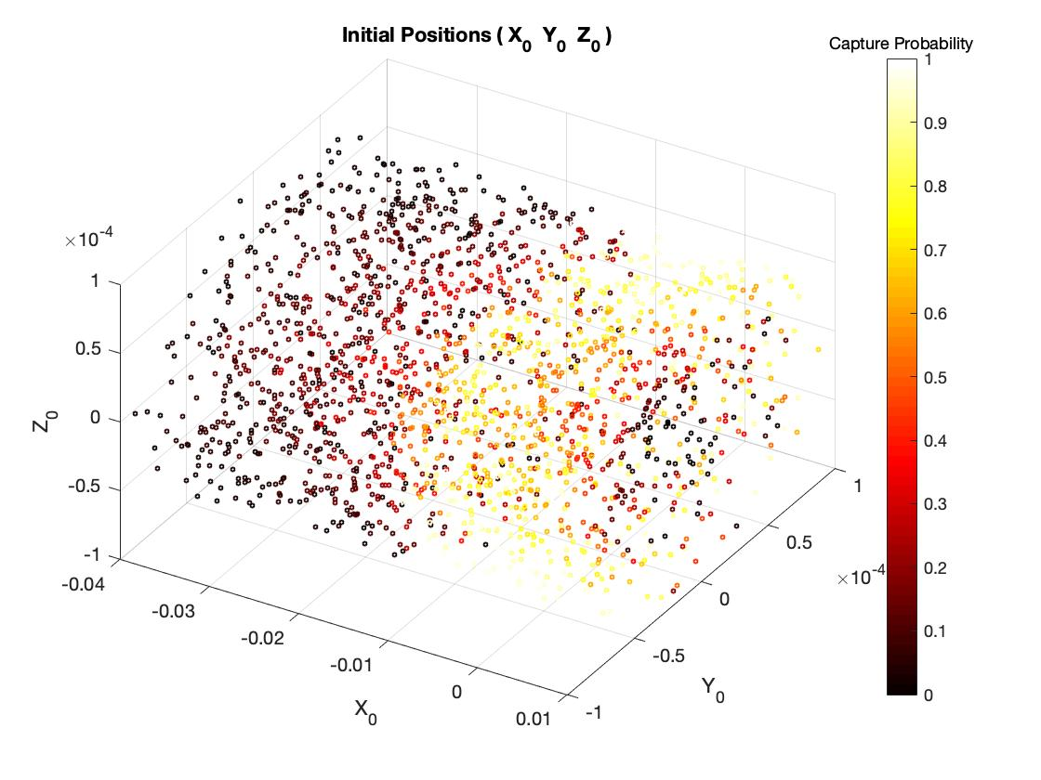

Fig 7.

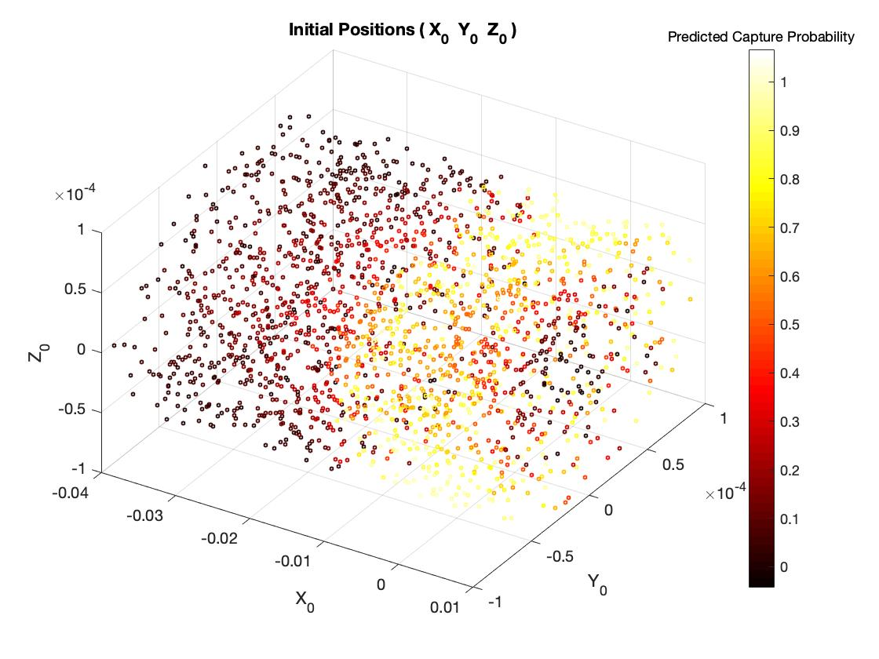

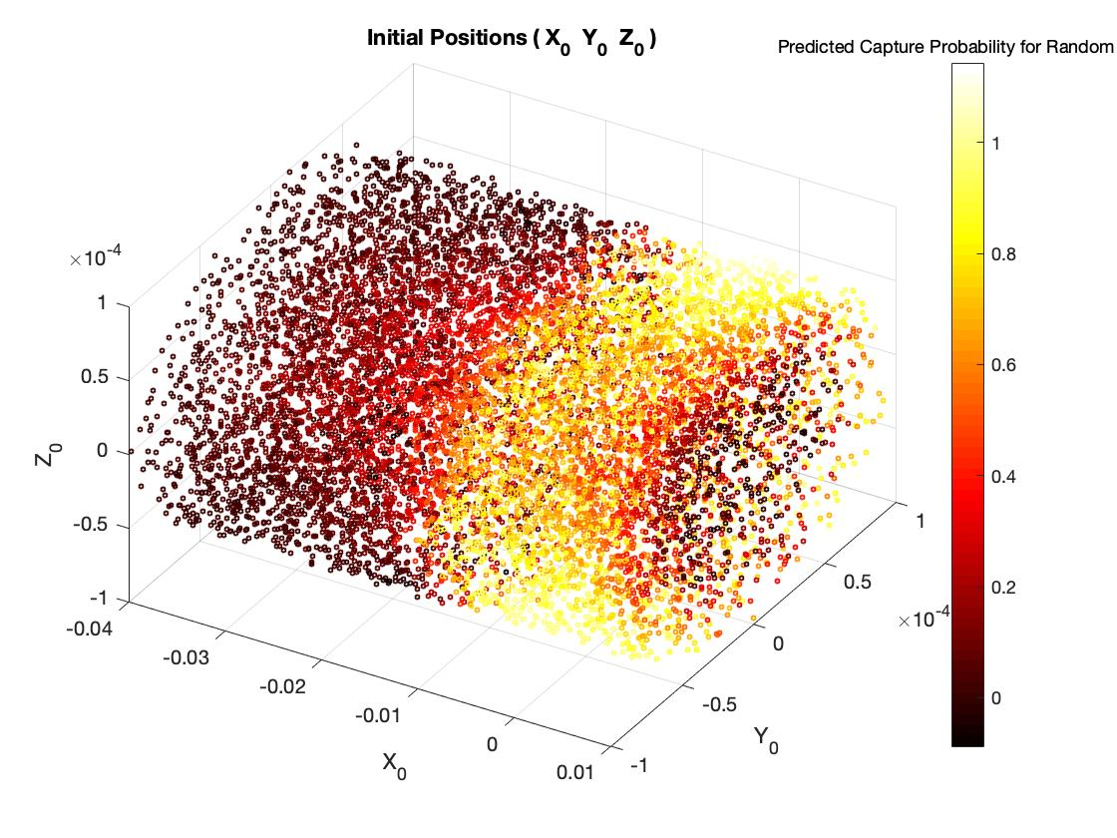Fig 8.

Fig 9.

Using this mapped model, the most optimal injection location was found to be between 0.01 to 0.005 meters (or 1 to 0.5 cm) away from the target (Fig 10). The initial positions in this “slice” of the vein have an average of 78.72% percent capture rate. Before calculating the average percent capture rate, the over and under estimates generated by the model, >1 & <0, where converted to 1 and 0 respectively in order to prevent the average from being skewed. (The predictions can be limited by the complexity of the model – by increasing the complexity of the model you are at greater risk of overfitting. In addition, changing these high or low values back to the maximum and minimum values actually results in a greater average percent capture rate.

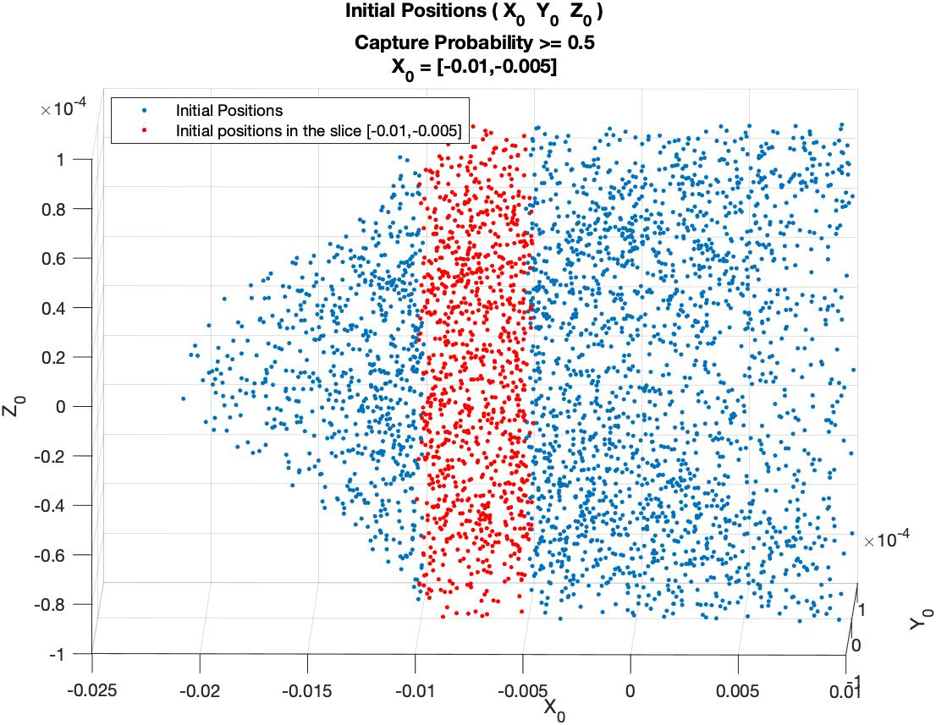

Fig 10.

**Significance & Conclusion**

This optimal “slice” is large enough to allow accurate and applicable injection and has a high average capture rate while still factoring in the initial position of the cluster on the Y and Z axes. The size of the “slice” is arbitrary: a rounded whole number that was picked through visualization, error, and reasonable size for application.

Additionally, according to the data generated and the values from the model, outside the “slice” the average capture probability either drops to 0 completely (for the initial position in front of the tumor) or decreases at an exponential rate.

By modeling the relationship between initial cluster position and capture probability, the optimal injection range was found to be between 0.01 m to 0.05 m away from the target. This result is very practical as it it’s a relatively large range while still reaching up to 79% accuracy.

**Metrics:**

Smoothing Spline (Used to model the relationship between x0 and P.

Smoothing parameter (p) = 0.99999975

SSE = 2.241

R2 = 0.9528

RMSE = 0.0503

Ridge Regression (Used to model the relationship between y0 and P).

Degree = 4

α = 0.01.

MSE = 0.00074

R2 = 0.93

Ridge Regression (Used to model the relationship between z0 and P).

Degree = 4

α = 0.01.

MSE = 0.00075

R2 = 0.94

** Gaussian Process Regressor (Used to model the relationship between x0, y0, z0 and P)

Kernel function = Rational Quadratic

Isotropic Kernel =true

PCA = False

RMSE = 0.067695

R2 = 0.96

MSE = 0.0045827

Note: MATLAB automatically prevents overfitting with the Gaussian Process Regressor.