Alex Janosi

Problem Set #5

1. Flight number and date are unique so made primary keys. An aircraft can have multiple flights, but each flight must have only one aircraft. The assignment specified why seats is a weak entity-set. NOTE: I am assuming that some planes have no seats (otherwise the arrow from flt_seat to aircraft would be double lined).

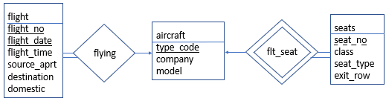

2. Customers can be made up of two subclasses: travelers and purchasers. There can be multiple travelers per purchaser, but there must be only one purchaser. A purchaser can purchase multiple items, but there is only one purchaser per purchase. NOTE: there must be one or more phone numbers in the customer entity-set.

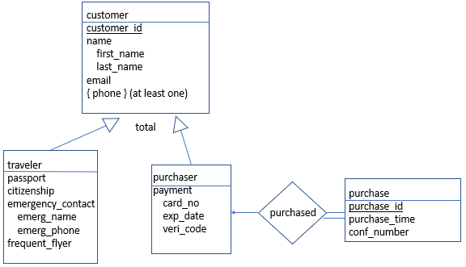

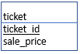3. Single purchases can buy at least one ticket for at least one traveler. Multiple tickets can be associated with each traveler. Each ticket is unique to one traveler, flight, and seat.

tix

associated

unique_r



NOTES: Each customer must have AT LEAST one phone number. The arrow from flt_seat to aircraft is only single lined because I am assuming that some flights have no seats (e.g. cargo planes). Given the unique relation, not every seat will be possible on each flight. Thus, there will not always be a given seat for a plane.