CS 156a Problem Set #1

1. (i) not learning as the information is already given from the U.S. Mint. No inferences or trends will need to be made (ii) is supervised learning as the algorithm just takes in large amounts of labeled data which will then present the differences in coins through the creation of boundaries. (iii) is reinforcement learning as given moves are inputs that result in a win or loss output. The algorithm then punishes itself with a low grade if there is a loss and keeps trying until it always wins. The answer is [d] not learning, supervised learning, and reinforcement learning.

2. The essence of machine learning is that a pattern exists, we cannot pin it down mathematically, and we have data on it. (i) is not suited for machine learning because this can be pinned down mathematically which makes machine learning useless. (ii) is suited for machine learning as there is a ton of data that does not have a mathematical pattern. Credit card fraud has been traced out through purchasing patterns for a long time, so machine learning can make it easier. (iii) has a pattern that can pinned down mathematically, so this does not require machine learning to calculate. It is simple physics. (iv) is suited for machine learning as there is tons of data each day, and there are general patterns of when cars arrive that cannot be mathematically derived. So, the answer is [a] (ii) and (iv).

3. We have the probability of choosing a black ball and then having the second ball being black. At first, there is a 2/3 (three black balls) chance of picking a black ball in the bag with two black balls. Then, the probability of picking the second black ball is 100%. The other bag probabilities are 1/3 and 0. Thus, we can calculate the odds by (2/3)(1) + (1/3)(0). There is a 2/3 chance that you pick the second black ball so [d] is the answer.

4. The sample consists of drawing ten marbles from the bin. The chance of drawing a red marble is 0.55, so the chance of drawing a green marble is 0.45 since (1 – 0.55). The probability of drawing ten green marbles is 0.4510 which comes out to 3.4051 x 10-4 which is closest to [b].

5. The probability of getting at least one marble in a sample is 1 – (0.45)10, so the probability of 1000 samples is (1 – (0.45)10)1000. However, we want the compliment of that: 1 - (1 – (0.45)10)1000 which equals 0.2886. This answer is closest to [c].

6. For each of the three points, we can either have a 0 or a 1 output, so we have eight combinations of outputs that we can check with each hypothesis.

[a]: 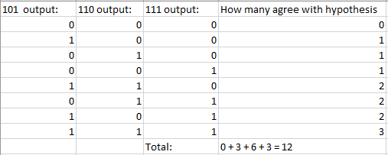

[b]: 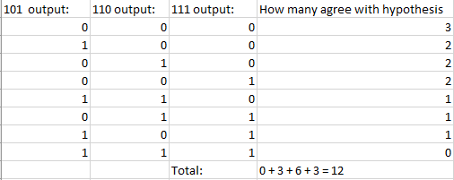

[c]: 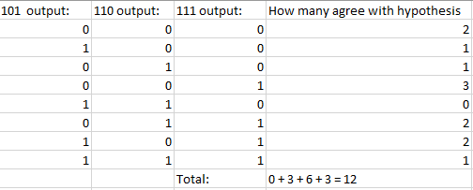

[d]: 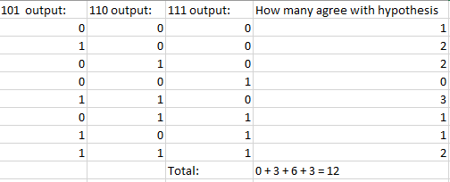

Since all the hypothesis all score to 12, the answer is [e].

Code for the PLA and Command Prompt output:

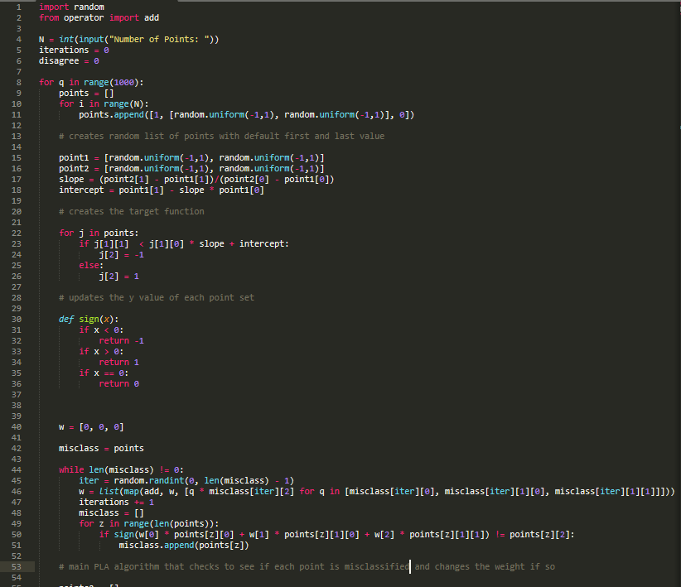

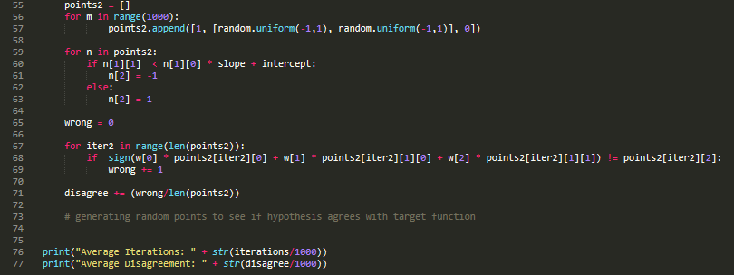

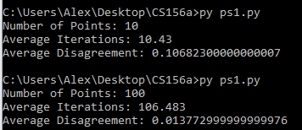

7. The average iterations for N = 10 was 10.43 which is closest to 15 so [b]

8. The average probability of disagreement was 0.107 which is closest to 0.1 so [c]

9. The average iterations for N = 100 was 106.48 which is closest to 100 so [b]

10. The average probability of disagreement was 0.014 which is closest to 0.01 so [b]