CS156a Problem Set #2

1. Work is in my code:

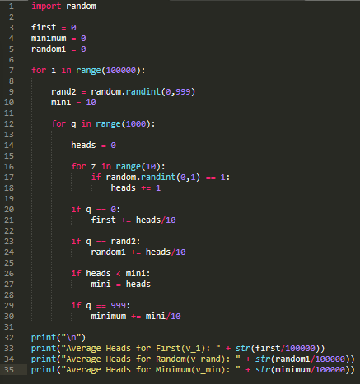

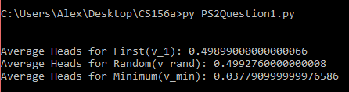

The value for ν­min is 0.0378 which is closest to 0.01, so the answer is [b]

2. The Hoeffding Inequality states that the probability of a sample can become increasing close to the true probability. This comes around through bigger sample sizes, which cause the sample probability to converge to the true probability. In our case, the true probability is ½ as there is a ½ chance of flipping a head. Thus, we will try each sample result in the inequality to see if meets the conditions:

P[|ν − µ| > ǫ] ≤ 2e−2(ǫ^2)N

First, we take the absolute value for each:

|0.49899000000000066 – 0.5| = 0.00101

|0.4992760000000008 – 0.5| = 0.000724

|0.037790999999976586 – 0.5| = 0.462209

At this point, it becomes clear which sample probabilities will satisfy the Hoeffding Inequality. Since the

inequality depends on how close the sample probability is with the true probability, the samples with a

very small difference will be able to satisfy the inequality (since the right side will be close to zero for

larger ǫ values). Thus, the c­1 and crand will satisfy the equation because of how close their sample

probability is (which makes the right side always close to two), while cmin has a difference almost as large

as the true probability (this makes the inequality false for ǫ values closeto 0.462209). The answer is [d].

3. We can create a table to see the results. Since *h* and *f* are binary functions, if there is an error

both, the outcome will not be an error:

|  |  |  |
| --- | --- | --- |
|  | P(y|x) Correct | P(y|x) Wrong |
| *h* Correct | (λ) (1 - µ) | (1−λ) (1 - µ) |
| *h* Wrong | (λ) (µ) | (1−λ) (µ) |

The probability of error are the overlaps of rights and wrongs, so (λ) (µ) + (1−λ) (1 - µ). The answer is [e].

4. As shown in the table above, each probability will either have λ or 1 – λ multiplied by a quantity with µ or 1- µ. If we plug 0.5 into the probability of *h* making an error, we get (0.5) (µ) + (1−0.5) (1 - µ) = 0.5. If we do the same for the probability of *h* not making an error, we get 0.5 as well. This means that there is a 50/50 chance of making an error, which is independent of µ. The answer is [b].

5. Closest to [c]

6. Closest to [c]

7. Closest to [a]

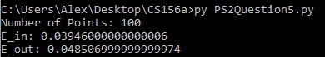

N = 10 for this result: 

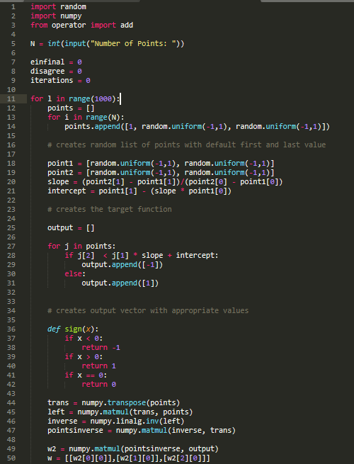

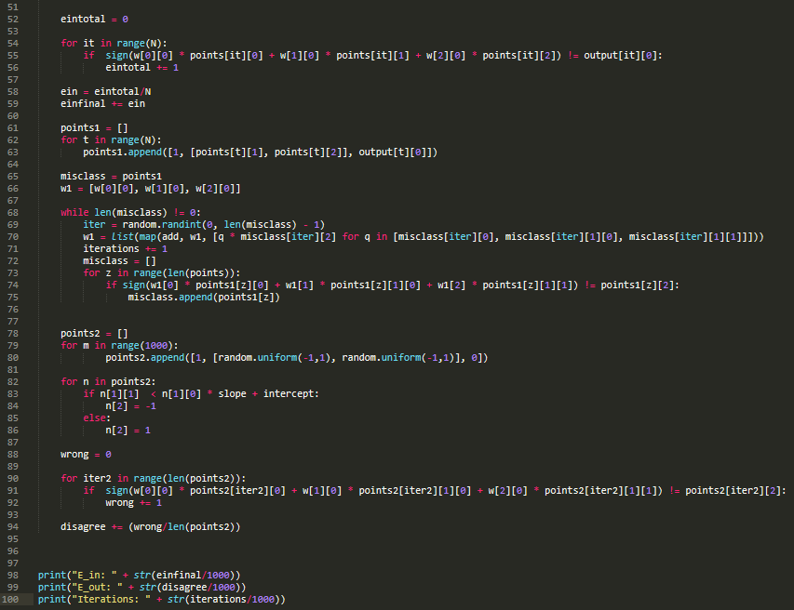

8. The answer is closest to [d]

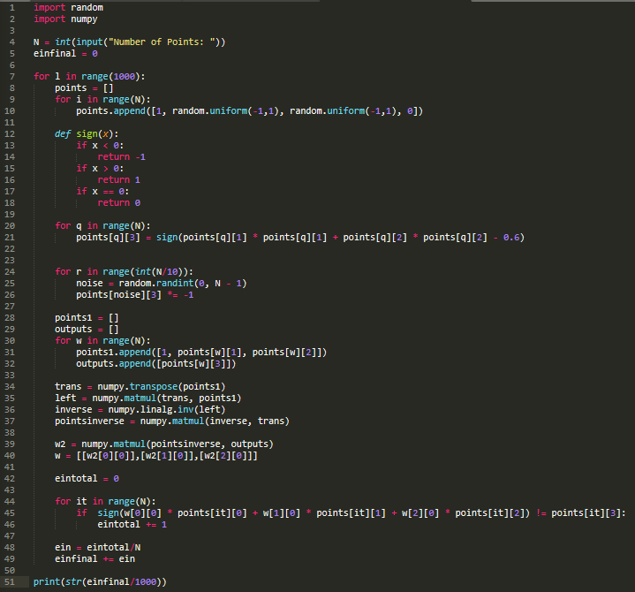

9. The hypotheses that agrees the most is [a].

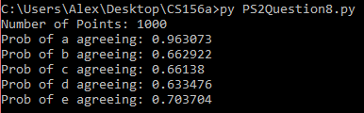

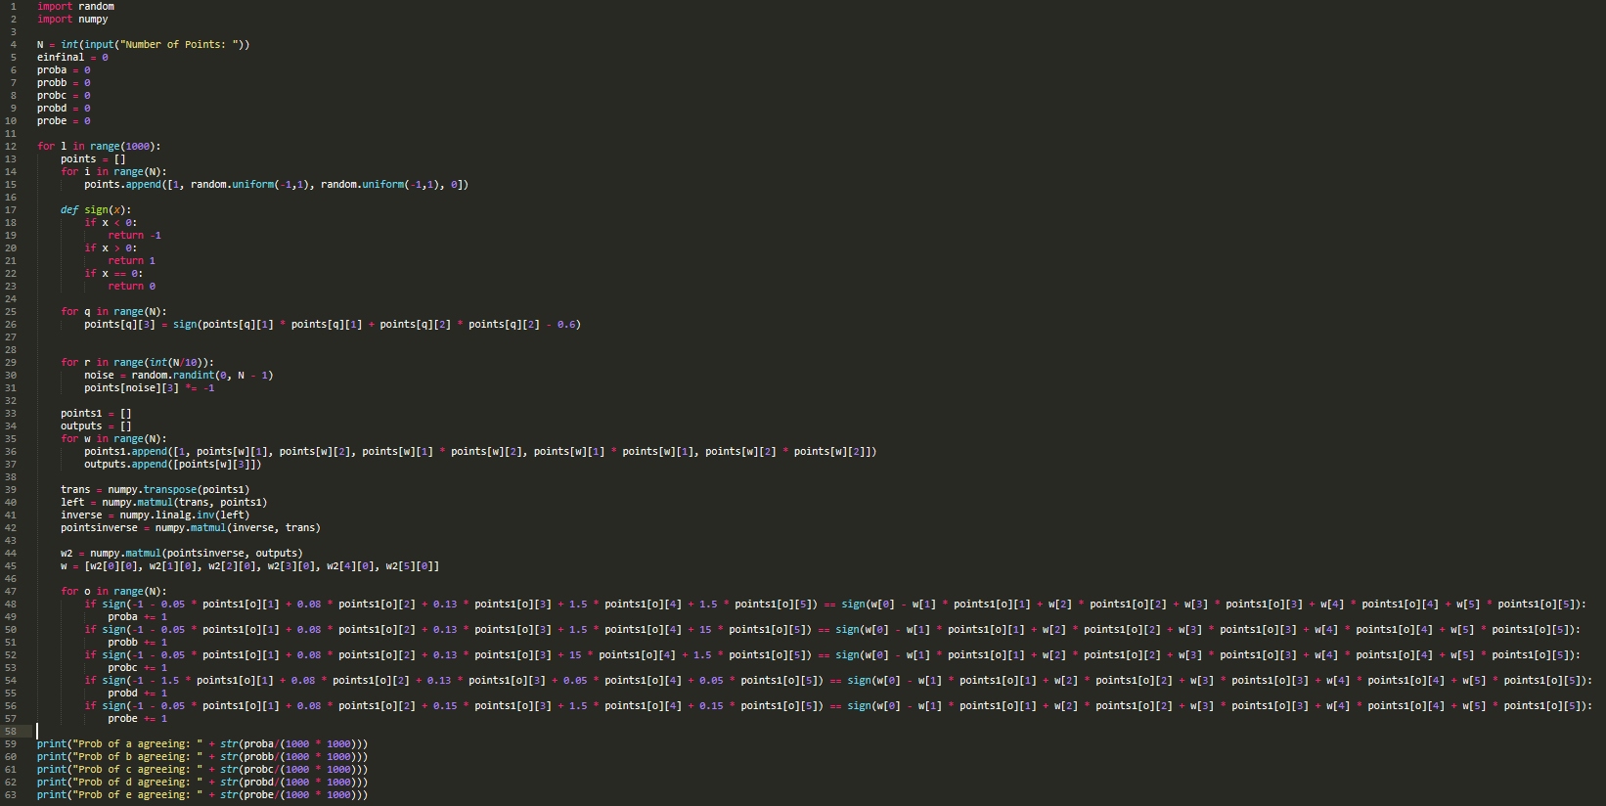

10. The answer is closest to [b]

