Part 1: Project Overview
A neutron is net neutral, but if you look at its components:
one up-quark and two down-quarks could give it a(n electric) dipole moment.
But for the moment we don’t know it. At this point in time, our lowest
experimental upper bound is 10 to five exponents
larger, in e*cm, than the Standard Mod(el)’s nEDM.
By the way, this presentation’s at 100 bpm;
I’mma spit a couple facts, so hold your questions ‘til the end.
Just sit back, relax; I’ll tell you all about my tedium:
Our proposed experiment| uses liquid helium
Which scintillates with neutron spin
precession… increasing our precision.
Wait but something’s missing: What motivates our mission?
CP violations, as per Sakharov Conditions.
If the neutron dipole moment is within our sensitivity,
then subatomic EDMs yield baryon asymmetry.
(More matter than antimatter - currently a mystery!)
We’ll put some neutrons in a field, plus helium for spin dressing.
Record precession frequencies, then instantly we’ll flip the E
Re-measure the precession, and ideally the shift should be
Purely correlated with (equation 3)’s little d.
But that’s only the case with no B-field spatial gradient
Because field variation with location means there’s more to see:
a geometric phase shift from B-field non-uniformity:
A signal deviation, that’s proportionally also sourced from E
So minimization of the field fluctuations, is a high priority.

Part 2: Field Compensation System
I began my research project making a constant offset compensation
Mathematica DC coil simulation.
The FCS, or field compensation system
Is a set of 6 square current loops, in a rectangular prism,
that's 12 feet high, with a width n' length (of) 8 meters,
it's designed to provide a field that deals with the Earth's.
…which is similar to a giant dipole – then make it simpler:
In particular, it’s almost constant within our perimeter.
We then shield the net field, with a Mu-metal cylinder
More effective, but expensive; thanks to the FCS, we can get thinner
layers of material, without saturating it;
Mine mostly minimize magnitudes, while shims take care of gradients.
But when I tried to measure the field, in the previously planned radius,
phone’s probe kept going crazy, just reporting recordings insanely in
excess of what I expected. Upon further inspection,
we detected that the field close to the floor was most excessive:
It’s magnetic! …But how could the field be so strong? Appears that this
floor must’ve been affected by the synchrotron experiment!
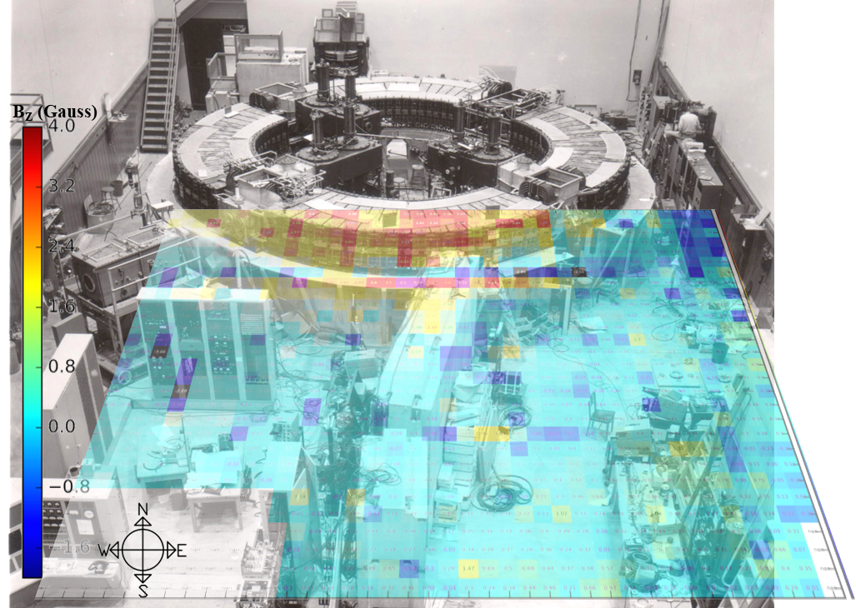
$B_{z}$ floor map overlayed onto an old photograph of the Caltech Electron Synchrotron. I wasn’t able to line up the perspectives perfectly, but the overlap is still quite compelling.

The Larmor precession frequency $ω_{n}=-2\frac{μ_{n}B_{0}±d_{n}E}{ℏ}$ was eq. 3 in the poster I originally presented this with.
Here, “mine” refers to the coils used for the Direct Current components of the FCS, since my project focused on offsetting time-independent external fields.

