Topic Modeling using LDA

In this notebook I will present an use case for Latent Dirichlet Allocation, which is Topic Modeling. In machine learning and natural language processing, a topic model is a type of statistical model for discovering the abstract topics that occur in a collection of documents. Topic modeling is frequently used in data mining techniques in an attempt to find hidden semantics in the text data. In general, we use this algorithm to find words that are repeating in a subset of documents, or even finding documents that share a similar topic just by using words from the same field, or synonyms. In our case, we will be looking at finding topic clusters for books, which could be an useful project in an application that can recommend other similar books to the ones you just bought or read. On the most basic level you could just group books together by the author, the year it was written. Other useful information for sorting an entire database of books would be genre or some other literal aspects, such as reviews or comments. But what would happen if the application was not build with keeping in mind that functionality, of grouping books in categories. Here is where the power of LDA begins to show. Intuitively this algorithm is able to find the keywords of an entire dataset just using the text documents that are available. This means that the database containing only text bodies of data can be labeled with keywords easily. The only difficult part is cleaning the data and feature engineering so that the resulting keywords have meaning. Intuitively, we do not want to use words that repeat to often during training, such as "the", "a", "an". We call these types of words stopwords. It depends on the dataset used, but usually we want to include other words in these blacklist too. Some other examples of words that we may consider useless are pronouns ("I", "you", etc.), person names, or any other set of words that would make sense to ignore. Generally we will find these as we work on cleaning the dataset by looking at examples or histograms of word counts.

LibriSpeech Dataset

In this project I will present an use case for Latent Dirichlet Allocation, which is generating topic clusters for a dataset of audio books. The dataset used in this work is LibriSpeech. This contains the audio files as well as the transcription of each book, which is what I will be using as training data. However, the dataset is not already preprocessed and we will have to go trough the steps of cleaning the data and modeling. The modeling stage is pretty straight forward, since we just have to showcase the use of LDA. The original data format is presented in the LibriSpeech release and comes with tools that are able to parse the text from the target files. I just had to concatenate each piece of text and group them by book and then saved them in a tabular format. In the end we are left with three comma separated value files, one for the training stage, one for validation and one for testing (or the holdout set).

Imports

The tools I used for this project are NLTK, which is an open source library, Natural Language Toolkit. NLTK is a leading platform for building Python programs to work with human language data. It provides easy-to-use interfaces to over 50 corpora and lexical resources such as WordNet, along with a suite of text processing libraries for classification, tokenization, stemming, tagging, parsing, and semantic reasoning, wrappers for industrial-strength NLP libraries, and an active discussion forum. We will be using this library for it's powerful preprocessing techniques, which will in turn make our model yield better results.
The other important library I will be using is gensim, which contains the implementation of the LDA algorithm and metrics that will be useful to test the implementation. I will use the gensim library because I am the most familiar with it, in case of topic modeling, it is open source, meaning we have access to look at how it is implemented and it works very fast.

Data Loading

As previously mentioned, the dataset is LibriSpeech, a collection of audio books. However, in this project we are only interested in the text bodies of the audio books, so I saved just the text files alongside with the book titles and the duration of each book, just to be able to discard examples that are too short and would not add any value to the final implementation. For now the text contained in each books is not filtered, so it basically contains the transcript of each audio book.

We can see that the distribution of the audio books lengths varies quite a lot so we can remove the examples that fall outside the range given using the zscore, in our case we want to keep the data that is at most 3 standard deviations away from the mean. In statistics, the standard score is the number of standard deviations by which the value of a raw score is above or below the mean value of what is being observed or measured. Raw scores above the mean have positive standard scores, while those below the mean have negative standard scores.
After we have removed the samples that were either too long or too short, we can focus on cleaning the wording of the books. I started with expanding the abbreviations, or contractions between the pronouns and verbs, from the dataset. This will allow us to have less tokens in the list of stopwords and will make the process easier to follow.

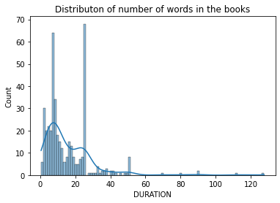Figure 1: Distribution of the audio book length before cleaning

Another important step in the process of data cleaning is work tokenization, where we have to split the text stream into words. After this step we could even run the LDA algorithm, but we would get really bad results from a human perspective, since the algorithm will only care about maximizing the score, and will most likely choose the most frequent words as keywords, such as the aforementioned stopwords, "the", "an", "a", etc.
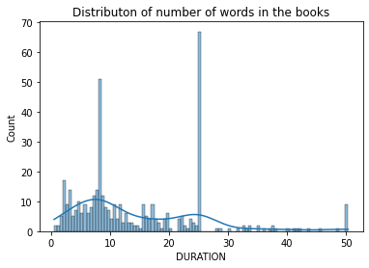Figure 2: Distribution of the audiobook lengths after cleaning (removing the books that are three standard deviations away from the mean with respect to length)
To speed up the rest of the pipeline we will be removing words that are short, less than three letters is a good enough threshold for the English language. This will remove most of the stopwords and pronouns, but still leave some other examples in that can be eliminated.

For this particular dataset we want to remove interjections, such as "oh" and "ah", the words "yes" and "no", archaic terms, that are used in some of the books and would cause a biased response, since they actually refer to pronouns and other words that are being removed. Also other words that have caught my attention were "mister" and "miss", which appear very often, alongside with person names, which would not add any value. And even if the book is about some person, it would still be better to cluster it together with books that are related to the same topic, which can be whatever at this point.

Now that we have only the most important words remaining we can see that there is a lot of redundancy in cases such as using the present tense and past tense, or singular and plural, or types of adjectives, etc. To balance these aspects we can do a part of speech analysis and use lemmatization to bring each word to its simplest form. Lemmatization (or lemmatisation) in linguistics is the process of grouping together the inflected forms of a word so they can be analysed as a single item, identified by the word's lemma, or dictionary form. In our case we want to convert adjectives into their simplest form, nouns into singular nouns, and verbs into infinitive form. This will basically reduce the number of different words from out dataset. This is important because for the algorithm it doesn't make sense that words with different forms refer to the same thing syntactically, and that would create a huge number of features to train for. Imagine that every noun would also have it's plural form in the dataset. That would basically double the size of the dataset from the perspective of the machine learning model, and would not help the distribution of that word's meaning. This is one of the most important steps, besides removing stopwords, because it can make the difference between a word appearing as a keyword or not. For example it can be a keyword, but it's to spread out due to it's multitude of froms it can be written as. Stemming and lemmatization are methods used by search engines and chatbots to analyze the meaning behind a word. Stemming uses the stem of the word, while lemmatization uses the context in which the word is being used. We'll later go into more detailed explanations and examples. The aim of both processes is the same: reducing the inflectional forms of each word into a common base or root. However, these two methods are not exactly the same. The main difference is the way they work and therefore the result each of them returns. Stemming algorithms work by cutting off the end or the beginning of the word, taking into account a list of common prefixes and suffixes that can be found in an inflected word. This indiscriminate cutting can be successful in some occasions, but not always, and that is why we affirm that this approach presents some limitations. Lemmatization, on the other hand, takes into consideration the morphological analysis of the words. To do so, it is necessary to have detailed dictionaries which the algorithm can look through to link the form back to its lemma.

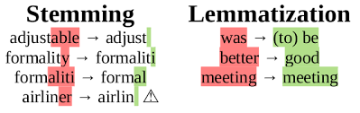Figure 3: Example of Stemming vs Lemmatization

Feature engineering

Now we have completed the process of data cleaning and are able to start with feature engineering. To recap, we started with the text bodies of each audio books, then we expanded abbreviations, then we tokenized the text into words, we removed the short words and the stopwords, and finally we applied lemmatization on the resulted tokens, leaving us with the most important pieces of the data. As we might know, machine learning models are not capable of using text data as input, so we have to vectorize, or in other words convert the data from words to numbers, to be able to train a model. To accomplish this task we can make use of a frequency counter, meaning that we take each word and count how many times it appears in the entire dataset. To further improve the quality of the data we can discard the words that are not frequent enough or that appear in too many documents.
We can even generate a word cloud with some of the resulting words, that are the most frequent, or that have the best scores for that matter.

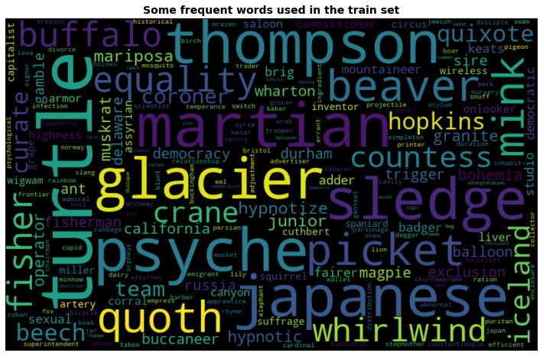Figure 4: Wordcloud with the most frequent words from the LibriSpeech Dataset, as we will see some of these words will become label keywords

Modeling

In this stage we are going to use the LDA algorithm from the gensim library to train and test the topic modeling algorithm for our dataset. We can look at different numbers of topics and choose the parameters that yield the best results. To do this we will make use of the coherence metric. Before we understand topic coherence, let’s briefly look at the perplexity measure. Perplexity as well is one of the intrinsic evaluation metric, and is widely used for language model evaluation. It captures how surprised a model is of new data it has not seen before, and is measured as the normalized log-likelihood of a held-out test set. Focussing on the log-likelihood part, you can think of the perplexity metric as measuring how probable some new unseen data is given the model that was learned earlier. That is to say, how well does the model represent or reproduce the statistics of the held-out data. However, recent studies have shown that predictive likelihood (or equivalently, perplexity) and human judgment are often not correlated, and even sometimes slightly anti-correlated. This limitation of perplexity measure served as a motivation for more work trying to model the human judgment, and thus Topic Coherence. The concept of topic coherence combines a number of measures into a framework to evaluate the coherence between topics inferred by a model. Topic Coherence measures score a single topic by measuring the degree of semantic similarity between high scoring words in the topic. These measurements help distinguish between topics that are semantically interpretable topics and topics that are artifacts of statistical inference. A set of statements or facts is said to be coherent, if they support each other. Thus, a coherent fact set can be interpreted in a context that covers all or most of the facts. An example of a coherent fact set is "the game is a team sport", "the game is played with a ball", "the game demands great physical efforts".

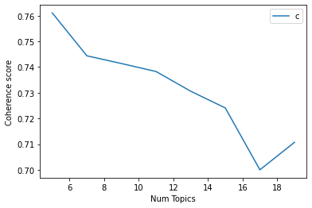Figure 5: Chart with the coherence score of the LDA model for the LibriSpeech Dataset with respect to the number of topics chosen. The higher the coherence the better.

To test how the LDA algorithm works I decided to try a grid search over the number of topics. This parameter tells us in how many categories are we going to group the documents that we are using for the dataset. In the case of the LibriSpeech dataset, the transcriptions of the audio books, the best score was obtained for a number of topics equal to 5. We can see the score change in the graph below. I have plotted the coherence score by the number of topics tested, in this case a range from 5 to 21. Since the model with the highest coherence is the one with 5 different topics we are going to choose that model for the next part, which is actually showing details and topic information for the dataset, and in particular showing details for some of the books contained in the LibriSpeech corpus.

First we are going to look at the generated topics, which are basically just sets of keywords that we can control the sizes of. I chose to generate 10 keywords per each topic since that seems to be enough to make an idea of what is contained in a book, or what is the main idea and subject of that book. From the obtained data we can see that the first and third topics share some ideas and look quite similar. This can be the case if the two topics would be sub categories of a bigger topic. We can see the confirmation that those two topics are similar in the LDAvis graph which shows the Intertopic Distance Map. The intertopic distance map is a visualization of the topics in a two-dimensional space. The area of these topic circles is proportional to the amount of words that belong to each topic across the dictionary. The circles are plotted using a multidimensional scaling algorithm (converts a bunch of dimension, more than we can conceive with our human brains, to a reasonable number of dimensions, like two) based on the words they comprise, so topics that are closer together have more words in common. The bar chart by default shows the 30 most salient terms. The bars indicate the total frequency of the term across the entire corpus. Salient is a specific metric, defined at the bottom of the visualization, that can be thought of as a metric used to identify most informative or useful words for identifying topics in the entire collection of texts. Higher saliency values indicate that a word is more useful for identifying a specific topic. When you select a topic in the intertopic distance map, or specify a topic in the top panel, the bar chart changes to display the most salient words included in that specific topic. A second darker bar is also displayed over the term’s total frequency that shows the topic-specific frequency of words that belong to the selected topic. If the dark bar entirely eclipses the light bar, that term nearly exclusively belongs to the selected topic. When you select a word in the bar chart, the topics and probabilities by topic of that word are displayed in the intertopic distance map, so you can see which other topics a term might be shared with. You can adjust the words displayed in the bar chart for a topic by adjusting the λ (lambda) slider. Adjusting lambda to values close to 0 highlights potentially rare but more exclusive terms for the selected topic. Larger lambda values (closer to 1) highlight more frequently occurring terms in the document that might not be exclusive to the topic. The authors of this visualization found in a user study that a λ value close to 0.6 was optimal for interpreting the topics, although they expected this value to change based on the data and individual topics.

Table 1: The keywords that were found by the LDA algorithm for the LibriSpeech dataset. Each row represents a topic.
glacier | sledge | quixote | hypnotize | canyon | granite | onlooker | hypnotic | japanese | fisher
beaver | martian | iceland | turtle | buccaneer | balloon | simpleton | spaniard | fisherman | grape
psyche | turtle | buffalo | whirlwind | california | coroner | exclusion | cupid | temperance | commissioner
thompson | team | junior | fisher | operator | badger | countess | artery | equality | liver
japanese | picket | quoth | keats | beech | durham | bohemia | wharton | russia | magpie

Now we can look at the main reason for using LDA in the first place, which is finding the distribution of topics in a particular book. For example we can take a look at a specific book and see from what topics it is formed. The main idea of this algorithm is that it finds what proportion of each topic is contained by a document, so we can visualize that and choose whatever topic, or topics if we feel like it is the case, that are dominant. In an application we will assign the keywords of the dominant topics to this book and allow users to search books by keyword, without the need to know the name or the author. They will just have to think of some idea, or topic for that matter, that they want to read about, and they will be greeted with a large collection of books that contain that topic to choose from. Now what is useful in this type of search is that a book does not need to contain a specific topic keyword in it's text to still be categorized as that topic. For example let's say that we have a topic about sports and you would think that both football and basketball would be great candidates for topic keywords, but let's say that we have a book about the life of some basketball player and thus it would most probably never reference the word football, but if an user is into sports and searches for football might also find this book interesting, at some extent. This is why it is a good idea to have a large dataset to train the LDA model on, because we will have a multitude of words to choose from for the topic keywords. However LDA is not really intended to build a recommendation system, but it can showcase some of the ideas that can lead to us building such a system, such as the keywords we just found for our book. Another great aspect about LDA is that, after it has been trained it can generate topic labels for books that it had never seen before. This can be useful when we need to update our database of books and add new ones, generating keywords in real time, and being able to serve them to the users of the application. In my opinion, for a online book application it is a good idea to keep multiple topics per each book, since it gives a chance to each of them to be discovered by an user, and also give them a chance to maybe discover a new topic that they might like. This is the main idea of recommender systems and other interesting algorithms like page rank that the result, or outputs, of the LDA algorithm can mimic and build up to.

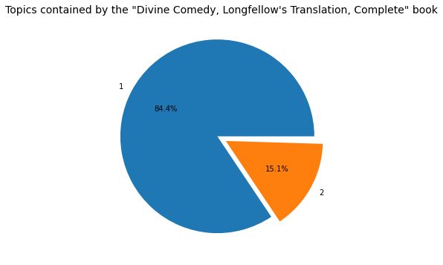Figure 6: Distribution of the topics in one of the books in the LibriSpeech Dataset. We denoted with 1 the second topic and with 2 the third one (staring from zero)

Now that we saw how each book contains a number of topics in a dirichlet distribution, some books having only one topic, other containing all of them, we can look at which is the most representative book for each topic. This information can also help us in deciding how to name each topic, because for now we are only looking as what keywords are building each topic and not really what is the name of the topic. This is still very useful, since we are showcasing an proof of concept for a online book library, which would benefit more from a collection of keywords being associated with each book, in some sense simulating a larger number of topics. To make this process even better we can make use of other natural language processing tricks such as word vectorization and generating synonyms for each keyword, further expanding our generated base by the LDA algorithm. For example, looking at the resulting books, that are the most representative for each topic we can see some interesting results, that prove that the keywords were chosen well. The title of the most representative book for the first topic, which for now we unimaginatively called topic 0, seems to indicate that it is about psychology, which seems to be an accurate try by looking at some of the keywords that the LDA model found in the our dictionary generated from the set of books. The interesting keywords of the first topic, that we saw is very close to psychology, are "hypnotize" and "hypnotic". However there are also some keywords that are not related to this field, but it is to be expected since this is an unsupervied learning method and we are not labeling the books by hand. Maybe these keywords would make sense in a more general topic cluster that is only limited to this book. Because how we know we are interested in increasing the coherence of the model, or as we saw decreasing the perplexity, and thus making the model less surprised when it find out what words a certain book contains. Maybe with a large enough dataset and higher number of topics it would try and separate better between each type of book. Now for the second topic thing seem simpler since the book might make us think that this cluster is about stories that include elements of fantasy and adventure in them. And looking at the keywords that we found for the second topic, are also indicating that this might be the case, as we might agree that most books about adventure themes will contain such keywords or main ideas in them. The most interesting keywords for this topic are "martian", "iceland", "buccaneer", "balloon", "spaniard", "fisherman". We can apply the same logic for the rest of the topics and find some other names for them. Again, in my opinion, this is the best strategy in obtaining topic names if you are in need of such information. I have also tried automated methods, the first one being the naive but sometimes efficient method of choosing the first word as the topic label, but in the case of this project, that would not make much sense, because we saw that some of the more interesting words are not the most common but somewhere in the middle. Another method of finding a common label is by making use of word vectorization. Word Embeddings or Word vectorization is a methodology in NLP to map words or phrases from vocabulary to a corresponding vector of real numbers which used to find word predictions, word similarities/semantics. After computing the embeddings of each word, which can be done using frequency counters or some other methods that are not in the scope of this project, as we are only interested in knowing how vectors look and how to use them after we obtained them with some process, we can perform mathematical operations on them to find, for example the average. Intuitively, we might expect to find the "average" word in that location with some sort of inverse transformation that maps to the closest word to that location, and use that as the topic label. Finding this word can be done with cosine similarity, for example. After the words are converted as vectors, we need to use some techniques such as Euclidean distance, Cosine Similarity to identify similar words. Count the common words or Euclidean distance is the general approach used to match similar documents which are based on counting the number of common words between the documents. This approach will not work even if the number of common words increases but the document talks about different topics. To overcome this flaw, the "Cosine Similarity" approach is used to find the similarity between the documents. However, even if this method sounds like a great option, we would need a lot of examples of words in our dictionary to find the best match, and even then I found that manually choosing the topic name yields the best results. However, I felt like it would be a great information to know that you could be able to automate this process, in the favor of losing some accuracy.

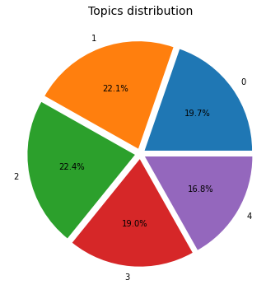Figure 7: Distribution of the topics found by the LDA algorithm for the LibriSpeech dataset.

As we saw in the LDAvis chart we were able to determine by the sizes of each bubble topic that they are pretty much equal in distribution, however we can also look at the numbers directly and confirming that fact, and continue to support our claims. Finally, as I mentioned before, we are able to run the LDA algorithm on new books and obtain the results that were included in the original dataset. This can prove useful for any application that has to deal with topic modeling at some point. And as a note we can also use the gensim library to export the model with its final state and run it in any application, without the need to retrain it on the dataset, even though it is very fast, but what is great about this is that we don't need to download the dataset again, which can be quite large. And the final model will just contain the counter of words, or the frequency dictionary as embeddings in its final file.

Reuters Dataset

For the second dataset I chose the retuers dataset, which is a dataset for the text categorization task and contains different sources of news articles grouped by different categories. But for this project we are only interested in the documents and the text they contain, since we want to create our own labels. Just imagine that we were tasked with coming up with the categories for these news papers in an automated way, just by knowing the text that they contain. So we can again use LDA, as in the case of our book library application example. The Reuters-21578 dataset is a collection of documents with news articles. The original corpus has 10,369 documents and a vocabulary of 29,930 words. Text categorization is the task of deciding whether a piece of text belongs to any of a set of prespecified categories. It is a generic text processing task useful in indexing documents for later retrieval, as a stage in natural language processing systems, for content analysis, and in many other roles, which is a similar task to what we try to achieve, but in an unsupervised manner. To use the retuers dataset we will be using the nltk library which will allow us to use it's API and interact with the aforementioned files from the retuers archive. To make an idea these are some of the topics that are contained in the reuters dataset: 'acq', 'alum', 'barley', 'bop', 'carcass', 'castor-oil', 'cocoa', 'coconut', 'coconut-oil', 'coffee', 'copper', 'copra-cake', 'corn', 'cotton', 'cotton-oil', 'cpi', 'cpu', 'crude', 'dfl', 'dlr'. We can see later if we find keywords that are similar to these ones. The preprocessing steps will be similar to the ones of the LibriSpeech dataset, but in this case we start with the words being already tokenized, so we just have to start from that step. So first we will remove short words, this is very important in case of the reuters dataset, since it contains not only alhpabetical characters but also symbols, which we have to discard, since they would not make for a good topic name.

Feature engineering

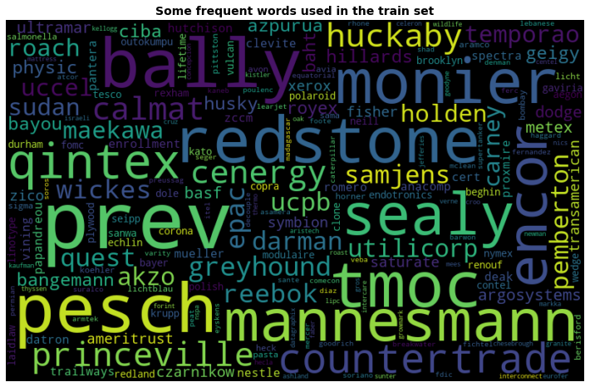Figure 8: Wordcloud with the most frequent words from the Reuters Dataset, as we will see some of these words will become label keywords

Modeling

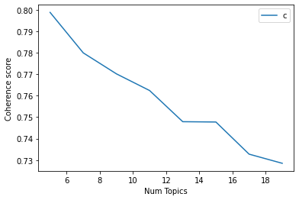Figure 9: Chart with the coherence score of the LDA model for the Reuters Dataset with respect to the number of topics chosen. The higher the coherence the better.

Table 2: The keywords that were found by the LDA algorithm for the Reuters dataset. Each row represents a topic.
lipc | growmark | otsuki | hecla | madagascar | tmoc | novamin | breakwater | nics | ambrit
huckaby | husky | varity | linde | masse | labatt | bally | renouf | fruehauf | seng
sudan | linotype | utilicorp | basf | thermo | ultramar | olivetti | adhesive | encor | wickes
krupp | bayou | cenergy | princeville | holden | baht | astral | nervously | greenwood | modulaire
equatorial | foote | pesch | vietnam | flower | degussa | contel | cruz | redstone | meston

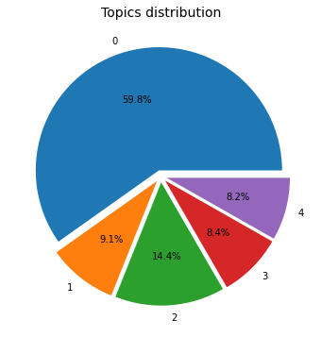Figure 10: Distribution of the topics found by the LDA algorithm for the Reuters dataset.

