**Pre-lab 3**

**Time-Varying Voltage Sources in SPICE**

Name:_______Alex Hoff___

Section (select one): _X__Tuesday ___Wednesday ___Thursday

1. In the Lab Assignment #3, the netlist provided is almost working, except the two incomplete voltage sources:

VA A1 0

VB B1 0

Complete the SPICE description of the two time-varying voltage sources with the following characteristics, and print-out the completed netlist. If necessary to improve the legibility of (time, voltage) data points, use the MS Word's zoom feature.

TEST

*TEST circuit for MYNAND2

.OPTIONS POST=1

**CIRCUIT DESCRIPTION

* Power Supplies / Signal Sources

.GLOBAL VDD

*

V1 VDD 0 DC 3.3

VA A1 0 PULSE(0 3.3 90n 10n 10n 190n 300n)

VB B1 0 PULSE(0 3.3 190n 10n 10n 290n 500n)

*

* Element Descriptions

XNAND1 OUT1 A1 B1 MYNAND2

CLOAD OUT1 0 2P

*

.SUBCKT MYNAND2 OUT A B

MPA OUT A VDD VDD PCH W=3.2u L=0.4u

MPB OUT B VDD VDD PCH W=3.2u L=0.4u

MNA J A 0 0 NCH W=3.2u L=0.4u

MNB OUT B J 0 NCH W=3.2u L=0.4u

.ENDS

*

* Model Statements

.model PCH PMOS LEVEL=1

.model NCH NMOS LEVEL=1

*

**Analysis Requests

.TRAN 10n 690n

*

**Output Requests

.probe

*

.end

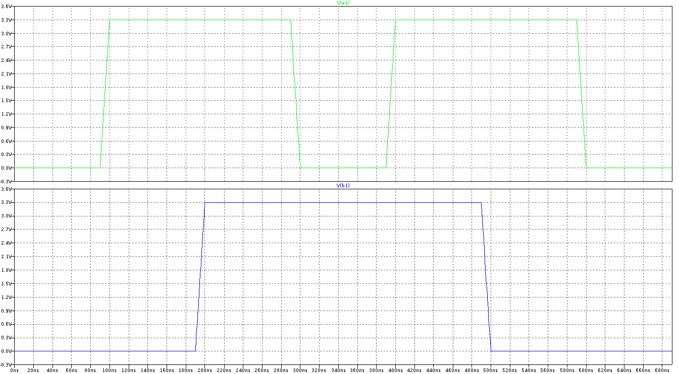

Hints: You will need PWL or PULSE statements. Refer to pages 4-5 of "SPICE 'Quick' Reference Sheet" if necessary.

2. Run HSPICE of the completed netlist at the Design Center, and 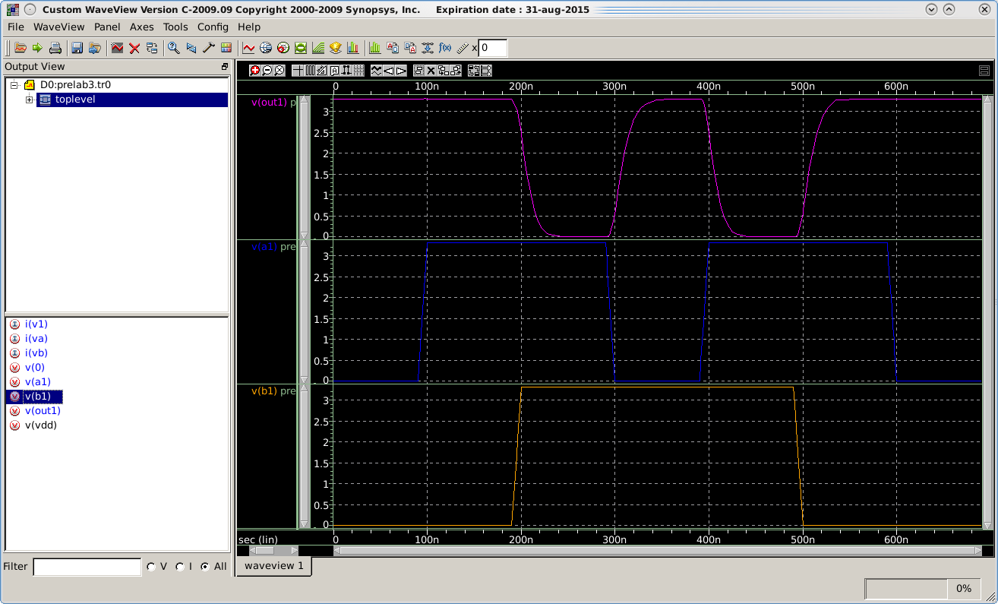print-out the graphs of V(OUT1), V(A1) and V(B1) waveforms in three separate panes.