Assignment 1 – Deliverable 4 – MacLean/Kwan

Scenario 1: A user withdrawing from an account

1. Login as Manager
2. Create a user with a chequing account
3. Logout from Manager account
4. Login as created user
5. Deposit money into chequing account
6. Withdraw from chequing account

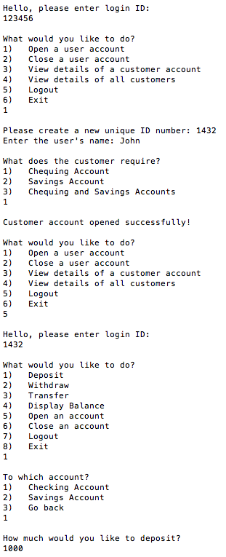

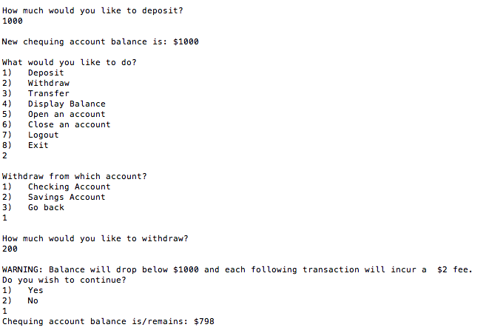

Scenario 2: Manager views a customer’s account

1. Login as manager
2. Create a user account
3. Choose to view a customer’s account
4. Enter desired customer’s ID number

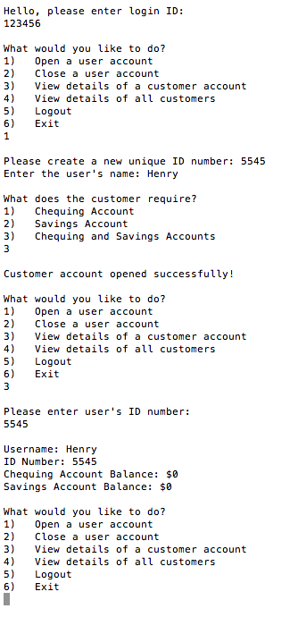

Scenario 3: Customer transfers money from chequing to savings accounts

1. Login as Manager
2. Create a customer with chequing and savings accounts
3. Logout from Manager account
4. Login as customer
5. Deposit money into both accounts
6. Choose to do a transfer
7. Select to transfer from chequing to savings
8. Enter amount to transfer

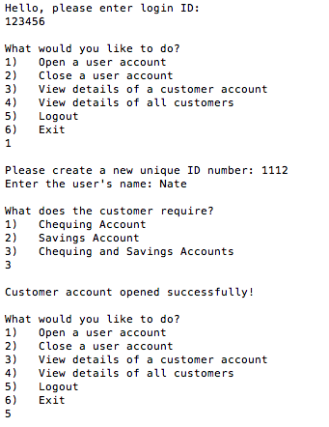

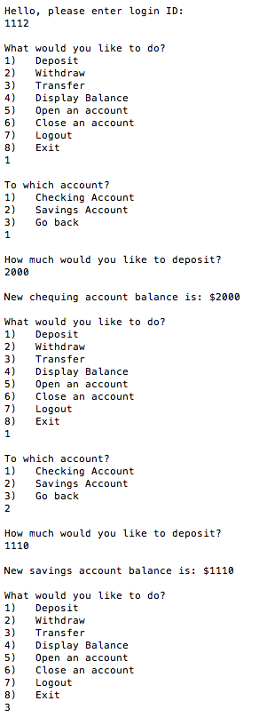

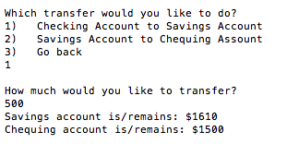

Scenario: Manager closes a customer’s account

1. Login as Manager
2. Create a customer account
3. Select the option to close an account
4. Enter desired customer’s ID number
5. Customer deleted!

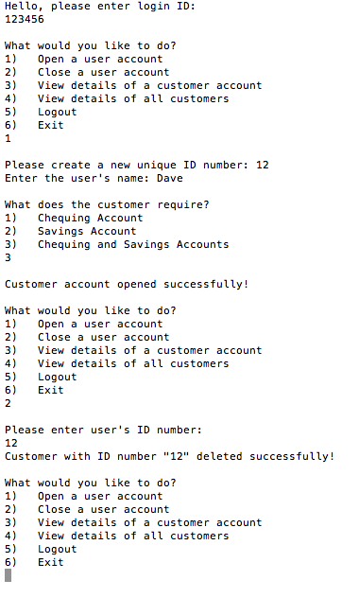

Scenario 5: Customer tries to close an account with a non-zero balance

1. Login as Manager
2. Create a user with chequing and savings accounts
3. Logout
4. Login as the customer
5. Add some money to both accounts
6. Choose to close an account
7. Error message will display and account will not close

