Computer Science 2212b

Team Assignment 3

Team 10

Due: March 15th, 2014 at 11:59 PM

**Team Members:**

Henrique Brighenti

Will Callaghan

Alex MacLean

Stephen Solis

Marcus Tonogai

**SECTION 1: REVISED UML CLASS DIAGRAM**

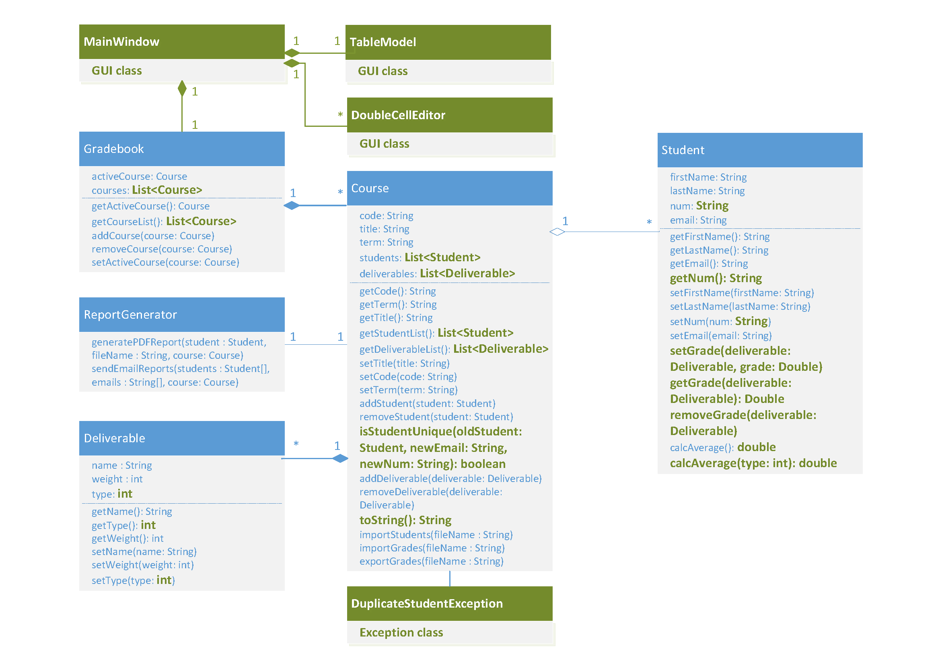

**SECTION 2: REVISED USER STORIES**

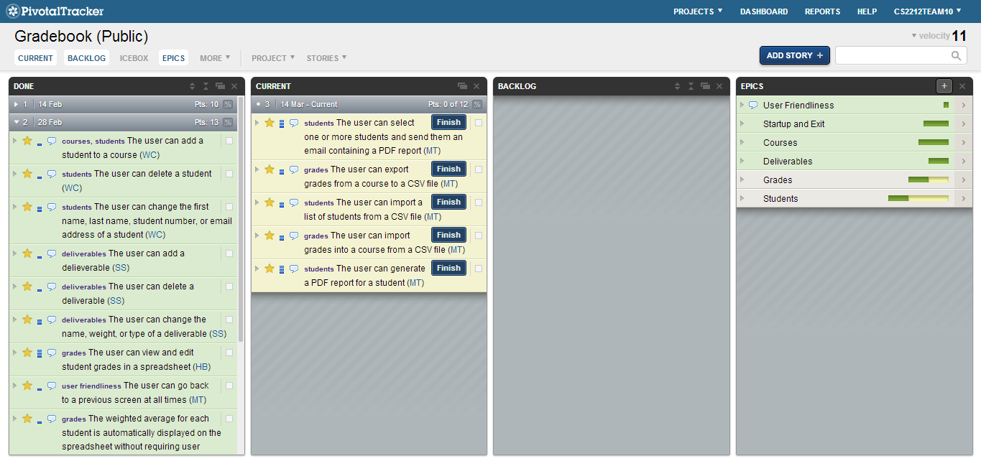

<https://www.pivotaltracker.com/s/projects/1003292>

**Completed User Stories:**

* User can add a course
  + Hit the first icon underneath File menu in the top left or go to the courses menu and hit “Add Course”
* User can delete a course
  + Hit the third icon underneath the File menu in the top left or go to the courses menu and hit “Delete Course”
* User can change the code, title, or term of a course
  + The middle icon below the File and Courses menus will allow a user to edit a course or got to the Courses menu and click “Edit Course”
* User can change the active course
  + Use the drop down menu in the top right to select an active course
* User’s data is retrieved and restored whenever the system is started
  + Courses previously added are in the spreadsheet area when program starts
* User’s changes are stored prior to exiting the program
  + No need to hit a save button!
* User can quit the application at any time
  + Hit the red “x” button in the top left

**SECTION 3: ACCEPTANCE TESTING**

|  |
| --- |
| **ID** 1 |
| **Testing**  User adding a new course; no course code |
| **References**  Requirement 4.2.1.a |
| **Test Case**  1. Enter nothing for the course code |
| **Expected Output**  Error.  Message: Invalid course code: course code is blank |

|  |
| --- |
| **ID**  2 |
| **Testing**  User adding a new course; no course title |
| **References**  Requirement 4.2.1.b |
| **Test Case**  1. Enter nothing for the course title |
| **Expected Output**  Error.  Message: Invalid course title: course name is blank |

|  |
| --- |
| **ID**  3 |
| **Testing**  User adding a new course; no course term |
| **References**  Requirement 4.2.1.c |
| **Test Case**  1. Enter nothing for the course name |
| **Expected Output**  Error.  Message: Invalid course term: course term is blank |

|  |
| --- |
| **ID**  4 |
| **Testing**  User editing an existing student; no first name |
| **References**  Requirement 4.3.1.a |
| **Test Case**  1. Enter nothing for the student’s first name |
| **Expected Output**  Error.  Message: Invalid student first name: first name is blank |

|  |
| --- |
| **ID**  5 |
| **Testing**  User editing an existing student; no last name |
| **References**  Requirement 4.3.1.b |
| **Test Case**  1. Enter nothing for the student’s last name |
| **Expected Output**  Error.  Message: Invalid student last name: last name is blank |

|  |
| --- |
| **ID**  6 |
| **Testing**  User editing an existing student; no email address |
| **References**  Requirement 4.3.1.d |
| **Test Case**  1. Enter nothing for the student’s email address |
| **Expected Output**  Error.  Message: Invalid student email address: email address is blank |

|  |
| --- |
| **ID**  7 |
| **Testing**  User editing an existing student; no student number |
| **References**  Requirement 4.3.1.c |
| **Test Case**  1. Enter nothing for the student’s student number |
| **Expected Output**  Error.  Message: Invalid student number: student number is blank |

|  |
| --- |
| **ID**  8 |
| **Testing**  User editing an existing student; duplicate student number |
| **References**  Requirement 4.3.1.c |
| **Test Case**  1. Create two new students with the same student number |
| **Expected Output**  Error.  Message: Invalid student number: student number already exists |

|  |
| --- |
| **ID**  9 |
| **Testing**  User editing an existing student; duplicate email address |
| **References**  Requirement 4.3.1.d |
| **Test Case**  1. Create two new students with the same email address |
| **Expected Output**  Error.  Message: Invalid student email address: email address already exists |

**SECTION 4: JENKINS CI**

URL: http://ec2-54-227-195-219.compute-1.amazonaws.com/

Username: ta

Password: cs2212

**SECTION 5: PROJECT PLAN DOCUMENTATION**

