Computer Science 2212b

Team Assignment 2

Team 10

Due: February 28th, 2014 at 11:59 PM

**Team Members:**

Henrique Brighenti

Will Callaghan

Alex MacLean

Stephen Solis

Marcus Tonogai

**SECTION 1: REVISED UML DIAGRAM**

**SECTION 2: REVISED USER STORIES**

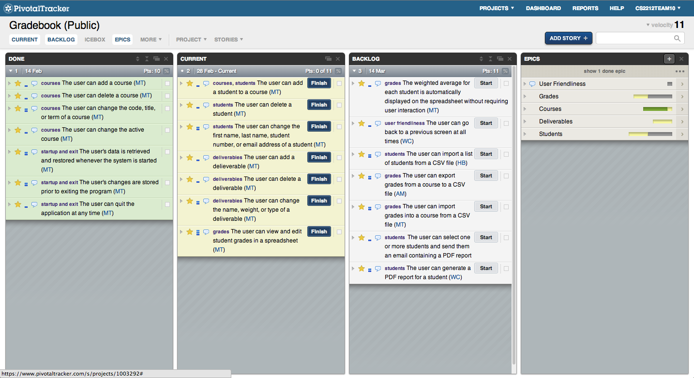

<https://www.pivotaltracker.com/s/projects/1003292>

**Completed User Stories:**

* User can add a course
  + Hit the first icon underneath File menu in the top left or go to the courses menu and hit “Add Course”
* User can delete a course
  + Hit the third icon underneath the File menu in the top left or go to the courses menu and hit “Delete Course”
* User can change the code, title, or term of a course
  + The middle icon below the File and Courses menus will allow a user to edit a course or got to the Courses menu and click “Edit Course”
* User can change the active course
  + Use the drop down menu in the top right to select an active course
* User’s data is retrieved and restored whenever the system is started
  + Courses previously added are in the spreadsheet area when program starts
* User’s changes are stored prior to exiting the program
  + No need to hit a save button!
* User can quit the application at any time
  + Hit the red “x” button in the top left

**SECTION 3: CLASS DESCRIPTIONS**

**SECTION 4: PROJECT PLAN DOCUMENTATION**



