Computer Science 2212b
Team Assignment 4
Team 10

Due: April 2nd, 2014 at 11:59 PM

Team Members:
Henrique Brighenti
Will Callaghan
Alex MacLean
Stephen Solis
Marcus Tonogai

SECTION 1: REVISED USER STORIES

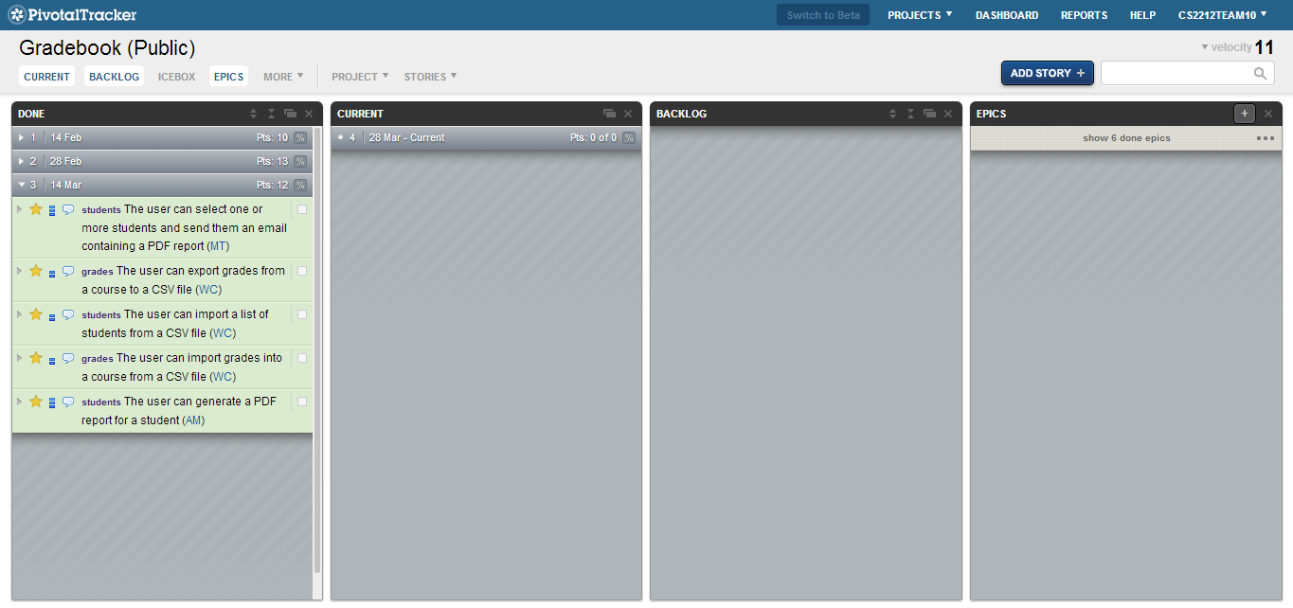

https://www.pivotaltracker.com/s/projects/1003292

Completed User Stories:
- User can email one or more students a PDF report of their grades
  - Click the email button near the top
  - Check the boxes for the students you wish to send reports to
  - Enter SMTP details
  - Hit “Send Email”
- User can export grades from a course to a CSV file
  - Click the File menu and go to Export -> Export grades to CSV file
  - Then choose a destination to save the .csv file to
  - Click “Save”
- User can import a list of students from a CSV file
  - Go to File file menu -> Import -> Import student from CSV file
  - Choose a CSV file
  - Click “Open”
- User can import a list of grades from a CSV file
  - Go to File file menu -> Import -> Import grades from CSV file
  - Choose a CSV file
  - Click “Open”
- User can generate a PDF report for each student
  - Click the “Generate Reports” button near the top
  - Check the boxes for the students you wish to generate reports for
  - Choose a destination folder
  - Click “Save”

SECTION 2: PROJECT VIDEO

https://www.youtube.com/watch?v=cRz2hWz48qk

SECTION 3: PROJECT PLAN

SECTION 4: UNIT TESTS

Non-GUI Classes:
- CommonFunctions (only formatGrade())
- Course
- CSVException
- Deliverable
- DropboxClient
- DuplicateObjectException
- Gradebook
- ReportGenerator
- Student

GUI Classes:
- AppLauncher
- CheckBoxTableHeader
- CommonFunctions (all other methods)
- CustomFileChooser
- DialogTableModel
- DoubleCellEditor
- EmailDialog
- GradeCellEditor
- GradeCellRenderer
- MainWindow
- ReportDialog
- TableModel
- UserEntryPrompter

Non-GUI but non-testable classes:
- ChartCustomizer (JasperReports internal functionality)

