Java Cheat Sheet V0.1

Red = new in Version 10 “XYZ” = any word(s)
Primitives | ❑ 8 of them(byte size): boolean, byte(1), char(2), short(2), int(4), long(8), float(4), double(8)   Autoboxing: Boolean, Byte, Character, Short, Integer, Long, Float, Double   manual unboxing: Integer.intValue(); Long.longValue();   Range: Integer.MAX_VALUE/MIN_VALUE, Long.MAX_VALUE/MIN_VALUE   Other number object types: BigDecimal, BigInteger, AtomicInteger, AtomicLong   Bit operations: <<, >> (shift with sign), >>> (shift fill zero), &, |, ~, ^
String | ❑ int len = str.length()   char c = str.charAt(int index)   String intStr = String.valueOf(int myInt)   String str = myString.substr(int beginIdx, int endIdx)   boolean Character.isLetterOrDigit(char)   Character.toLowerCase
Arrays and ArrayList<E> | ❑ ArrayList.size()   ArrayList.add(E e), add(int index, E element) to append or insert   ArrayList.get(int index)   Create 2D array: int[][] my2DArray = new int[5][7]   init array with same value: Arrays.fill(in[] myArray, -1);   static Arrays method: T[] = copyOfRange(T[], int startIdx, int endIdx)
Stack and Queue | ❑ Stack: empty(), peek(), pop(), push(E item), search(Object o)   Queue   ops that throw exceptions: add(E e), remove(), element()   ops that do not throw exception but may return false or null: offer(E e), poll(), peek()   Queue<Integer> q = new LinkedList<>(); add(e)(E e) and remove() and others just work. Other useful APIs: offerFist/Last(), peekFirst/Last(), pollFirst/Last()
Set and Map | ❑ Set is an interface, use TreeSet or HashSet instead.   add(E e); clear(); contains(E e); isEmpty(); removeAll(anotherSet), retainAll(anotherSet); size()   Map is an interface, use HashMap instead.   containsKey(); containsValue(); put(K,V), remove(K), remove(K,V), keySet(), entrySet()
Graphs | ❑ DFS and BFS simply data structures: boolean[] marked; int[] edgeTo; int[] distTo[]   DFS logic: mark the current node, visit all un-marked neighbors   BFS logic: dequeue the current node, visit un-marked neighbors one-by-one and enqueue them   Always remember: mark the one once done with it.
  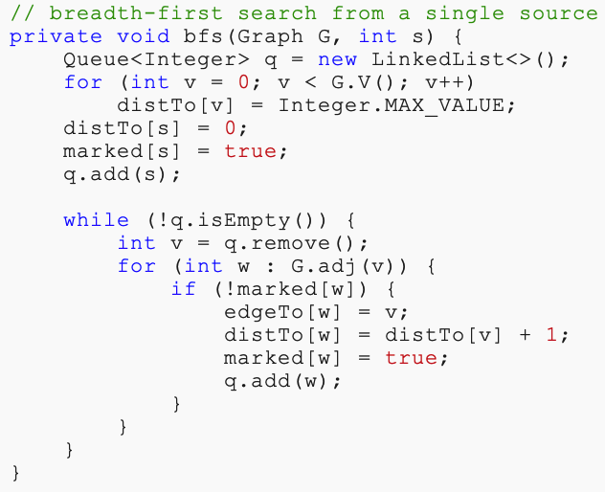 | 