C++ Cheat Sheet V0.1

Red = new in Version 10 “XYZ” = any word(s)
Primitives & arrays | ❑ Range: INT_MAX/INT_MIN; LONG_MAX/LONG_MIN (from <limits>   Bit operations: <<, >> (shift with sign for signed type), >> (shift fill zero if unsigned), &, |, ~, ^   Init array to all 0’s: int a[100] = {0}; init to all “-1” values: std::fill_n(a, 100, -1);
string | ❑ int len = str.lengh()   char c = str.at(int index) or []   string intStr = to_string(int myInt); int I = stoi(string s);   string str = myString.substr(int beginIdx, int len)   size_t pos = myString.find(subString)
Vector<>  List<> | ❑ front(), back(), push_back(), pop_back()   search: std::vector<int>::iterator it = find (v.begin(), v.end(), 30);   sort: ArrayList.get(int index)   Reverse: std::reverse(v.begin(), v.end())   emplace (construct new element into iter position), splice (move a sequence into iterator position)
Stack, Queue & PriorityQueue | ❑ Stack: empty(), push(), pop(), top()   Queue: front(), back(), push(), pop()   priority_queue: push(), pop(), top()
Set and Map | ❑ Set is an interface, use TreeSet or HashSet instead.   add(E e); clear(); contains(E e); isEmpty(); removeAll(anotherSet), retainAll(anotherSet); size()   Map is an interface, use HashMap instead.   containsKey(); containsValue(); put(K,V), remove(K), remove(K,V), keySet(), entrySet()
Graphs | ❑ DFS and BFS simply data structures: boolean[] marked; int[] edgeTo; int[] distTo[]   DFS logic: mark the current node, visit all un-marked neighbors   BFS logic: dequeue the current node, visit un-marked neighbors one-by-one and enqueue them   Always remember: mark the one once done with it.
  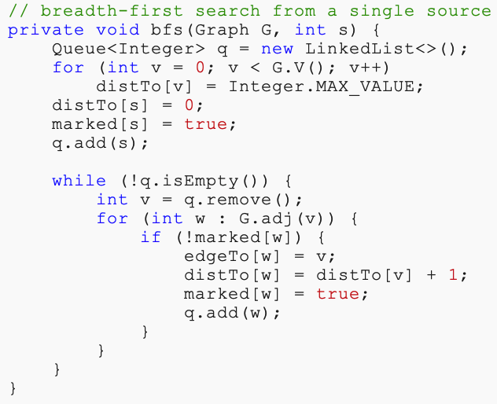 | 