Media Player User Manual

Alex Thomson

Contents

Application Layout 3

Adding a Scope 3

Removing a Scope 3

Reloading a Hierarchy Container 3

Adding a Playlist 3

Renaming a Playlist 3

Removing a Playlist 3

Adding Media to a Playlist 4

Removing Media from a Playlist 4

Adding/Editing a Comment to a Media File 4

Adding/Editing Categories to a Media File 4

Binding an Image to a Media File 4

# Application Layout

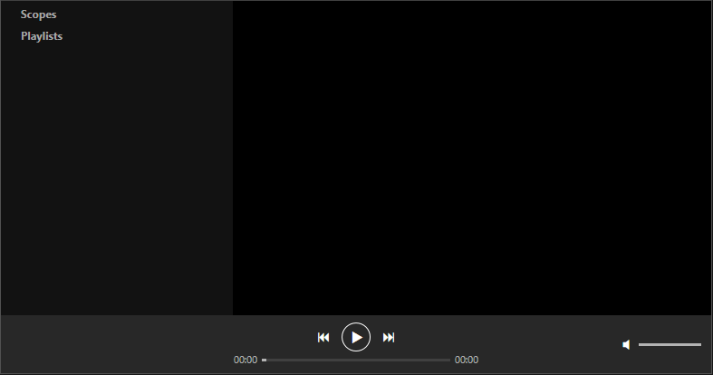

The left columnwill be referred to as the **hierarchy** in this document. The **hierarchy** contains your scopes and playlists.

# Adding a Scope

1. Right click on **Scopes** in the hierarchy.
2. Click **Add Scope**.
3. Select a directory to add as a scope.

# Removing a Scope

1. Right click the scope you want to remove.
2. Click **Remove**.

# Reloading a Hierarchy Container

1. Right click the container in the hierarchy you want to reload.
2. Click **Reload**.

# Adding a Playlist

1. Right click on **Playlists** in the hierarchy.
2. Click **Add Playlist**.

# Renaming a Playlist

1. Right click a playlist you want to rename.
2. Click **Rename**.
3. Enter the new name of the playlist in the dialog box at the top of the window.
4. Press **OK**.

# Removing a Playlist

1. Right click a playlist you want to remove.
2. Click **Remove**.

# Adding Media to a Playlist

1. Select a playlist by left clicking on it in the hierarchy.
2. Right click on a media file you want to add to the selected playlist.
3. Select **Add to Playlist**.

# Removing Media from a Playlist

1. Right click the media you want to remove from a playlist.
2. Click **Remove**.

# Adding/Editing a Comment to a Media File

1. Right click a media file you want to add a comment to.
2. Click **Edit Comment**.
3. Enter the comment you want to associate with the media file in the dialog box at the top of the window.
4. Press **OK**.

# Adding/Editing Categories to a Media File

1. Right click a media file you want to add/edit the categories for.
2. Click **Edit Categories**.
3. Enter the categories into the dialog box at the top of the window. Make sure you separate the categories with commas. For example: *Classical, Orchestral, Symphony*
4. Press **OK**.

# Binding an Image to a Media File

1. Right click a media file you want to bind an image to.
2. Click **Bind Image**.
3. Select the image you wish to bind to the media file.