Methods of allocation of urban centers
Aleksandr Katynsus¹[0009-0004-4653-7839], Ekaterina Shapovalenko2[1111-2222-3333-4444], Anna Pavlova³[1111-2222-3333-4444], Inna Arseneva⁴[1111-2222-3333-4444] and Sergey Mityagin5[1111-2222-3333-4444]
¹ ITMO University, Saint-Petersburg Kronverkskiy Prospekt, 49, Russia
² Springer Heidelberg, Tiergartenstr. 17, 69121 Heidelberg, Germany
lncs@springer.com
Abstract. The paper considers a set of methods that solve the problem of identifying central places in the current urban environment. The problems of research are caused by the need to consider the proximity and location of the actual central places of cities and settlements in almost all processes of planning development and transformation of the environment. Errors in determining the location of the territory to be transformed in the system of central places of the city lead to significant financial and temporary losses. However, there are currently no common approaches to defining central locations. The paper presents the result of research on the systematization of methods based on information about the distribution system in the city, the placement of city services, as well as information about the actual activities of citizens based on spontaneous data. The developed methods are summarized in a general application scenario and experimentally demonstrated on the data of the city of Miass.
Keywords: Network modeling, Information modeling, Graph algorithms, Urban quarter modeling, Urban environment modeling, Centrality of urban quarters, Urban quarter profiling, NLP, Open data
- Introduction
The paper addresses the problem of identifying and modeling central location systems in modern cities. Central locations in urban environments are an essential concept in modern urban planning, with their emergence being caused by natural resource distribution variations throughout the city, spatial clustering tendency, collocation, and competition effects of urban services, as well as incompatibility effects of individual citizens' activities. The complex system of interactions between citizens and the urban environment contributes to the formation of the city's central locations. Absence of prominent central locations blurs the urban environment, reduces its quality and accessibility to leisure facilities, and creates spontaneous migration. This is reflected in the fact that no city exists without central places, and if they are not evident or regulated, central places begin to form spontaneously in places that are not equipped for it.
The methods for identifying central locations in the urban environment are particularly important when conducting preliminary studies. Failure to account for the role of transformable territory in the central location system of the city leads to significant financial losses, difficulty in ensuring the territory functions as expected, and the need to adapt the territory to real conditions after its transformation. Due to the ambiguity of the central location concept, there is a lack of established methodological approaches to solving this problem.
Residential central locations – areas with an increased concentration of the population according to the established settlement system. They are important for determining the structure of agglomerations.
Urban activity central locations – attraction zones for the daily activities of city residents. They are important for planning leisure or recreational spaces.
There are also quasi-central locations, which attract people e.g., transport hubs or monofunctional areas such as markets and squares. In addition, there are potential central locations. Their centrality is indicated by accessibility and connectivity, which requires the use of methods for determining agglomeration boundaries.
Therefore, identifying central locations in the urban environment is a complex task that requires a system of methods, what will be developed in this article.
- City central places allocation problems background
The issue of identifying central locations in the urban environment is well-known in the scientific literature, as it is one of the key tasks of information and analytical support for the process of planning the development of modern cities. The task of identifying urban centers is complex and can be decomposed into a series of related research tasks.
  - Definition of the urban central place
The problem lies in the fact that in the planning of urban areas, central places are not defined properly. Historically, this concept came from the theory of central places by Christaller-Lösch [1], which states that a central place is a designation of a city center for other settlements that provides them with goods and services. Although the Christaller-Lösch theory was developed for the supra-urban level, the concept of a central place proved to be useful for analyzing intra-urban processes.
At the intra-urban level, the concept of a central place is closely related to the concepts of attraction points or points of interest (POI) [2]. Considering the possible types of activity, different criteria for the centrality of such points can be identified. The concept of a point of interest gives a social meaning to the concept of a central place from the perspective of urban science and links it to the concept of "third places" [3] a place that can unite, create an atmosphere of interaction, communication, and creativity.
Thus, the task of identifying and planning central places in the city includes the following parts:
- identification of already established central places with social activity.
- determination of places that are central from the perspective of urban planning without social activity.
- identification of places with high centrality potential.
- planning the creation of new central places and public.
  - Spatial division of territory for centrality assessment
From an urban planning perspective, central places are primarily areas with defined boundaries. Each central place has a certain service radius, which is determined by the degree of centrality according to Christaller [4] or the catchment area [5]. These characteristics give rise to different approaches to spatially delineate central places and determine their boundaries. The most typical approaches are described in Table 1.
Table 1. Approaches to geographical delineation of central places
Description | Illustrations
Native delineation of central place boundaries using clustering and grouping of phenomena on a map. In this case, the boundaries themselves are not explicitly delineated, and the results require additional processing for use in spatial planning. | 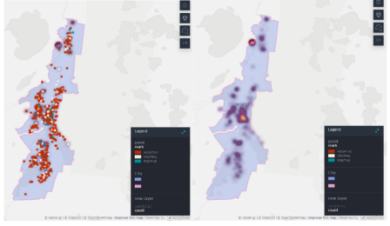  Figure 1 - Approach 1
Territory decomposition based on a grid of regular geometric shapes with the assignment of centrality scores for each shape [6]. This approach contradicts the established urban planning as it goes against the existing urban layout. | 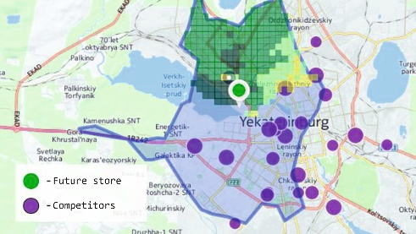  Figure 2 - Approach 2
Ranking of linear objects [7] | Figure 3 - Approach 3
Ranking of territorial planning units [8] | Figure 4 - Approach 4
In spatial planning tasks, the approach based on the assessment of territorial planning units has demonstrated the greatest potential.
  - Criteria for assessing centrality of places
There are various approaches to assessing the degree of centrality of territorial units. The first approach is based on definition of coverage area formed by the composition and strength of services located in the respective territory [9]. This method is applied to both individual planning units and linear objects. Another approach involves assessing the density of the resident population [10]. These methods aim to identify the structure of the settlement system and serve to align demand and supply in the territory.
Analyzing the correspondence between the first type of central places (based on the distribution of urban services) and the second type of places (based on residential centers) can be considered a traditional urban planning task [11]. Solving this problem has generated another direction of research aimed at identifying disparities between different types of centers and the negative effects they generate. One of the most notable effects is counter-urbanization [12].
  - Limits of application of methods of allocation of central
The task of determining central places is closely related to the task of determining the actual boundaries of the territory. There are two principal approaches for determining the boundaries of methods for highlighting central places:
• methods based on clustering spatial units with high centrality indices [13].
• methods based on network models that reproduce the spatial dynamics of citizens between central places of different types, such as residential and service centers [14].
The application of these methods is associated with the use of modern information technologies and the search for the most appropriate data and information resources.
  - Information technologies in the centrality of urban spaces assessment
There is a wide range of analytical methods to measure spatial distribution of urban centers from main characteristics of citizens such as population and employment densities: use of local knowledge to identify city centers, examinations of the spatial distribution with identifying local peaks as possible sub-centers, use of a regression model based on density and distance, space syntax [7].
All these methods have very significant drawbacks. As they were defined a long time ago, they do not consider all the data generated by city actors. Hence, scientists decided to develop new methods based on data and information technologies.
The first method “Revealing the Changing Spatial Structure of Cities from Human Activity Patterns” [15] based on different human activities data was proposed by MIT students. In the paper researchers have introduced a new centrality index applied on large-scale data to analyze the city. The main idea of the method was to combine the number of people attracted to a location and the range of their activities and define a new spatial index. Moreover, students provided a smoothed density function that detects spatial clusters of locations. Detected clusters can be understood as functional centers that create the whole picture of the spatial structure in a city.
The second method to measure centrality of the urban areas uses eigenvector centrality, graphs, and roads network. It was defined in the research “A Centrality Measure for Urban Networks Based on the Eigenvector Centrality Concept” [16]. In the paper discussed the method of locating the key areas of activity in urban areas of different shapes and sizes, and proposed a new algorithm of centrality measurement for the defined types of augmented urban networks, based on the eigenvector centrality index.
All the other methods can be defined as methods inside some software packages and programming tools. Since all the areas of science became very dependent on modern technologies, it was decided to add special packages and frameworks in programming languages and geo-informational systems. Only Python has at least 3 libraries with the help of which it is possible to measure centrality of urban areas. The first one is OSMnx [17], which has algorithms to measure the average shortest path between each node in the network and find centers by connectivity based on graph theory and the street network. Sometimes to a deep dive into the methods it is necessary to use NetworkX [17] library for calculations. Another software to measure centrality of urban spaces is the Cityseer-api [18] which is used for pedestrian-scale network-based urban analysis. The algorithm is intended to be data source agnostic and includes convenient methods for centrality measurement. A very important feature here is that computation of network centralities is using either shortest or simplest path heuristics on either primal or dual networks, including tailored methods such as harmonic closeness centrality.
- A complex approach to identifying central locations
After the analysis of the existing methods there were defined new ones based on modern approaches, practices, and technologies. In this paper we propose to use 4 new methods in one complex algorithm to reveal urban centers. The scheme of the process can be seen in Fig 5.
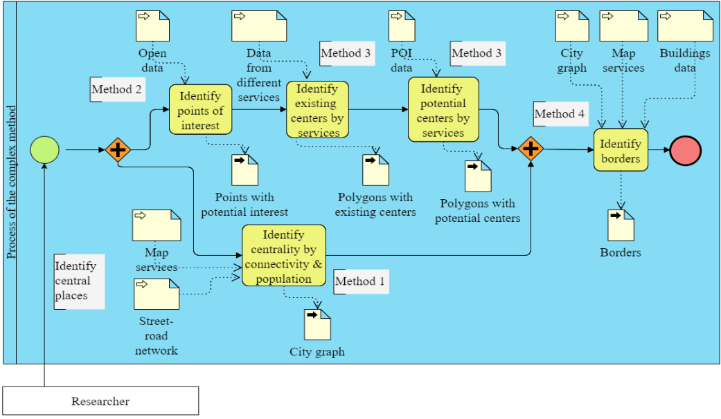
Figure 5 - General scheme
  - Method for determining the centers of population congestion in the city and assessing their connectivity. Method 1
This method represents the city model as a complex network consisting of planar graphs – nodes and undirected edges. The point is to use the graph to determine the central places of settlement in the city not only based on topological data, but also on population data. This method uses open spatial attributive data on population and street and road networks. The data sources are the population census data (in Russia, this is the reform of housing and communal services and Rosstat), the OpenStreetMap database. In general, the method is presented in the flowchart on Fig 6.
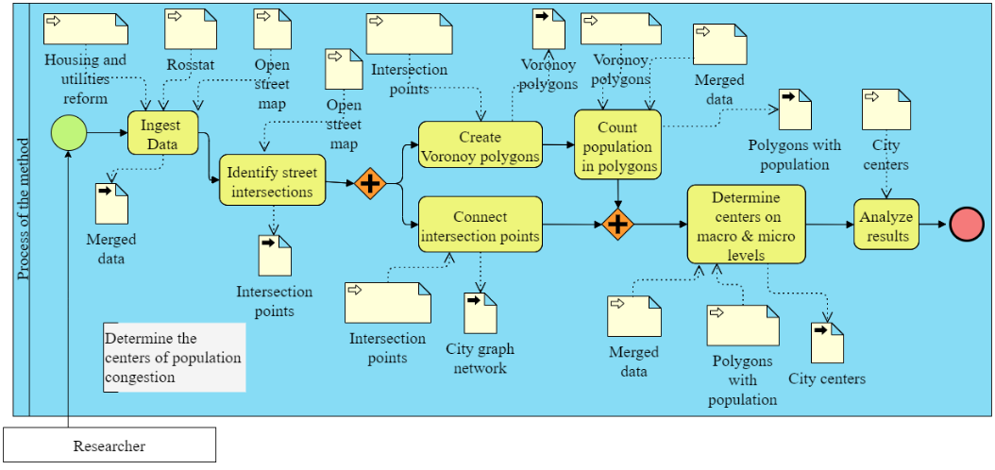
Figure 6 - Scheme of the method for determining the centers of population congestion in the city and assessing their connectivity.

First, topographic data is used to build the network: the street and road network of the city, it is a layer of lines with the type of street embedded in the attributes. The second dataset – population data with information about the number of people living in the area under consideration. Further, these data are loaded into one file into geographic information system, so the intersections of the main streets are determined, then the Voronoi polygons are built based on the intersection points. Voronoi polygons use the Euclidean distance [19]. In the Euclidean plane, let point a have coordinates (a1, a2) and let point b have coordinates (b1, b2), then the distance between a and b is given by:
$l=d[\left(a_{1}{,a}_{2}\right),(b_{1},b_{2})]=\sqrt{{(a_{1}-a_{2})}^{2}+{(b_{1}-b_{2})}^{2}}$ (1)

Each such polygon describes the nearest area at each of the intersections, in which the total population in each polygon is calculated, forming one common point. After that, links are built from each point to each other in a straight line within a radius of a comfortable walking distance, which is taken as 1 kilometer.
Visually, you can assess how dense the connections between the nodes are, compare this with data on the population, as well as building characteristics. When analyzing a graph network, you can use the criterion of centrality by degree, the closer it is to 1,0, the more central the place of settlement.
  - Method of defining centers of urban spaces based on extraction of points of interest. Method 2
The next method is based on the open data from social networks and cartographical services which is analyzed for extracting points of interest in a city. It is proposed to measure the centrality of urban spaces based on the number of points, their attractiveness and quality.
There are at least two types of data used in the algorithm: data from social networks and data from maps. Map data is represented by reviews of the point in the city. With the help of official API, the method receives all the reviews from places. Every row in the table where this data is stored is represented by the name of the place, review, and address to geocode it. Inappropriate content is filtered and cut from the dataset.
Data ingested from social networks is the most complicated because of the manner of writing and unofficial way of sharing the information with users. It can contain spam and advertisements. To filter the data, it is very important to use NLP models for classification of spam, advertisement and unwanted content to prevent false results after the execution of the algorithm. The scheme of the method can be seen in Fig 7.
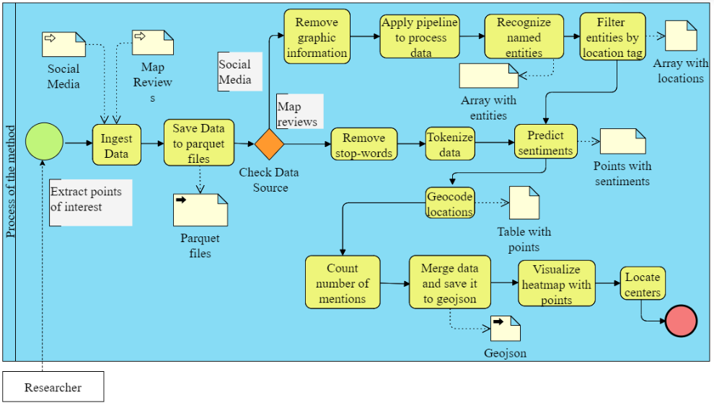
Figure 7. Schema of the second method
The first step in this new method is data ingestion. All the data is stored in the parquet files in one place. Parquet format has been chosen due to the possibility of compressing the data. To start the algorithm, users need to choose a city, and define time periods to get the data. Then comes data processing. As it is text data, we need to use methods of text processing like tokenization to split sentences by tokens, lemmatization to find words’ original forms. One of the most important tasks here is to remove all the stop words, because they do not have any useful information.
The most interesting step in this method is recognizing named entities (NER) from the social networks’ posts. There are some Python packages with pre-trained models that can do this task: DaData, Pullenti, Abbyy, In-foextractor, Dictum, and Stanza. In this method the main model is Stanza with its’ pipelines. In the pipeline it is possible to define all the processes the data should go through. All the extracted entities are filtered by locations and organizations.
Data coming from maps has no need in NER. The only process here is sentiment analysis to define the attractiveness of the point. The number of reviews and the sentiment of each review are combined in one metric.
The last step of the method is to geocode all extracted points and put them on the map. Geocoding is made with the help of GeoPy library and ArcGis geo-coder, what takes text address and converts it to coordinates. All the points have attractiveness split by colors: positive - green, neutral - gray, and negative - red.
  - Method of automatic identification of central locations in a city. Method 3
The next method allows for displaying existing service centers and identifying potential service locations based on a set of accompanying characteristics.
The main task that needs to be solved is the automatic identification of central places in the city. In other words, the method should work with minimal human input and identify central places. The output should be a map with polygons whose sizes correspond to the degree of saturation of each place with services.
The scheme in Fig. 8 consists of three stages, each requiring specific data in a specific format. Firstly, publicly available data about the actual locations of services, the city's master plan, the city map, and reviews with geographical coordinates need to be collected. The result depends on whether there is information about the actual locations of services.
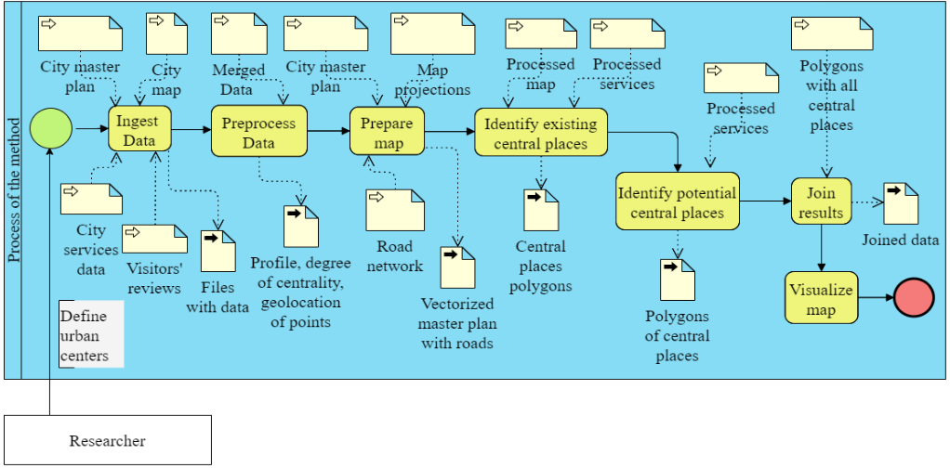
Figure 8. Schema of the method of automatic identification of central locations
If there is no information, then potential central places can be identified based on the combined characteristics of existing central places. If there is information about the actual locations of services, it needs to be processed to obtain the coordinates of the service, its profile, and the degree of centrality using the K-means method. In the third stage, the map needs to be prepared using the QGIS open-source geographic information system. The output is a map with polygons displaying existing or potential central places. This method is a universal tool for design organizations, private entrepreneurs, and active citizens.
  - Method for Delimiting Agglomeration Boundaries: Leveraging Open Data and Identifying Urban Centers. Method 4
This study employs a method focused on delineating the boundaries of urban agglomerations using an unevenly zoned model. The developed method relies on two crucial parameters: patterns of development and the stability of transport connectivity.
The analysis of the agglomeration's planning structure is based on the principle of the unevenly zoned Vysokovsky model. This model serves as the foundation for understanding the distribution and organization of different zones within the agglomeration. By examining the patterns of development and the connectivity of transportation networks, the methodology aims to provide insights into the spatial dynamics and functional characteristics of urban agglomerations.
To facilitate this analysis, a classifier of building morphotypes was specifically developed for this study. This classifier aids in categorizing the different types of buildings found within the study area, providing valuable insights into the built environment and its relationship with urban centers.
To gather the necessary data for the analysis, open data sources such as the housing and communal services reform, OpenStreetMap, and urban planning documents will be utilized. These data sources provide comprehensive information on the built environment, infrastructure, and urban development plans, enabling a detailed examination of the study area. The scheme of the method is in Fig. 9.
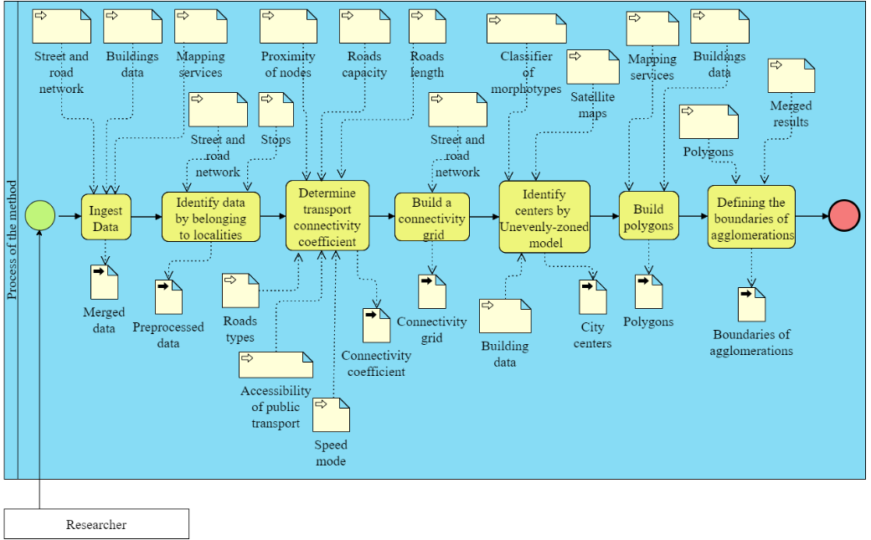
Figure 9 - Method for Delimiting Agglomeration Boundaries
By combining information on building morphotypes and transport connectivity, this methodology offers a comprehensive understanding of the characteristics and spatial organization of urban centers. The integration of open data sources ensures a robust and transparent analysis process, facilitating accurate assessments and informed decision-making in urban planning.
- Experimental studies of methods
All 4 methods were tested on the city in Chelyabinsk region - Miass. This is a small city with the population of approximately 150000 people. It is the best choice due to the volume of data generated in the city.
  - Demonstration of method for determining the centers of population congestion in the city and assessing their connectivity
In Fig 10 you can see where the links between the nodes are most densely located – there is a good connection between population clusters. Most of the population is in medium and high-rise residential buildings, but this does not mean the centrality of the place. Areas with denser mid-rise development take center stage as they tend to have a more connected pedestrian network, distances and spaces that are commensurate and comfortable for people. The private residential sector is rarely the center since there is a very low density of both population and buildings.

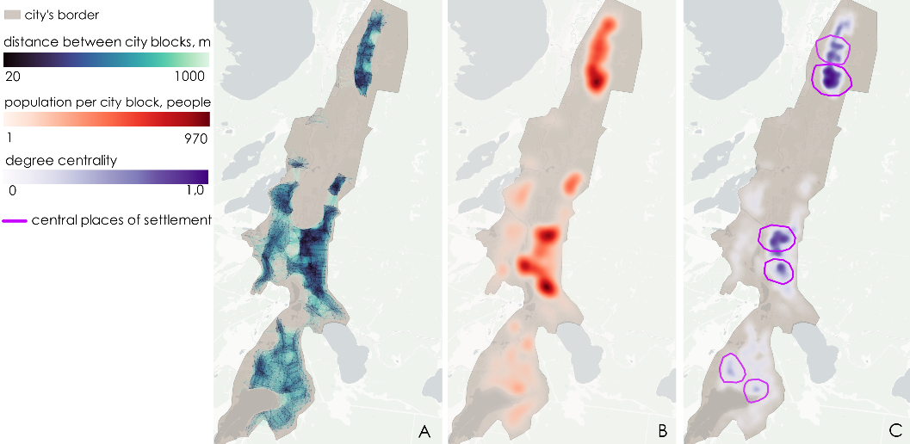
Figure 10 - A - density of connections of the road network, B - population density by city blocks, C - central places of the city

Residential areas with a large population can be defined as POI. Due to the low density, they can only form centers at the micro level. At the macro level of the city, densely built-up quarters will still be considered centers of attraction.
  - Demonstration of the method based on points of interest.
Final maps with the extracted points of interest can be seen in Fig 11.

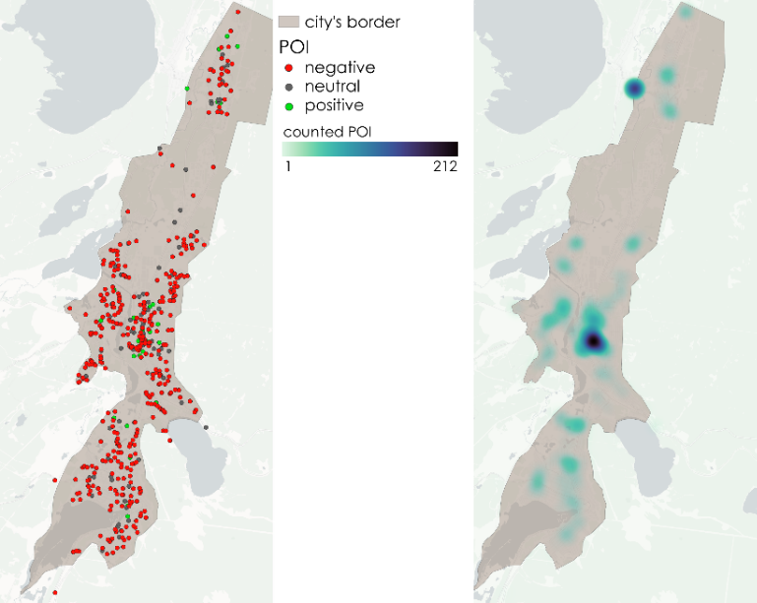
Figure 11 - Results of POI's extraction
All the data was ingested on a local machine and saved in parquet format and then analyzed. There were 998 groups about Miass city in VK (Russian online social media network) what were scrapped for the data. Moreover, all posts what contain the name of the city in Russian were also added to the dataset. After the data ingestion all the texts were tokenized and converted to numbers to extract named entities. The only entity needed was location, hence there was a filter to save only locations in the final dataset. At the same time all the texts have been processed semantically to define the attractiveness of the point.
The first map shows the distribution of points of all kinds. The second one is a heat map drawn by the number of mentions of every point. It shows the most popular points in the city, what can be defined as centers of urban spaces. There are at least 2 main and some minor centers in the city.
  - Demonstration of the Method of automatic identification of central locations in a city
To demonstrate the results, all services of the profile of interest are displayed on the map. A heat map is created based on the location of these services, showing where the concentration of services is highest (Fig. 12).
Subsequently, the K-means method is applied to cluster the existing services. After identifying the clusters, the degree of popularity of the central places is determined according to the heatmap. Thus, on the final visualization, the central places are represented in different colors according to their popularity (Fig. 12).
To identify potential central places, it is necessary to collect reviews mentioning specific points on the map and geocode them. Then, they are also displayed as a heatmap, clustered, and added to the final map. As shown in Fig. 1a, potential central places have lower popularity. This may be due to the absence of services on their territory that attract a large people flow.
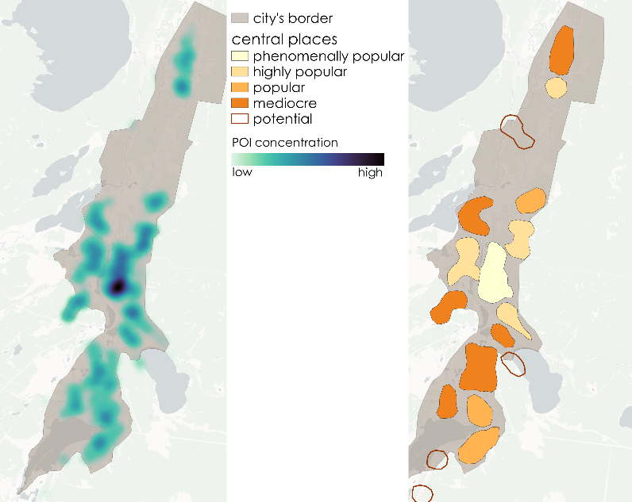
Figure 12 - Demonstration of the method of automatic identification of central locations

Thus, this method can be utilized for various tasks and produces different outcomes. However, its most valuable function is to identify those places that have the potential to become central, but currently do not have some service.
  - Demonstration of the method for Delimiting Agglomeration Boundaries: Leveraging Open Data and Identifying Urban Centers
The application of the proposed method for determining agglomeration boundaries and identifying urban centers in Miass yielded promising outcomes. The analysis of transport infrastructure connectivity revealed several areas with high levels of connectivity, indicating potential urban centers within the city. These areas demonstrated a concentration of road networks, public transportation routes, and other modes of transport, highlighting their importance in the city's overall connectivity.
Using a classifier, the processed data successfully identified and categorized urban centers based on various indicators such as population density, commercial activity, and availability of public facilities. The identified urban centers aligned well with the characteristics of developed and densely populated areas, showcasing their significance within the city's spatial structure.
The correlation analysis between the obtained results and the boundaries defined in the master plan for Miass's development by 2030 exhibited a high degree of agreement. The identified agglomeration boundaries based on transport infrastructure connectivity were found to be compatible with the long-term vision outlined in the master plan. This correlation validated the accuracy and reliability of the proposed method in defining agglomeration boundaries that align with the city's strategic objectives. The results and workflow are shown in Fig. 13.
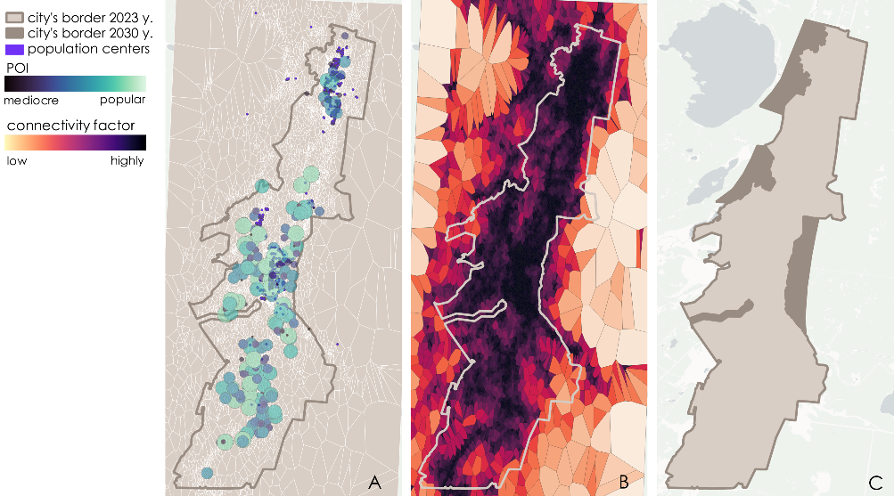
Figure 13 - Demonstration of the method for Delimiting Agglomeration Boundaries: Leveraging Open Data and Identifying Urban Centers

Overall, the results obtained through this method provide valuable insights into the spatial distribution of urban centers and the delineation of agglomeration boundaries in Miass. These findings can inform urban planning, resource allocation, and decision-making processes, facilitating sustainable development and efficient utilization of urban resources.
- Discussion
In this article four new urban centers allocation methods were defined and explained. All of them can be used as separate tools for city analysis, but the best result can be achieved if all the methods work together, so that every city in the world can be deeply analyzed and studied from different perspectives and sides. They form a new powerful tool in geo analysis and urban centers definition and extraction. Fig. 14e clearly shows the work of all four methods.
The method in Fig 14a shows the central places of settlement based on the connectivity of territories and the number of people in this area. It suggests in which places it is most profitable to develop POI. The method in Fig. 14b shows clusters of points of attraction and characterizes their degree of attractiveness. The method in Fig. 14c determines the area of accumulation of such points, as well as places with a potential increase in several POIs. Finally, the method in Fig. 14d shows a complete picture of the development of the city: the joint growth of places of settlement of people and the placement of points of attraction give an understanding of the potential directions for the development of the city's borders.
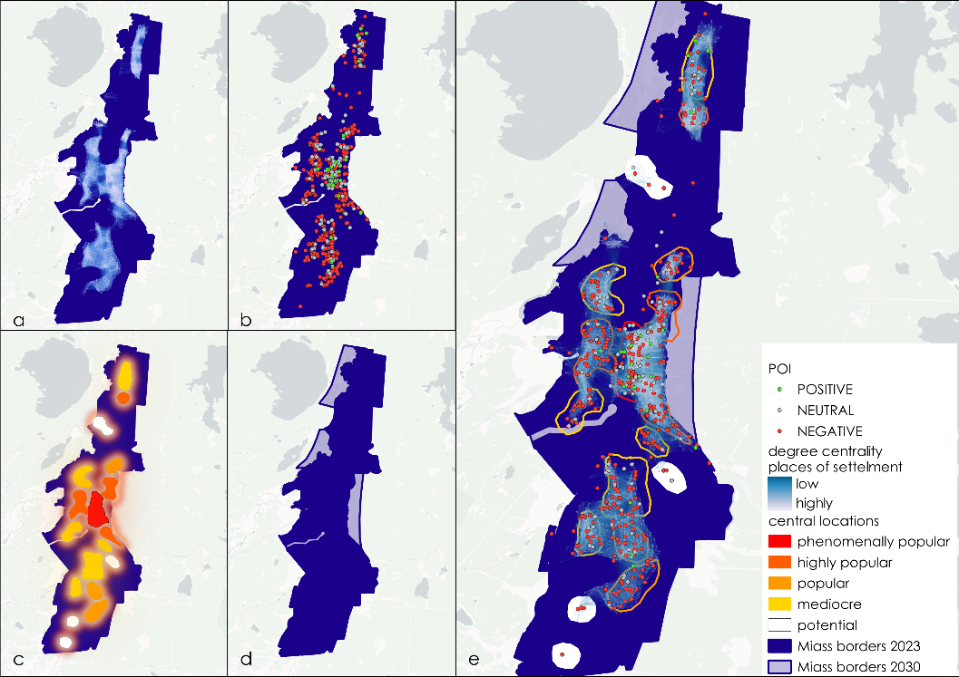
Figure 14 - Demonstration of the methods of allocation of urban centers
- Conclusion
In conclusion, this article has examined a diverse array of methods for identifying urban centers of different types, a careful analysis of the data concluded that these methods hold significant value both independently, for addressing specific challenges, and collectively, for conducting comprehensive analyses of cities. The versatility and effectiveness of these approaches offer valuable insights for urban researchers and planners alike. By employing these methodologies, we can gain a deeper understanding of urban dynamics and pave the way for more informed decision-making in urban development and management.

References
- Dmitriev R.V. Theory of Central Places: Abstract constructions and/or applied developments // Conference "Theoretical and Applied Problems of Geographic Science: Demographic, Social, Legal, Economic, and Ecological Aspects", pp. 62-66 (2019).
- Katynsus A.V. Study of methods for identifying points of public interest based on open data // Conference "12th Congress of Young Scientists". - St. Petersburg, (2023).
- Oldenburg R. The Great Good Place: Cafes, Coffee Shops, Bookstores, Bars, Hair Salons, and Other. 3nd edn. Marlowe & Company, US (1989).
- King, L.J. Central Place Theory. Reprint. Edited by Grant Ian Thrall. WVU Research Repository, 2020.
- Oldenburg R. The Great Good Place: Cafes, Coffee Shops, Bookstores, Bars, Hair Salons, and Other. 3nd edn. Marlowe & Company, US (1989).
- Ghadiri, Mehdi, Rassafi, Amir, Mirbaha, Babak. The effects of traffic zoning with regular geometric shapes on the precision of trip pro-duction models//Journal of Transport Geography, Elsevier, vol. 78(C), pр. 150-159 (2019).
- Yamu H.C. Space syntax: A method to measure urban space related to so-cial, economic and cognitive factors // The Virtual And The Real in Plan-ning and Urban Design: Perspectives, practices and applications, Routledge: Oxon, UK / New York, USA, pp. 136–150. (2018).
- Hudec, Miroslav & Vujosevic, Mirko. Integration of a Fuzzy Sys-tem and an Information System for the Territorial Units Ranking, рр. 374-377, (2007)
- Jahn Gehl. Cities for People. Island Press (2010).
- Pereira R., Nadalin V., Monasterio L.,Albuquerque P. Urban Centrality: A Simple Index// Geographical Analysis, pp. 77-89, (2013).
- Em, P. A Big City as an Independent Central Place System, a Case Study of Moscow // Regional Research of Russia. – Moscow, (2018).
- ŠIMON, M. Counterurbanization: Condemned to Be a Chaotic Conception? Geograﬁe, 116, No. 3, pp. 231–255, (2011)
- A. K. Jain, M. N. Murty, P. J. Flynn: Data clustering: a review. ACM Computing Surveys 31(3), pp. 264–323 (1999).
- M. E. J. Newman: Mathematics of networks. The New Palgrave Encyclopedia of Economics. 2nd edi-tion. Palgrave Macmillan, Basingstoke (2008).
- Chen Zhong, Markus Schläpfer, Stefan Müller Arisona, Michael Batty, Carlo Ratti, and Gerhard Schmitt: Revealing the Changing Spatial Structure of Cities from Human Activity Patterns. Urban Studies vol. 54, issue 2, pp. 437-455 (2016).
- Taras Agryzkov, Leandro Tortosa, José F Vicent, and Richard Wilson: A Centrality Measure for Urban Networks Based on the Eigenvector Centrality Concept. Urban Studies vol. 46, issue 4, pp. 668-689 (2017).
- Geoff Boeing, Urban Street Network Centrality, https://geoffboeing.com/2018/01/urban-street-network-centrality/, last accessed 2023/05/15.
- Gareth Simons: The cityseer Python package for pedestrian-scale network-based urban analysis. Environment and Planning B: Urban Analytics and City Science 0(0) (2022).
- Deza, M. M., Deza, E. Encyclopedia of Distances. 4th edn. Springer, Springer Heidelberg New York Dordrecht London
(2016)

